Windows Virtual machine

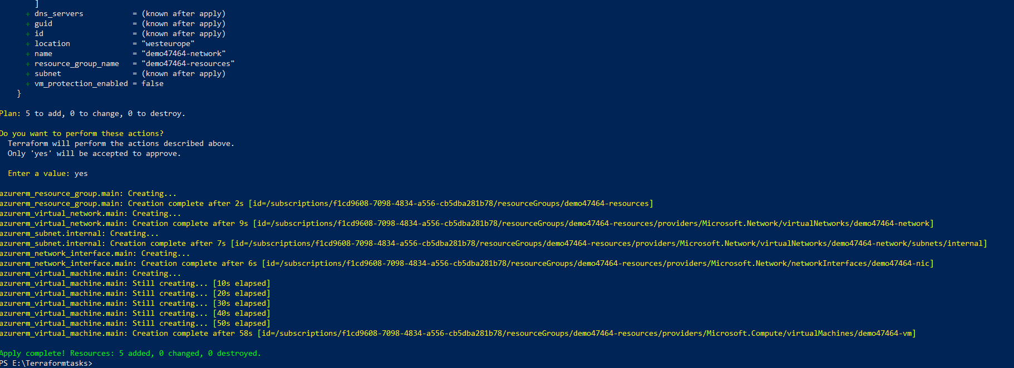

Linux Virtual Machine

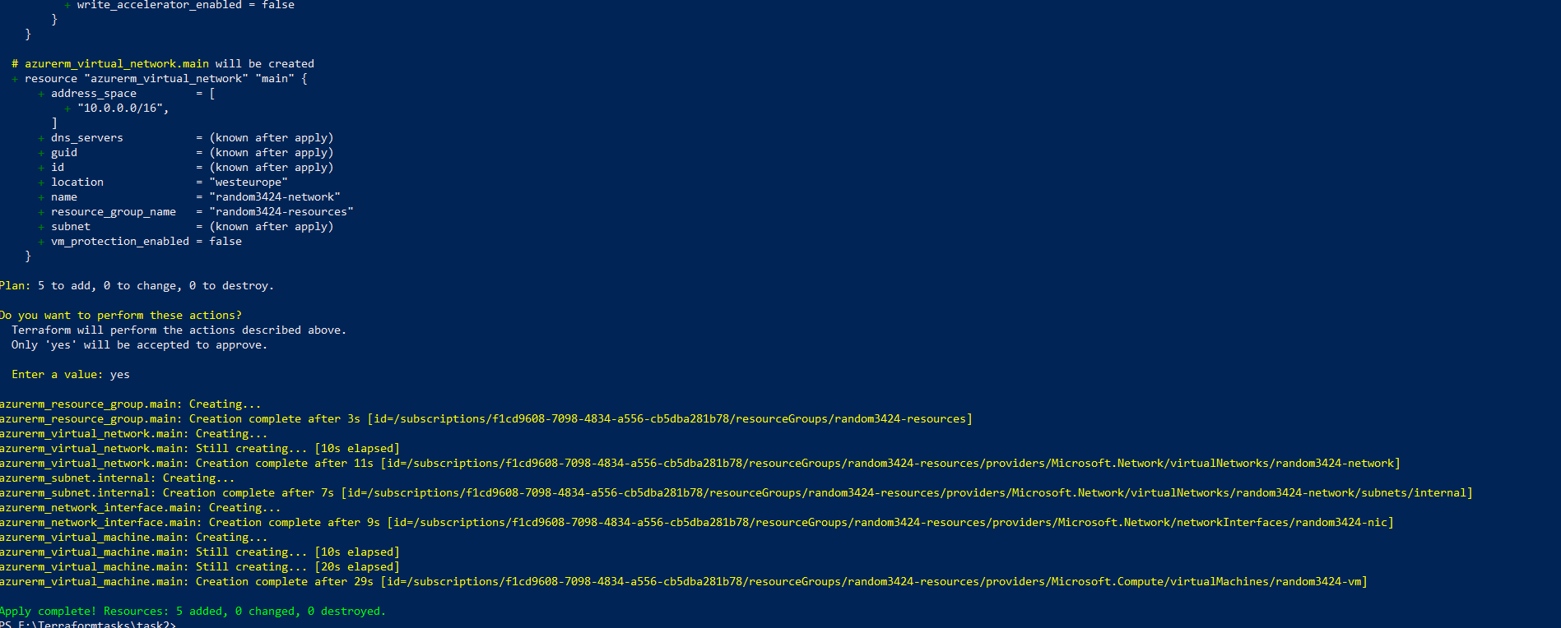

Virtual Network In Azure

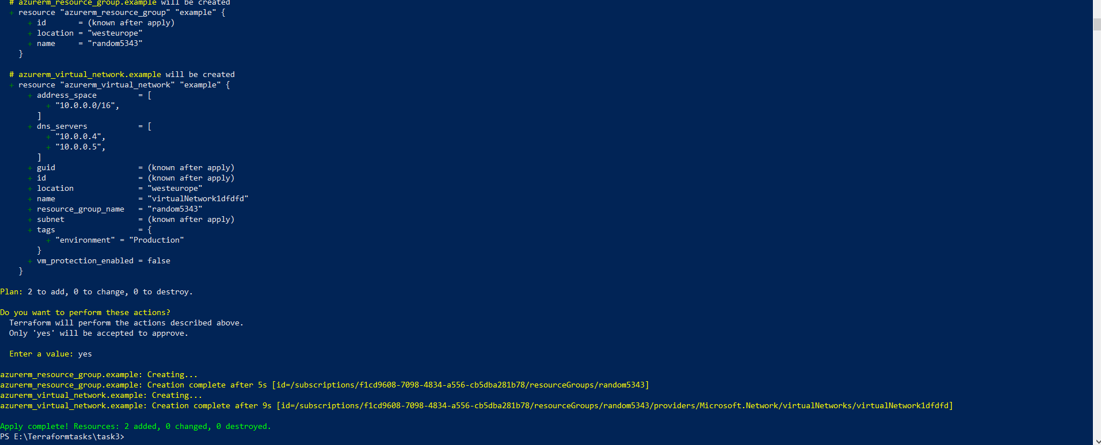

Resource group and Storage Account

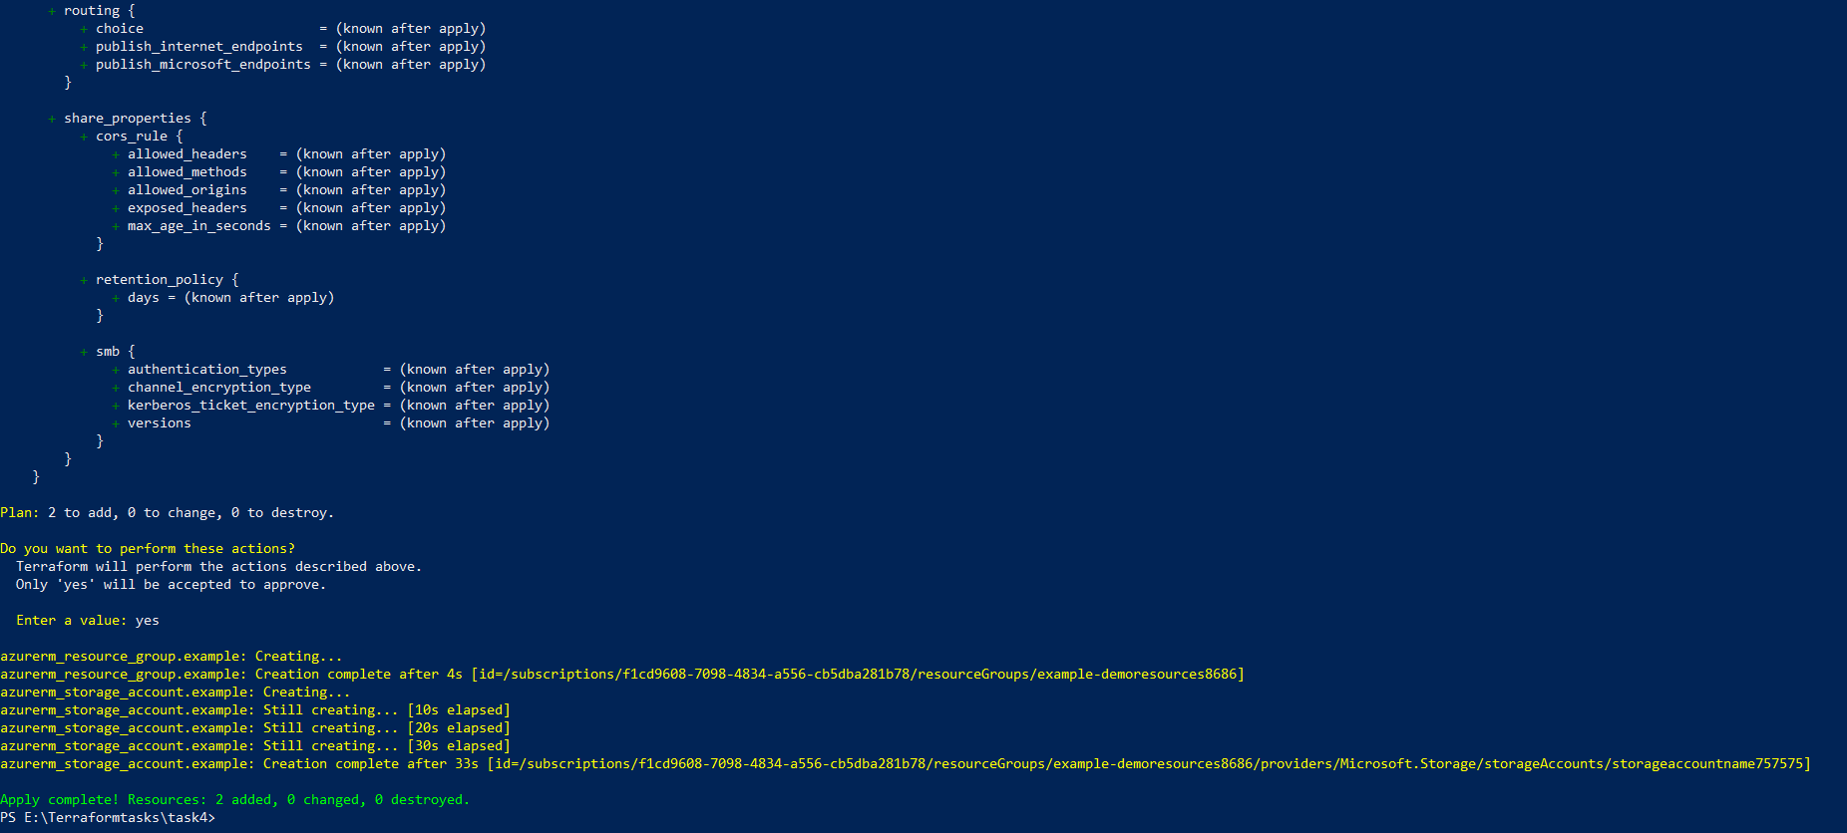

For each Block Execution

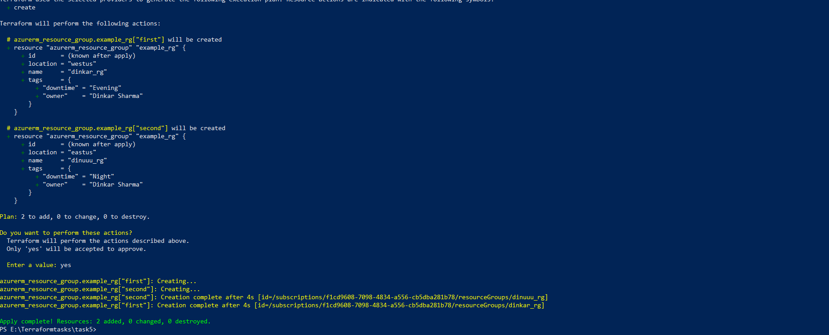

Ansible Tasks Screenshot:

Write a playbook to create a directory www at /srv on a debian based system using a Ansible playbook.

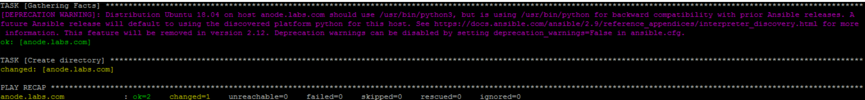

Write a plaaybook to checkout from git, upload the checkout (tarballed) to the production server (hosted externally) and then runs the deployment script.

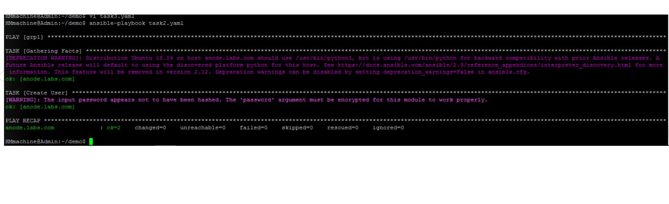

Write a playbook to Creating a new user and password with Ansible

Write a playbook to delete files and folders inside a directory.

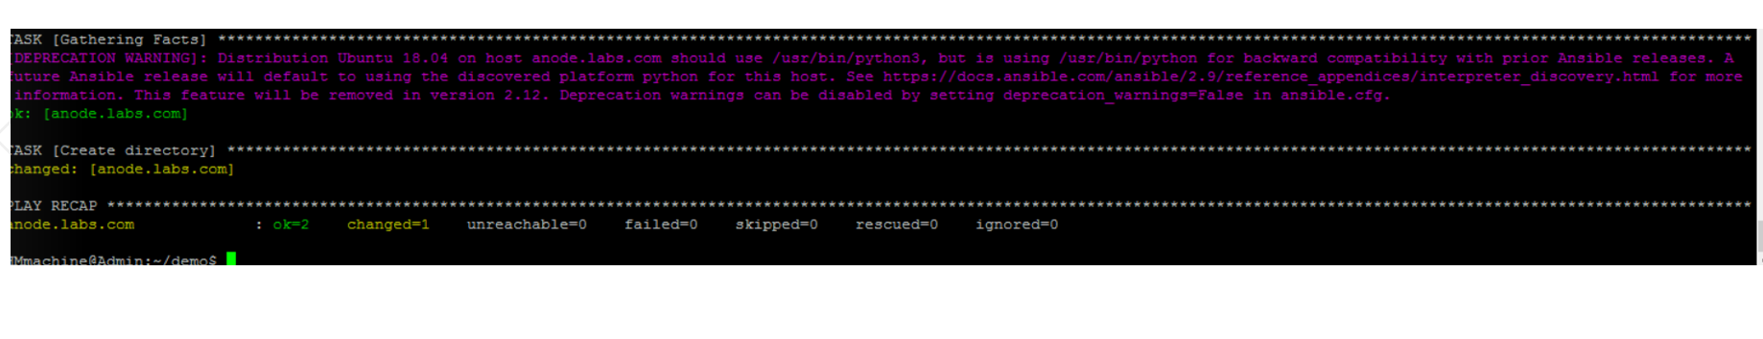

Write a playbook to move/rename a file/directory using an Ansible module on a remote system

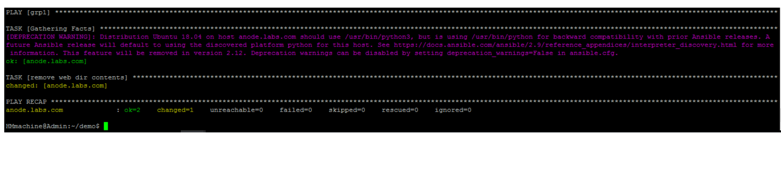

Write a playbook to create files and folders inside a directory.

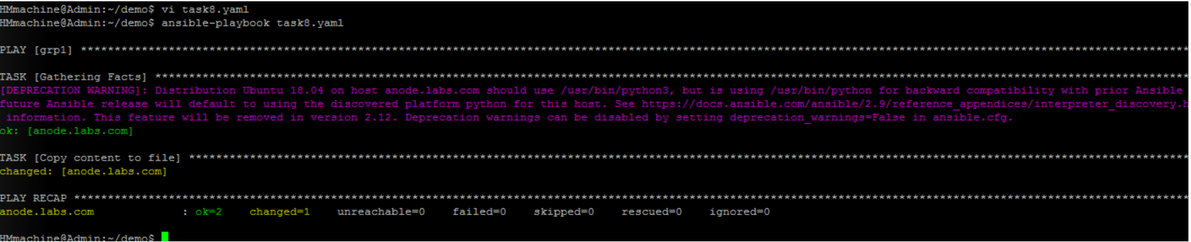

Find a way to How to only run one task in ansible playbook

