**Validation in ASP .NET Core**

[6 Replies](https://wakeupandcode.com/validation-in-asp-net-core/#comments)

This is the **twenty-second**of a [series of posts](https://wakeupandcode.com/aspnetcore/#aspnetcore2019) on ASP .NET Core in 2019. In this series, we’ll cover 26 topics over a span of 26 weeks from January through June 2019, titled **A-Z of ASP .NET Core!**

** A – Z of ASP .NET Core!**

**In this Article:**

* V is for Validation
* Validation Attributes
* Server-Side Validation
* Client-Side Validation
* Client to Server with Remote Validation
* Custom Attributes
* References

**V is for Validation**

To build upon a previous post on [Forms and Fields in ASP .NET Core](https://wakeupandcode.com/forms-and-fields-in-asp-net-core/), this post covers Validation in ASP .NET Core. When a user submits form field values, proper validation can help build a more user-friendly and secure web application. Instead of coding each view/page individually, you can simply use server-side attributes in your models/viewmodels.

**NOTE**: As of ASP .NET Core 2.2, validation may be skipped automatically if ASP .NET Core decides that validation is not needed. According to the [“What’s New” release notes](https://docs.microsoft.com/en-us/aspnet/core/release-notes/aspnetcore-2.2?view=aspnetcore-2.2#validation-performance), this includes primitive collections (e.g. a byte[] array or a Dictonary<string, string> key-value pair collection)

[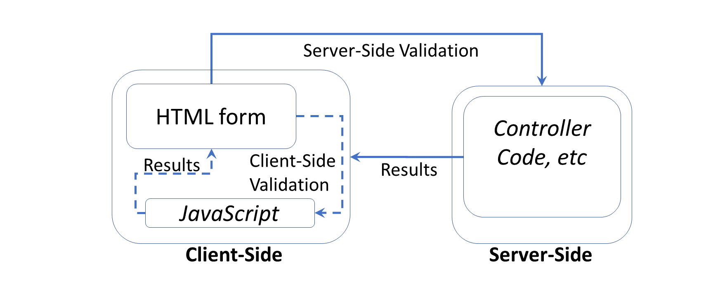](https://wakeupandcode.com/wp-content/uploads/2019/06/Blog-Diagram-Validation.png)

This article will refer to the following sample code on GitHub:

 Validation Sample App: <https://github.com/shahedc/ValidationSampleApp>

**Validation Attributes**

To implement model validation with [Attributes], you will typically use Data Annotations from the [System.ComponentModel.DataAnnotations](https://docs.microsoft.com/en-us/dotnet/api/system.componentmodel.dataannotations) namespace. The list of attribute does go beyond just validation functionality though. For example, the DataType attribute takes a datatype parameter, used for inferring the data type and used for displaying the field on a view/page (but does not provide validation for the field).

Common attributes include the following

* **Range**: lets you specify min-max values, inclusive of min and max
* **RegularExpression**: useful for pattern recognition, e.g. phone numbers, zip/postal codes
* **Required**: indicates that a field is required
* **StringLength**: sets the maximum length for the string entered
* **MinLength**: sets the minimum length of an array or string data

From the sample code, here is an example from the [CinematicItem model](https://github.com/shahedc/ValidationSampleApp/blob/master/ValidationMvc/Models/CinematicItem.cs) class:

public class **CinematicItem**{ public int **Id** { get; set; } **[Range(1,100)]** public int **Score** { get; set; } **[Required]** **[StringLength(100)]** public string **Title** { get; set; } **[StringLength(255)]** public string **Synopsis** { get; set; } [**DataType**(DataType.Date)] [**DisplayName**("Available Date")] public DateTime **AvailableDate** { get; set; } [**Required**] [**DisplayName**("Movie/Show/etc")] public CIType **CIType** { get; set; }}

From the above code, you can see that:

* The value for **Score** can be 1 or 100 or any integer in between
* The value for **Title** is a required string, needs to be less than 100 characters
* The value for **Synopsis** can be left blank, but has to be less than 100 characters.
* The value for **AvailableDate** is displayed as “Available Date” (with a space)
* Because of the **DataType** provided, **AvailableDate** is displayed as a selectable date in the browser
* The value for **CIType** (short for Cinematic Item Type) is displayed as “Movie/Show/etc” and is displayed as a selectable value obtained from the CIType data type (which happens to be an enumerator. (shown below)

public enum **CIType**{ Movie, Series, Short}

Here’s what it looks like in a browser when validation fails:

[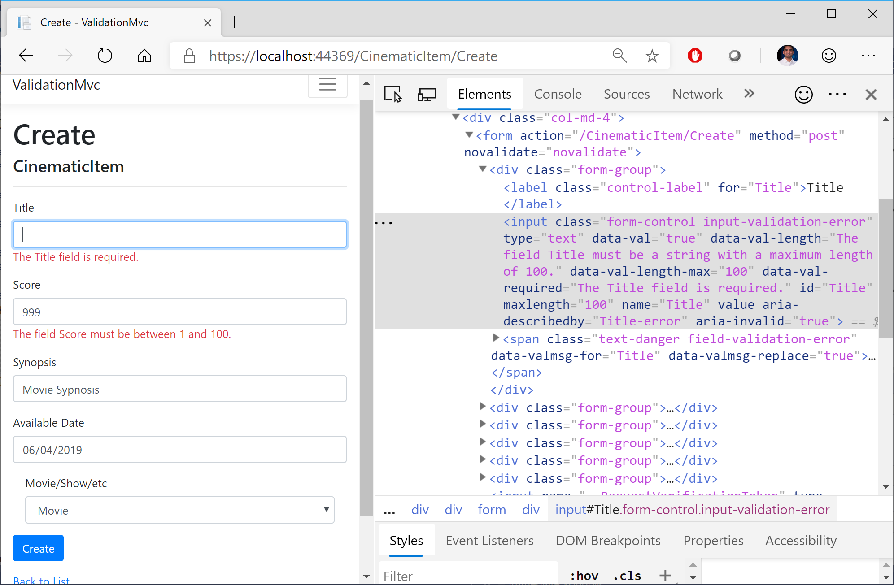](https://wakeupandcode.com/wp-content/uploads/2019/06/Validation-Fields-Errors.png)

The validation rules make it easier for the user to correct their entries before submitting the form.

**Server-Side Validation**

Validation occurs before an MVC controller action (or equivalent handler method for Razor Pages) takes over. As a result, you should check to see if the validation has passed before continuing next steps.

e.g. in an MVC controller

[**HttpPost**][**ValidateAntiForgeryToken**]public async Task<IActionResult> **Create**(...){ if (**ModelState.IsValid**) { // ... return RedirectToAction(nameof(Index)); } return View(cinematicItem);}

e.g. in a Razor Page’s handler code:

public async Task<IActionResult> **OnPostAsync**(){ if (!**ModelState.IsValid**) { return Page(); } //... return RedirectToPage("./Index");}

Note that **ModelState**.**IsValid** is checked in both the **Create**() action method of an MVC Controller or the **OnPostAsync**() handler method of a Razor Page’s handler code. If **IsValid** is true, perform actions as desired. If false, reload the current view/page as is.

**Client-Side Validation**

It goes without saying that you should always have server-side validation. All the client-side validation in the world won’t prevent a malicious user from sending a GET/POST request to your form’s endpoint. Cross-site request forgery in the [Form tag helper](https://docs.microsoft.com/en-us/aspnet/core/mvc/views/working-with-forms#the-form-tag-helper) does provide a certain level of protection, but you still need server-side validation. That being said, client-side validation helps to catch the problem before your server receives the request, while providing a better user experience.

When you create a new ASP .NET Core project using one of the built-in templates, you should see a shared partial view called [_ValidationScriptsPartial.cshtml](https://github.com/shahedc/ValidationSampleApp/blob/master/ValidationMvc/Views/Shared/_ValidationScriptsPartial.cshtml). This partial view should include references to [jQuery unobtrusive validation](https://github.com/aspnet/jquery-validation-unobtrusive), as shown below:

<environment include="Development"> <script src="~/lib/jquery-validation/dist/**jquery.validate.js**"></script> <script src="~/lib/jquery-validation-unobtrusive/**jquery.validate.unobtrusive.js**"></script></environment>

If you create a scaffolded controller with views/pages, you should see the following reference at the bottom of your page or view.

e.g. at the bottom of [Create.cshtml](https://github.com/shahedc/ValidationSampleApp/blob/master/ValidationMvc/Views/CinematicItem/Create.cshtml) view

@section Scripts { @{await Html.RenderPartialAsync("**_ValidationScriptsPartial**");}}

e.g. at the bottom of the [Create.cshtml](https://github.com/shahedc/ValidationSampleApp/blob/master/ValidationRazor/Pages/CinematicItems/Create.cshtml) page

@section Scripts { @{await Html.RenderPartialAsync("**_ValidationScriptsPartial**");}}

Note that the syntax is identical whether it’s an MVC view or a Razor page. That being said, you may want to disable client-side validation. This is accomplished in different ways, whether it’s for an MVC view or a Razor page.

From the official [docs](https://docs.microsoft.com/en-us/aspnet/core/mvc/models/validation?view=aspnetcore-2.2#disable-client-side-validation), the following code should be used within the **ConfigureServices**() method of your Startup.cs class, to set **ClientValidationEnabled** to false in your HTMLHelperOptions configuration.

services.**AddMvc**().**AddViewOptions**(options =>{ if (_env.IsDevelopment()) { options.HtmlHelperOptions.**ClientValidationEnabled** = false; }});

Also mentioned in the official docs, the following code can be used for your Razor Pages, within the **ConfigureServices**() method of your Startup.cs class.

services.Configure<**HtmlHelperOptions**>(o => o.**ClientValidationEnabled** = false);

**Client to Server with Remote Validation**

If you need to call a server-side method while performing client-side validation, you can use the [**Remote**] attribute on a model property. You would then pass it the name of a server-side action method which returns an **IActionResult**with a true boolean result for a valid field. This [**Remote**] attribute is available in the Microsoft.AspNetCore.Mvc namespace, from the [Microsoft.AspNetCore.Mvc.ViewFeatures](https://www.nuget.org/packages/Microsoft.AspNetCore.Mvc.ViewFeatures) NuGet package.

The model property would look something like this:

[**Remote**(action: "**MyActionMethod**", controller: "**MyControllerName**")]public string **MyProperty** { get; set; }

In the controller class, (e.g. **MyControllerName**), you would define an action method with the name specified in the [**Remote**] attribute parameters, e.g. **MyActionMethod.**

[**AcceptVerbs**("Get", "Post")]public IActionResult **MyActionMethod**(...){ if (TestForFailureHere()) { return **Json**("Invalid Error Message"); } return **Json(true)**;}

You may notice that if the validation fails, the controller action method returns a JSON response with an appropriate error message in a string. Instead of a text string, you can also use a false, null, or undefined value to indicate an invalid result. If validation has passed, you would use **Json(true)** to indicate that the validation has passed.

*So, when would you actually use something like this?* Any scenario where a selection/entry needs to be validated by the server can provide a better user experience by providing a result as the user is typing, instead of waiting for a form submission. For example: imagine that a user is buying online tickets for an event, and selecting a seat number displayed on a seating chart. The selected seat could then be displayed in an input field and then sent back to the server to determine whether the seat is still available or not.

**Custom Attributes**

In addition to all of the above, you can simply build your own custom attributes. If you take a look at the classes for the built-in attributes, e.g. [RequiredAttribute](https://docs.microsoft.com/en-us/dotnet/api/system.componentmodel.dataannotations.requiredattribute), you will notice that they also extend the same parent class:

* System.ComponentModel.DataAnnotations.ValidationAttribute

You can do the same thing with your custom attribute’s class definition:

public class **MyCustomAttribute**: ValidationAttribute { // ...}

The parent class [ValidationAttribute](https://docs.microsoft.com/en-us/dotnet/api/system.componentmodel.dataannotations.validationattribute), has a virtual **IsValid**() method that you can override to return whether validation has been calculated successfully (or not).

public class **MyCustomAttribute**: **ValidationAttribute**{ // ... protected override ValidationResult **IsValid**( object value, ValidationContext validationContext) { if (TestForFailureHere()) { return new **ValidationResult**("Invalid Error Message"); } return **ValidationResult.Success**; }}

You may notice that if the validation fails, the **IsValid(**) method returns a **ValidationResult**() with an appropriate error message in a string. If validation has passed, you would return **ValidationResult.Success** to indicate that the validation has passed.

**References**

* Add validation to an ASP.NET Core MVC app: <https://docs.microsoft.com/en-us/aspnet/core/tutorials/first-mvc-app/validation>
* Model validation in ASP.NET Core MVC and Razor Pages: <https://docs.microsoft.com/en-us/aspnet/core/mvc/models/validation>
* System.ComponentModel.DataAnnotations Namespace: <https://docs.microsoft.com/en-us/dotnet/api/system.componentmodel.dataannotations>
* ValidationAttribute Class (System.ComponentModel.DataAnnotations): <https://docs.microsoft.com/en-us/dotnet/api/system.componentmodel.dataannotations.validationattribute>

This entry was posted in [ASP.NET](https://wakeupandcode.com/category/asp-net/), [HTML](https://wakeupandcode.com/category/html/), [JavaScript](https://wakeupandcode.com/category/javascript/), [Learn](https://wakeupandcode.com/category/learn/), [Visual Studio](https://wakeupandcode.com/category/visual-studio/), [Web Development](https://wakeupandcode.com/category/web-development/) and tagged [.net](https://wakeupandcode.com/tag/net/), [.NET Core](https://wakeupandcode.com/tag/net-core/), [ASP.NET](https://wakeupandcode.com/tag/asp-net/), [ASP.NET Core](https://wakeupandcode.com/tag/asp-net-core/), [Validation](https://wakeupandcode.com/tag/validation/) on [June 4, 2019](https://wakeupandcode.com/validation-in-asp-net-core/) by [Shahed C](https://wakeupandcode.com/author/admin/).

**Post navigation**

[← Unit Testing in ASP .NET Core](https://wakeupandcode.com/unit-testing-in-asp-net-core/)

**6 thoughts on “Validation in ASP .NET Core”**

1. [**Dmitry Pavlov**](https://dmitry-pavlov.com)[June 4, 2019 at 1:05 pm](https://wakeupandcode.com/validation-in-asp-net-core/#comment-3519)

One more nice option for validation in ASP .NET Core is using the “Fluent Validation” (a popular .NET library for building strongly-typed validation rules): <https://fluentvalidation.net/aspnet#asp-net-core>

[Reply](https://wakeupandcode.com/validation-in-asp-net-core/?replytocom=3519#respond) ↓

1. **Shahed C** Post author[June 4, 2019 at 1:09 pm](https://wakeupandcode.com/validation-in-asp-net-core/#comment-3520)

Aah yes, I was expecting this to be the first comment here.  I had planned a section for FluentValidation, had it in my original outline and notes but removed it in the final draft late last night.

Thanks for sharing the link!

[Reply](https://wakeupandcode.com/validation-in-asp-net-core/?replytocom=3520#respond) ↓

1. [**Dmitry Pavlov**](https://dmitry-pavlov.com)[June 4, 2019 at 1:24 pm](https://wakeupandcode.com/validation-in-asp-net-core/#comment-3521)

It could be a separate post about that I believe. Maybe just out of this series.

[Reply](https://wakeupandcode.com/validation-in-asp-net-core/?replytocom=3521#respond) ↓

1. [**Evan Boissonnot**](http://devtobecurious.com)[June 5, 2019 at 11:56 am](https://wakeupandcode.com/validation-in-asp-net-core/#comment-3523)

hi Dmitri  
thanks for this article  
good stuff about validation

[Reply](https://wakeupandcode.com/validation-in-asp-net-core/?replytocom=3523#respond) ↓

1. **Shahed C** Post author[June 8, 2019 at 4:11 pm](https://wakeupandcode.com/validation-in-asp-net-core/#comment-3525)

Hi Evan, this is Shahed (the author of this article) 

[Reply](https://wakeupandcode.com/validation-in-asp-net-core/?replytocom=3525#respond) ↓

1. Pingback: [The Morning Brew - Chris Alcock » The Morning Brew #2760](http://blog.cwa.me.uk/2019/06/06/the-morning-brew-2760/)

**Leave a Reply**

This site uses Akismet to reduce spam. [Learn how your comment data is processed](https://akismet.com/privacy/).