# **Issues**

**#1**

Defect Description: **Clicking on the pando logo in the registration page doesn't take you to the login page**Steps to reproduce: In the registration page click the pando logo on the top-left corner  
Date Raised: 24/10/2018  
Detected by: Bernardo Correia

**#2**

Defect Description: **Adding a profile picture in the registration page doesn't resize it, being possible to occupy a large chunk of the page and block the Description area**Steps to reproduce: In the registration page add a profile picture  
Date Raised: 24/10/2018  
Detected by: Bernardo Correia  
Image:  
[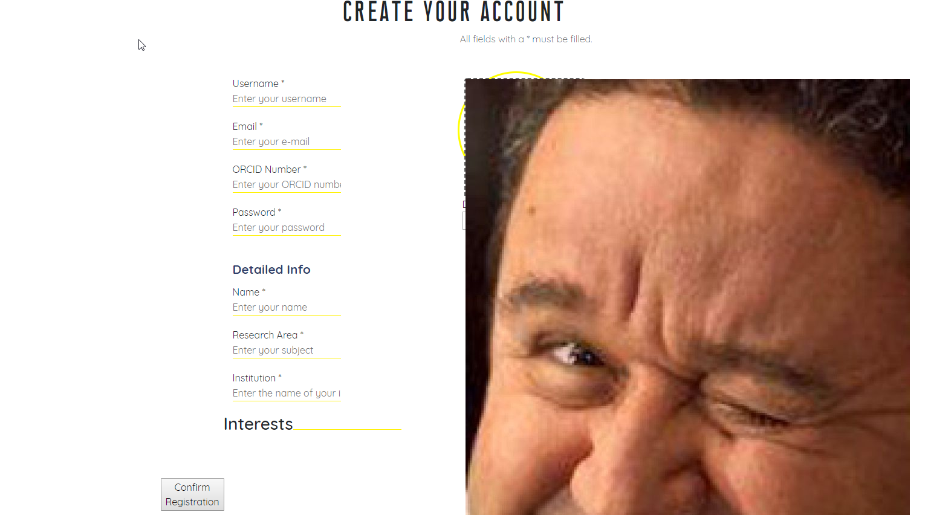](https://user-images.githubusercontent.com/43208429/47398692-23dd3580-d72d-11e8-93e0-d25eb8be3cf3.png)

**#3**

Defect Description: **The warning "Password has to be longer than 6 characters!" only appears when the ORCID Number camp has been written on.**  
Steps to reproduce: In the registration page write something on the password camp with less than 6 characters (no warnig is shown), then write something on the ORCID Number camp.  
Date Raised: 24/10/2018  
Detected by: Bernardo Correia  
Images:  
[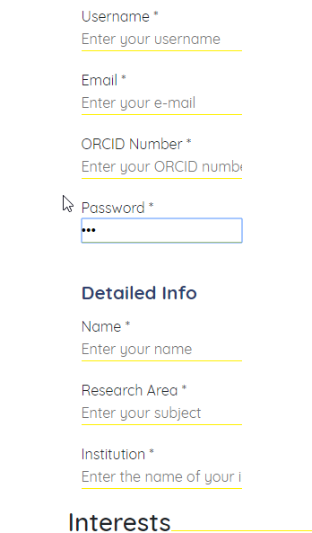](https://user-images.githubusercontent.com/43208429/47399778-1e361e80-d732-11e8-9de9-c86754fcf839.png)[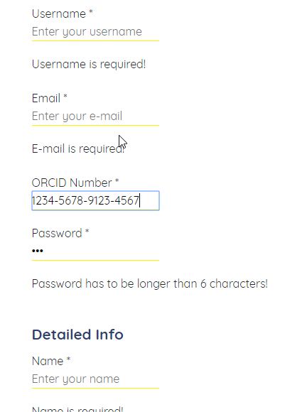](https://user-images.githubusercontent.com/43208429/47399780-20987880-d732-11e8-9785-bd0e4623be2e.png)

**#4**

Defect Description: **When adding new intrests they are not shown completely inside the blue block (with only one intrest chosen there is no blue block at all), making them partially invisible.**  
Steps to reproduce: In the registration page add Interests.  
Date Raised: 24/10/2018  
Detected by: Bernardo Correia  
Images:  
[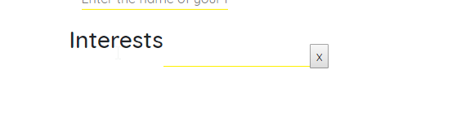](https://user-images.githubusercontent.com/43208429/47400379-d1a01280-d734-11e8-9d79-f5223418edef.png)[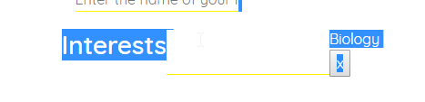](https://user-images.githubusercontent.com/43208429/47400380-d1a01280-d734-11e8-91d6-7afcfc8debe2.png)  
  
[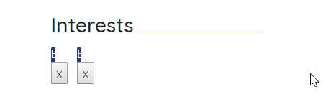](https://user-images.githubusercontent.com/43208429/47400381-d1a01280-d734-11e8-87dc-7bf0d1dfe159.png)[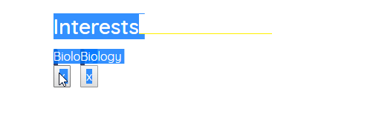](https://user-images.githubusercontent.com/43208429/47400382-d1a01280-d734-11e8-826d-75374ef9e083.png)  
[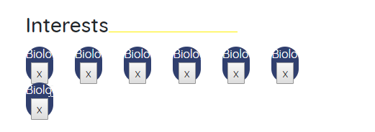](https://user-images.githubusercontent.com/43208429/47400384-d238a900-d734-11e8-8bb9-ee686aede264.png)

**#5**

Defect Description: **Clicking on logout button in profile page doesn't generate feedback.**  
Steps to reproduce: Click on logout button in profile page. No feedback, the presented page continues to be the profile page. Refresh so the login page is presented.  
Date Raised: 24/10/2018  
Detected by: Renato Matos

**#6**

Defect Description: **When adding new intrests if they have too many characters the layout of the page changes (the profile picture and description area go to the bottom)**Steps to reproduce: Add a new intrest with at least 60 characters.  
Date Raised: 24/10/2018  
Detected by: Bernardo Correia  
Imagem:  
[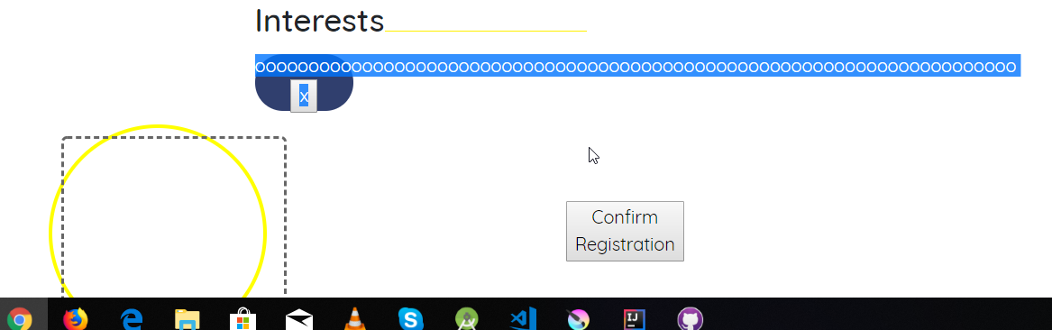](https://user-images.githubusercontent.com/43208429/47422822-79d8ca00-d77b-11e8-9433-eb62b7803ab9.png)

**#7**

Defect description: **Clicking on the pando logo in the profile page doesn't take you to the feed page.**Steps to reproduce: Click on the pando logo in the profile page.  
Data raised: 24/10/2018  
Detected by: Pedro Rodrigues

**#8**

Defect Description: **When leaving one or more required fields blank or invalid there are no warnings shown, unless the ORCID Number field has something on it.**Steps to reproduce: Write an invalid email or password or leave a required field blank (clicking the Confirm Registartion button shows no warnings ), then write something on the ORCID Number field.  
Date Raised: 24/10/2018  
Detected by: Bernardo Correia  
Images:

[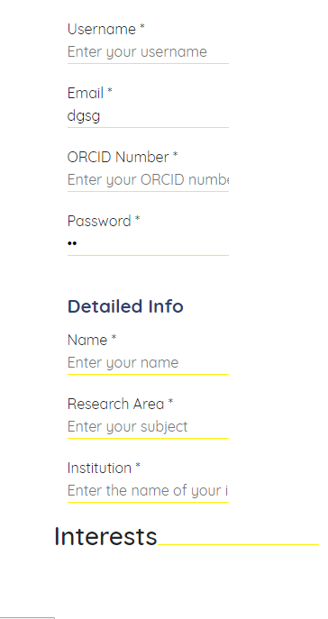](https://user-images.githubusercontent.com/43208429/47437520-ab17c100-d7a0-11e8-9a17-dfb5e8abc583.png)[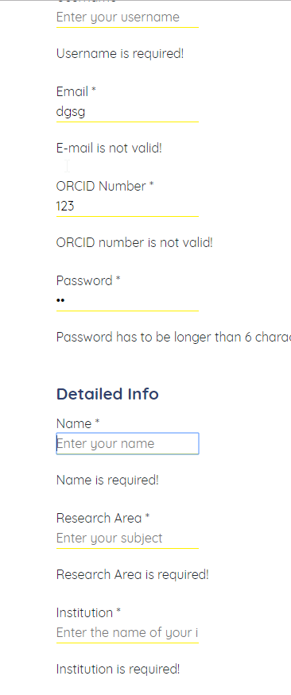](https://user-images.githubusercontent.com/43208429/47437525-ad7a1b00-d7a0-11e8-85f1-0597300a6636.png)

**#9**

Defect Description: **A large description doesn't appear entirely in the screen**Steps to reproduce: Write a large description in the perfil.  
Date Raised: 24/10/2018  
Detected by: Renato Matos