HiSPARC Installer

Implementation Notes

header.bmp

Robert Hart

Nikhef, Amsterdam, Netherlands



Contents

1 Introduction 3

2 Creating the Installer 3

3 Executing the HiSPARC installer 8

3.1 hisparcInstaller 8

3.2 adminUpdater 11

3.3 userUnpacker 13

4 Executing the HiSPARC uninstaller 14

5 Release Notes & Version History 17

5.1 Document Version 2.1 and HiSPARC 6.9 17

5.2 Document Version 2.2 and HiSPARC 6.11.4 17

5.3 Document Version 2.3 and HiSPARC 6.11.9 18

5.4 Document Version 2.4 and HiSPARC 7.12.18 18

5.5 Document Version 2.5 and HiSPARC 7.12.19 19

6 Appendix 20

6.1 Setting up a HiSPARC Development Area 20

6.2 Deployment of the HiSPARC station software 20

6.3 Supporting Python Scripts 21

6.4 HiSPARC Registry 21

6.5 Package Versions 22

6.6 Issues and miscellaneous remarks 22

# Introduction

The HiSPARC installer is generated by and based upon the “**Nullsoft Scriptable Install System**” (NSIS). It consists of three installers:

1. **adminUpdater**: the *administrator* installer which requires administrator rights.
2. **userUnpacker**: the *user* part of the HiSPARC software. No administrator rights are required.
3. **hisparcInstaller**: the overall or *main* installer of HiSPARC. Besides its own part, it includes the adminUpdater and userUnpacker as well. They are an integral part of it. Executing the hisparcInstaller requires administrator rights.

Both the adminUpdater and userUnpacker have their own version number (independent of each other). Furthermore the installer has an independent release number. The version number of the main installer is a combination of these numbers. Suppose version *X* for the adminUpdater, version *Y* for the userUnpacker and release number *Z*, then the following executables (installers) are generated (compiled):

1. **adminUpdater_v*X*.exe**
2. **userUnpacker_v*Y*.exe**
3. **hisparcInstaller_v*X*.*Y.X*.exe**

The reason to have three separate installers is to distribute updates in some kind of automatic way. The *updater* process (as part of the HiSPARC system) checks at regular intervals the central installer repository for newer versions of the adminUpdater and userUnpacker. If a more recent version is found, it is copied and in case of the userUnpacker automatically executed. In case of the adminUpdater a message box is presented indicating an admin update is available. In the latter case an administrator should execute manually the latest version of the adminUpdater.

Initially, one starts with the combined or main hisparcInstaller. Practically you do not need the other two.

# Creating the Installer

The installer is created by a set of batch, Python and NSIS scripts.

The following list of remarks explains how it is implemented.

1. The folder containing the HiSPARC software[1] contains the folder: bake.

NB: It also contains (and requires) the folders admin, persistent and user!

1. The bake folder itself contains the following files/folders:

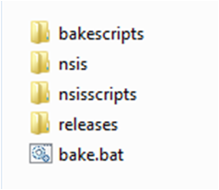

The releases folder does not exist initially. It is created as soon as an installer is made. The bake.bat batch file is the starting point of creating the installer. Double-clicking it will start the creation procedure. The three installers are stored in the releases folder. The bakescripts folder contains a couple of Python sources to initiate and support the creation. The nsis folder contains version 2.46 of NSIS and the nsisscripts folder the NSIS sources of HiSPARC.

1. The contents of bake.bat is shown in Script 2‑1. It simply calls a Python script: bakescripts\bake.py which continues the execution. It uses the Python executable from the user part of the installer.

NB: “%~dp0” denotes the current directory of the script itself.

|  |
| --- |
| @echo off  :: call the python bake script  call "%~dp0..\user\python\python.exe" "bakescripts\bake.py"  pause |

Script 2‑1: bake.bat

1. The bakescripts folder contains the following files:

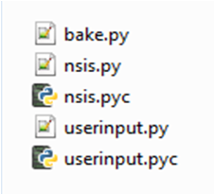

The bake.py scripts is called by the bake.bat script. It uses two supporting Python scripts: nsis.py and userinput.py (see Appendix 6.2). The two .pyc files (compiled Python) are irrelevant. They are generated only once.

1. The contents of the Python script bake.py is shown in Script 2‑2. When executed it checks whether the releases folder already exists. If not, it is created. Then it continues asking which version number of the administrator installer and user installer are to be created. Finally it asks for a release number. The Python script userinput.py is used to get these numbers. If the corresponding version already exists (inside the releases folder), then the generation of it is skipped. The main installer is always generated (compiled).

|  |
| --- |
| # bake.py  # Create the HiSPARC installer.  import os  import sys  from datetime import datetime  from userinput import *  from nsis import *  #files created will always be put in the "\bake\releases" directory  RELEASE_DIRECTORY = "./releases"  input = userInput()  nsiHandling = nsiHandling()  print "\nWelcome to the HiSPARC bake script!\n"  adminVersion = input.getVersion("administrator")  userVersion = input.getVersion("user")  releaseNumber = input.getVersion("release")  tNow = datetime.today()  releaseDate = "%d%02d%02d_%02d%02d%02d" % (tNow.year, tNow.month, tNow.day, tNow.hour, tNow.minute, tNow.second)  #check if the RELEASE_DIRECTORY exists, if not create it  if not os.access(RELEASE_DIRECTORY, os.F_OK):  os.makedirs(RELEASE_DIRECTORY)  #compile the administrator software first  if os.path.exists("%s/adminUpdater_v%s.exe" % (RELEASE_DIRECTORY, adminVersion)):  print "Administrator installer already exists, not creating a new one!"  else:  try:  nsiHandling.compileNSI("./nsisscripts/adminupdater/admininstaller.nsi",  ["ADMIN_VERSION=%s" % adminVersion])  except:  print "ERROR: Compilation could not be finished!"  sys.exit  #compile the user software  if os.path.exists("%s/userUnpacker_v%s.exe" % (RELEASE_DIRECTORY, userVersion)):  print "User unpacker already exists, not creating a new one!"  else:  try:  nsiHandling.compileNSI("./nsisscripts/userunpacker/userunpacker.nsi",  ["USER_VERSION=%s" % userVersion])  except:  print "ERROR: Compilation could not be finished!"  sys.exit  #compile the main installer  try:  nsiHandling.compileNSI("./nsisscripts/maininstaller/hisparcinstaller.nsi",  ["ADMIN_VERSION=%s" % adminVersion]+["USER_VERSION=%s" % userVersion]+["RELEASE=%s" % releaseNumber]+["RELEASE_DATE=%s" % releaseDate])  except:  print "ERROR: Compilation could not be finished!"  sys.exit  print "\nFinished compilation of version %s.%s.%s.\n" % (adminVersion, userVersion, releaseNumber) |

Script 2‑2: bake.py

1. In case all installers are created the bake.py calls the nsis builder three times with the following arguments (example: administrator version = 6, user version = 11, release number = 4):
   * adminUpdater

|  |  |
| --- | --- |
| Prog | nsis\makensis.exe |
| Arg1 | /V1 |
| Arg2 | /DADMIN_VERSION=6 |
| Arg3 | nsisscripts\adminupdater\admininstaller.nsi |

* + userUnpacker

|  |  |
| --- | --- |
| Prog | nsis\makensis.exe |
| Arg1 | /V1 |
| Arg2 | /DUSER_VERSION=11 |
| Arg3 | nsisscripts\userunpacker\userunpacker.nsi |

* + hisparcInstaller

|  |  |
| --- | --- |
| Prog | nsis\makensis.exe |
| Arg1 | /V1 |
| Arg2 | /DADMIN_VERSION=6 |
| Arg3 | /DUSER_VERSION=11 |
| Arg4 | /DRELEASE=4 |
| Arg5 | /DRELEASE_DATE=20130129_125929 |
| Arg6 | nsisscripts\maininstaller\hisparcinstaller.nsi |

NB: Arg1: /V1: verbosity level 1 = errors only.

1. The results are placed in the releases folder and after completion it should contain three files (example: admin version = 6, user version = 11, release number = 4):

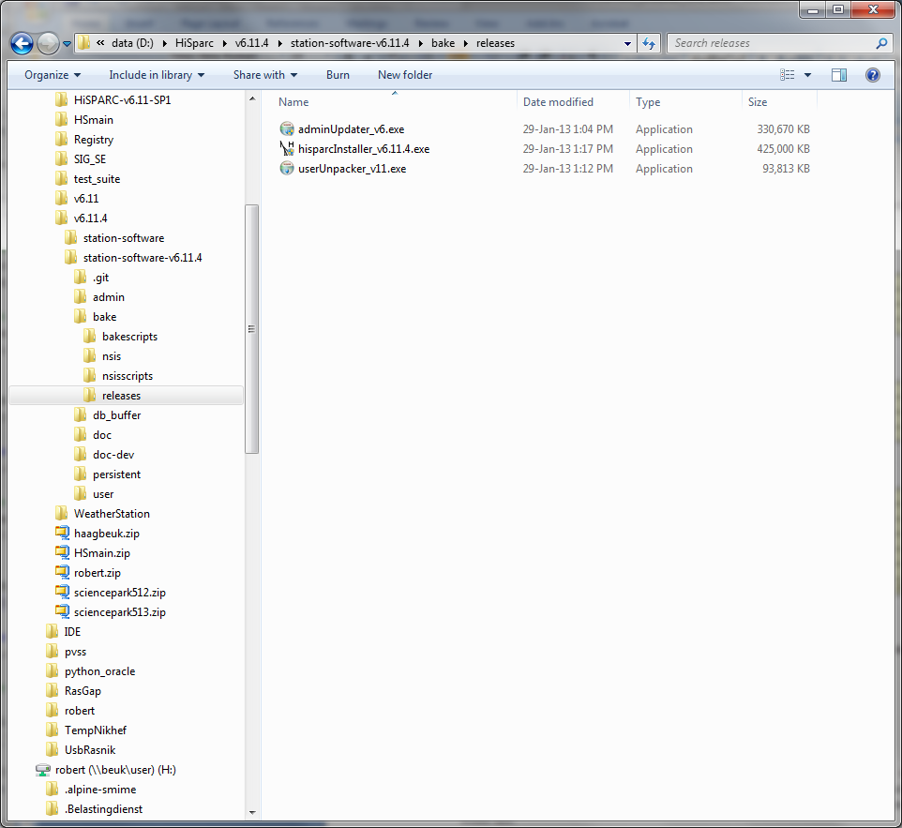

The hisparcInstaller_v6.11.4.exe is the final installer and is the combined adminUpdater and userUnpacker installer, including the main part. The admin part and user part are not created, if they already exist in this folder. For a clean build, delete all files in this folder first.

1. Figure 2.1 shows the complete output of the execution of bake.bat. In this case the creation of the HiSPARC installer version 6.11.4. A complete rebuilt takes about 15 minutes.

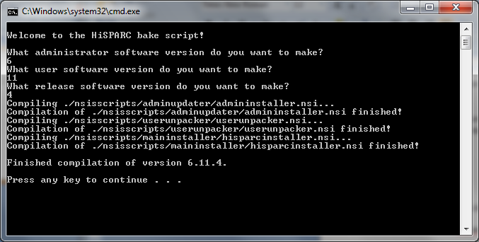

Figure 2.1: Output HiSPARC installer v6.11.4

1. Each installer has its own folder with NSIS sources. Below the contents of the folders are shown:

***hisparcInstaller*** ***adminUpdater*** ***userUnpacker***

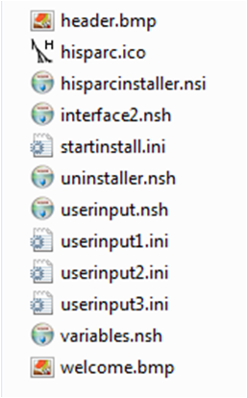 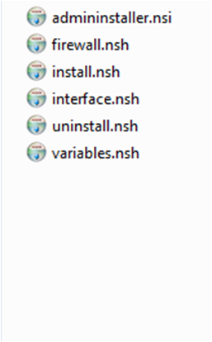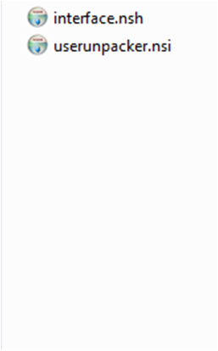

All installers have their own .nsi file (the default extension for NSIS), which is called by the bake.py script to start the creation. The .nsi files contain the .onInit function, by which the NSIS generation is started. The supporting .nsh files (NSIS header files) take care of a specific part of the installer. The main installer folder contains also a couple of picture files (.ico and .bmp) for decoration purposes. Furthermore it contains a couple of .ini files which define the input boxes of the main variables.

The three installers share a common include file hs_def.nsh containing definitions used by all of them, mainly registry definitions. This file resides one level up inside the nsisscripts folder.

# Executing the HiSPARC installer

Each installer has its own set of tasks and for that it uses its own specific folder, which is created inside the HiSPARC installation folder. Table 3.1 shows which folder is used by which installer.

|  |  |  |
| --- | --- | --- |
| **Installer** | **Nickname** | **Folder** |
| hisparcInstaller | *main* | persistent |
| adminUpdater | *administrator* | admin |
| userUnpacker | *user* | user |

Table 3.1: Installer folder

The following chapters explain in more detail what each installer does.

## hisparcInstaller

The hisparcInstaller (or *main* installer) takes care of the complete installation of HiSPARC. For that purpose it contains the adminUpdater and userUnpacker as well. The following list shows what it does:

1. The .onInit function inside the file hisparcinstaller.nsi starts with some checks:
   * Platform check: the installation is aborted if the PC is of type Windows ME, 95 or 98. At the moment only WXP, W7 and more recent versions (i.e. W8, W10) are supported.
   * Administrator check: the installation is aborted if the user has no administrator privileges.
   * Determine whether it is a 32-bit or 64-bit processor.
   * Check registry if HiSPARC is already installed. If installed, the user is asked to continue or not.
2. The NSIS modern user interface 2.0 is started (from interface2.nsh). Its task is to get and set the main parameters. The first mandatory parameter is the installation path:

|  |
| --- |
| C:\Program Files\HiSPARC |

NB: On a 64-bit machine the installation path is: C:\Program Files (x86)\HiSPARC

1. The variable $HisparcDir is assigned to the installation path.
2. The selectable parameters are:

* Station number (mandatory)
* Station password (mandatory)
* Security certificate (mandatory)
* Web address local database (optional)
* Connected detectors:
  + HiSPARC detector (seems obvious)
  + Weather station
  + Lightning detector

1. The entire persistent folder, as found in the HiSPARC base area besides the bake folder, is copied into the $HisparcDir folder.
2. The folder downloads is created inside the folder $HisparcDir\persistent. The *adminUpdater* and the *userUnpacker* (with the proper version numbers) are copied into this folder.
3. The folder $HisparcDir\persistent\uninstallers is created. Each installer has its own uninstaller. They reside in this folder.
4. The security certificate file (a zip file) is copied into the folder: $HisparcDir\persistent\configuration
5. The configuration file $HisparcDir\persistent\configuration\config.ini is updated with the following parameters:

* Station number
* Station password
* Security certificate (name of location of the zip file)
* Web address local database
* Connected detectors: HiSPARC, weather and lightning

1. The HiSPARC system has its own registry entry which, at this point, is created with the following key and name:

|  |  |
| --- | --- |
| HKLM | SOFTWARE\HiSPARC |

One of the entries, which is created and written, is the Path variable, containing $HisparcDir.

Others are the version numbers and the parameters mentioned in the previous item. The main variables are stored both in the configuration file and registry. See also Appendix 6.3.

NB: The version number of the adminUpdater and userUnpacker are written by the installer itself, not by the main installer!

1. The environment (system) variable HISPARC_ROOT is created and set to $HisparcDir.
2. The main installer now calls the **adminUpdater** (chapter 3.2), as found in $HisparcDir\persistent\downloads
3. The main installer now calls the **userUnpacker** (chapter 3.3), also found in $HisparcDir\persistent\downloads
4. Two local user accounts are created (the passwords are not shown):

* **hisparc**: the user logged on when HiSPARC is running. No administrator privileges, the account never expires and its password cannot be changed.
* **admhisparc**: user with administrator privileges. The account never expires. This user may occasionally be necessary when updates have to be installed which require administrator rights.

Finally all accounts are set so that their passwords never expire.

1. Enable automatic logon at reboot. The following registry variables (Table 3.2) with key HKLM and path ‘SOFTWARE\Microsoft\Windows NT\CurrentVersion\Winlogon’ are set:

|  |  |
| --- | --- |
| **Variable** | **Value** |
| DefaultUserName | hisparc |
| DefaultPassword | !Usr4hisp |
| AutoAdminLogon | 1 |
| ForceAdminLogon | 0 |
| DefaultDomainName | $CpuName |

Table 3.2: Autologon variables

The $CpuName variable contains the name of the computer. If the name could not be determined, the value “this computer” is used.

1. Several HiSPARC commands are added and grouped as shortcut to the ‘All Programs’ list. They reside inside the group HiSPARC, which contains the following shortcuts (Table 3.3):

|  |  |
| --- | --- |
| **Shortcut link** | **Program** |
| HiSPARC directory | %windir%\explorer.exe $HisparcDir |
| Start HiSPARC Software | $HisparcDir\persistent\startstopbatch\StartUserMode.bat |
| Expert/DSPMon | $HisparcDir\user\dspmon\DSPMon.exe |
| Expert/HiSPARC DAQ | $HisparcDir\user\hisparcdaq\HiSPARC DAQ.exe |
| Expert/HiSPARC Weather | $HisparcDir\user\hisparcweather\HiSPARC Weather Station.exe |
| Expert/Uninstall | $HisparcDir\persistent\uninstallers\mainuninst.exe |
| Status/Diagnostics | $HisparcDir\user\diagnostictool\run_diagnostictool.bat |
| Status/Registry | $HisparcDir\persistent\startstopbatch\HiSPARC_Registry.exe |
| Status/RunStatus | $HisparcDir\persistent\startstopbatch\RunStatus.bat |

Table 3.3: 'All Programs' HiSPARC commands

The ‘Start HiSPARC Software’ link starts the entire HiSPARC system, including the LabVIEW application (detector and/or weather), the MySQL daemon, the HiSPARC *monitor* and *updater*.

1. The following shortcut is added to the general **Startup** folder:

|  |  |
| --- | --- |
| StartHiSPARCSoftware | $HisparcDir\persistent\startstopbatch\StartUp.bat |

As a result the StartUp.bat file is executed each time a user logs on. If the user is not hisparc it does nothing. If the user is hisparc it executes the Start HiSPARC Software link as found in Table 3.3, hereby executing the HiSPARC system. In combination with the automatic logon of hisparc at startup, it somehow guarantees that the entire HiSPARC system is always running.

1. The *main* uninstaller, mainuninst.exe, is created and stored into the folder: $HisparcDir\persistent\uninstallers. The Uninstall shortcut from the HiSPARC command group points to this uninstaller. Furthermore a separate registry entry is created for the HiSPARC system with the following key and name:

|  |  |
| --- | --- |
| HKLM | SOFTWARE\Microsoft\Windows\CurrentVersion\Uninstall\HiSPARC |

Several variables are created and written. As a result, the HiSPARC system is added to the list of removable packages/programs found in the Windows Control Panel.

1. The security and properties of the entire HiSPARC area (i.e. $HisparcDir) is set to “**FullAccess**” for all users.
2. The installation is finished. The user is asked to restart the computer or not. If yes, the following command is executed: “shutdown –r –f –t 0”. Due to the automatic logon facility and the Startup.bat program at startup, the HiSPARC system will be up and running within a few minutes.

## adminUpdater

The **adminUpdater** is responsible for the installation of several packages, such as:

* + OpenVPN
  + TightVNC
  + NAGIOS
  + ODBC
  + LabVIEW (Runtime Engine only)
  + FTDI drivers

OpenVPN, TightVNC and NAGIOS are handled as *service* (in the Windows context).

The adminUpdater is part of the hisparcInstaller and executed by it. However, the adminUpdater can also be executed separately. If installed separately, it uses a simplified GUI, without any decoration. The following sequence is carried out by the adminUpdater:

1. The .onInit function of the adminUpdater, located in the adminInstaller.nsi file, starts with several checks:

* Administrator check: the installation is aborted if the user has no administrator privileges.
* Registry check: the installation is aborted if the HiSPARC registry entry path does not exist or is empty (HKLM, SOFTWARE\HiSPARC\Path). If it exists the variable $HisparcDir is assigned to it.
* HiSPARC folder check: the installation is aborted if the folder $HisparcDir does not exist.
* Configuration file check: the installation is aborted if the configuration file $HisparcDir\persistent\configuration\config.ini does not exist.
* Certificate check: from the configuration file the location of the security certificate file is determined. The file name is assigned to the variable $CertZip. The installation is aborted if this (zip) file does not exist.

1. The variable $AdminDir is declared and assigned to: $HisparcDir\admin.
2. A check is performed whether the PC has a 32-bit processor. If yes, the variable $OpenVpnDir is assigned to $AdminDir\openvpn32. Otherwise it is assumed that the PC has a 64-bit processor and the variable $OpenVpnDir is assigned to $AdminDir\openvpn64. The same is valid for TightVNC. In accordance the variable $TvncFolder is set to $AdminDir\tightvnc32 or $AdminDir\tightvnc64.
3. The entire admin folder, as found in the HiSPARC base area besides the bake folder, is copied into the folder $HisparcDir.
4. The variable $AdminDir is declared and assigned to: $HisparcDir\admin. The installation is aborted if one of the following folders or files does not exist:

* $AdminDir
* $OpenVpnDir\bin\tapinstall.exe
* $OpenVpnDir\bin\openvpnserv.exe
* $AdminDir\tightvnc\tvnserver.exe
* $AdminDir\nsclientpp\NSClient++.exe
* $AdminDir\odbcconnector\Install_HiSPARC.bat
* $AdminDir\nirte2014\setup.exe
* $AdminDir\ftdi_drivers\dpinst.exe

1. Setup and install **OpenVPN**.
   * Register OpenVPN into its registry (HKLM,SOFTWARE\OpenVPN). Several variables are set and defined.
   * Install the *tap* driver by executing: $OpenVpnDir\bin\tapinstall.exe with the following 3 arguments:

* Install
* $OpenVpnDir\driver\OemWin2k.inf
* tap0901
  + Install the OpenVPN server by executing: $OpenVpnDir\bin\openvpnserv.exe –install
  + Unzip (extract) the certificate zip file $CertZip into the folder: $OpenVpnDir\config

1. Setup and install **TightVNC**.
   * Register TightVNC into its registry (HKLM,SOFTWARE\TightVNC). A lot of variables are set and defined.
   * Install the TightVNC server by executing: $TvncFolder\tvnserver.exe –install –silent
2. Install **NAGIOS** (nsclient++) by executing: $AdminDir\nsclientppNSClien++.exe /install
3. Install and setup **ODBC.**

* Install ODBC by executing: $AdminDir\odbcconnector\Install_HiSPARC.bat
* Register ODBC into its registry (HKLM,SOFTWARE\ODBC\ODBC.INI\buffer). A couple of variables are set and defined.

1. Install the **LabVIEW** Runtime Engine version 2014 by executing: $AdminDir\niruntimeinstaller\setup.exe with the following 4 arguments:

* /acceptlicenses
* yes
* /r:n
* /q

1. Install the **FTDI** (USB) drivers by executing: $AdminDir\ftdi_drivers\dpinst.exe /q
2. The 3 *services* (OpenVPN, TightVNC and NAGIOS) are set to *automatic* and *started*.
3. Adjust some firewall rules by opening specific ports. The following NSIS commands (from firewall.nsh and based on the SimpleFC plugin) are executed:

|  |
| --- |
| SimpleFC::AddPort 5666 "HiSPARC Nagios" 6 2 2 194.171.82.1 1  SimpleFC::AddPort 12489 "HiSPARC Nagios" 6 2 2 194.171.82.1 1  SimpleFC::AddPort 5900 "HiSPARC VNC" 6 2 2 172.16.66.0/24 1  SimpleFC::AllowDisallowIcmpInboundEchoRequest 1 |

Script 3‑1: firewall rules

1. Update the adminUpdater version number into the configuration file and HiSPARC’s registry entry: SOFTWARE\HiSPARC\AdminVersion
2. Read the NI installation folder variable ($NIdir) from the registry. Key is HKLM, variable is: SOFTWARE\National Instruments\Common\Installer\NIDIR. The $NIdir folder is granted “**FullAccess**” for all users.
3. The *admin* uninstaller, adminuninst.exe, is created and stored into the folder: $HisparcDir\persistent\uninstallers

## userUnpacker

The **userUnpacker** is responsible for the installation of supporting programs and tools, like the *monitor* and *updater*. They are mainly Python scripts. It is part of the hisparcInstaller and executed by it. However, the userUnpacker can also be executed separately. If installed separately, it uses a simplified GUI, without fancy decorations. The following sequence is carried out by the userUnpacker:

1. The .onInit function of the userUnpacker, located in the userunpacker.nsi file, starts with several checks:

* Registry check: the installation is aborted if the HiSPARC registry entry path does not exist or is empty (HKLM, SOFTWARE\HiSPARC\Path). If it exists, the variable $HisparcDir is assigned to it.
* HiSPARC folder check: the installation is aborted if the folder $HisparcDir does not exist.
* Configuration file check: the installation is aborted if the configuration file $HisparcDir\persistent\configuration\config.ini does not exist.

1. The entire user folder, as found in the HiSPARC base area besides the bake folder, is copied into the folder $HisparcDir.
2. The variable $UserDir is declared and assigned to: $HisparcDir\user. The installation is aborted if the folder $UserDir does not exist.
3. Update the userUnpacker version number into the configuration file and HiSPARC’s registry entry: SOFTWARE\HiSPARC\UserVersion
4. The *user* uninstaller, useruninst.exe, is created and stored into the folder: $HisparcDir\persistent\uninstallers

# Executing the HiSPARC uninstaller

Like the installer the uninstaller consists of three parts. One for the *main* part, one for the *admin* part and finally one for the *user* part. The main uninstaller contains and executes the admin and user part as well. It is recommended not to execute the admin or user uninstaller separately. The following list shows what the uninstaller, as started by the ‘All Programs\HiSPARC\Expert\Uninstall’ shortcut[2], does:

1. The .un.onInit function of the main uninstaller starts with some checks:

* Administrator check: the removal of HiSPARC is aborted if the user has no administrator privileges.
* Registry check: the removal is canceled if the HiSPARC registry entry path does not exist or is empty (HKLM, SOFTWARE\HiSPARC\Path). If it exists, the variable $HisparcDir is assigned to it.
* HiSPARC folder check: the removal is aborted if the folder $HisparcDir does not exist.
* The user is now asked whether he wants to remove HiSPARC completely or not. If not, the removal is canceled. If confirmed, the removal of HiSPARC is granted.

1. The removal continues with the execution of the following batch program: $HisparcDir\persistent\startstopbatch\StopAdminMode.bat

This batch program calls a Python script to stop the Admin-Mode applications: TightVNC, NAGIOS and OpenVPN and a Python script to stop the User-Mode applications: LabVIEW executables (DAQ and/or Weather), MySQL, the *monitor* and *updater*. Figure 4.1 shows the output.

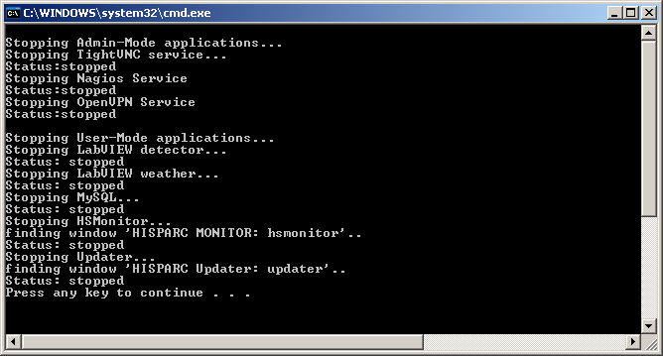

Figure 4.1: Output of StopAdminMode

As a result all services are stopped and the entire HiSPARC system is not longer running. Press any key to continue.

1. The main uninstaller now starts the admin uninstaller by executing: $HisparcDir\persistent\uninstallers\adminuninst.exe /S

NB: /S runs the uninstaller silently.

* Because this uninstaller can also be called directly, the user is checked again if he has administrator privileges. If not, exit.
* Assign $AdminDir to $HisparcDir\admin.
* Assign $OpenVpnDir to $AdminDir\openvpn32 if it is installed on a 32-bit processor and to $AdminDir\openvpn64 if it is not. Do the same for the $TvncFolder.
* Uninstall OpenVPN
* Remove OpenVPN by calling: $OpenVpnDir\bin\openvpnserv.exe –remove
* Remove registry key: SOFTWARE\OpenVPN
* Remove the *tap* device by calling: $OpenVpnDir\bin\tapinstall.exe remove tap0901
* Remove the folders: $AdminDir\openvpn32 and $AdminDir\openvpn64
* Uninstall TightVNC
* Remove TightVNC by calling: $TvncFolder\tvnserver –remove
* Remove registry key: SOFTWARE\TightVNC
* Remove the folders: $AdminDir\tightvnc32 and $AdminDir\tightvnc64
* Uninstall NAGIOS
* Stop NAGIOS by calling: $AdminDir\nsclientpp\NSClient++.exe /stop
* Uninstall NAGIOS by calling: $AdminDir\nsclientpp\NSClient++.exe /uninstall
* Remove the folder: $AdminDir\nsclientpp
* Uninstall ODBC
* Remove the registry key: SOFTWARE\ODBC\ODBC.INI\buffer
* Clear the registry variable: SOFTWARE\ODBC\ODBC.INI\ODBC Data Sources\buffer
* Uninstall ODBC by calling: $AdminDir\odbcconnector\Uninstall_HiSPARC.bat
* Remove the folder: $AdminDir\odbcconnector
* Uninstall the NI Runtime engine (optional)

The user is asked whether to remove the *NI Runtime Environment* or not. If yes, the following actions are carried out:

* Read the NI installation folder variable ($NIdir) from the registry. Key is HKLM, variable is: SOFTWARE\National Instruments\Common\Installer\NIDIR.
* Remove the engine by calling: $NIdir\Shared\NIUninstaller\uninst.exe /qb /x /all
* Remove the folder: $NIdir

As a result the Runtime Engine (version 2014) is removed.

* The entire folder $AdminDir is removed.
* The 3 *services* (OpenVPN, TightVNC and NAGIOS) are stopped and removed from the list of services. Stopping the services may seem redundant, because they have been stopped already in step 2 of the un-installation.
* The final step of the admin uninstaller is to remove itself, so the following file is deleted: $HisparcDir\persistent\uninstallers\adminuninst.exe

1. The main uninstaller now starts the user uninstaller by executing: $HisparcDir\persistent\uninstallers\useruninst.exe /S

NB: /S runs the uninstaller silently.

* Assign $UserDir to $HisparcDir\user.
* The entire folder $UserDir is removed.
* The final step of the user uninstaller is to remove itself, so the following file is deleted: $HisparcDir\persistent\uninstallers\useruninst.exe

1. The two local user accounts, hisparc and admhisparc, are removed.
2. The registry values for the automatic logon are cleared.
3. Delete the HiSPARC registry key: SOFTWARE\HiSPARC.
4. Delete the HiSPARC uninstall registry key: SOFTWARE\Microsoft\Windows\CurrentVersion\Uninstall\HiSPARC
5. The group of HiSPARC shortcuts inside ‘All Programs’ is removed.
6. The shortcut to Startup.bat inside the general (i.e. All Users) Startup folder is removed.
7. The main installer is removed, so the following file is deleted: $HisparcDir\persistent\uninstallers\mainuninst.exe
8. The user is asked whether he wants to keep the HiSPARC program folder or not. Remember that the admin and user folder are removed already! If confirmed the folder $HispardDir is removed.
9. The final step of the main uninstaller is whether the user wants to reboot the computer or not. If yes, the following command is executed: shutdown –r –f –t 0

# Release Notes & Version History

## Document Version 2.1 and HiSPARC 6.9

HiSPARC version 6.9 was made with an installer which was thoroughly checked and improved in November 2011. A lot of additional checks were added and where possible redundant code removed. The following remarks are applicable to this and later versions of the installer and is related to version 2.1 of this document:

1. The installer is now completely in English. Not only the appearance of the installer but also the NSIS code.
2. The mandatory installation path is now: C:\Program Files\HiSPARC. There is no choice anymore. Previous versions used as default a ridiculous long name:

C:\Program Files\HiSPARC Client Application.

1. The configuration file $HisparcDir\persistent\configuration\config.ini is used by a lot of supporting programs (even between the 3 installers) to get and exchange certain variables. The new installer publishes these variables into the HiSPARC registry. The installer itself already makes use of these facility. In future, after all programs have been modified, the use of this configuration file will become obsolete.
2. The HiSPARC software made extensively use of a virtual drive, which mapped the $HisparcDir to a single letter, mostly **Z**:. This symbolic link was used as a shortcut to the HiSPARC folder. The installer itself did the same, but any reference to this virtual drive is removed. Version 6.11 of the HiSPARC software, June 2012, has no reference anymore to this virtual drive.
3. In January 2012 the entire HiSPARC software repository has been moved from *Bazaar* to *GitHub.*

## Document Version 2.2 and HiSPARC 6.11.4

Version 2.2 of this document (January 2013) is related to HiSPARC version 6.11.4. Compared with 2.1 (June 2012) the following modifications have been applied:

1. The version number of the installer has been extended with a release number.
2. If executed not on a 32-bit platform, the installer will not quit anymore, but may be continued if wanted. It makes it possible to run it on a 64-bit machine (which has not been tested yet!).
3. The version of the FTDI driver set is upgraded from 2.08.08 to 2.08.24 (x86, 32-bit).
4. An additional NI Runtime-engine is added to the installer. Apart from version 8.2.1 also version 2012 is installed. Old and new versions of LabVIEW executables may now run in parallel.
5. The NI run-time-engines do not require a license and/or serial number. The initialization file (hisparcspec.ini) containing this information has been removed.
6. After installation of the NI Runtime engines, their original folders inside the admin folder are not removed anymore.

## Document Version 2.3 and HiSPARC 6.11.9

Version 2.3 of this document (May 2013) is related to HiSPARC version 6.11.9. Compared with 2.2 (January 2013) the following modifications have been applied:

1. The applied version of OpenVPN has been upgraded from 2.1.4 to 2.2.2. It makes it possible to use OpenVPN on 64-bit processors as well. The *tap* installer requires a 64-bit binary for a 64-bit machine and a 32-bit binary for a 32-bit machine. The installer contains 2 instances of version 2.2.2. One for 32-bit processors (openvpn32) and one for 64-bit processors (openvpn64).
2. The station number and password are now mandatory (step 3 of the hisparcInstaller). It is not allowed anymore to leave it empty. The station number allows only digits.
3. The Startup.bat file (step 17 of the hisparcInstaller)has been modified. If the user hisparc logs on the registry variable ScreenSaveActive is disabled.
4. The installation results of OpenVPN, TightVNC, NAGIOS, ODBC and the NI RunTime engines are checked. If not correct a message-box will appear containing the error code. The installation is suspended. It resumes when the error is confirmed by pressing the OK button.

## Document Version 2.4 and HiSPARC 7.12.18

Version 2.4 of this document (December 2015) is related to HiSPARC version 7.12.18. Compared with 2.3 (May 2013) the following modifications have been applied:

1. The possibility of an Earth Magnetic field detector has been removed.
2. The installation path has been moved 1 step higher in the tree. Instead of C:\Program Files\HiSPARC\hisparc, it is now C:\Program Files\HiSPARC. On 64-bit PCs it is C:\Program Files (x86)\HiSPARC.
3. The Python scripts *monitor* and *updater* make use of the sophisticated *logging* facility:

import logging

1. Starting and stopping the Python scripts have been modified. If the script is minimized the Python icon is shown , instead of the Windows command prompt icon .
2. Only **one** NI run-time-engine is used (version 2014). The HiSPARC DAQ and Weather application are written in accordance with this version.
3. The HiSPARC DAQ and Weather executables do (regretful) have spaces in their names.
4. Inside the initialization file of MySQL (my.ini) the following line has been added in order to avoid the ERROR_INVALID_PARAMETER error, which appeared on W8 PCs: innodb_flush_method=normal
5. The installation of the NI-RTE 2014 sometimes returns with an error 1603 (something with NI-VISA?). However, the installation is completed and seems okay. The installer ignores this error and continues.

## Document Version 2.5 and HiSPARC 7.12.19

Version 2.5 of this document (August 2016) is related to HiSPARC version 7.12.19. Compared with 2.4 (December 2015) the following modifications have been applied:

1. The installer makes sure the folder C:\Users\Public\Documents exists. The NI run-time-engine requires this folder during installation. On some Windows systems this TARGETDIR does not exist.
2. NI run-time-engine 2014 is replaced by run-time-engine 2015. The HiSPARC DAQ and Weather applications are replaced in accordance with this version.
3. The HiSPARC DAQ and Weather applications have their own dedicated .ini files in order to correctly deal with the fonts.
4. The folder Weatherlink 6.0.3 has been added to the folder admin\utilities.
5. In order to disable FTDI COM-port enumeration, 2 registry entries are added.
6. In order to prevent a lockscreen on Windows 10 systems, one registry variable is added.

# Appendix

## Setting up a HiSPARC Development Area

The following sequence describes how to get the HiSPARC software and what modifications are necessary in order to create an installer. It is assumed that *GitHub[3]* (and inclusively *git* version 1.7.9) is installed on your PC.

1. Run the command prompt of *git*: All Programs → Git → Git Bash

It behaves like a (Bourne Again) Shell.

1. Go to the folder you want the software to reside.
2. Execute: git clone https://github.com/HiSPARC/station-software

1. The checkout location should now contain the folders station-software and inside this folder it should contain (at least): admin, bake, db_buffer, persistent and user.
2. Several passwords, like the one for the database buffer and the HiSPARC admin-user admhisparc, are not committed in the HiSPARC repository. Before you can make an installer this information has to be supplied. This classified information can be obtained from a password protected PDF file (see also Appendix 6.2: Deployment of the HiSPARC station software):

<http://www.nikhef.nl/~robert/docu/HiSPARC_Installer_Classified.pdf>

## Deployment of the HiSPARC station software

Here are the steps you have to perform before you can create an HiSPARC installer. It is necessary to modify some develop files. Some are renamed to provide templates for the actual files. They have been added to .gitignore, so no sensitive information is accidently committed.

1. Copy the file /db_buffer/buffer-develop.sql to /db_buffer/buffer.sql. Then replace the PLACEHOLDERs with the actual passwords in the new file.
2. Create the following file to override the buffer password in the *monitor* configuration: /user/hsmonitor/data/config-password.ini. This file should contain the following data (with the PLACEHOLDER replaced by the actual password) :

[BufferDB]

Password=PLACEHOLDER

1. Copy the file /bake/nsisscripts/password-placeholder.nsh to /bake/nsisscripts/password.nsh. Then replace the PLACEHOLDERs with the actual passwords in the new file.

## Supporting Python Scripts

|  |
| --- |
| import subprocess  NSISPATH = "./nsis"  class nsiHandling():  def __init__(self):  self.nsisExe = "%s/makensis.exe" % NSISPATH  def compileNSI(self, nsiPath, defines):  definelist = ""  #print str(defines)  for i in defines:  definelist = "%s /D%s" % (definelist, i)  #print definelist  command = "%s /V1 %s %s" % (self.nsisExe, definelist, nsiPath)  #print command  print "Compiling %s..." % nsiPath  nsiProcess = subprocess.Popen(command)  nsiProcess.wait()  print "Compilation of %s finished!" % nsiPath |

Script 6‑1: nsis.py

|  |
| --- |
| class userInput():  def __init__(self):  pass  def getVersion(self, type):  version = ""  while (version == ""):  version = raw_input("What %s software version do you want to make? \n" % type)  return version |

Script 6‑2: userinput.py

## HiSPARC Registry

Table 6.1 shows the contents of the HiSPARC registry of a typical HiSPARC station.

|  |  |
| --- | --- |
| **Variable** | **Value** |
| Path | C:\Program Files\HiSPARC |
| VolatilePath | C:\Program Files\HiSPARC |
| DisplayName | HiSPARC |
| HiSPARCVersion | 7.12.18 |
| AdminVersion | 7 |
| UserVersion | 12 |
| Release | 18 |
| ReleaseDate | 20151117_135133 |
| StationNumber | 510 |
| HasHiSPARC | 1 |
| HasWeather | 1 |
| HasLightning | 0 |

Table 6.1: HiSPARC Registry

## Package Versions

Table 6.2 shows the version numbers of the packages as used in HiSPARC version 7.12.19.

|  |  |
| --- | --- |
| **Package** | **Version** |
| NI Runtime engines | **2015** (32-bit) |
| MySQL Server | **5.1.53** (x86, 32-bit) |
| MySQL ODBC | **5.1.8** (x86, 32-bit) |
| OpenVPN | **2.2.2** |
| TightVNC | **2.0.3** |
| FTDI | **2.08.24** (x86, 32-bit) |
| GPS-DSPMon | **1.46** |
| NAGIOS | **0.3.8** |
| Python | **2.7.1** |

Table 6.2: Version numbers of the Packages

## Issues and miscellaneous remarks

1. **Driver Signing**: During installation one (virtual) hardware driver is installed. The *tap* driver, part of the OpenVPN installation, creates one. On Windows XP machines a justified modal notification warning will appear. To suppress this warning in advance, perform the following:

Start → Control Panel → Driver Signing → Ignore

It was impossible to make this mechanism part of the installer. Multiple tap installs yield multiple warnings. A single tap de-install clears them all (without modal warnings).

On Windows 7 machines, there is no such thing as Driver Signing. It is disabled.

1. **Return values of package installation**: On success TightVNC, ODBC, NAGIOS and OpenVPN return with the value 0. The FTDI driver installation always returns with the value 512. The NI Runtime engines return with the value: 3010 (0xBC2), which means according to the NI web-pages: ERROR_SUCCESS_REBOOT_REQUIRED.

NI-RTE 2014 sometimes returns error code 1603, but does not affect the total installation. Hence, it is ignored as well.

1. **ODBC installation**: The installation of this package is rather nested. One .bat file after the other. The return value in case of success is passed by an “EXIT /B 0” command. But if it is no success (≠0) then in older installers a PAUSE was executed, stopping the installation or de-installation. In the latest installer this is replaced by a timeout of 10 seconds in order to read the diagnostics. However, the command TIMEOUT is not supported on Windows XP, so a general solution to create a timeout of 10 seconds is applied: “ping 1.1.1.1 –n 1 –w 10000 > nul”.
2. **Uninstaller**: The main installer uses the NSIS ExecWait primitive to run the *admin* and *user* installer. The primitive does what is says, it waits until completion. However, if used by an uninstaller, it starts the execution but does not wait for completion. According to the NSIS web-pages it is a known “feature”. For the HiSPARC uninstaller it means that the *main*, *admin* and *user* uninstallers run in parallel.
3. **Registry:** Unfortunately Windows handles the registry differently on 64-bit PCs. In fact it maintains a 32-bit registry for 32-bit applications in parallel. The installer has to know about this and uses the commands SetRegView 32 and SetRegView 64 accordingly. Version 2.2.2 of OpenVPN, which is applied in version 7.12.18 of HiSPARC, contains a bug concerning the registry. On a 64-bit machine it still reads its registry as a 32-bit application. The installer takes care of it. A newer version of OpenVPN may solve this exception.
4. **TightVNC:** Like OpenVPN a 32-bit and 64-bit version is supported. Unlike OpenVPN it is not necessary for TightVNC to utilize a 64-bit version on a 64-bit PC. A 32-bit will do as well. It will simplify the installer.
5. **FTDI-driver:** The current installer only supports the 32-bit driver. On a clean 64-bit PC and after installing HiSPARC, the DAQ and Weather application complain about a missing ftd2xx.dll. A temporary solution is to connect a HiSPARC box via USB to the PC. As a result the driver is automatically loaded and installed.
6. **Directories inside shortcut lists:** It seems that on Windows 8.1 and 10 the possibility of having directories in the shortcut list do not exist.

1. See Appendix 6.1: Setting up a HiSPARC Development Area
2. It is also possible to uninstall HiSPARC by the Programs and Features section of the Control Panel.
3. GitHub: A cloud-repository to share code easily. Based on git, a distributed version control system.