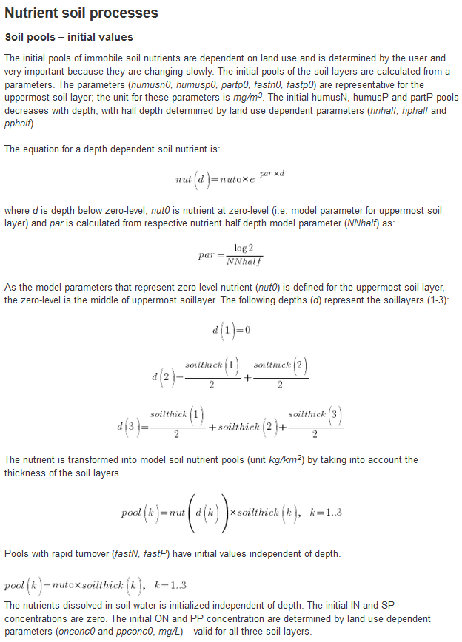

**Immobile Soil Nutrient Pool Transformations (N1,4; P1)**

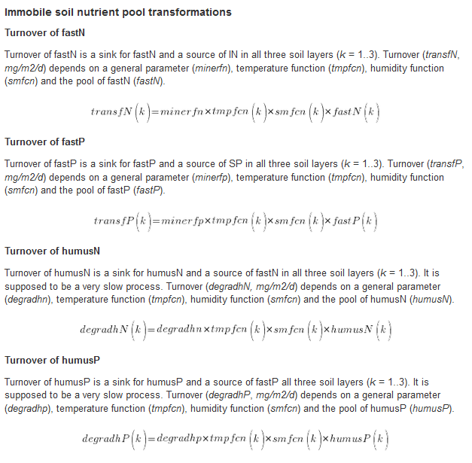

**Dissolution of soil organic pools (transformation N2,3; P2,3)**

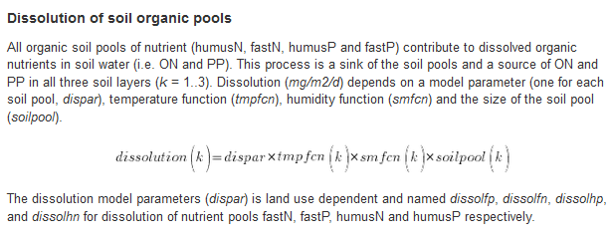

**Percolation (transformation )**

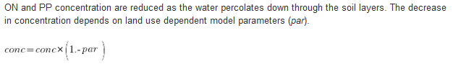

**Balance SRP-partP (transformations P 4,5,6)**

