Deep Learning Homework 1: Linear and Neural Network Classifiers
Group Members and Contributions:
107004 | Diogo Martins Prata Pinto de Sousa
105855 | Diogo Miguel Ferra dos Santos Pica
117194 | Florian Huhnd

Florian Huhnd worked on Question 1. Diogo ___ worked on Question 2. Diogo ______ worked on Question 3. We presented each other the results for each question and put the results together in this report. AI was used as described in each section.

Question 1: Handwritten Letter Classification with Linear Classifiers (35 points)

How AI was used in this section
Exercise 1 could easily be derived from the solutions of practical_02, I only needed a little help to convert the functions from explicitly taking the weights as an argument to taking the self-object.
In exercise 2 I let AI create some helper functions to actually display the hand-written letters, as my first idea was to cut off unnecessary edges. It turned out that there were no pixels really unused, however the function still came in handy to show the downsampled images. The downsampling itself was implemented by AI as well, but I went through it line by line to make sure I understood what it was doing. The general structure of the solution still follows practical_03 and the lecture slides; AI was mainly used to debug and clean up code I had already written. For the grid search, I took my working code from the exercises (a) and (b) and let AI construct the grid search framework, which I adapted to my preferences later.
For exercise 3 I tried to stick as close to both the previous exercises as well as practical_04. Since they followed slightly different structures had some help implementing the results of the practical into the structure of the previous framework without losing functionality. Otherwise I mainly used AI to help me explain mistakes I made while trying to implement the methods by myself based on the practical lessons. I discarded some ideas supposed to improve speed or stability, as I felt they went far beyond the scope of what was taught in the lecture so far.

Perceptron (10 points)
The best validation accuracy occurred in epoch 6 with 61.27%, having a training accuracy of 62.08%. The test accuracy was 61.11%. Training took around 26 seconds on my device.
The following plot shows the train and validation accuracies over each epoch.
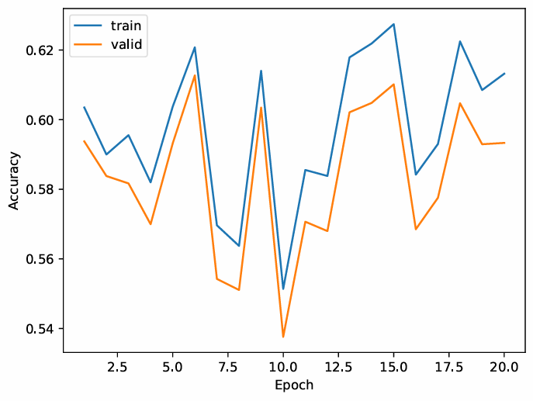

Logistic Regression (25 points)

Baseline Logistic Regression with L2 Regularization (10 points)
The results stored in .json-file can be seen in the table below, followed by the plot of the train and validation accuracies over each epoch. It shows. That the accuracy increased with each epoch.
best_valid | selected_epoch | test | time
0.6959134615384616 | 20 | 0.6975 | 169.80031561851501

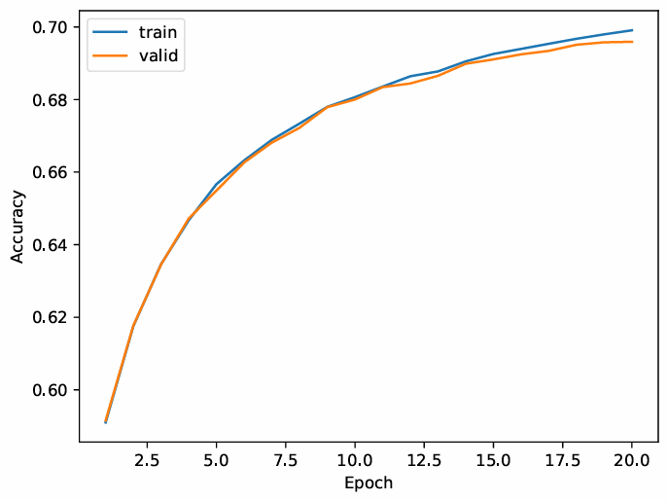

Alternative Feature Representation (5 points)
Blurring the images by averaging the grey scale value of four adjacent pixels into one bigger cell reduces the feature size by factor 4 from 28x28 to 14x14, making it a lot more efficient without losing much of accuracy, as shown later. As stated above, I also thought about reducing feature size by removing the outer lines of pixels, but displaying the images showed me that there was not a lot to cut off. The idea of downsampling is pretty self-explaining so I did not take it from a specific reference, however I just recently watched this great explanation of what a convolution does by mathematician and Youtuber Grant Sanderson (“3 Blue 1 Brown”), which probably helped to immediately come up with this solution: But what is a convolution?
The following two images compare the regular 28x28 images (top) with the downsampled 14x14 images (bottom). The table and the plot below show the final results on the downsampled images. A comparison with the results from 2 (a) shows, that the code was twice as fast while still having a test accuracy of 65.21% (compared to the original test accuracy of 69.75%).
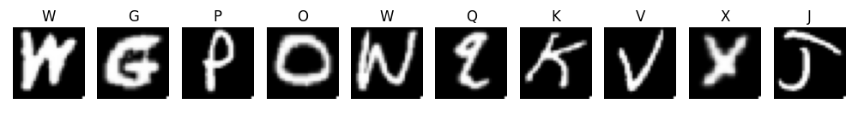
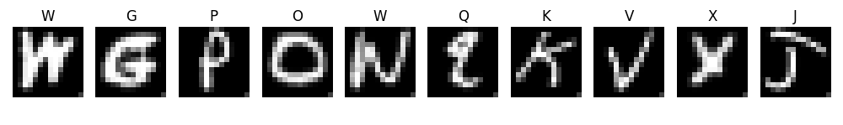

best_valid | selected_epoch | test | time
0.6544230769230769 | 20 | 0.6520673076923077 | 84.73830533027649

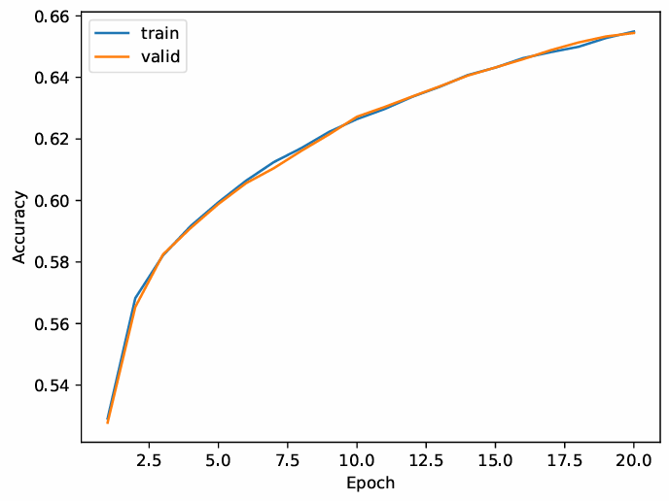

Grid Search over Hyperparameters (10 points)
The following picture shows the output table of the grid search including the validation accuracies (best_valid_acc), test accuracies (test_acc) and the training time in seconds (time_seconds).
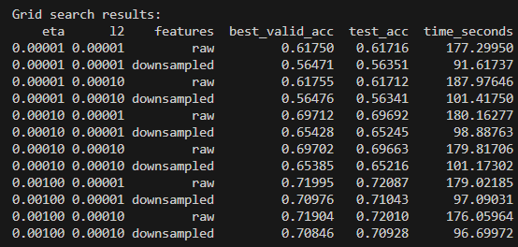
The best configuration (judged by highest validation accuracy) is given by the following hyperparameters. The test accuracy achieved was 72.09%.
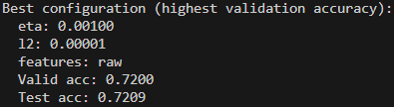

Multilayer Perceptron
The results of the best performing checkpoint are presented in the table below.
best_valid | selected_epoch | test | time
0.8803365384615385 | 18 | 0.8775 | 426.5372622013092

The following two plots show the train loss and train and validation accuracies as a function of the epoch number.
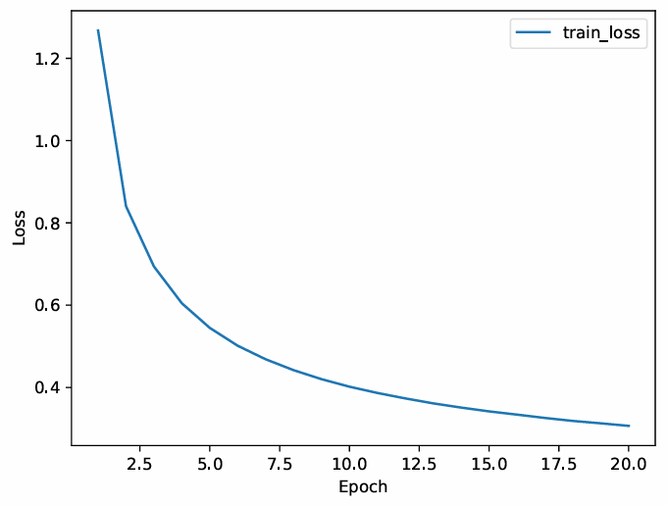
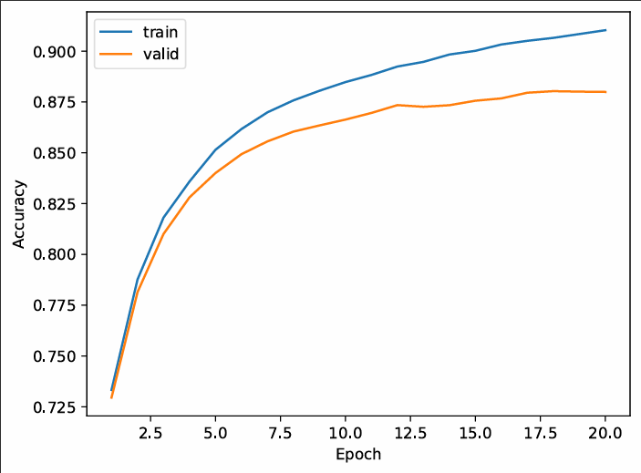

Question 2: PyTorch-Based Neural Networks (35 points)
[This section will be populated when you implement Question 2. For now, mark as TODO.]

FFN Implementation Warmup (5 points)

Infinite-Width One-Layer FFN (18 points)

Effect of Network Depth (12 points)

Question 3: Normalized ReLU and Sparse Softmax Alternatives (30 points)
[This section involves mathematical proofs and closed-form derivations. Include your work below.]

Proof that ReLU is Projection onto Non-negative Orthant (5 points)

ReLUMax and Scale Invariance (5 points)

Closed-Form Analysis for K=2 (10 points)

Jacobian of ReLUMax (5 points)

Modified Cross-Entropy Loss for ReLUMax (5 points)

