Azure Secure Landing Zone
Professional Implementation & Cloud Security Assessment

1. Executive Summary
This project demonstrates the design and implementation of a secure Azure landing zone focused on:
- Network segmentation
- Least privilege access
- Governance
- Cost control
- Infrastructure as Code
- Security monitoring
Technologies: Azure • Terraform • RBAC • Azure Policy • NSG • Resource Graph

2. Solution Architecture
The architecture illustrates a structured and secure Azure deployment with segmented networks and comprehensive governance controls.
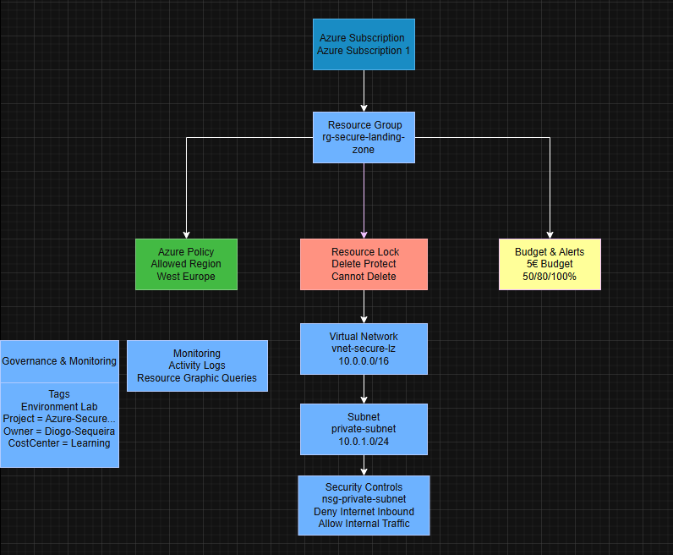

Governance Controls
- Azure Policy
- Resource Lock
- Tags
- Budget Alerts
- RBAC

3. Network Design
The virtual network was segmented into multiple security zones following industry best practices:
- Management Subnet (10.0.1.0/24) – For administrative access
- Private Subnet (10.0.2.0/24) – Isolated internal resources
- Workload Subnet (10.0.3.0/24) – Application deployment
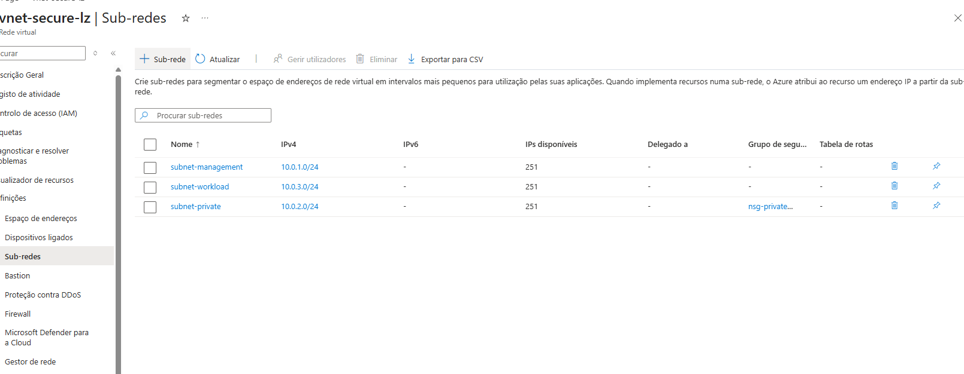
This design follows security segmentation principles and reduces attack surface by isolating resources based on function and trust level.

4. Network Security
Network Security Groups (NSGs) were implemented to enforce inbound and outbound traffic policies:
- NSG associated with private subnet
- Inbound Internet traffic explicitly denied
- Secure-by-default principle applied
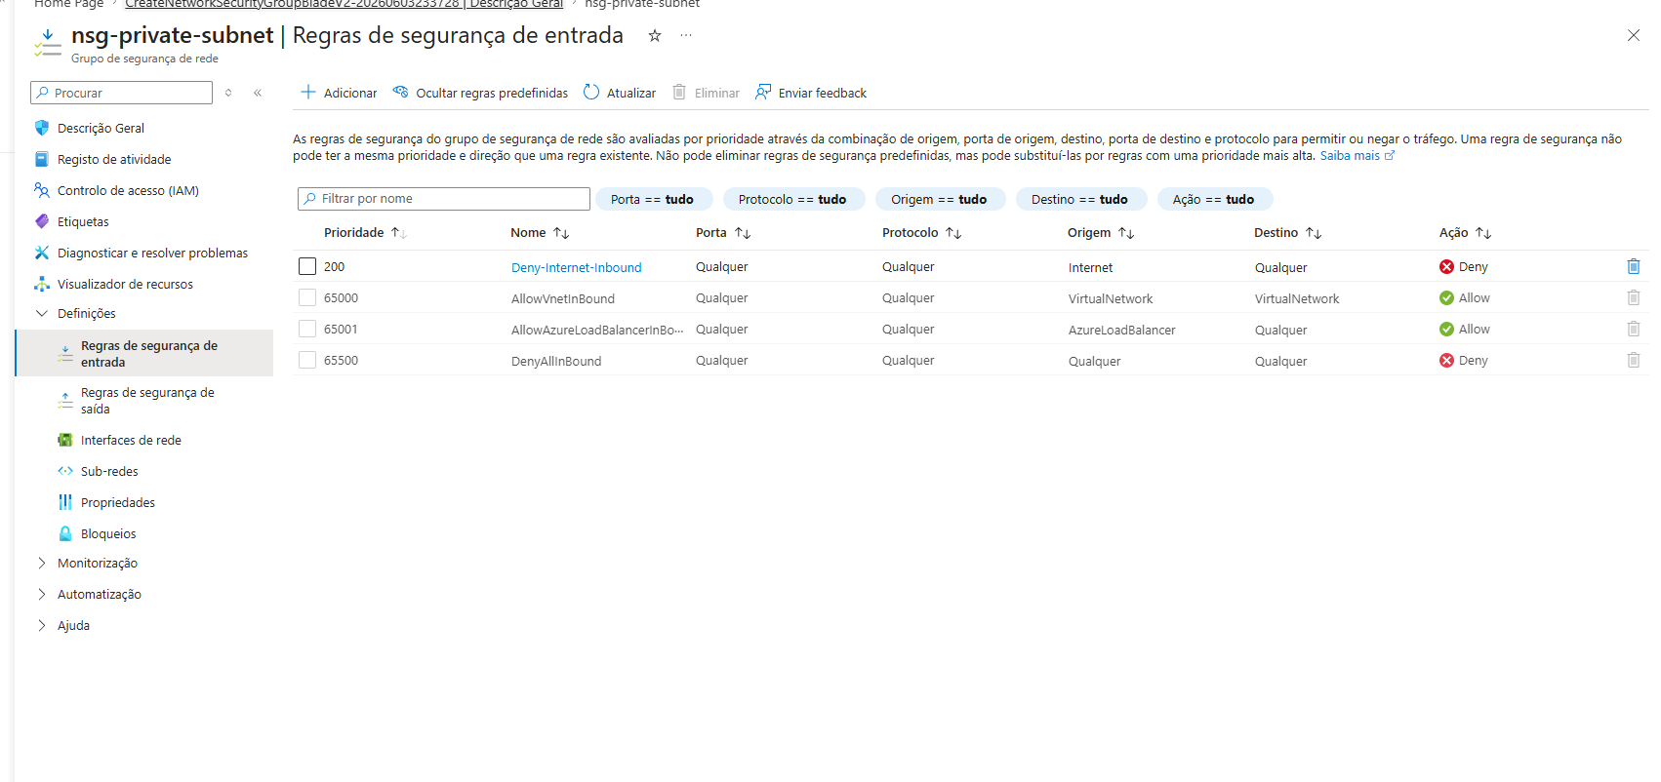
These rules demonstrate the implementation of a zero-trust approach, where all traffic is denied by default and only explicitly allowed flows are permitted.

5. Governance and Compliance

Azure Policy
Policy enforced: "Allowed Locations" – Only West Europe
This policy ensures resources are deployed only in compliant regions, reducing deployment sprawl and supporting regulatory compliance requirements.
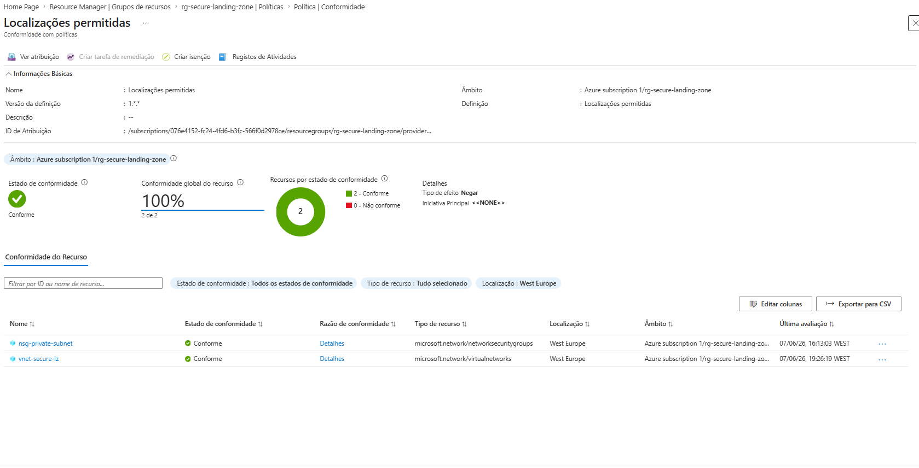

Resource Lock
Delete protection was applied to critical resources, preventing accidental or unauthorized removal.
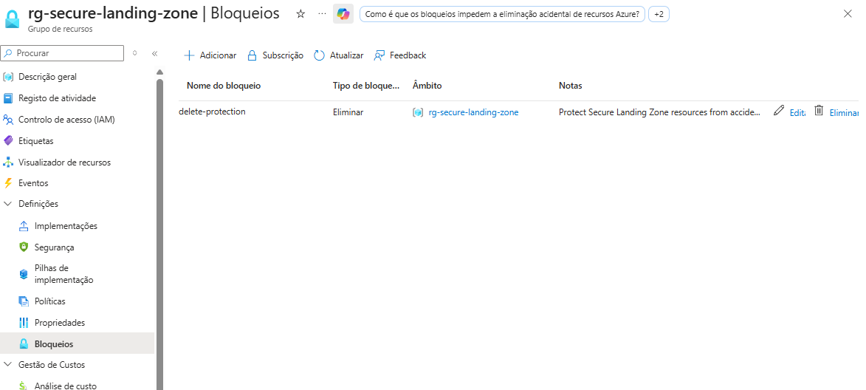

Resource Tags
Tags were implemented for improved governance, cost tracking, and resource ownership clarity across the organization.
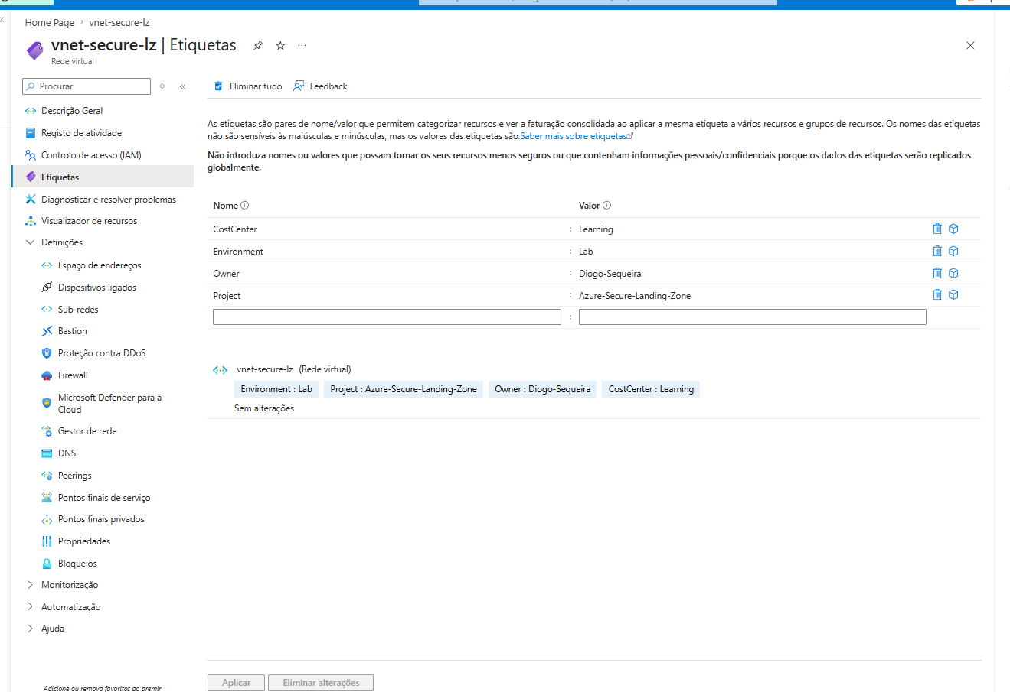

6. Identity and Access Management
Azure Role-Based Access Control (RBAC) was reviewed and validated:
- Owner – Full administrative control
- Reader – Read-only access

This demonstrates understanding of least privilege principles and proper access governance within the organization's security framework.

7. Cost Management
Budget configured: €5/month
Alert thresholds:
- 50% – Early warning
- 80% – Escalation threshold
- 100% – Critical limit
This demonstrates proactive cost management and financial governance, ensuring resources are utilized efficiently within budgetary constraints.

8. Monitoring and Auditing

Activity Log
Azure Activity Log captured all administrative operations, providing a complete audit trail for compliance and troubleshooting purposes.

Azure Resource Graph
Advanced queries were used to validate governance controls and identify non-compliant resources across the organization.

9. Infrastructure as Code
The landing zone was recreated using Terraform, demonstrating Infrastructure as Code best practices:
- Resource Group deployment
- Virtual Network configuration
- Subnet creation
- Network Security Group rules
- Security policy enforcement
This approach ensures reproducibility, version control, and rapid deployment of secure infrastructure.

10. Skills Demonstrated
- Azure Resource Manager
- Azure Networking & Virtual Networks
- Subnets & Network Segmentation
- Network Security Groups (NSG)
- Azure Policy & Compliance
- Azure RBAC
- Resource Locks & Tags
- Cost Management & Budgets
- Azure Resource Graph
- Activity Logs & Audit Trail
- Terraform & Infrastructure as Code
- Cloud Security & Governance

