|  |  |
| --- | --- |
| **Nome / Número** | Diogo Miguel Cunha Fernandes / PG47150 |
| **Orientador/s** | Rui Machado |
| **Título** **da Dissertação** | FPGA accelerated spectrogram generator for applications based on CNN techniques. |

1. **Enquadramento / descrição problema**

Nowadays, artificial intelligence (AI) and machine learning (ML) allow us to automatically solve complex tasks and problems that before could only be solved by Human. There are many applications for AI, like object detection and identification, voice assistance, autonomous vehicles, predictive maintenance, among others. The Convolutional Neural Networks (CNN) are a type of artificial neural networks algorithms that has been emerging in recent years, being the most suitable for image and video processing.

A spectrogram is a way of representing a signal’s strength in the time domain, in its various frequencies, creating a visual representation of the signal using a colour gradient. So, spectrograms show a signal’s variations in frequency over a certain period of time. In the Figure 1, one can see three spectrograms from three different locations where an earthquake occurred. The vertical axis shows the frequency domain, while the horizontal axis shows the time domain. The intensity of the signal is computed by a grey scale or colour intensity, where the red colour represents high intensity and the blue colour represents low intensity. Therefore, a CNN algorithm can be applied to the signal’s spectrogram to detect and identify certain variations in the captured signal.

This project intends to investigate, design and implement a Field Programmable Gate Array (FPGA) accelerated system capable of sampling an input signal, generate the respective spectrogram and send it to other system to be analysed by a CNN algorithm.

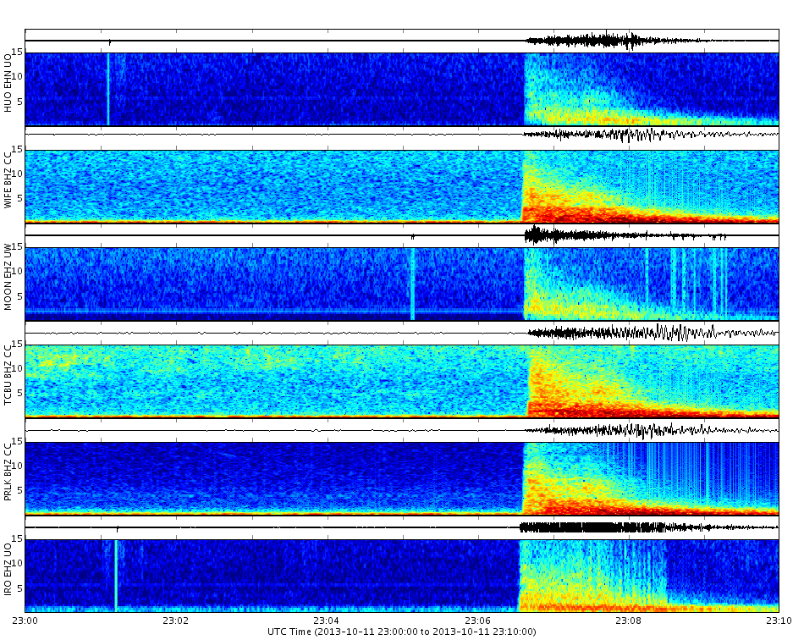

Figure 1 - Earthquake Spectrogram obtained from 3 different locations.

1. **Requisitos**

The system must sample two signals: one from an accelerometer and one from a microphone. The sample frequency needs to be adequate to the type of signals to be studied. Knowing that the limits of human hearing are roughly between 20 and 20 kHz, one can define the minimum sample frequency for the microphone as 40 kHz, which corresponds to two times higher than the maximum frequency of a signal. The sample frequency for the accelerometer may be lower than the last one because the vibration signals have a lower frequency than sound signals. It is required to apply a filter or a bank of filters to the signal, in order to obtain the desired spectrogram. The obtained spectrogram needs to be dispatched to other system using a communication protocol, that transmits the spectrogram’s data at a higher frequency than it is produced.

1. **Relevância técnico-científica**

It is possible to extract a spectrogram from whatever signal. The spectrogram may then be processed by a ML algorithm that uses a CNN model for its classification. The spectrograms have an important role because, without spectrograms, there weren’t a mechanism for an analog signal to be classified by the CNN model.

As seen above, spectrograms are such an extensive matter, they can be used in the context of many applications. For example, in the automotive industry, a microphone can be used to detect the alarm sirens of emergency vehicles trying to pass, allowing the drivers to know, in advance, their presence. Also in this segment, it can be used an accelerometer to detect a minor crash when parked, activating the alert system and, eventually, take a picture of the car’s registration plate.

Predictive maintenance is another application for spectrograms. These applications intend to ensure that faults can be detected, diagnosed and predicted. When the predictive maintenance system detects an error, the production line can be stopped, allowing a much faster repair than it was compared to a forced stopping, reducing its costs.

There are other important applications for spectrograms that uses audio processing, for example a bird species tracker, in which one can identify and geographically locate them, in order to protect them. It can also be used to do speech recognition in voice assistants or to help in the process of teaching blind students. Furthermore, as seen above, the seismology is another area where one can apply spectrograms to detect earthquakes and tectonic movements.

1. **Motivação**

One can emphasize the constant evolution of technology and industry for motivation. The number of sensors used in a car has increased exponentially in the last decade, bringing the necessity of systems that process all the data produced by them, allowing to improve decision making. This is an adaptable solution given that it can be applied to whatever analog sensor signal that one wants to use, decreasing the final product’s market value and time-to-market.

It may take some time to generate a signal spectrogram in a bare metal application, using a microcontroller. Thus, it is important to develop an accelerated system in FPGA, that generates the signal’s spectrogram and feeds it to other system for processing. Beyond that, one knows that CNN algorithms may be slow as well, so this system proposition can be extended to add in a ML classification model, also implemented in FPGA.

Moreover, the advance of ML algorithms facilitates its implementation and adaptation to different datasets and types of signals captured by different analog sensors, simplifying the solution adaptation to other signals.

1. **Passos para a solução**

The project is divided into five phases: analysis, design, implementation, tests and validation, and dissertation writing.

Firstly, in the analysis phase, one must understand the problem, define its requirements and the state-of-the-art topics that will be necessary throughout the design and implementation phases. These topics may involve the architectures to be used to sample of the signals and generate its spectrograms, standard algorithms related to the matter, and others. In addition, one can go through a market study.

In the design, implementation and tests phases, one must define the most suitable sensors for the solution, considering its communication interface. They should be tested using a simple microcontroller program to configurate its registers and understand how they work. It is needed to design a system block diagram as well as its individual blocks, testing them in the FPGA. To better test and validate the system, a PCB will be designed and fabricated. Moreover, one has to define the protocol interface to send the spectrogram for other system to apply the ML model.

At last, it is necessary to integrate all the individual architectures and test all the system, using the FPGA, the selected sensors and the developed PCB.