Índice

1 -> Software failure cases 3

1.1 -> Bar exam failure 3

1.2 -> Amazon 1p Glitch 5

1.3 -> US prisoners released early by software glitch 7

2 -> “No silver bullet” reading notes 8

1 -> Software failure cases

1.1 -> Bar exam failures

Brief Summary:

In July of 2014, thousands of law students were not able to submit their answers to the bar exam due to a software glitch, which resulted in many lawsuits against ExamSoft Worldwide Inc., responsible for the software students were using at the time.

“On the long list of things about which exam takers should be worried, wondering whether they will be able to turn in their exams for grading should be at the very bottom”, according to a lawsuit filed in Washington state. “It is hard to imagine anything more basic in an exam than being able to turn it in for grading.”

As it turns out, students who weren’t able to have their answers submitted in due time, although it was the software’s fault, failed the bar exam.

To this day, the company has not told the public why the incident happened and refuses to let more on. Also, 90$ refunds were made on the purchased software, which cost between 125$ and 150$.

After this problem occurred, the company has improved its technology and communication with its users, setting up a new website with better information about the exam.

Photos:

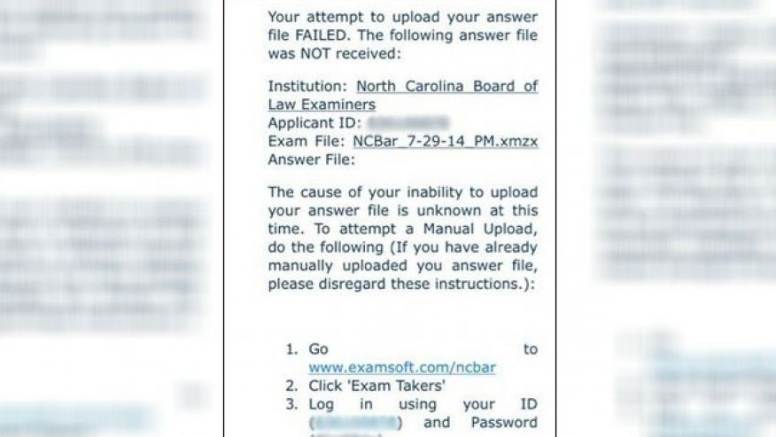

Important Dates: July of 2014.

Consequences: Answers to bar exam not submitted.

Impact: Students failing the bar exam; Several lawsuits.

Flaw: not disclosed.

Source:

<http://www.mercurynews.com/2014/08/12/bar-exam-software-failure-sets-off-wave-of-lawsuits/>

<https://www.nytimes.com/2015/05/21/business/dealbook/after-glitches-in-test-law-graduates-who-took-bar-exam-offered-a-small-consolation.html?mcubz=1>

<http://www.foxnews.com/us/2014/07/30/bar-exam-fail-law-grads-unable-to-submit-completed-tests-due-to-software-glitch.html>



1.1 -> Amazon 1p Glitch

Brief Summary:

Two weeks before the 2014’s Christmas, customers could not believe their eyes, as they saw the price of thousands of items going down to 1p on retailing website Amazon.

This was caused due to a technical glitch in the software developed by RepricerExpress that lasted for about an hour. This software automatically reprices items of stock if a cheaper version becomes available online. Although customers were in for a treat, many small businesses walked into the new year with the wrong foot as they were faced with heavy losses and some even the very real possibility of bankruptcy.

According to the Guardian, a seller on the website went as far as saying the glitch could have cost him more than £100,000. This seller was warned by a competitor that all his listings were on for a penny and was, therefore, able to take his store offline. At that point, £30,000 worth of merchandise had already been ordered by customers.

Amazon has since said that the response to this incident was fast, as they were able to cancel most of orders placed on these affected items, without any penalty to the sellers.

Photos:

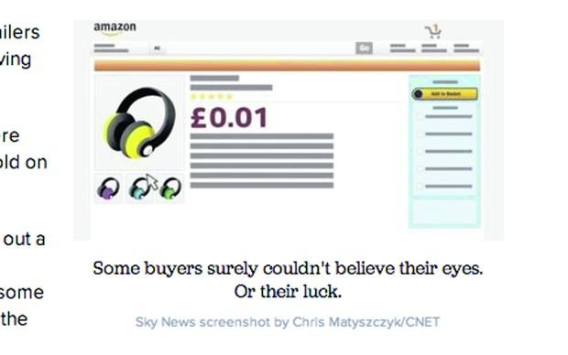

Videos:

Retail Expert on Amazon’s Glitch:

<https://www.youtube.com/watch?v=9ieRPtDxKBk>

Purchase Made During Glitch:

<https://www.youtube.com/watch?v=Ihmq_paRhwY>

Important Dates: December 2014.

Consequences: Prices of thousands of products crashed to 1p

Impact: Poor ratings for sellers who cancelled their shipments; Thousands of dollars lost in merch, including up to the point of bankruptcy; Loss in trust on Amazon; Up to this day, users still attempt to explore glitches on the website to get products for much cheaper or even for free.

Flaw: Glitch in software by RepricerExpress

Source:

<https://www.theguardian.com/money/2014/dec/14/amazon-glitch-prices-penny-repricerexpress>

<http://www.cityam.com/assets/uploads/content/2016/09/amazon-1p-57edacd31a986.jpg>

<http://www.telegraph.co.uk/finance/newsbysector/retailandconsumer/11292999/Amazon-glitch-leads-to-rush-over-1p-bargains.html>



1.3 -> US prisoners released early by software glitch

Brief Summary:

Since 2002 and during a period of 13 years, inmates have been released  early due to an update introduced in 2002 followed by a court ruling about applying good time credits. The total number of inmates released totals 3200 thanks to a decrease in their sentences.

On average the sentences were calculated and decreased by a total of 49 days and 3% of the inmates released were given excessive good time credits making their sentences greatly smaller.

This bug was discovered in 2012 when a prisoner's family discovered that he was getting released earlier than expected. Although the officials started working on the problem right away, it was only when a new IT boss for the DoC was appointed that the problem received the right amount of attention.

Videos:

Inmates lives after being released:

<https://youtu.be/WRlELk2xXtc>

Important Dates:

2002 - System update causes glitch.

2012 - DoC discovers the mistake.

2015 December 22 - News released to the press.

Consequences: Inmates have been released earlier than expected, during a period of 13 years.

Impact: The early release of the inmates had an impact in the life of them and their families. Later the police officers and correctional officials had to locate them and try to discern whether it was necessary for them to return to prison.

Flaw: Glitch in “good time” credits given to prisoners.

Source:

CNN Report:

<http://edition.cnn.com/2015/12/22/us/washington-state-inmates-early-release-sentencing-errors/index.html>

BBC Report:

<http://www.bbc.com/news/technology-35167191>

2 -> “No silver bullet” reading notes