# 

INSTITUTO SUPERIOR DE ENGENHARIA DO PORTO

**Glossary**

|  |  |
| --- | --- |
| Roles |  |
| Administrator  RECEPCIONIST  Medical lab TECHnician | Also known as admin, usually this role has the most important functionalities, the people who’ve this role usually manage the system overall.  The Receptionist role, usually manages the Client role as a whole.  Also known as MLT, this role manages the Lab Technician part of the program, it’s able to modify tests at some sort. |
| Clinical chemistry technologist  Specialist doctor  Laboratory coordinator | Also known as CCT, this role is used to check the registered tests, and add results to them.  This role can analyze tests and write reports about them.  This role is able to check the performed tests, the CCT and the Specialist Doctor work, and validates it. It is also able to import Tests from other files/programs into the software. |

|  |  |
| --- | --- |
| Technology terms |  |
| Barcode  Camel case | Identification mechanism generated automatically by an external API.  Is the practice of writing phrases without spaces or punctuation. |
| Clinical blood test  Collecting methods  Configuration file  Covid-19 Test | Tests performed in CAL.  Procedure adopted by the MLT to Collect Samples to be tested from the Client.  Used to configure the initial settings and parameters in some programs.  Type of test - Collects a Swab and results in a positive or negative result. |
| Daily Report  Diagnosis  Hemogram  IntelIJ  JUnit  Java  JavaCoCo  JavaDoc  JavaFX  Lab Order  Many Labs  National Health Service  NHS number  Netbeans  Notification  Report  SVG  Sample  Swab  Tax Identification Number  User Manual | Report required from NHS and made by Many Labs with a summary of the Covid-19 data for that given day.  Written by the SD and it's written inside the Report - Description of the results found because of the test - *"investigation or analysis of the cause or nature of a condition, situation, or problem".*  A blood testing exam; A systematic report of the findings from a blood examination.  A special programming environment largely meant for Java.  Is a unit testing framework.  A computer programming language designed to produce programs.  Is a code coverage.  Is a documentation generator.  A set of graphics of media packages specialized in User Interface.  Mandatory document to have the client analysis done, given by an External Doctor to them.  Name of the company requesting the application.  *"Service in the UK that provides free or cheap medical treatment for everyone and is paid for through taxes"* - UK's Public National Health Service System.  Identifying number of the client in the NHS.  A Java-based integrated development environment.  Event – Sending of information to the client reporting that the results of their analysis are available in the system.  Document given to the client his personal info and registers the client into the system.  Software that describes.  “A piece or portion of a whole that will demonstrate “.  Result of test when collecting for Covid-19 Test.  Number given by the State to Fiscally identify the citizen.  “A handbook containing instructions on how to use a device, piece of software; an instruction manual; etc; |

INDEX

Introduction 5

Purpose and Scope 5

System Overview 5

System Requirements 5

Software Installation 5

System Features 6

Register a new Client 6

Update Personal information 6

Register a new CAL 6

Register a new employee 6

Register a new Test 6

Specify a new Test-Type 6

Specify a new Parameter 6

Specify a new Category 6

Record samples 6

Record Results 6

Write Report and Diagnosis 6

Validate analysis and Report 6

Import tests via a CSV file 6

Send Covid-19 Report to the NHS 6

Send and Define Automatically Covid-19 Reports to the NHS 6

Troubleshooting 7

Issue # 7

Contacts 7

FAQ’s 8

Q1: “” 8

Q2: “” 8

Attachments 9

Annex A 9

# Introduction

## Purpose and Scope

The purpose of this program is to teach the Users who are willing to use our program how it works so they can use its functionalities to the fullest. This program was built by students from ISEP (Instituto Superior de Engenharia do Porto), in order to help Many Labs, a company specializing in medical research and medical tests, we’ve developed a program which can help in their research by calculating and organizing the date that the company needs.

With Many Labs being our priority, this User Manual will be mainly for people who work for Many Labs, however everyone who is willing to use our program outside of Many Labs will easily understand the program functionalities by reading this User Manual.

## System Overview

Using JavaFX or the cmd (Command Prompt) can boot the program up, if you don’t know how to boot them up using these two applications, this User Manual will teach you how to install/use them in the Software Installation. When you boot the program, it will ask to Log in.

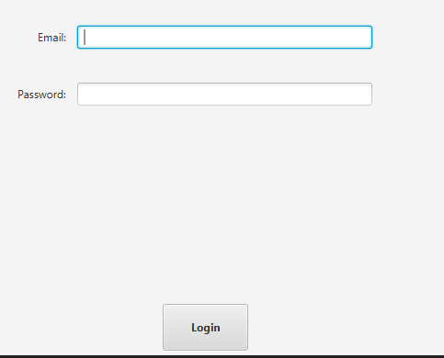

Figure 1 JavaFX Log In Interface

If you didn’t create an employee yet, you can log in as an admin to create new employees. When you access a role, the program will display you the role functionalities which you’ll just need to type the number of the action you wish to select. We will explain each system feature further in this User Manual:

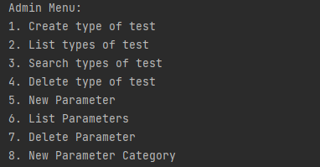

Figure 2Admin Menu

## System Requirements

* JavaFX (Scene Builder);
* IntellIJ;
* Java;

## Software Installation

### Command prompt

1. Open the Project File and there you’ll find the “Sem2App_jar” file, you can move it to easier access place of your computer if you want.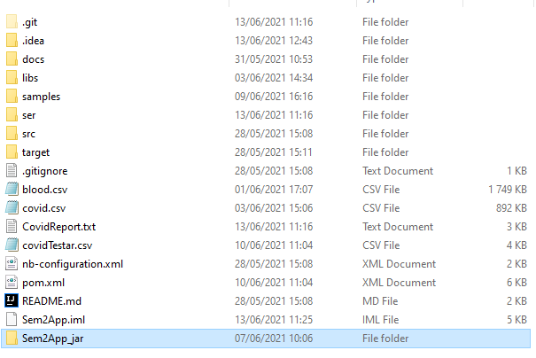
2. If you’re using Windows 10, click on the magnifying glass on your bottom left side of the screen, if you’re using a Mac, there’ll be a magnifying glass on the top right side of your screen.
3. Search for: “Command Prompt” or “cmd”.
4. After accessing the Command Prompt, copy the Sem2App_jar directory.



1. After copying the file’s directory, type the command on the cmd: “cd (directory)”, you will access the file’s directory by the cmd.



1. With finally having the access to the File’s directory now it’s time to access the program. You just have to type the command “java –jar Sem2App.jar”, and you’ll be able to access the program.



### JAVAFX Interface

1. Open the IntellIJ application and go to File > Open… , on the top left side of the IntellIJ screen.

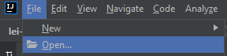

1. Open the program file, and you’ll have access to the program.
2. After accessing the program, click Run > Run ‘Main’, and you’ll finally be able to access the program.



# System Features

## Register a new Client

This is a function for the Receptionist Role, log in as a receptionist to access its menu.

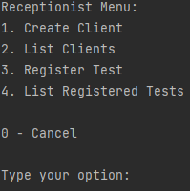

Select the Create Client option and the program will start asking information about the client: name, email, National Health Service, TIN, Birth Date (must be in YYYY/MM/DD format), sex and phone number. After creating the Client, its password will be generated by the program and sent to the client.

## Update Personal information

## Register a new CAL

This is a function for the Administrator Role, log in as an administrator to access its menu.

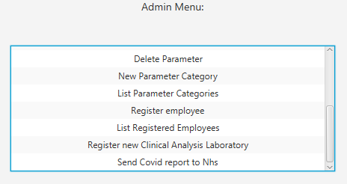

Click the “Register new Clinical Analysis Laboratory”, and the program will start asking you information about the Clinical Analysis Laboratory you wish to create.

The program will ask you the Laboratory’s ID, name, phone number, address, Tax Identification Number and it will ask you if your Laboratory is able to perform Covid-19 Tests. Be aware that to create the ID you must type 5 characters, for its name you can’t type more than 20 characters, for the phone number type 11 numbers, for the address no more than 30 characters and for the TIN needs to be 10 characters. After giving the information for the program to create the Laboratory, it will ask you if you’re sure if you want to create it, answer with a Y – for a yes and N – for a no.

The Clinical Analysis Laboratory will be created.

## Register a new employee

This is a function for the Administrator Role, log in as an administrator to access its menu.

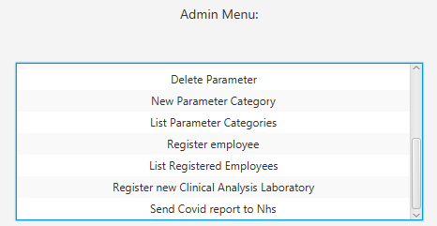

Click the “Register Employee” option to access the Register Employee User Interface.

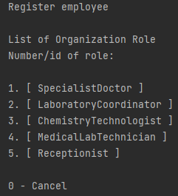

This list of options will appear, each number represents a type of employee, and a type of employee is role in the program, each role can do different things that other roles can’t, for example the Receptionist role is able to register a client into the software, this is a functionality that only the Receptionist role is able to. In this User Manual we will teach you how to create an employee for each role. Let’s start with the Specialist Doctor, type the number: 1, to select the Specialist Doctor creation. The program will ask you the employee’s name, address, phone number (be aware of the 11 digits rule!), Soc code and Doctor Index Number.

At the end of the employee’s creation, it’ll appear a list of the employee’s date, you’re about to create:

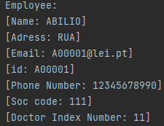

The program will ask you to confirm the data. If you confirm with “Y”, the program will send to the employee through email, the generated password and it will be successfully created.

These Instructions can also be applied when you’re creating a Laboratory Coordinator, a Chemistry Technologist, a Lab Technician and Receptionist, but you won’t need to input the Doctor Index Number unlike the Specialist Doctor.

## Register a new Test

This is a function for the Receptionist Role, log in as a receptionist to access its menu.



Press 3, to access the “Register Test” Interface, the interface will as you the Client’s TIN Number ( we suggest to use the List Clients before to register any Test, so you’ll be able to check all client’s TINs), the program will ask you which Test Type you wish your test to be:

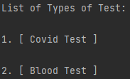

In our program, we’ve pre-registered two Test Types: the Covid Test and the Blood Test.

## Specify a new Test-Type

This is a function for the Administrator Role, log in as an administrator to access its menu.

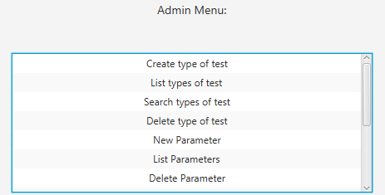

Click the “Create Type of Test” option to access its interface. You have to input a new code (5 alphanumeric numbers), a description (15 characters), a collecting Method (20 characters). After inputting these attributes, the UI will display the Parameter Categories available in the system.

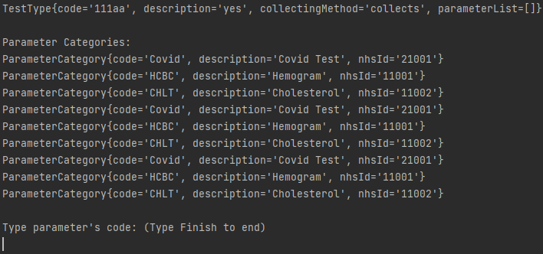

Input the code of the Parameter Category you wish to implement in your Test. And a new Test Type will be created.

## Specify a new Parameter

## Specify a new Category

## Record samples

## Record Results

## Write Report and Diagnosis

## Validate analysis and Report

## Import tests via a CSV file

## Send Covid-19 Report to the NHS

## Send and Define Automatically Covid-19 Reports to the NHS

# Troubleshooting

## Issue #

## Contacts

# FAQ’s

## Q1: “”

## Q2: “”

# Attachments

## Annex A