**A Methology Proposal for Aging Analisys in Electronical Ciruits Based on Uncertainly Propagation**

Diogo da Silva Borges[1]

Rodrigo Pereira Barretto da Costa Félix

Maria de Lourdes Moreira

Deise Diana Lava

The analysis of systems aging has a fundamental role in quality assurance and in the reliability of processes and operations. Thus, the adoption of methodologies capable of predicting the availability of systems susceptible to aging is essential. In order to meet this demand, the present paper aims to present a methodology capable of predicting the behavior of a system based on its degradation, which is caused by aging. For this, important predictive and statistical analysis techniques should be used, such as Faul Tree and Fussel Vesely Techniques, Principal Component Analysis and the Monte Carlo Method. As a result of the proposal, the paper presents results capable of detailing the behavior of a system, adopted as an example application case, as well as the contribution of its components to its unavailability, according to Weibull’s Probability Density Function. The proposed methodology and the analysis carried out take into account the uncertainties associated with the variables of interest, which is a determining factor in the quantification of the probability of systems failure. It is expected that the proposed methodology presented is relevant for aging studies and that it has a direction for research and applications in installations that require high reliability of equipment and systems.

# Introduction

The need to assess the reliability of systems over time of operation is intrinsic to quality assurance and control. The concern in determining the characteristics of a system susceptible to aging demonstrates aspects inherent to the safety of its operation and maintenance in relation to its precision and trueness, which in other words, are directed towards its accuracy in relation to the parameters defined in the base of project. In addition, an efficient management of aging allows the determination of maintenance routines effectively, directly impacting costs, reliability and availability. Based on this, it is important to point to the fact that aging is an agent capable of degrading components of a system. In addition, it can cause deterioration in component insulation, damage by fatigue in mechanical parts and erosion in metal structures .

The qualitative and quantitative aspects of the stages that make up the life cycle of systems and components are described by means of a hazard function, whose outcome is consolidated in a distribution pattern known in the literature as the bathtube model (Fig.1).

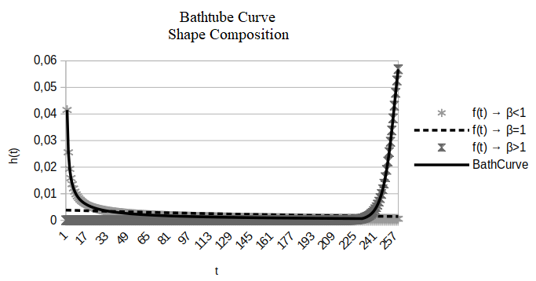

Bathtube Based (Elaborated by the author)

The region of greatest impact for a system, with regard to the risk of unavailability or loss of function, originates over the time when the failure rates of its electronic components are in the region of exponential increase (see Fig.1).

Issues related to the analysis of system failures refer to the concern with what is conceptualized as risk. This thermo is defined as: “Risk is usually defined as the combination of probability of occurrence of harm and the severity of that harm"

The consideration of failures associated with the effects of aging point to dangers arising from the use of systems over time, which have a close relationship with potential damage. In this sense, the danger can be defined as a potential source of unwanted consequences, such as loss of accuracy (e.g. loss of precision and veracity ), unexpected operational deviations and loss of function, for example.

Based on what has been exposed, the present paper aims to carry out a methodological approach capable of being used in the failure analysis of systems. To this, it is proposed to use known techniques for failure analysis and the development of predictive models. In order to fulfill this objective, a methodological approach should be carried out considering the use of the Fault Tree (FT) technique, pre-processing, Principal Component Analysis (PCA), use of statistical indicators and considerations related to the uncertainties arising from the determination of the failure rate, which should be processed using the Monte Carlo Method (MC). As an application example, an electronic circuit developed for amplifying low voltage signals should be considered.

# Theoretical Background

The methodology for analysis of aging is formulated based on methodologies, concepts and techniques known for assessing uncertainty and failures, such as Weibull distributiuon, FT technique, PCA, MC methodology and techniques for propagating uncertainty. Thus, the realization of a theoretical approach is extremely important for the understanding and use of these devices in the composition of aging methodology, which will be presented in the following subsections.

## Considerations for Using the Fault Tree Technique

The FT technique makes it possible to characterize the failure probability of a system or equipment by considering the probabilistic analysis of the individual components present (events), which are associated with independent failures. The working mechanisms of the methodology consist of the propagation of probabilities through mathematical relationships between components (gates) .

The mathematical modeling of the failure of a system using FT technique is done through Boolean logic. Additionally, there is a need for a deep and detailed knowledge of the object of study. In this way, a FT carries with it an intrinsic knowledge of the functioning of a system, which must be analyzed in order to consider its behavior based on the failure of its components.

The flow of propagation of faults in an FT is carried out mathematically through the relationship between the events, which is conveniently treated by means of a literal modeling. This approach makes it possible to use important simplifications for the processing of the model, mainly by considering the concept of minimal cutsets.

The fault tree processing must rely on the concept of minimal cutsets, which represents the maximum simplification that can be performed in the FT methodology. Such simplification can be achieved through operations pertaining to numerical sets, such as union, intersection and the Distributive Law, for example.

## Weibull Distribution

The Weibull distribution has excellent applicability in relation to the study of component life . The distribution is able to describe failures in three periods of importance: Infantile Mortality (represents the initial phase of operation of a system in which the failure rate decreases exponentially), Random Failures (characterized by a period of constant failure rates) and Wearout Failures (the period depicts an increase in associated failure rates) (see Fig.1).

The Probability Density Function (PDF) for Weibull Distribuiton can be used in order to determine the probability of failure of each component of a system for the three periods described above. It is worth mentioning that this parameter should be input to the methodology of analysis of systems aging. Weibull’s PDF is given by Eq.[eq:3.5] .

Where:

is the shape parameter (or slope);

is the scale parameter, or characteristic life;

is the location parameter (or failure free life); and

is the analisy time.

There is the possibility to analyze the failure of a system for a given period of interest, which is identified by varying the parameter . Considering this variable, the Child Mortality regions are given by , Random Failures by and the Wearout Failures region by .

## Monte Carlo Method and Uncertainly Propagation

MC method presents itself as a mathematical statistical tool that is commonly used in the exact sciences to perform simulations with a more interesting bias for highly complex approaches.

The propagation of uncertainties must be made by considering the deviations from the failure rates of each component. Such considerations should be made for all sources of uncertainty that may be associated with determining an exact failure rate value . Thus, the following steps must be followed for the correct realization of propagation of uncertainties:

**Determination of uncertainty sources:** The sources of uncertainty are characterized as mechanisms responsible for the variation in the determination of a measurand. Thus, numerous factors can be responsible for these changes, such as: environmental conditions, calibration and resolution of equipment, systematic error and adjustments, for example.

**Determination of the uncertainty types:** The associated uncertainties can come from two characteristic sources of determining uncertainties :

**Type A uncertainty:** All uncertainties that can be obtained through statistical analysis; and

**Type B uncertainly:** All uncertainties that are characterized by any method other than statistical analysis.

**Calculation of standard uncertainty:** For an input quantity determined by repeated and independent observations ,, the standard uncertainty of its estimate is , with is calculated according to :

Where:

is the experimental variance of the mean;

indicates the number of observations; and

represents the random variable (definition of random variable in ).

Regarding Type B uncertainties, quantification is obtained by means of : Data from previous measurements, experience with or general knowledge of the behavior and properties of relevant materials and instruments, manufacturer specifications, data provided in calibration certificates and data from manuals. Thus, the determination of the standard uncertainty associated with Type B must take into account the type of distribution associated with the determination of deviations in values, such that:

Where:

represents Type B uncertainty; and

is the standard deviation of the distribution that depicts the behavior of the failure rate. In a practical way, can be obtained by considering Tab.[table:1].

Table based in .  
 According to the calibration certificate.  
 Obtained through the inverse two-tailed t-student function considering a level of coverage and the degree of freedom involved.

**Calculation of expanded uncertainty:** The calculation of the expanded uncertainty should be performed using the MC methodology in line with the proposed system aging analysis.

## Interpretation and Data Visualization Techniques

Techniques for analyzing and interpreting the data obtained from the aging analysis help to understand the behavior of the system and its components susceptible to aging. Of these, the PCA and Fussel-Vesely (FV) techniques should be used.

The integration between the techniques allows the creation of an "additive model", in which it is possible to analyze failures in later periods of time through a previously built model, that is, through a predictive model. A large number of data may be necessary to determine a more accurate model, however it is more practical than performing calculations associated with the participation of component failures through the MC.

## Fussel-Vesely Technique

The FV technique allows to identify the contribution of each component to the unavailability of a system. The technique related to the direct effect of component failures for the unavailability of a system. In this sense, the participation of each component is determined through the proportion of its failure probabilities to the system, that is, its components . In view of this, the participation of each component can be quantified through the Eq.[eq:5.1].

Where:

refers to the probability of the top event (system unavailability) for the base case, which is computed using the actual failure probabilities of all components in the system; and

is the probability when component i is assumed to be working perfectly, e.g., when .

The FV technique generates a parameter of relevance to the aging methodology, which is important in the participation of Probabilistic Failure Analyzes (PSA). Through the defense-in-depth requirement, the study of failures relates to traceability in relation to the behavior of system components , which makes the FV technique an essential participation tool in your analysis.

## Principal component analysis

PCA presents itself as a tool for analyzing multivariate statistical data. Through it it is possible to analyze a set of data by means of new orthogonal variables, which are called main components, and to show patterns of similarity of variables in point maps . An example of reduction is shown in Fig.2.

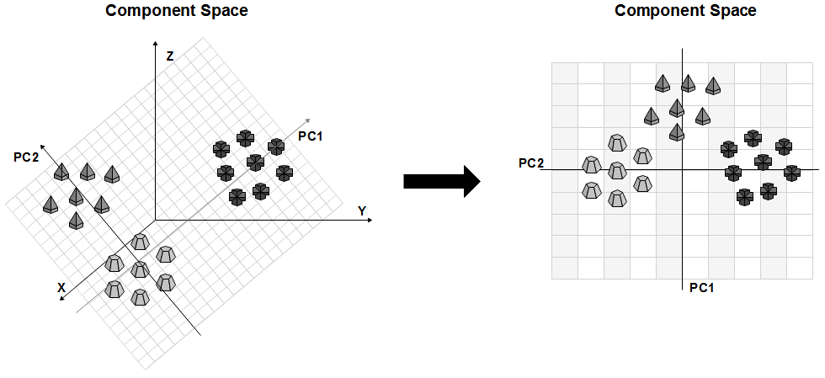

PCA Dimension Reduction Example (Based on ).

The objective of the technique is to determine a dimensional space () that can be used to transform data of a large dimensional space for a smaller dimensional space , where represents the total number of samples or observations and represents sample, pattern, or observation. All samples have the same dimension . Consequently, PCA makes it possible to reduce the size of a data set while retaining as much of the present variation as possible.

# Materials and Methods

The techniques presented throughout this paper should be combined in order to result in the desired aging methodology. Therefore, they should be used as follows:

**Fault Tree construction:** The system should be modeled by means of an intrinsic and deep knowledge about its functioning.The development of the FT requires knowledge about the system behavior for each failure mode considered. The failure modeling result depicts the system’s behavior for each predicted anomaly. For more complex systems, it may be necessary to form an integration group in order to determine the real behavior between the components for a given task.

**Mathematical Processing:** The MC should be used to analyze system unavailability over time. The technique allows calculations of the probability of failure of the component based on the propagation of uncertainties. In this way, it becomes possible to consider the uncertainties in all the calculation phases.

**Components study:** The analysis of the components in relation to aging is done using the FV technique. In addition, the PCA should be used in order to perform a more perceptual analysis regarding the behavior of the system in relation to its components and aging.

In order to create a strategy for applying the aging analysis methodology, the Fig.3 presents a flow chart of application of the methodology. The flowchart contains the sequential steps required to perform an aging analysis from the perspective of the proposed methodology.

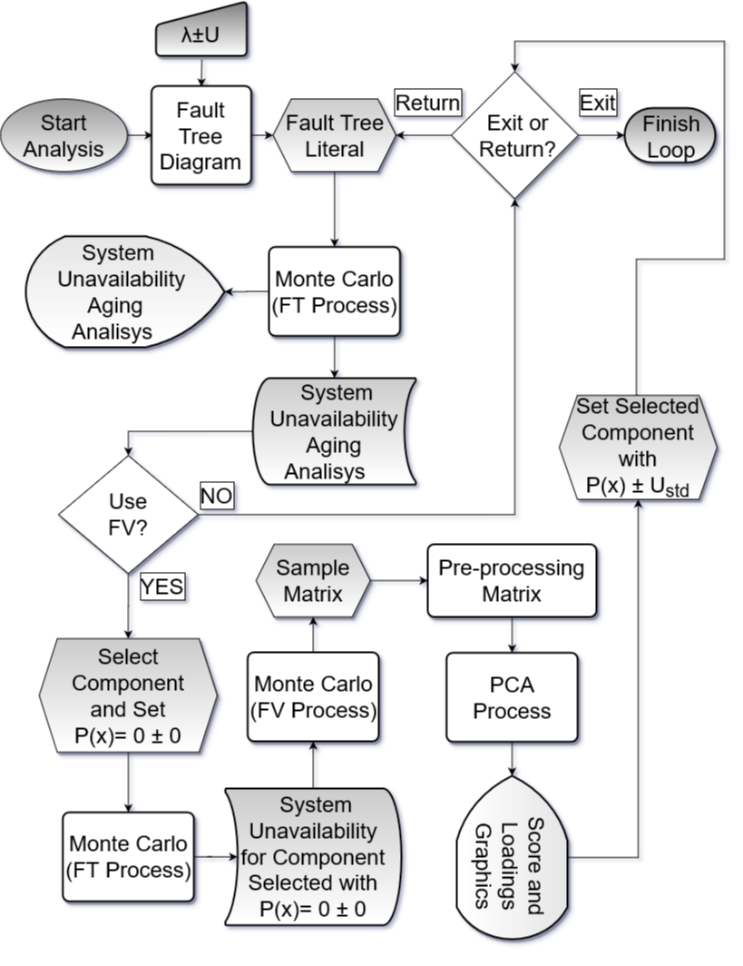

Aging Analisys Methodology Flow Chart (Elaborated by the author)

It is important to mention that in Fig.3, represents the probability of component failure; , the standardized uncertainty and the failure probability. The quantification of these variables must be done using the Weibull PDF.

## Aging Analysis Methodology Application

The application of the methodology should be directed to a system composed of an electronic circuit used in signal amplification systems with high fidelity. It is modularized in two distinct parts. One refers to a preamplification stage of the signal and the other to a final amplification stage.

The pre-amplification phase of the circuit consists of two central cores responsible for an initial amplification, whose purpose is to perform an initial treatment of the acquisition signal. The 3D model of the circuit for the initial amplification stage is shown in Fig.4.

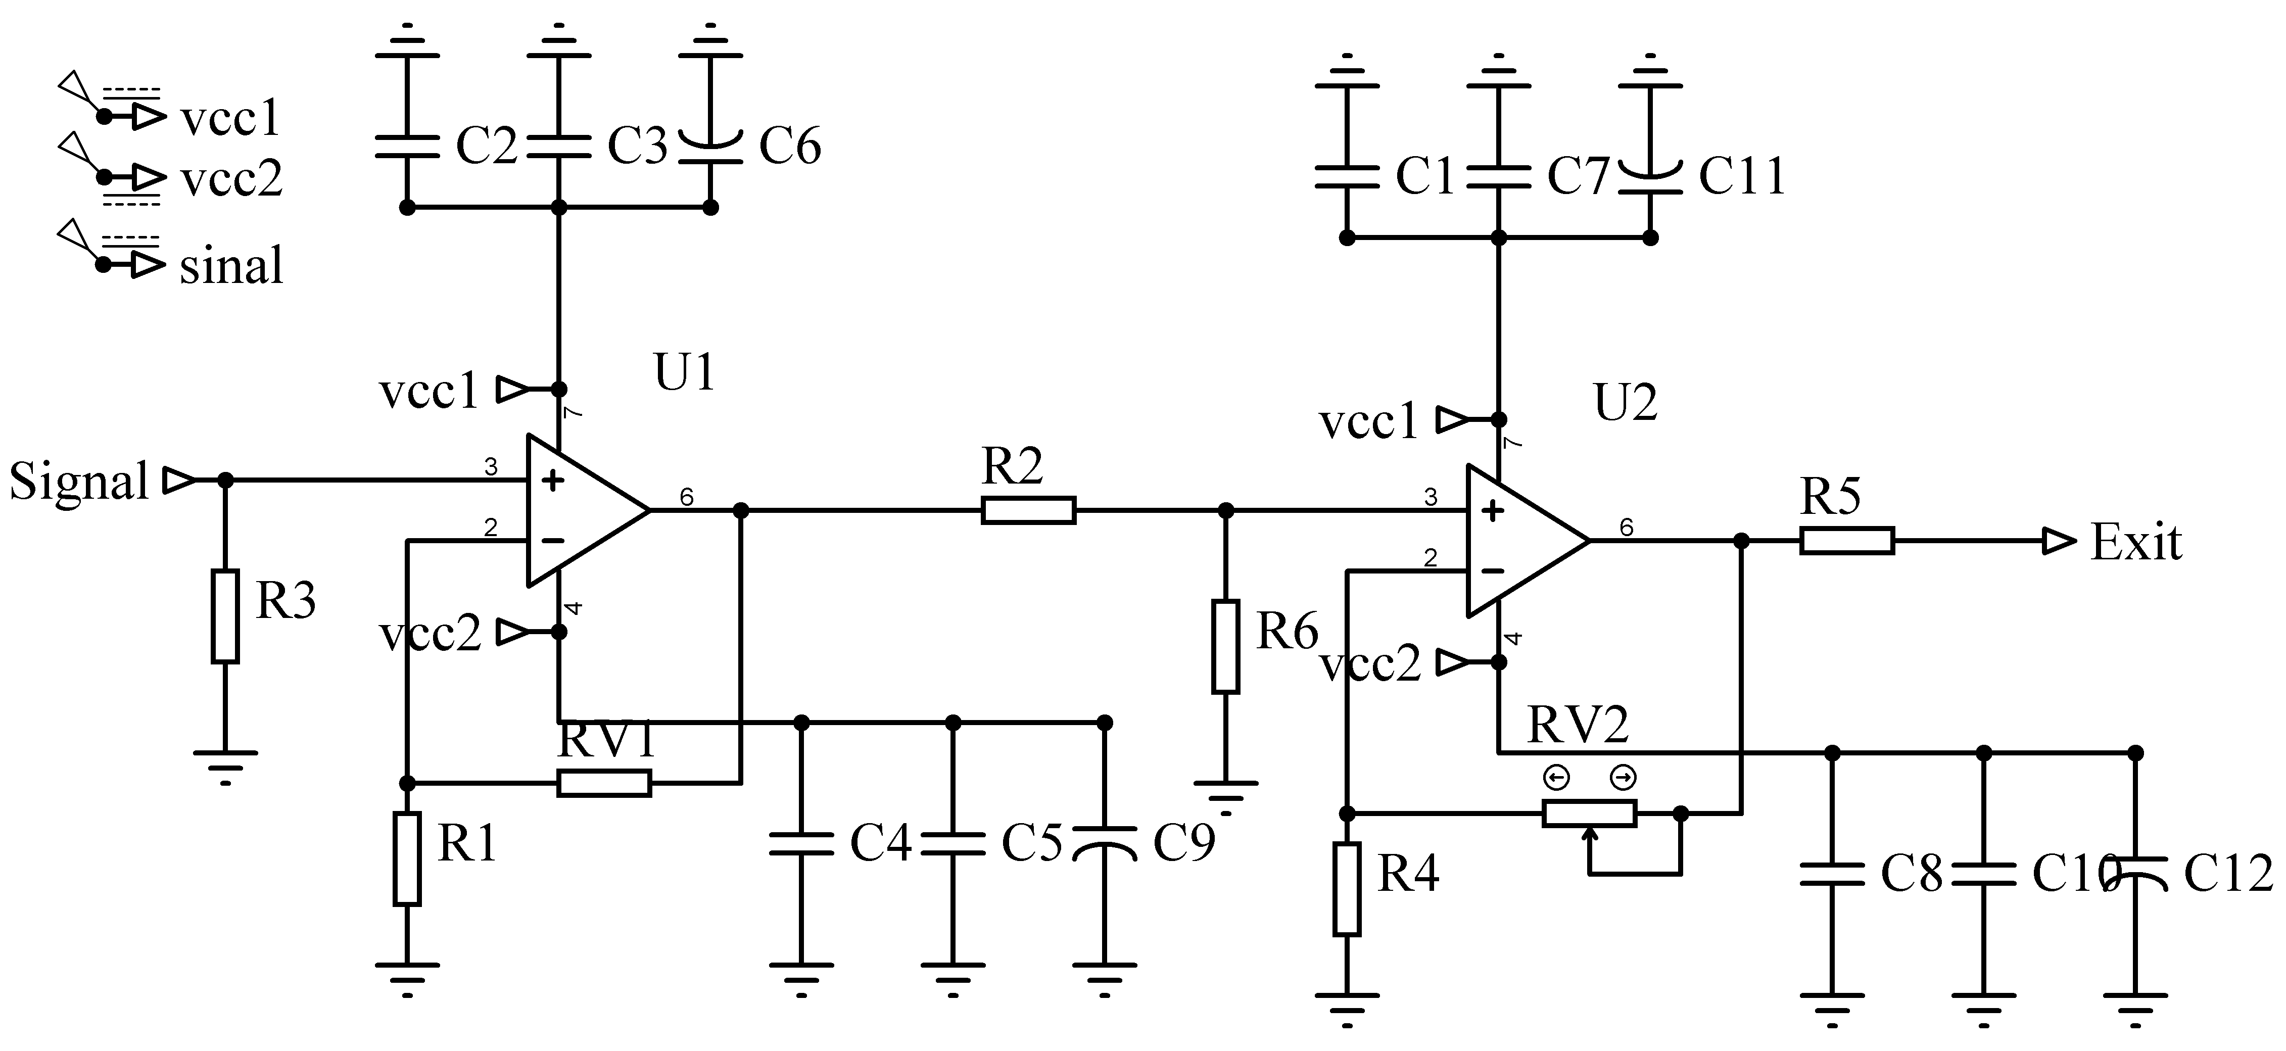

Schematic Diagram Pre-Amplification Module

The second module (Fig.5) of the circuit refers to the final amplification phase, responsible for generating a signal with known and reliable characteristics to the original.This phase should be responsible for delivering a signal with well-defined characteristics in relation to its voltage, with low noise and low distortion. This phase aims to raise the voltage level to expected values.

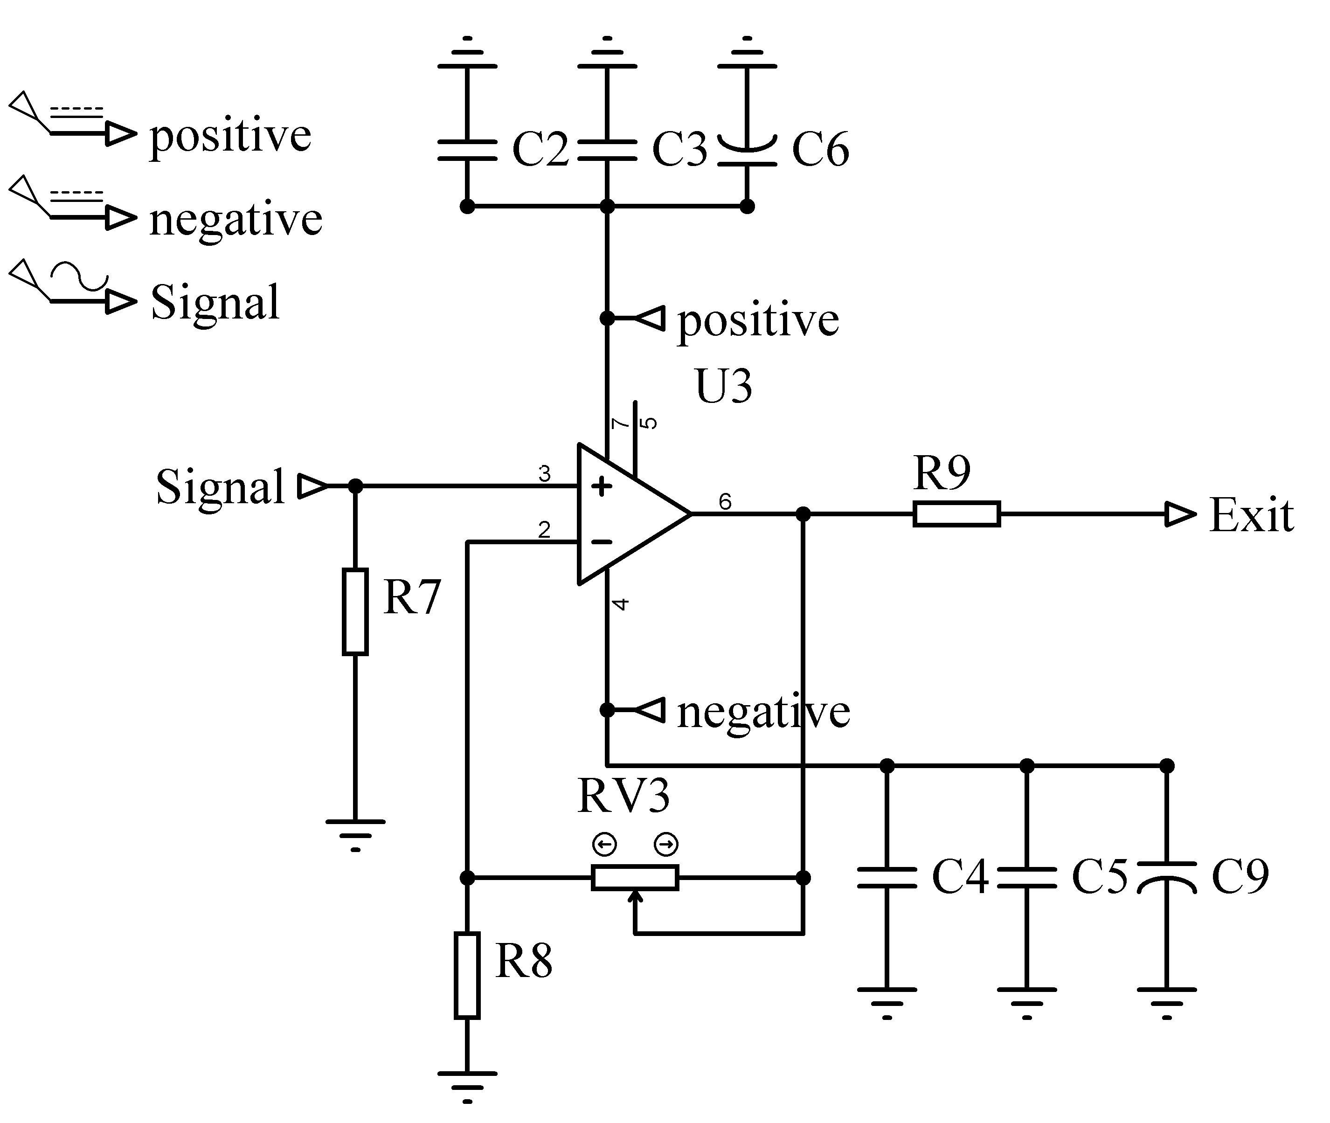

Schematic Diagram Pre-Amplification Module

The modularized phases of this circuit aim to increase the voltage of a signal. In this way, the initial phase is directed towards the minimum increase in voltage necessary for the second amplification phase to be able to detect the signal. In this way, a low intensity signal can be included in a cascade circuit in order to acquire characteristics necessary for an operation.

In order to elucidate the electronic schemes provided, circuits were simulated in order to visualize their dimensions and constructive characteristics. In this way, the Pre-amplification circuit is presented in Fig.6.

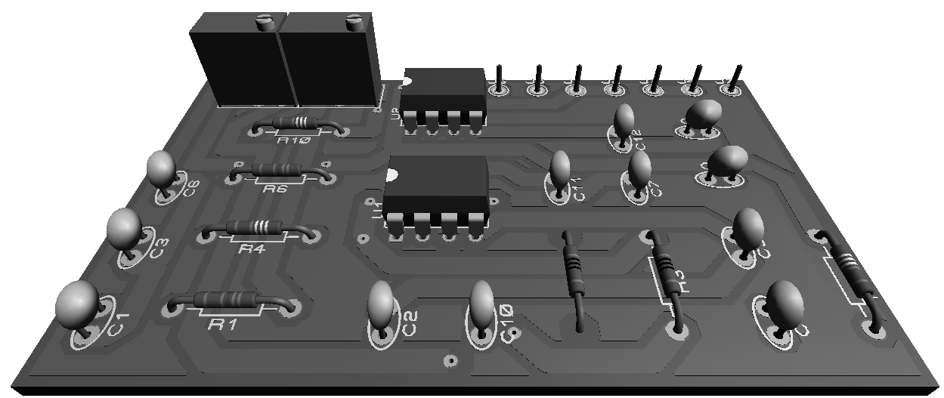

Simulated Pre-Amplification Circuit

Like the pre-amplification module, the amplification module was simulated. The structural result of this amplification step is presented in Fig.7.

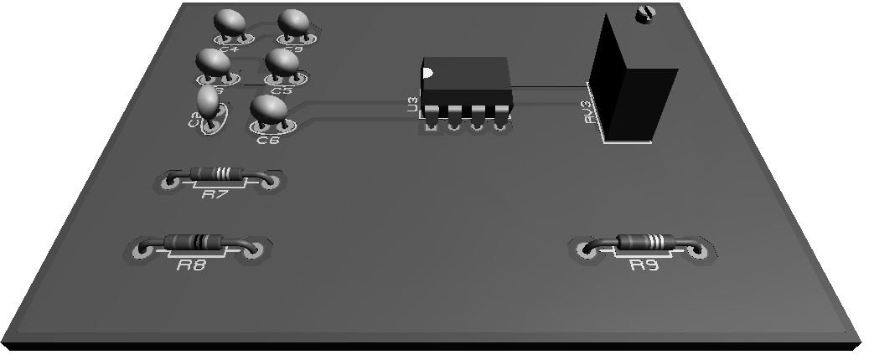

Simulated Pre-Amplification Circuit

The electronic circuit presented comprises the example case of application of the methodology. Based on its construction, it is possible to carry out the construction of the FT in order to model the unavailability of the system based on the failure modes considered.Furthermore, with the quantification of failure rates, as well as the uncertainties involved, it becomes possible to define a model to be considered in the analysis of aging based on the methodological proposal. The quantification of these values must be presented in the following subsection.

## Failure Data and PCA Criterias

In order to exemplify the application of the methodology, the Tab.[table:2] concentrates the values considered, as well as the associated failure modes, as a basis for the choice of system components. Consideration of the failure modes was performed in order to consider the loss of output signal parameters based on the failure of the electronic circuit components.

t-student distribution with and , considering a confidence interval of 95%.  
 Gaussian distribution.  
 Type A: t-student distribution with , and ; Type B: Rectangular distribution with and .

Regarding the application of the PCA, the results obtained with FV should be considered as a basis for the construction of the model. For this, they must be pre-processed. Among the pre-processing techniques, the scaling method can generate in results that are more compatible with failure analysis para a metodologia proposta, given its ability to handle data with large dispersions, usually above an order of magnitude. This pre-processing technique consists of applying the centering technique in the mean and subsequent processing with the scale technique.

# Results and Discussions

All the results to be presented in that respective section refer to the coverage interval of ninety-five percent.

The first result to be considered is the definition of the FT, which results from the knowledge regarding the functioning of the circuits presented in the Fig.4 and Fig.5. In addition, the failure scenario is modeled on loss of control over a maximum amplified signal configuration of the circuit as a result of component failures. Based on this, the obtained FT is presented in the Fig.8.

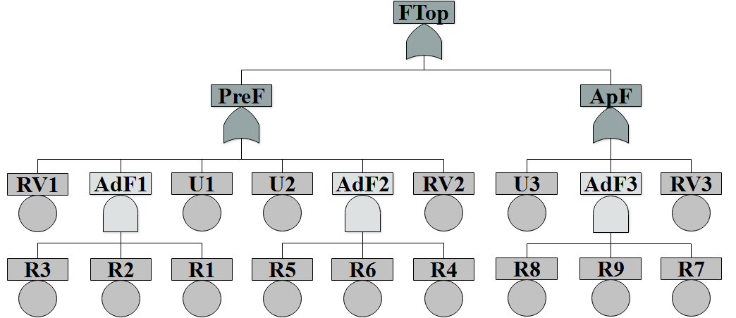

Amplification Circuit Failure Tree

The FT presented in Fig.8 has events related to the circuit resistors (R tag), variable resistors (RV tag) and integrated circuits (U tag). In addition, it has gates for adjustment failure (AdjF tag), general failure of the pre-amplification circuit (PreF tag), amplification circuit (ApF tag) and a top event that symbolizes the failure of the circuit in not being able to maintain the fidelity of an amplified signal with pre-established characteristics (FTop tag). Still in relation to the FT presented, its literal form is obtained through Eq.[eq:8.1], which indicates the failure probability by considering the failure probability of each component.

It is important to mention that the equation presented does not take into account the failures of the capacitors that make up the analysis system. The exclusion of these components is due to the fact that they are filters for the power supply system, having no impact on the failure analysis model. In this sense, the analysis of these components is more pertinent in the analysis of aging of sources used in the supply of the presented circuit.

Using MC based in Eq.[eq:8.1] considereing data from Tab.[table:2], it becomes possible to perform the aging analysis of the circuit described in the fault tree presented in Fig.8, which refers to the system composed of the circuits presented in the Fig.3 and Fig.4 .

The equation that governs system failure behavior (Eq.[eq:8.1]) it was processed using the MC methodology for an analysis time interval of one thousand five hundred and fifty days with a time step of ten days. Each time step was processed by generating five million random numbers. With this processing, the behavior of the probability of failure of the system susceptible to aging is shown in Fig.9.

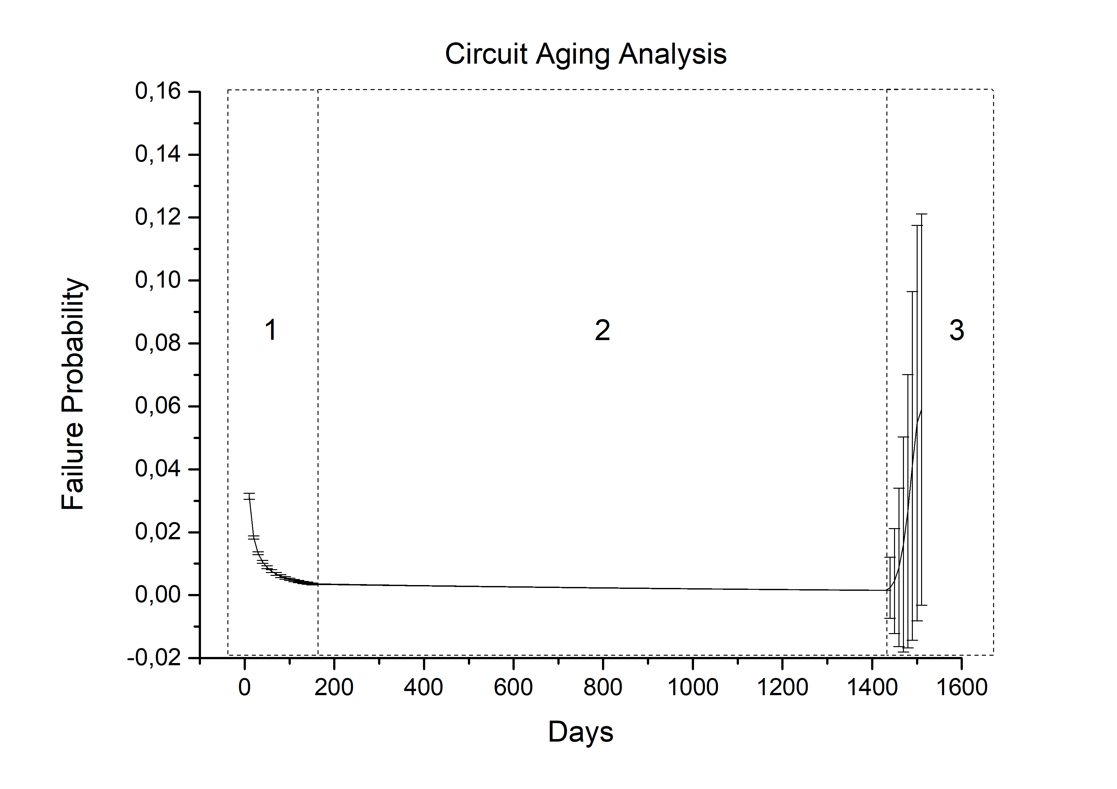

System Failure Analysis Results

[fig:10]

The Fig.9 comprises a perfect bathtub curve model. A Special attention should be directed to region three. The uncertainty in this region increases exponentially and is capable of generating failure probability values compatible with region two, which presents probability of failures with little variation. Other interesting consideration is the behavior of the probability of failure in region two of the Fig.9. The associated uncertainty don’t have a constant behavior, different from what is pointed out in the literature. The fact is presented in the in Fig.10.

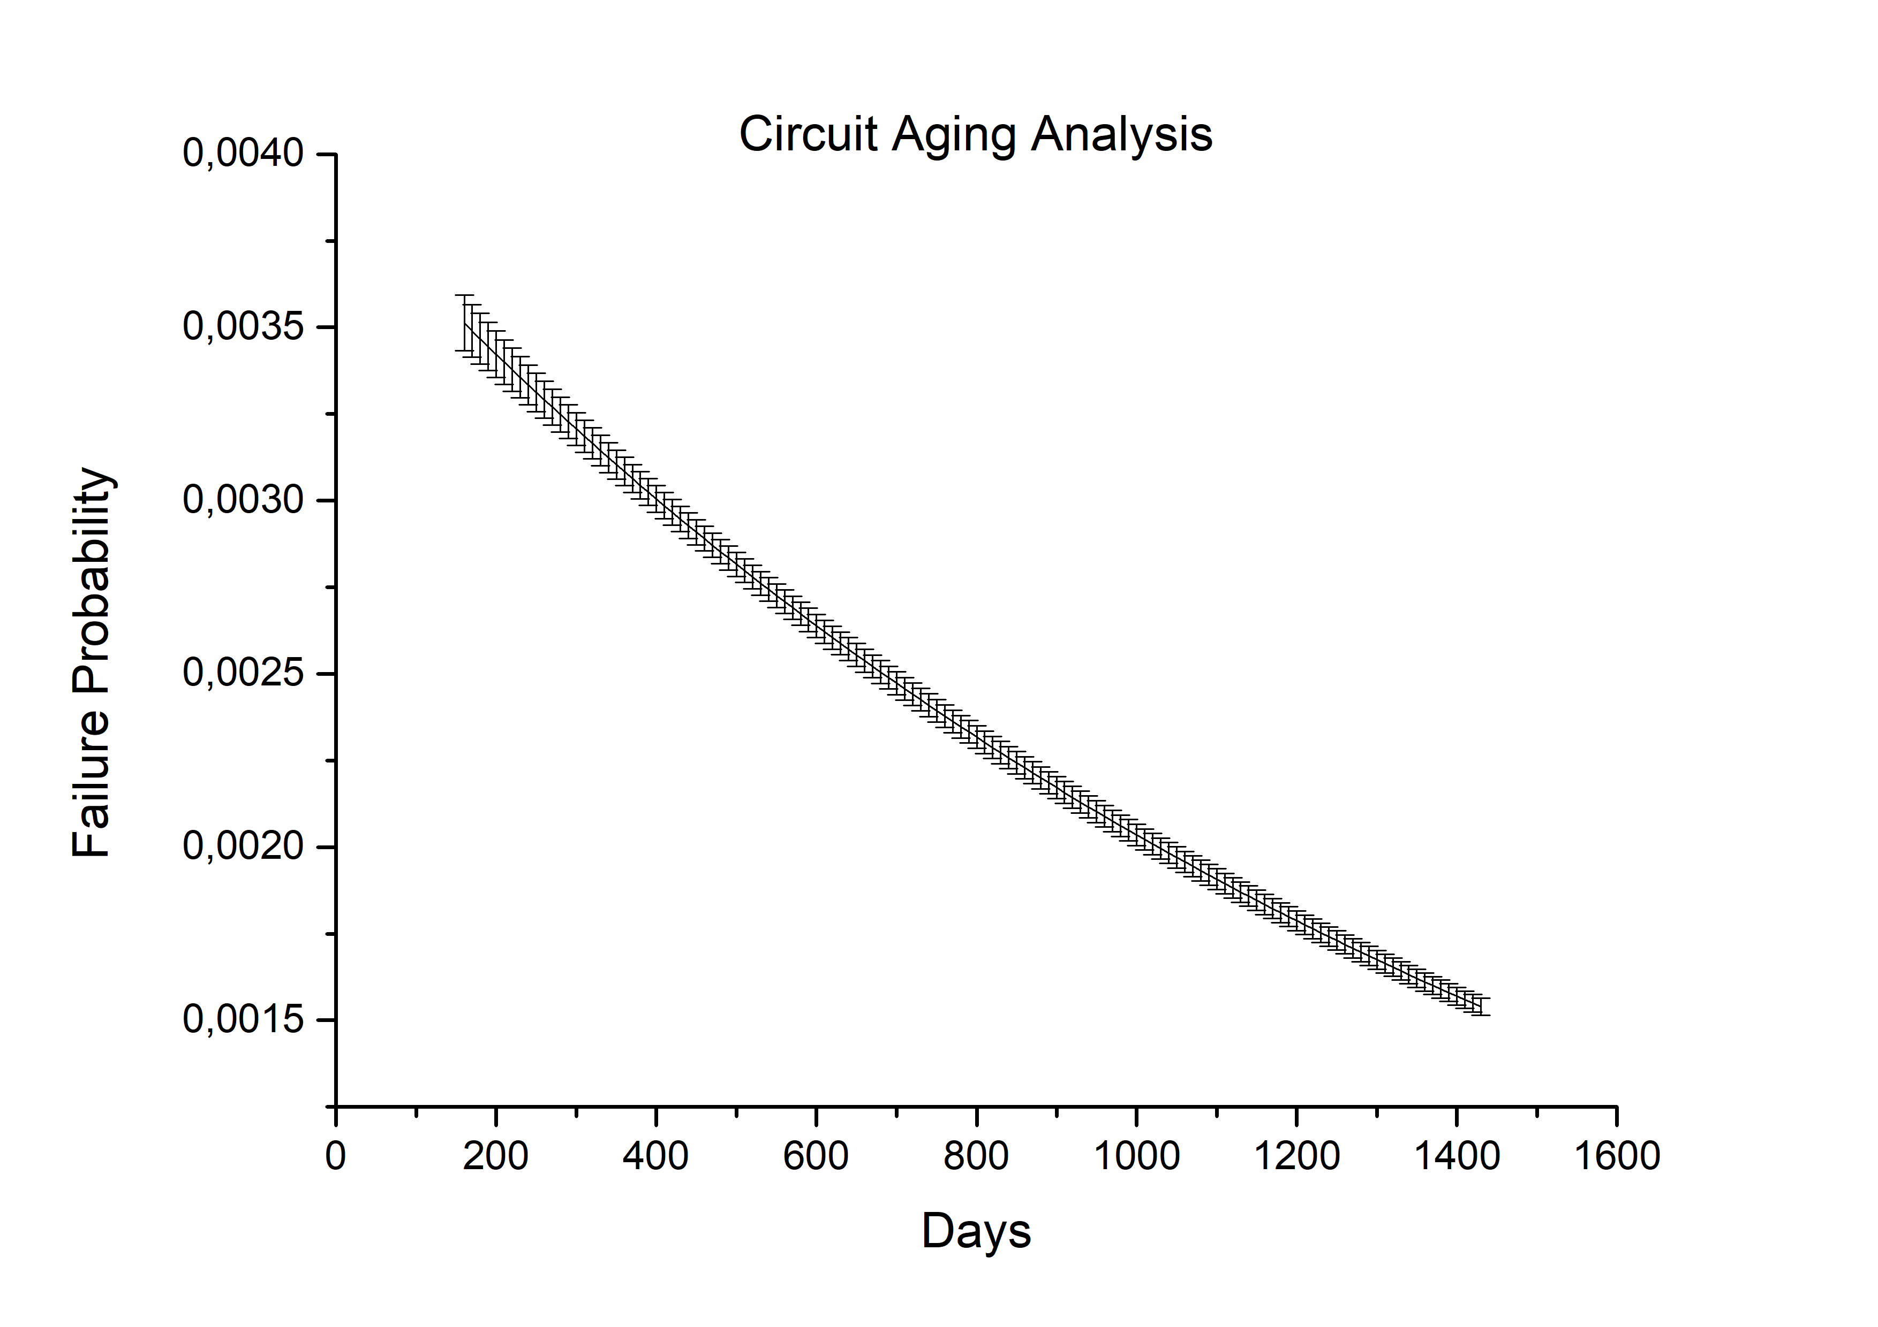

Variation in the Fault Region of the Bath Curve

[fig:11]

Although region two is considered to be a region of constant failures, it has a variation in relation to the probability of failure of a system or component. Even though this variation is present during the analysis, it is small compared to the other analysis regions, which makes it possible to consider it constant. This approach also allows this region to be described using exponential PDF.

In addition to the failure study, an in-depth analysis was carried out around the percentage participation of the components for a system failure. This analysis was done using FV Technique. The processing of the technique was carried out by applying the MC methodology using the same considerations applied to the study of the system failure. Based on this, three different graphs were obtained in relation to the percentage participation for the failure, where each one points to one of the components presented in Fig.8.

The first analysis graph for the contribution to the failure unavailability, taking into account the aging of the system and the associated uncertainties, is directed to the analysis of the resistor. The graphic mentioned is shown in Fig.11.

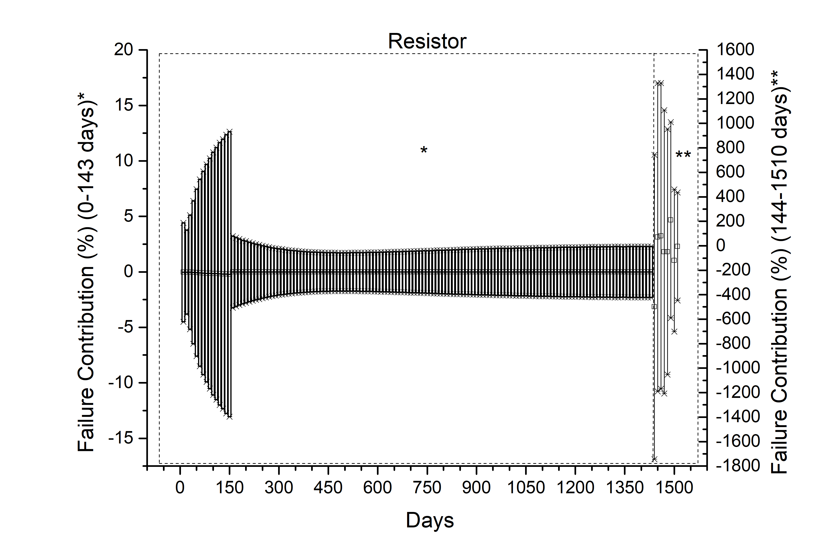

Failure Contribution (Resistor)

[fig:12]

In comparison with the previous graph, the contribution to the failure by the variable resistor does not remain constant over the analysis time. Therefore, there is a variation in the average value of contributions.

The variable resistor presents itself as one of the most significant components for the unavailability of the system, showing greater relevance for the unavailability of the system over the analysis time, whose contribution to the system failure is shown in Fig.12. In addition to the variable resistor, it will be next that the integrated circuit has a contribution as significant as the variable resistor. Thus, the two components are the most obliged components of the system, each responsible for their participation involved in the unavailability of the system due to the effects of aging over the amplification circuit adopted as an example application case.

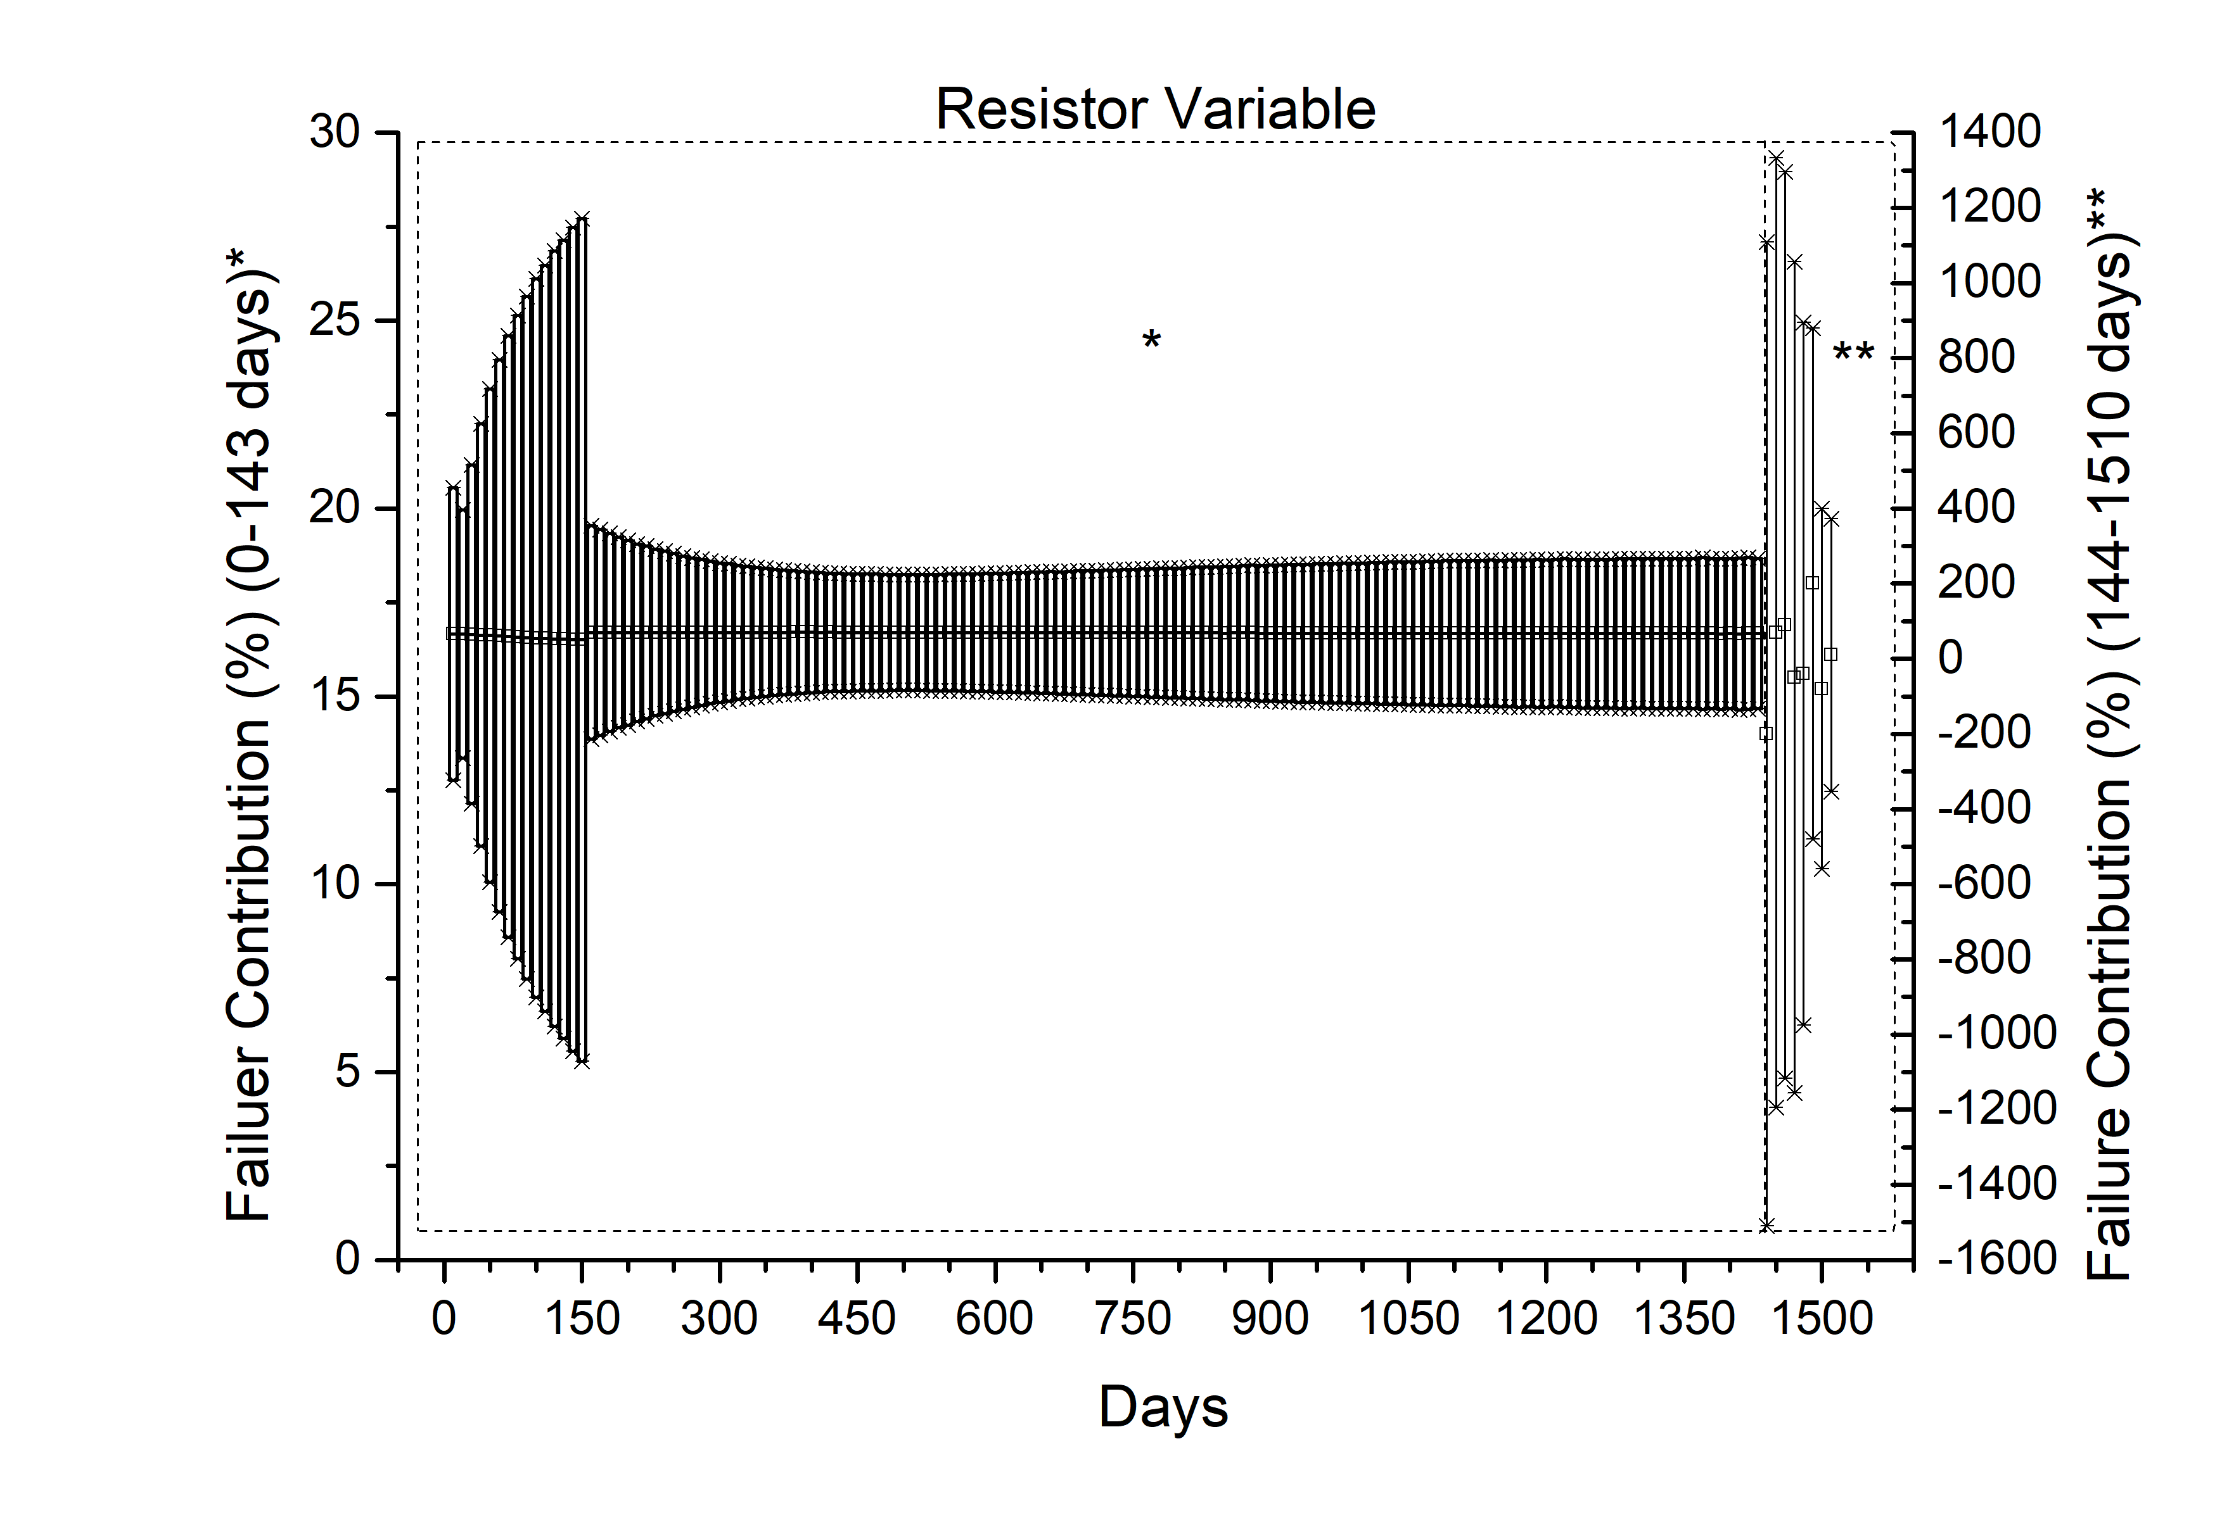

Failure Contribution (Variable Resistor)

[fig:13]

The last component to be analyzed is the Integrated Circuit, which has a contribution to the unavailability of the resistor equivalent system. The analysis for the percentage contribution of the component is presented in Fig.13.

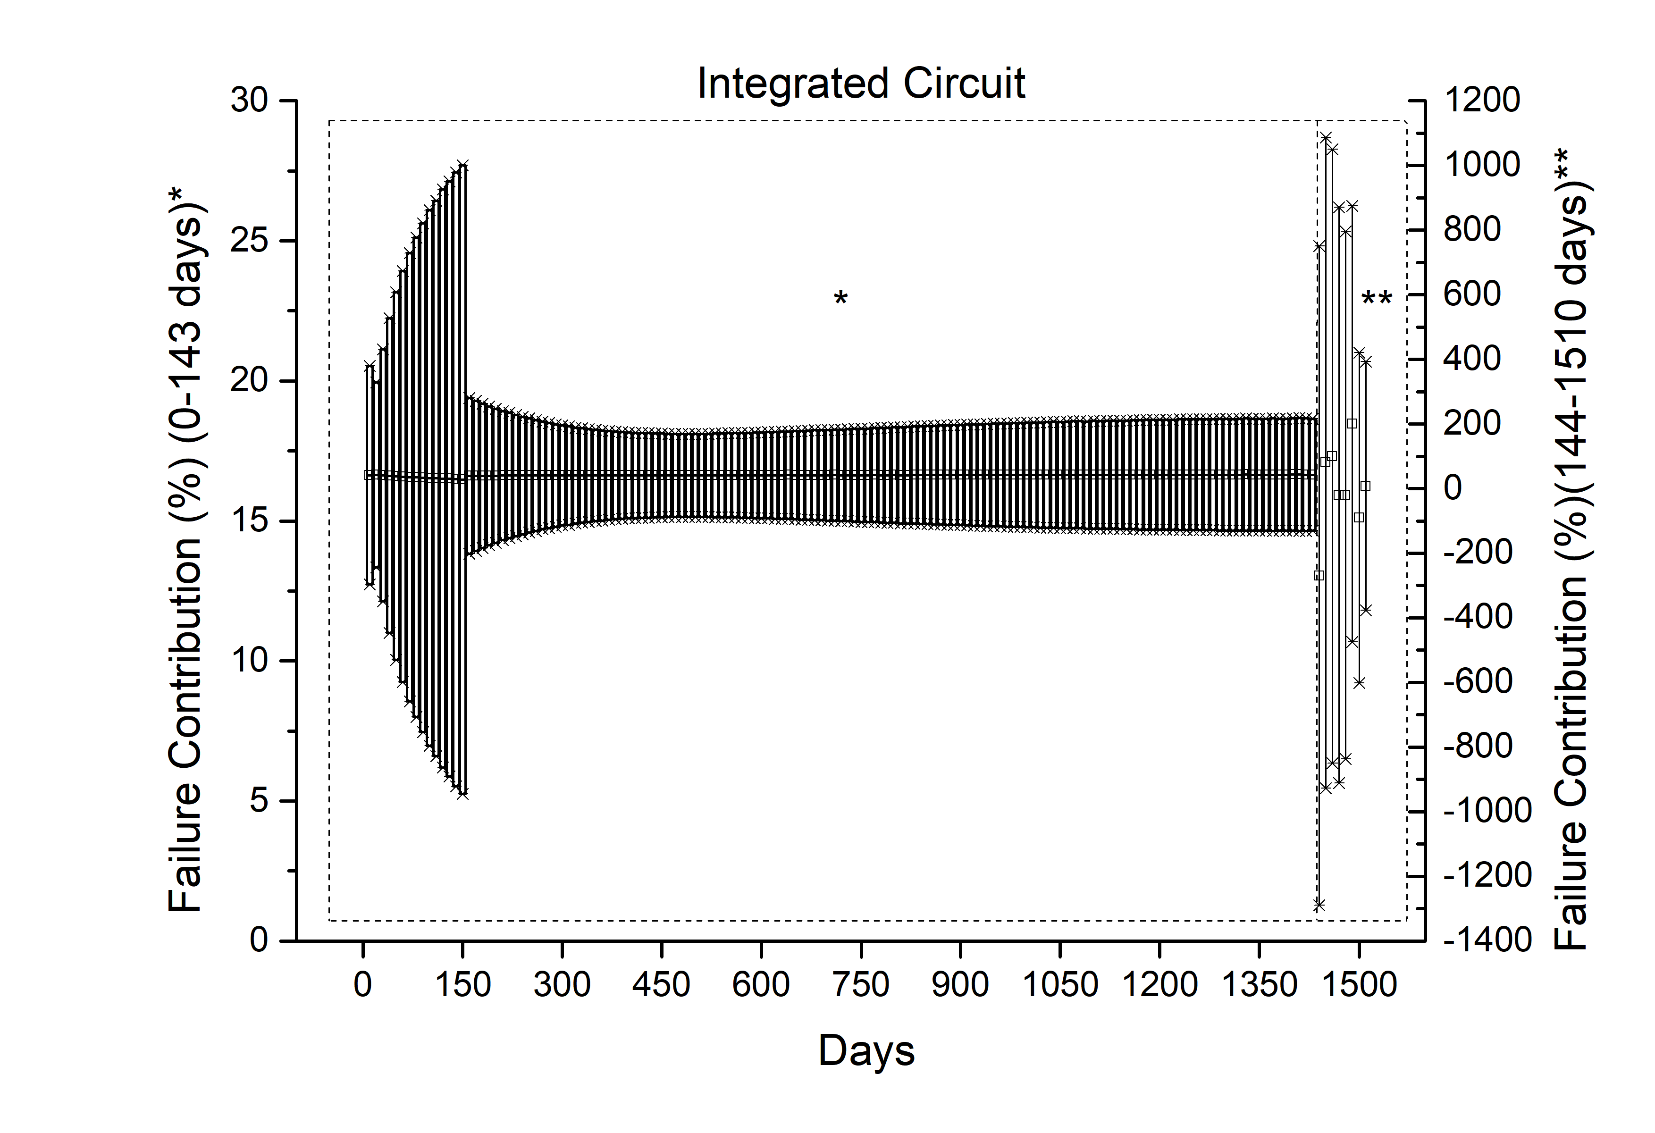

Failure Contribution (Integrated Circuit)

[fig:14]

The similarity in relation to the participation in the system failure through the Integrated Circuit and the Resistor Variable can be explained by the mathematical operators associated with these components, as well as their position in the fault tree. These components are the most participatory for the unavailability of the system, unlike the resistor, which has low participation.

Regarding the phase of exponential increase in failures, it is important to highlight the fact that anomalies appear at the beginning of this region, indicating that the participation of the components has extreme values in this region.

Analysis using the FV technique can generate countless results that can be difficult to visualize graphically. Thus, PCA can present itself as an important tool for the composition of a model that can be visualized as the information can be inserted and analyzed in relation to the contribution of components to the failure of a system.

Through the use of the values obtained with FV, with the scaling processing technique and with the application of the PCA, the contribution to the failure of the components can be seen in a simpler way. For this, it is necessary to compose graphs pertinent to the technique, e.g., score graphs and loadings (Fig.14). The comparison between these graphs makes it possible to determine the greatest correlation between components and time passages. This analysis generates results similar to those presented in the previous graphs on the contribution of components to the unavailability of the electronic circuit.

Based on the analysis of the contribution to the unavailability of the system in relation to its components, apparently, components that have a greater contribution to the failure of the system generate greater uncertainties, as well as the anomaly perceived at the beginning of the exponential increase in system failure.

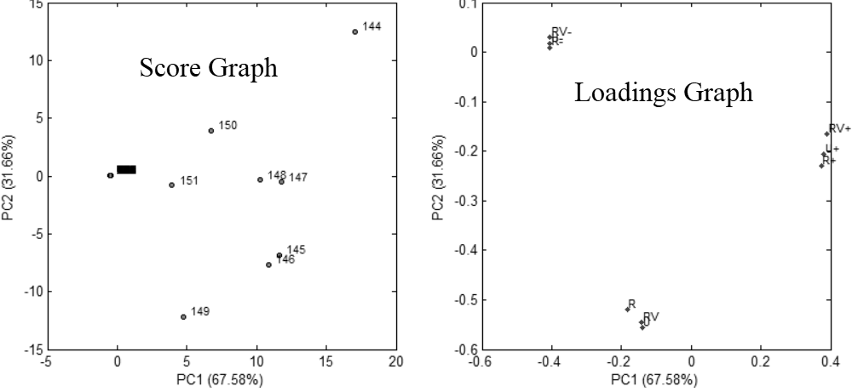

Score and Loadings Graphics

[fig:16]

Still using the PCA, a dendogram can be created in order to verify the compatibility between the components, e.g., which of them can be grouped according to the participation for the unavailability of the system. In this way, Fig.15 presents the dendogram referring to the analysis system.

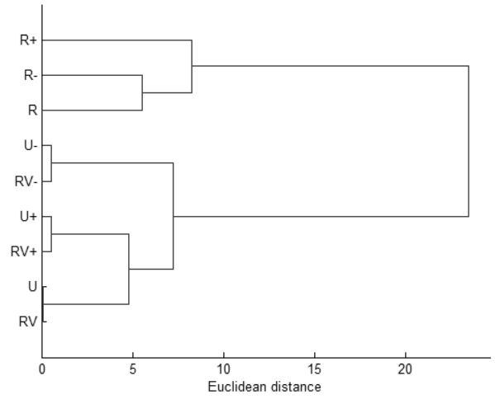

System Dendogram

[fig:17]

the graphs presented in Fig.14 and Fig.14 present components considered in the FT of the analysis case and are pointed out through combinations of their first letters. Furthermore, uncertainties are considered, being presented by means of their upper limit, indicated by the symbol , and the lower limit, indicated by the symbol .

# Acknowledgment

I am grateful for the help and cooperation of the Instituto Nacional de Metrologia, Qualidade e Tecnologia (INMETRO), the Instituto de Engenharia Nuclear (IEN) and the Fundação de Amparo à Pesquisa do Estado do Rio de Janeiro (FAPERJ), which contributed to the work presented in this paper has been carried out.

# Conclusions

The concepts and techniques used in the development of the proposed aging analysis methodology are known in the literature, mainly in failure analysis applications, except for the use of PCA, whose application is a pioneer in failure analysis. The joint use of these tools makes it possible to obtain relevant results in an aging study. Additionally, the consideration of the associated uncertainties pointed to the fact that alone it is capable of generating results that make it impossible to compose a predictive model that describes the reality of the system in relation to aging.

The methodology proposed in this work, refers to the use of high production analysis tools, thus generating the expectation of developing predictive models, which can be formed in real time with any given system. In this perspective, it is important to mention that a proposal presented throughout this role can be applied in a number of types of systems, its application being essential in installations that require high reliability, such as a nuclear, aerospace industry, for example.

Regarding the analyzed circuit, it was found that the variable resistor and the integrated circuit are the most sensitive components of the system, being responsible for the greatest contribution to the unavailability of the system. This determination points to decision-making measures that can impact the increase in the reliability of the system, such as replacing them on the basis of the circuit design or over the time of operation.

The application of the methodology for analysis of aging throughout this paper enables the modeling, analysis of aging and clear presentation of analysis data of a system throughout its operation. In this way, the methodology is relevant for failure studies and presents itself as a contribution to the increase in reliability and system availability guarantees.

0

Wenyuan Li and E. Vaahedi and P. Choudhury, Power system equipment aging, *IEEE Power and Energy Magazine* **3** (2006) 52–58.

G. Klutke and P.C. Kiessler and M.A. Wortman, A critical look at the bathtub curve, *IEEE Transactions on Reliability* **1** (2003) 125–129.

Matsuoka Takeshi, Failure data and system reliability analysis, *Nuclear Safety and Simulation* **2** (2012) 104–118.

Bureau International des Poids et Mesures (BIPM), International Vocabulary of Metrology - Basic and General Concepts and Associated Terms (JCGM 200:2012) *BIPM* **1** (2012) 1–95.

Borges, Diogo S. *et all*, Nondeterministic method to analysis of the aging effects in PWR power plants components *Annals of Nuclear Energy* **81** (2015) 249–256.

Marko Čepin and Borut Mavko, A dynamic fault tree *Reliability Engineering & System Safety* **1** (2002) 83–91.

Chin-Diew Lai and D.N. Murthy and Min Xie, Weibull Distributions and Their Applications *Springer Handbook of Engineering Statistics* **1** (2006) 63–78.

Arjun K. Gupta and Wei-Bin Zeng and Yanhong Wu, Exponential Distribution *Probability and Statistical Models* **1** (2010) 23–43.

Horst Rinne, The Weibull Distribution *Chapman and Hall/CRC* **1** (2008) 01–92.

Hélio Yoriyaz, Monte Carlo Method: principles and applications in Medical Physics *Revista Brasileira de Física Médica* **1** (2014) 141–149.

Antonio Carlos Baratto, Jailton Carreteiro Damasceno, João Antonio Pires Alves, Jorge Trota Filho, Paulo Roberto Guimarães Couto and Sérgio Pinheiro de Oliveira, Avaliação de dados de medição — Guia para a expressão de incerteza de medição *JCGM 100:2008* **1** (2008) 01–138.

H. M. Nor Shadiah and Ahmad Arshad and A. R. Khalil Mohamed and Oladokun Olagoke, Integration of fault tree and importance measure for toxic prevention barrier *E3S Web of Conferences* **90** (2008) 02007.

M van der Borst and H Schoonakker, An overview of PSA importance measures *Reliability Engineering & System Safety* **3** (2001) 241–245.

Sidharth Mishra and Uttam Sarkar and Subhash Taraphder and Sanjoy Datta and Devi Swain and Reshma Saikhom and Sasmita Panda and Menalsh Laishram, Principal Component Analysis *International Journal of Livestock Research* **3** (2017) 01–20.

Alaa Tharwat, Principal component analysis - a tutorial *International Journal of Applied Pattern Recognition* **3** (2017) 01–142.

Adcock, Jeremy and Allen, Euan and Day, Matthew and Frick, Stefan and Hinchliff, Janna and Johnson, Mack and Morley-Short, Sam and Pallister, Sam and Price, Alasdair and Stanisic, Stasja, Advances in quantum machine learning *Advances in quantum machine learning* **1** (2015) 01–37.

Robert A van den Berg and Huub CJ Hoefsloot and Johan A Westerhuis and Age K Smilde and Mariët J van der Werf, Centering, scaling, and transformations: improving the biological information content of metabolomics data, *BMC Genomics* **1** (2006).

Alessandro Parente and James C. Sutherland, Principal component analysis of turbulent combustion data: Data pre-processing and manifold sensitivity *Combustion and Flame* **2** (2013) 340–350.

Han, Jiawei, Data mining : concepts and techniques *Elsevier/Morgan Kaufmann* **1** (2012) 01–740.

1. Instituto Nacional de Metrologia, Qualidade e Tecnologia (INMETRO) - Av. Nossa Sra. das Graças, 50 - Xerém, Duque de Caxias - RJ, 25250-020, Brazil