**My segment of the group report – aboturab jasim student 4**

Making my trap and spikes more visually appealing and dramatic is my main goal. I will reconstruct the spikes so that they have a more metallic look and a pointy edge. It will resemble something like this.

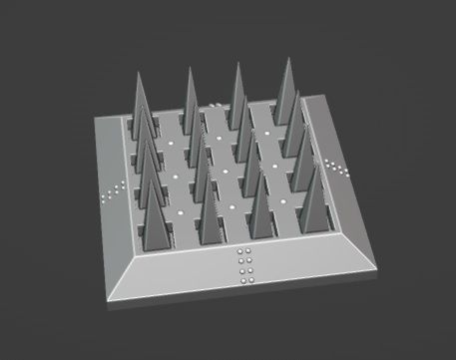

This way it will improve the overall quality and feel of the game.

I can also add a sound bite which will play if the spikes are activated. Something along the lines of liquid explosion to imitate the sound of the spikes actual penetrating the player.