**Sem:** V

**Academic Year:** 2022-23  **Date:** 13/9/2022

**DBMS&QP LAB MINI PROJECT SYNOPSIS**

**Title:**  **Inventory Management System**

**Abstract:**

An inventory management system is the combination of technology (hardware and software) and processes and procedures that oversee the monitoring and maintenance of stocked products, whether those products are company assets, raw materials and supplies, or finished products ready to be sent to vendors or end consumers.

**Description of Modules**

* We can forecast the sales by analyzing the previous sales statistics.
* We can get an idea that when we need to order new inventory.
* We can reduce the chances of any kind of fraud done by the staff members in the inventory.
* Customer details can be added.
* Invoice generation.
* We can keep a track of transactions received through different payment methods.

**Identifying End Users**

* **Admin**

**Identifying Entities.**

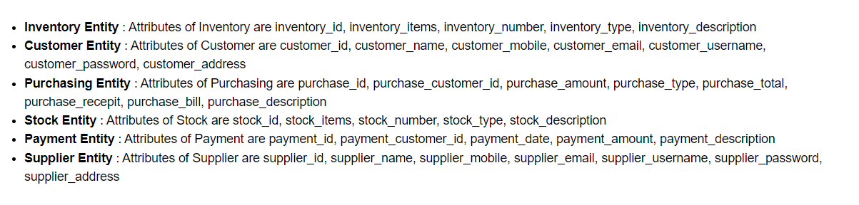

**Tools to be used**

Front End tools:- HTML/JAVA/C#

Back end tools :- oracle

**Team Details :**

|  |  |  |  |
| --- | --- | --- | --- |
| **Sr.No** | **Roll No** | **Name of Students** | **Signature** |
| 1. | 20CE20 | Dion Moraes |  |
| 2. | 20CE26 | Harsha Deshpande |  |
| 3. | 20CE34 | Lincoln Costa |  |