**Edison Javier Ortiz Solis**

**PERSONAL INFORMATION**

ADDRESS: Av Anibal granja y Sabido Barrero , 180215 Ambato , Ecuador

PHONE: 0983860122

EMAIL: eortiz5364@uta.edu.ec

**OBJECTIVE OF THE PRE-PROFESSIONAL PRACTICE**

By the end of the program, I want to understand how things work in the industry, improve my skills, and learn how to work in an international environment. This experience will help me connect what I learned in university with real-world work and prepare me for my future career.

**EDUCATION**

* CURRENT MAJOR YOU ARE STUDYING:
* LAST APPROVED SEMESTER:
* FINAL GRADE OBTAINED IN THE LAST SEMESTER:

**CERTIFICATES**

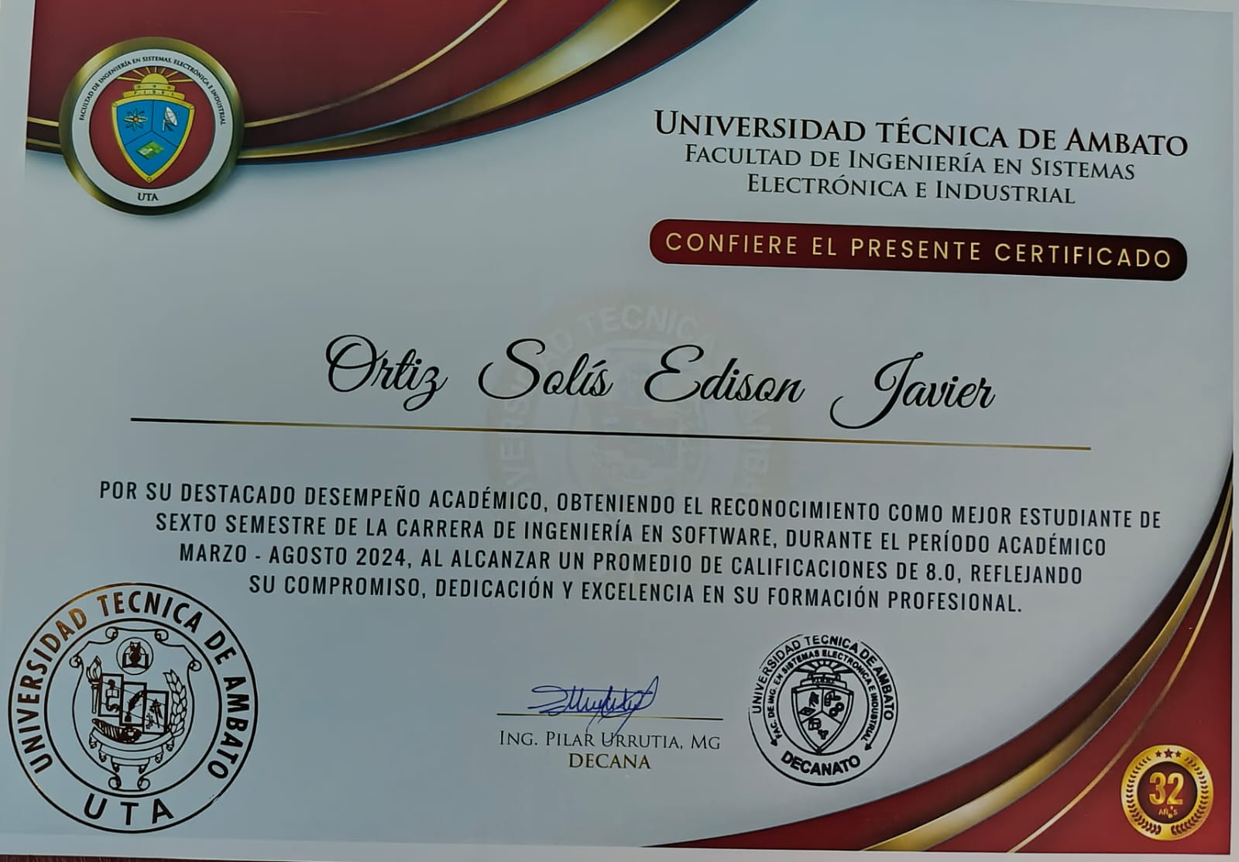

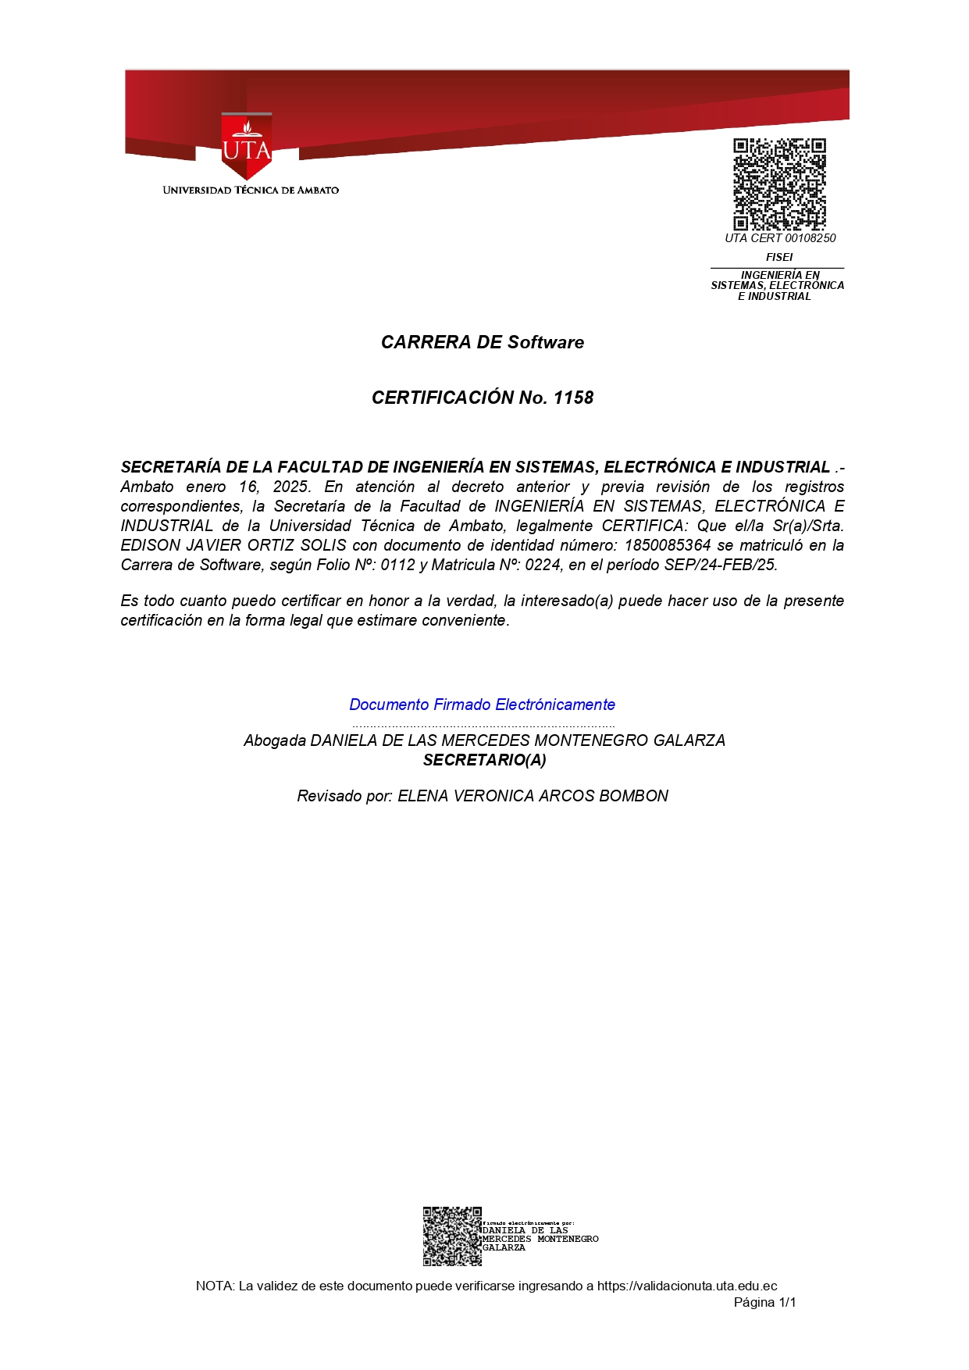

**LANGUAGES**

SPANISH: MOTHER TONGUE FLUENT BASIC KNOWLEDGE NOTHING

ENGLISH: MOTHER TONGUE FLUENT BASIC KNOWLEDGE NOTHING

GERMAN: MOTHER TONGUE FLUENT BASIC KNOWLEDGE NOTHING

OTHER LANGUAGE: ……………………………………………………………….