EXTENDED TECHNICAL EVIDENCE REPORT
AION-6G
AI-Native Intent Orchestrator for Cloud-Edge Systems
Architecture, runtime proofs, experiments, telemetry, failures, security, and reproducibility
FULL LOCAL + DOCKER + KUBERNETES VALIDATION
Evidence snapshot: 15 July 2026
Scope boundary: Experimental Cloud-Edge orchestration testbed. Not a real 6G radio deployment, network-slicing platform, Open RAN implementation, or production telecom system.

Document Control and Evidence Status
Field | Value
Document | AION-6G Extended Technical Evidence Report
Validation date | 15 July 2026
Repository branch | main
Final readiness | READY FOR PRIVATE REVIEW
Standard test suite | 36 passed, 0 failed, 2 deselected
Docker integration | 1 passed, 0 failed
Kubernetes integration | 1 passed, 0 failed
Experiment dataset | 60 rows; 56 passed; 4 failed
Secret scan | gitleaks 8.30.1; 0 findings
Visual QA | DOCX rendered to PDF and every page inspected

Evidence rule: A Kubernetes success is accepted only when an actual worker pod returns a workload response and the evidence includes cluster, namespace, deployment, pod, container, ready replica, restart, endpoint, checksum, and verification fields.

All status claims in this report are derived from the checked repository, generated artifacts, observed runtime state, test output, Docker Compose state, and the isolated kind cluster. Historical reports were treated as claims rather than sources of truth.

Contents
- Executive Summary
- Project Purpose and Scope
- Discovery and Baseline
- System Architecture
- Intent and SLA Model
- Telemetry and Source Classification
- Local Runtime Validation
- Docker Runtime Validation
- Kubernetes Runtime Validation
- Truthful Execution and Evidence Contract
- Placement Policies
- Adaptive Demonstrations
- Cross-Runtime Fallback
- Profile Evaluation
- Scenario Evaluation
- Experimental Methodology
- Experimental Results
- Testing and Regression Coverage
- Security Assessment
- Threats, Limitations, and Readiness
- Conclusion
- Appendix A - Exact Commands
- Appendix B - Evidence Catalog
- Appendix C - Experiment Sample
- Appendix D - Change Summary

Figures
- Figure 1. Experiment runs by placement policy.
- Figure 2. SLA outcomes by placement policy.
- Figure 3. SLA outcomes by service profile.
- Figure 4. Orchestration-time distribution.
- Figure 5. Measured endpoint latency across 60 runs.
- Figure 6. Measured local CPU and RAM telemetry.
- Figure 7. Selected execution target by policy.
- Figure 8. Execution-mode distribution.
- Figure 9. Fallback usage by policy.

1. Executive Summary
AION-6G now demonstrates an end-to-end intent orchestration path across three validated execution environments: a host-local worker, an isolated Docker Compose deployment, and a real worker pod in an isolated kind cluster. The project accepts natural-language service requests, converts them into structured constraints, evaluates targets, executes bounded allowlisted workloads, verifies checksums and SLA conditions, and persists evidence.
The most important technical correction is the removal of fabricated cross-runtime success. Kubernetes execution now requires a reachable aion-6g-cluster, namespace aion-6g, a ready aion6g-worker deployment, a successful HTTP workload response, KUBERNETES runtime identity, and complete pod metadata. Unavailable Kubernetes remains UNAVAILABLE and carries no artificial zero-latency measurement.
Dimension | Verified result | Primary evidence
Local | LOCAL workload PASSED | policy_always_local.json
Docker | DOCKER workload and restart recovery PASSED | docker_validation.json
Kubernetes | Live pod workload PASSED | kubernetes_edge_success.json
Placement | Three policies validated | policy_*.json
Adaptive | Local and Kubernetes selections demonstrated | adaptive_selects_*.json
Fallback | One-retry cross-runtime success and failure | fallback_real_*.json
Experiments | 60 rows, 56 passed, 4 failed | experiment_summary.csv
Security | 0 gitleaks findings | security_scan.json

- Measured: local CPU, local RAM, local HTTP latency, Kubernetes HTTP latency, deployment/pod readiness, and restart count.
- Unavailable: Kubernetes CPU/RAM percentages because metrics-server was not installed.
- Emulated: jitter, packet loss, bandwidth, and scenario latency additions unless explicitly stated otherwise.
- Controlled: local-high-cpu, selected-target-failure, and no-eligible-target scenario overrides.

2. Project Purpose and Scope

Purpose
AION-6G is an experimental, AI-native and 6G-oriented intent orchestration testbed for Cloud-Edge systems. It combines deterministic SLA-aware placement, real local and Kubernetes workload execution, measured compute and HTTP telemetry, and explicitly labelled emulated network conditions.

Supported workflow
- Accept a natural-language service request through FastAPI.
- Parse service type, SLA constraints, priority, and fallback permission.
- Collect local and Kubernetes runtime telemetry.
- Evaluate candidate eligibility and deterministic scores.
- Call the selected HTTP worker with bounded validated parameters.
- Verify workload checksum, runtime identity, metadata, and SLA conditions.
- Persist JSON evidence and aggregate experiments into CSV, JSON, statistics, and figures.

Explicit exclusions
- No real 6G radio deployment or radio measurements.
- No real network slicing or Open RAN integration.
- No telecom-operator production infrastructure.
- No production hardening, multi-cluster failover, or external identity platform.
Interpretation: The term 6G-oriented describes the research direction and intent/SLA orchestration context. It does not imply a radio-access implementation.

3. Discovery and Baseline

Repository state before modification
The repository was on branch main and already contained modified and untracked files. Those changes were preserved. The actual baseline was weaker than the previous report: 32 tests passed, one failed, one Kubernetes placeholder was skipped, and 13 matplotlib-related warnings were emitted.
Baseline item | Observed result | Implication
Default Python | Python 3.13 without pytest | Used installed Python 3.11 environment
Test suite | 32 passed, 1 failed, 1 skipped | Fallback logic required correction
Docker | Desktop available; old AION container running | Scoped Compose validation possible
kind | CLI missing | Installed kind 0.32.0
Kubernetes context | kind-jarvis-edge | Created separate aion-6g-cluster
Port 8001 | Old AION Uvicorn process | Stopped only the conflicting AION process
Historical evidence | Six false Kubernetes successes | Reclassified as invalid legacy evidence

Historical evidence audit
The audit identified 6 timestamped artifacts that selected kubernetes-edge and claimed PASSED without KUBERNETES mode, worker endpoint, or pod metadata. Each original claim was preserved under legacy_original_claim, while the active classification was changed to SIMULATED / FAILED.
Result: After reclassification, zero remaining JSON artifacts present kubernetes-edge as a successful real execution without KUBERNETES mode, pod name, and worker endpoint.

4. System Architecture

Logical component model
Layer | Components | Responsibility
API | app/main.py | Health, readiness, profiles, telemetry, orchestration, result access
Intent | deterministic_parser.py | Natural language to ServiceIntent
Models | intent.py, telemetry.py, result.py | Strict validated schemas
Telemetry | local_collector.py, kubernetes_collector.py | Measured and unavailable runtime state
Placement | eligibility.py, placement.py | Constraint filtering and deterministic score
Execution | executor.py, worker_api.py | Bounded local/Docker/Kubernetes HTTP workload
Verification | verifier.py | Checksum, identity, metadata, and SLA checks
Evidence | orchestrator.py, experiments | Timestamped JSON and aggregate results

Control flow
- FastAPI receives IntentRequest containing request, policy, scenario, and fallback flag.
- The deterministic parser selects a profile and validates numeric constraints.
- Collectors probe the local worker and the exact kind context/deployment.
- Scenario overrides are applied with CONTROLLED or EMULATED labels.
- Eligibility rejects unhealthy, unready, over-CPU, over-memory, or over-latency candidates.
- Placement selects the highest scoring eligible target or returns no eligible target.
- The orchestrator calls /execute on the chosen HTTP worker.
- The verifier requires a successful status and checksum; Kubernetes also requires metadata.
- Fallback records the original attempt and retries exactly once when permitted.
- The result is packaged with evidence ID, timestamps, source labels, and persisted JSON.

Trust boundaries
- The API does not accept shell commands or filesystem paths from clients.
- Workers accept only three allowlisted workload types.
- Remote runtime identity is returned by the worker and checked by the orchestrator.
- Kubernetes telemetry is scoped to a fixed context, namespace, deployment, label, and endpoint.

5. Intent and SLA Model
The ServiceIntent model represents service type, latency, jitter, packet loss, bandwidth, CPU, memory, priority, and fallback. The parser uses profile defaults and explicit numeric requirements from the request. Conflicting priorities and invalid negative or non-numeric requirements are rejected by tests.
Profile | Purpose | Default SLA
critical-control | Reliability-sensitive control | 20 ms latency; 2 ms jitter; 0.1% loss; 70% CPU
immersive-xr | Latency-sensitive interaction | 15 ms latency; 4 ms jitter; 0.5% loss; 50 Mbps; 75% CPU
massive-iot | Scalable message processing | 100 ms latency; 2% loss; 80% CPU

Validation and bounds
Input | Validation
Request text | Non-empty; parser rejects unsupported malformed requirements
Workload type | critical-control, immersive-xr, or massive-iot only
Iterations | Worker API: 1 to 1,000; workload implementation bounded
Payload size | 1 to 4,096 bytes
Experiment repetitions | 1 to 20 per scenario through API model
Remote request | HTTP timeout applied

6. Telemetry and Source Classification

Metric provenance
Metric | Local | Kubernetes | Classification
CPU | psutil | Metrics API unavailable | MEASURED / UNAVAILABLE
RAM | psutil | Metrics API unavailable | MEASURED / UNAVAILABLE
HTTP latency | Real health request | Real port-forwarded request | MEASURED
Ready replicas | Not applicable | Deployment status | MEASURED
Restart count | Not applicable | Pod container status | MEASURED
Jitter | Scenario model | Scenario model | EMULATED
Packet loss | Scenario model | Scenario model | EMULATED
Bandwidth | Scenario model | Scenario model | EMULATED

Observed telemetry distribution
- Local CPU percent: min 0.000, median 14.550, mean 14.398, max 20.100.
- Local RAM percent: min 64.900, median 65.050, mean 65.052, max 65.200.
- Local HTTP latency (ms): min 1.287, median 2.389, mean 9.757, max 53.513.
- Kubernetes HTTP latency (ms): min 4.941, median 14.585, mean 15.913, max 60.173.
Kubernetes compute metrics: kubectl top nodes and kubectl top pods returned 'Metrics API not available'. CPU and RAM were therefore stored as UNAVAILABLE instead of being estimated or fabricated.

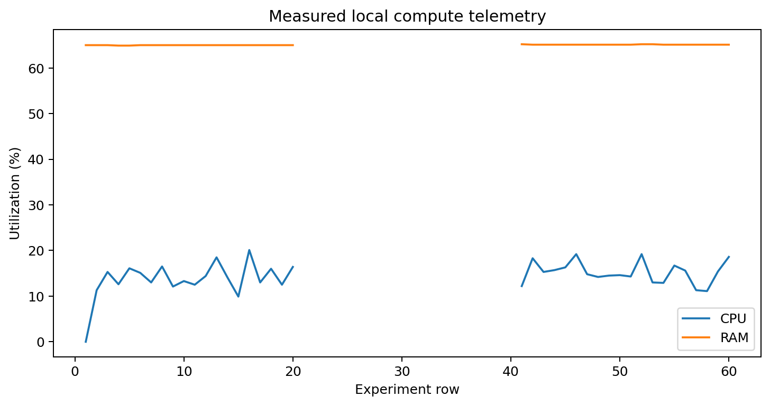
Figure 6. Measured local CPU and RAM telemetry across the experiment.
Source: results/experiment_summary.csv

7. Local Runtime Validation
A host worker was started on localhost and returned execution_mode LOCAL from /health. The orchestrator measured CPU and RAM using psutil, measured a real HTTP health request, selected local-edge under always-local and adaptive baseline policies, and called the worker /execute endpoint.
Evidence field | Observed value
Selected target | local-edge
Execution mode | LOCAL
Worker endpoint | http://127.0.0.1:8011
CPU | 14.5
RAM | 65.0
HTTP latency (ms) | 1.71
Workload | massive-iot
Checksum | a6038248e1ab938bf805ba0da67e89971cd0b5c856c931999c688fc213a87b6d
Verification | PASSED

The checksum is deterministic for a given workload type, iteration count, and payload size. This enabled correctness checks across normal execution and controlled restart recovery.

8. Docker Runtime Validation
The Docker configuration was rebuilt into the isolated Compose project aion6g. Resource names are prefixed with aion6g-, and only the AION-6G Compose project was changed. The deployment contains a FastAPI control-plane container and a dedicated local worker container.
Container | Image | Port | Role
aion6g-app | aion6g-aion6g-app | 8000 | API, orchestration, dashboard
aion6g-local-worker | aion6g-aion6g-local-worker | 8001 | DOCKER bounded workload worker

Endpoint validation
Endpoint | Status code | Result
health | 200 | PASS
ready | 200 | PASS
api/v1/profiles | 200 | PASS
api/v1/telemetry | 200 | PASS

Controlled restart
The Docker worker executed a bounded critical-control workload, returned DOCKER identity and a checksum, was restarted through Docker Compose, recovered health, and returned the same checksum for the same input. The Docker integration marker completed with one passing test.
Docker result: Image build, startup, health, readiness, workload execution, checksum correctness, controlled restart, and recovery were all VERIFIED.

9. Kubernetes Runtime Validation
A separate kind cluster named aion-6g-cluster was created without deleting or modifying the existing jarvis-edge cluster. The worker image was loaded into kind, deployed only to namespace aion-6g, and exposed only through a ClusterIP service plus localhost port-forwarding.
Kubernetes evidence | Value
Cluster | aion-6g-cluster
Namespace | aion-6g
Deployment | aion6g-worker
Pod | aion6g-worker-6f477d6f5f-lvjgs
Pod UID | e901a8ad-8d3d-4a9c-abab-b4f68351c43b
Container | aion6g-worker
Worker endpoint | http://127.0.0.1:8002
Ready replicas | 1
Restart count | 0
Execution mode | KUBERNETES
Execution latency (ms) | 0.05
Verification | PASSED

Workload proof
status: ok
runtime: KUBERNETES
workload_type: critical-control
iterations: 200
payload_size: 64
checksum: f36177aab62d5de3b2d00f8fd9622cee3e6dd6704bfe99ee2064dc7af2df1969
pod_uid: e901a8ad-8d3d-4a9c-abab-b4f68351c43b
verification: PASSED
Kubernetes result: The always-kubernetes and integration-test paths reached a real pod and returned complete metadata plus a checksum. This is real Kubernetes workload execution, not local execution with a Kubernetes label.

10. Truthful Execution and Evidence Contract
Mode | Meaning | Success requirements
LOCAL | Host-local worker | Healthy local endpoint, LOCAL identity, checksum, SLA checks
DOCKER | Docker worker | Healthy Compose container, DOCKER identity, checksum
KUBERNETES | Live worker pod | Exact cluster/deployment/pod metadata and pod response
SIMULATED | Historical or explicit simulation | Cannot be treated as real runtime success
UNAVAILABLE | Runtime cannot execute | Must remain FAILED; timing is null

Regression guarantees
- kubernetes-edge cannot execute through a LOCAL runtime identity.
- Kubernetes cannot return PASSED when the expected cluster is unreachable.
- Simulated execution cannot be labelled KUBERNETES.
- Kubernetes verification requires cluster, namespace, deployment, pod, UID, and container.
- Unavailable targets cannot be selected successfully.
- Fallback cannot fabricate a successful second runtime.
Zero timing policy: Unavailable or skipped execution uses null execution latency. A value of 0 ms is never substituted for a missing real measurement.

11. Placement Policies
Eligibility and scoring are deterministic. Health, endpoint readiness, CPU, memory, and measured HTTP latency can reject a candidate. Eligible candidates receive weighted latency, CPU, memory, health, and readiness components. Missing required compute telemetry receives a conservative neutral component rather than a perfect score.
Policy | Purpose | Validated outcome
always-local | Force local-edge | LOCAL / PASSED
always-kubernetes | Force kubernetes-edge | KUBERNETES / PASSED
adaptive | Rank both eligible targets | LOCAL baseline and KUBERNETES high-CPU demo

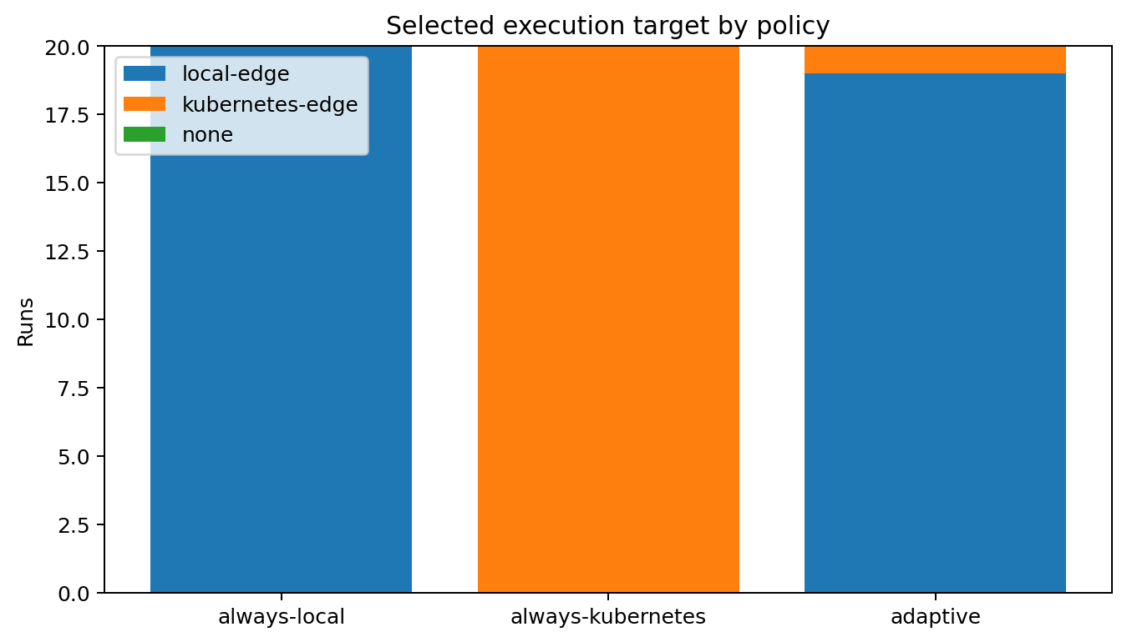
Figure 7. Selected execution target by policy.
Source: results/experiment_summary.csv
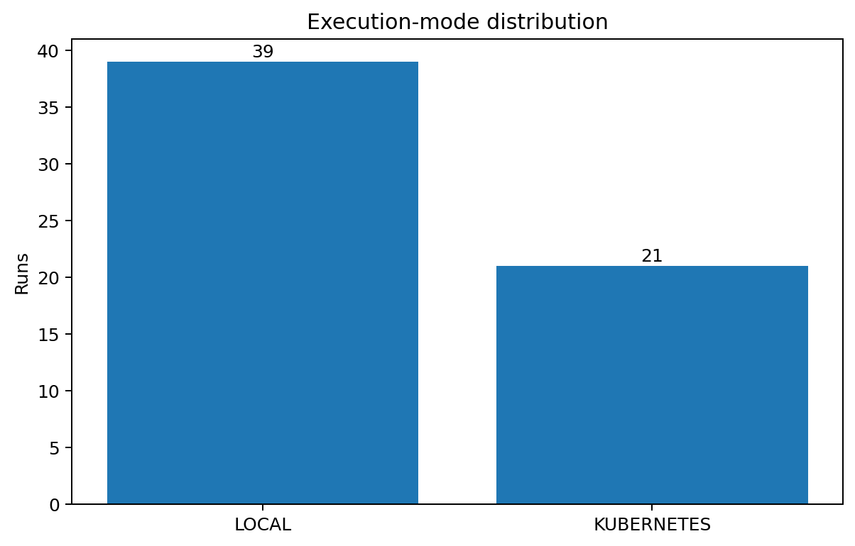
Figure 8. Execution-mode distribution across the experiment.
Source: results/experiment_summary.csv

12. Adaptive Demonstrations

Demo A - baseline selects local
Both runtimes were healthy and eligible. The deterministic score selected local-edge, the LOCAL worker executed the workload, and verification passed.
Candidate | Eligible | Score | Rejection reasons
local-edge | True | 0.96 | None
kubernetes-edge | True | 0.83 | None

Demo B - controlled high CPU selects Kubernetes
The local CPU value was overridden to 99 percent with CONTROLLED provenance. Local eligibility failed, Kubernetes remained healthy, a real pod executed the workload, and verification passed.
Candidate | Eligible | Score | Rejection reasons
local-edge | False |  | CPU utilization exceeds the requested maximum
kubernetes-edge | True | 0.8 | None

Provenance: The high CPU value is not presented as a measured psutil observation. It is stored in scenario_overrides with source CONTROLLED.

13. Cross-Runtime Fallback

Successful fallback
- Both targets were initially healthy and eligible.
- Adaptive placement selected local-edge.
- A CONTROLLED failure was injected only for local execution.
- The failed original attempt and reason were retained.
- The orchestrator retried exactly once.
- kubernetes-edge was selected for the retry.
- A real worker pod returned KUBERNETES identity, checksum, and metadata.
- Final verification passed.
Attempt | Target | Mode | Verification | Reason
1 | local-edge | LOCAL | FAILED | controlled local execution failure
2 | kubernetes-edge | KUBERNETES | PASSED | Completed

Failure proof
The AION-6G Kubernetes deployment was scaled to zero and the same controlled local failure flow was executed. The fallback attempted kubernetes-edge once, received UNAVAILABLE, and remained FAILED. The deployment was then restored to one replica.
Field | Observed value
Fallback used | True
Retry count | 1
Final mode | UNAVAILABLE
Final status | FAILED
Reason | primary target failed; fallback target did not complete successfully

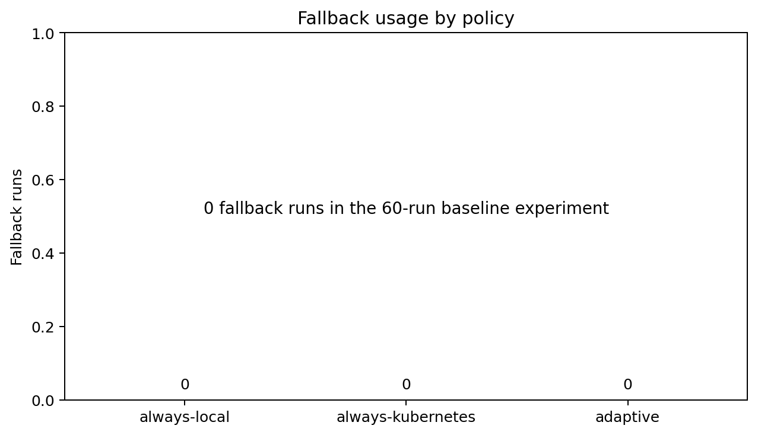
Figure 9. Fallback usage by policy in the 60-run experiment.
Source: results/experiment_summary.csv

14. Profile Evaluation
Profile | Runs | Passed | Failed | Execution modes
critical-control | 21 | 17 | 4 | LOCAL:13, KUBERNETES:8
immersive-xr | 21 | 21 | 0 | LOCAL:14, KUBERNETES:7
massive-iot | 18 | 18 | 0 | LOCAL:12, KUBERNETES:6

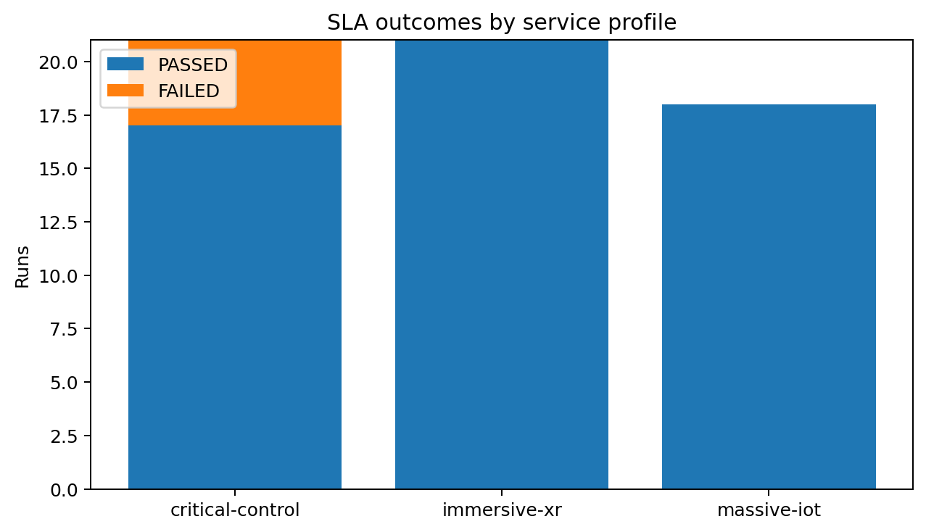
Figure 3. SLA outcomes by service profile.
Source: results/experiment_summary.csv

Per-profile evidence
- critical-control: real Kubernetes execution, checksum, metadata, and PASSED verification.
- immersive-xr: real Kubernetes execution with bandwidth requirement represented in the parsed intent and emulated network profile.
- massive-iot: real LOCAL execution with packet-loss SLA and bounded batch-style workload.

15. Scenario Evaluation
Scenario | Selected target | Mode | Status | Override source
baseline | local-edge | LOCAL | PASSED | Network fields EMULATED
local-high-cpu | kubernetes-edge | KUBERNETES | PASSED | CONTROLLED
kubernetes-high-latency | local-edge | LOCAL | PASSED | EMULATED
packet-loss-degradation | local-edge | LOCAL | PASSED | Network fields EMULATED
selected-target-failure | kubernetes-edge | KUBERNETES | PASSED | CONTROLLED
no-eligible-target |  | UNAVAILABLE | FAILED | CONTROLLED

Interpretation
- baseline validates normal measured endpoint and local compute telemetry.
- local-high-cpu validates rejection and migration to a real Kubernetes worker.
- kubernetes-high-latency validates explicit EMULATED latency addition.
- packet-loss-degradation validates an EMULATED network constraint violation path.
- selected-target-failure validates one-retry cross-runtime fallback.
- no-eligible-target validates truthful UNAVAILABLE / FAILED behavior.

16. Experimental Methodology
The experiment runner executed 60 baseline orchestrations: 20 always-local, 20 always-kubernetes, and 20 adaptive. The three service profiles were rotated across runs. Always-kubernetes rows called the live kind worker. Always-local rows called the host LOCAL worker. Adaptive rows evaluated both targets and selected according to actual measured state and deterministic scoring.
Recorded field group | Fields
Identity | run_id, timestamp, policy, service_profile, scenario
Decision | selected_target, execution_mode, rejection_reasons
Outcome | execution_success, sla_status, fallback_used
Timing | orchestration_time_ms, local_http_latency_ms, kubernetes_http_latency_ms
Compute | local/kubernetes CPU and memory percentages
Network | jitter, packet loss, bandwidth, network_data_type

Data-quality rules
- Failed runs remain failed and are included in statistics.
- Missing timings are not converted into valid zero measurements.
- Execution mode is recorded for every row.
- Kubernetes CPU/RAM remain blank because the Metrics API was unavailable.
- Charts use matplotlib defaults without seaborn or custom styles.
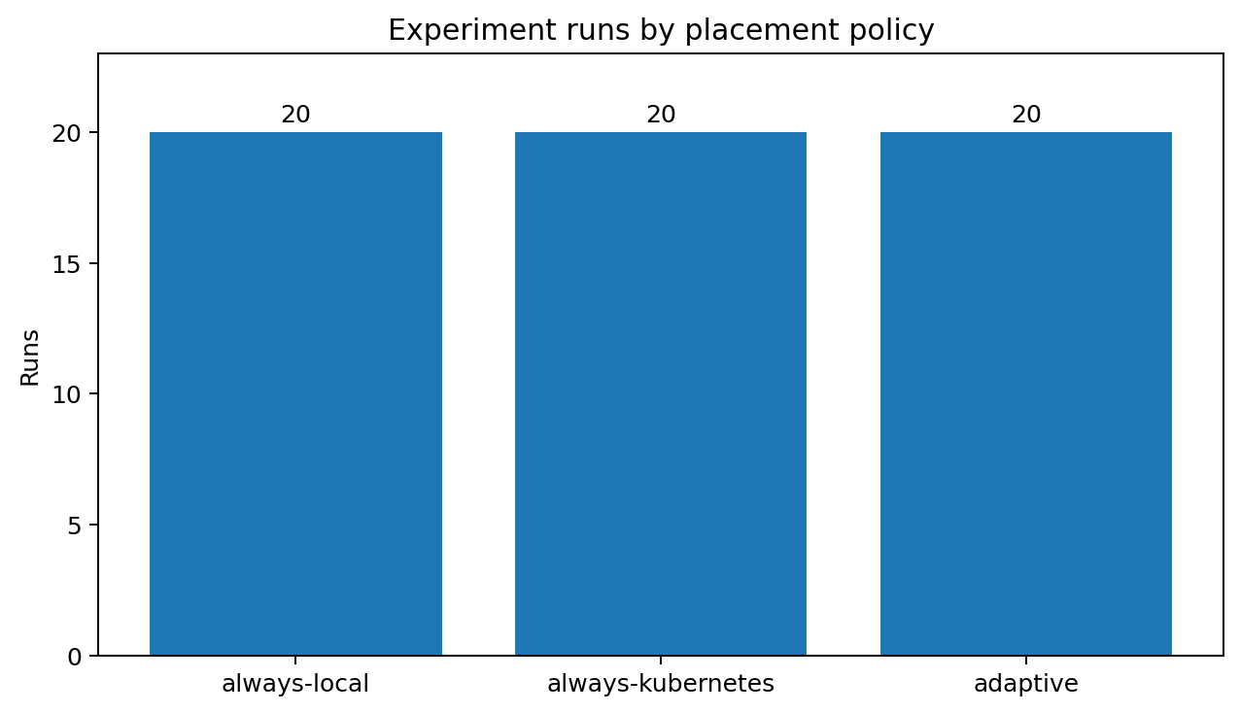
Figure 1. Experiment runs by placement policy.
Source: results/experiment_summary.csv

17. Experimental Results

Policy-level results
Policy | Runs | Passed | Failed | Mean ms | Median ms
always-local | 20 | 18 | 2 | 234.25 | 228.65
always-kubernetes | 20 | 18 | 2 | 239.72 | 235.50
adaptive | 20 | 20 | 0 | 233.41 | 229.82

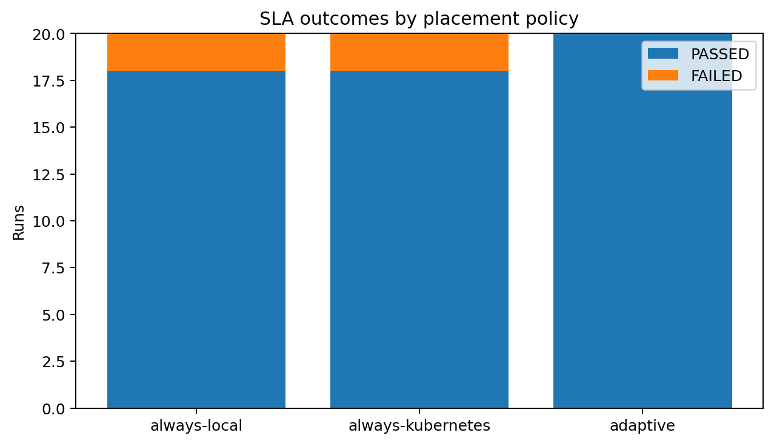
Figure 2. SLA outcomes by placement policy.
Source: results/experiment_summary.csv

Orchestration timing
The distribution includes kubectl deployment and pod queries for Kubernetes-aware runs. Consequently, end-to-end orchestration time is expected to be higher than the bounded workload's internal execution latency. The latter measures only the small checksum-producing workload inside the selected worker.
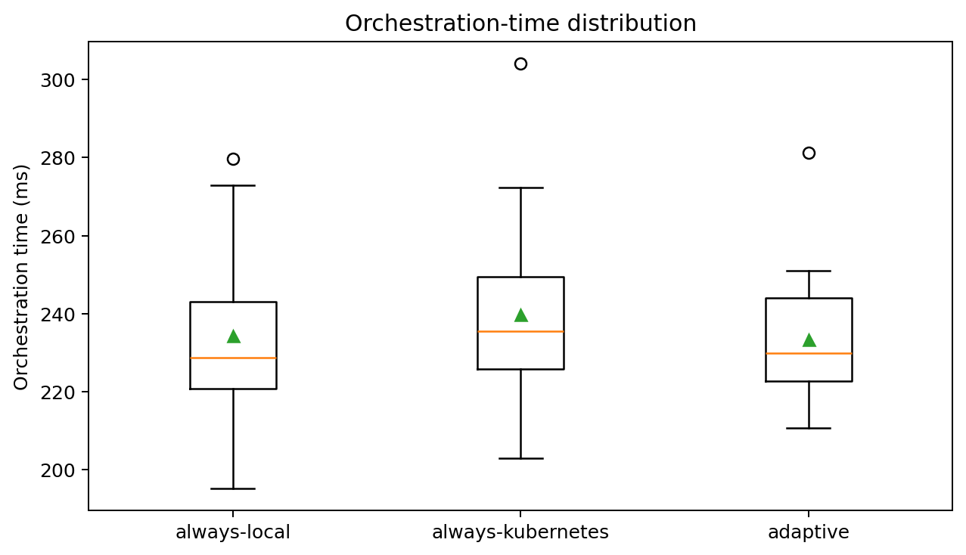
Figure 4. Orchestration-time distribution by policy.
Source: results/experiment_summary.csv

HTTP latency
HTTP measurements are real round trips to localhost endpoints. Kubernetes measurements traverse kubectl port-forwarding into the ClusterIP service and pod. They are not radio, WAN, or 6G latency measurements.
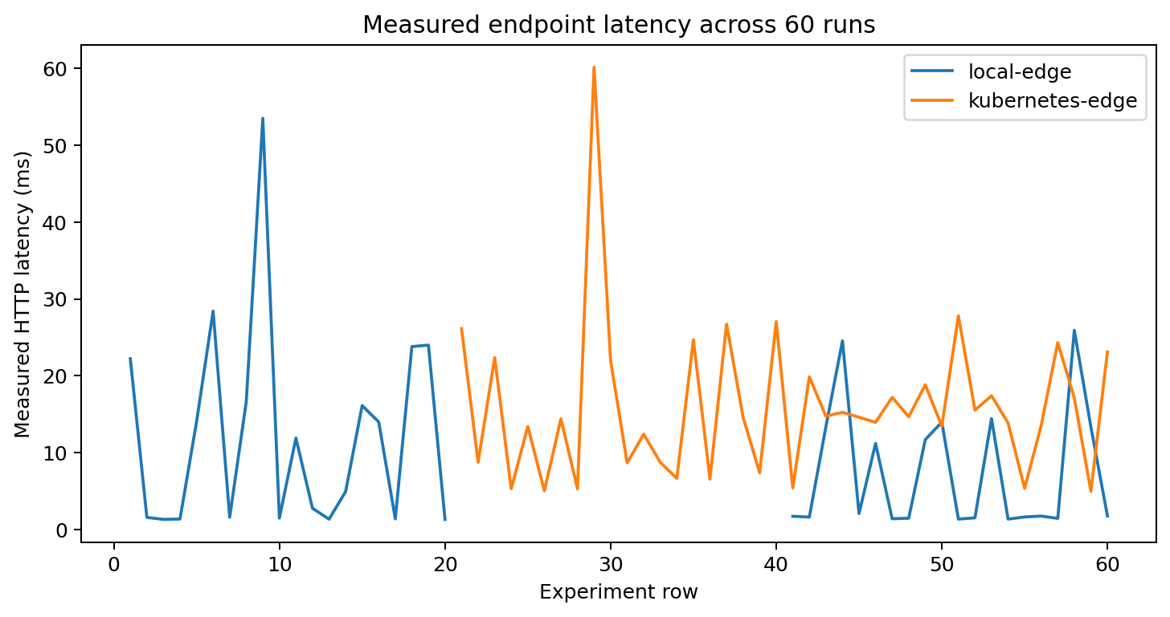
Figure 5. Measured endpoint latency across the 60-run experiment.
Source: results/experiment_summary.csv

Summary
- Total rows: 60.
- Passed: 56.
- Failed: 4.
- All 20 always-local rows executed with mode LOCAL.
- All 20 always-kubernetes rows executed with mode KUBERNETES.
- Adaptive selected LOCAL in 19 rows and KUBERNETES in 1 row.
- No successful real execution used an invalid zero timing.

18. Testing and Regression Coverage
Suite | Command | Passed | Failed | Skipped/deselected | Warnings
Baseline | pytest -ra | 32 | 1 | 1 | 13
Standard final | pytest -m not docker/kubernetes | 36 | 0 | 2 | 13
Docker | pytest -m docker | 1 | 0 | 37 | 13
Kubernetes | pytest -m kubernetes | 1 | 0 | 37 | 13

Coverage areas
- FastAPI health, readiness, profiles, telemetry, parser, orchestration, experiment and result endpoints.
- Profile parsing, numeric constraints, invalid values, and conflicting priorities.
- Eligibility rejection, deterministic scoring, no-eligible behavior, and SLA verification.
- All three bounded workloads and checksum production.
- Truthful Kubernetes runtime identity and metadata requirements.
- One-retry fallback success and non-fabrication failure.
- Real Docker and Kubernetes integration paths guarded by environment flags.
Warning interpretation: The 13 warnings are matplotlib/pyparsing deprecation warnings from installed dependencies; they are not test failures.

19. Security Assessment
Gitleaks 8.30.1 scanned both the single-commit Git history and the complete working tree with redaction enabled. Both scans completed with exit code 0 and zero findings.
Security control | Observed result
No arbitrary shell-execution API | PASS
Allowlisted workloads enforced | PASS
Parameter bounds enforced | PASS
Execution timeouts present | PASS
Path-safe evidence storage | PASS
No committed environment file | PASS
No public load balancer | PASS
No manifest credentials | PASS

Execution safety
- No client-controlled shell command endpoint exists.
- Subprocess usage is internal and invokes kubectl with a fixed executable, context, namespace, and bounded arguments.
- Workload names are allowlisted and parameters are validated before execution.
- HTTP and kubectl calls include timeouts.
- Evidence filenames are generated internally under the fixed results directory.

Deployment safety
- The Kubernetes service is ClusterIP, not LoadBalancer.
- No credentials or secrets are present in manifests.
- The .env file is ignored and only an empty .env.example is stored.
- Docker and Kubernetes operations were scoped to AION-6G resource names.

20. Threats, Limitations, and Readiness

Threats to validity
- Local, Docker, and kind runtimes share one Windows/Docker Desktop host and are not independent hardware systems.
- HTTP latency is a localhost or port-forward measurement and cannot be generalized to radio or WAN performance.
- Short bounded workloads demonstrate correctness rather than sustained throughput or overload behavior.
- The 60-run experiment is a functional validation dataset, not a large statistical benchmark.
- Scenario network metrics are emulated and should not be interpreted as packet-level observations.

Known limitations
- Kubernetes CPU/RAM percentages are unavailable because metrics-server is not installed.
- Jitter, packet loss, and bandwidth are emulated rather than radio/network measurements.
- Four of 60 experiment rows failed SLA checks and remain labelled as failures.
- This is an experimental Cloud-Edge testbed, not production telecom infrastructure.

Readiness rationale
The project is suitable for private technical review because the core runtime paths are reproducible, the execution contract is truthful, integration tests exist, evidence is machine-readable, and limitations are explicit. Public release still warrants a maintainer review of the dirty worktree, generated artifacts, dependency choices, four retained SLA failures, and whether metrics-server should be added.
Readiness: READY FOR PRIVATE REVIEW

21. Conclusion
The completed validation converts AION-6G from a local prototype with ambiguous fallback evidence into an evidence-backed Cloud-Edge orchestration testbed. Local, Docker, and Kubernetes workers now return explicit identities; Kubernetes success is tied to a real pod; unavailable targets remain failed; and emulated or controlled conditions retain their provenance.
The placement and fallback demonstrations prove both decision directions and the absence of fabricated recovery. The experiment runner produces 60 traceable rows with explicit execution modes and retains failures. The security scan found no secrets, and the repository contains no public Kubernetes exposure or arbitrary execution API.
The strongest next improvement is metrics-server integration or another verified Kubernetes resource measurement path. Beyond that, larger repeated experiments, independent hardware targets, network emulation tools, signed evidence, authentication, and multi-cluster policy evaluation would support deeper research claims.

Appendix A - Exact Commands
# Environment and baseline
python --version
git branch --show-current
git status --short --branch
py -3.11 -m pytest -ra --durations=10

# Docker
docker version
docker info
docker compose version
docker compose -p aion6g config
docker compose -p aion6g build
docker compose -p aion6g up -d --remove-orphans
docker compose -p aion6g ps
docker compose -p aion6g logs --no-color --tail 100
docker compose -p aion6g restart aion6g-local-worker

# kind and Kubernetes
kind create cluster --name aion-6g-cluster --image kindest/node:v1.36.1 --wait 180s
kind load docker-image aion6g-worker:validation --name aion-6g-cluster
kubectl --context kind-aion-6g-cluster create namespace aion-6g
kubectl --context kind-aion-6g-cluster apply -f deployments/kubernetes/
kubectl --context kind-aion-6g-cluster rollout status deployment/aion6g-worker -n aion-6g --timeout=180s
kubectl --context kind-aion-6g-cluster port-forward -n aion-6g service/aion6g-worker 8002:8001
kubectl --context kind-aion-6g-cluster top nodes
kubectl --context kind-aion-6g-cluster top pods -n aion-6g

# Evidence and tests
python scripts/run_full_validation.py
python scripts/generate_experiment_evidence.py
pytest -m "not docker and not kubernetes" -ra
$env:AION_RUN_DOCKER_TESTS='1'; pytest -m docker -ra
$env:AION_RUN_KUBERNETES_TESTS='1'; pytest -m kubernetes -ra

# Security
gitleaks git . --redact=100 --report-format json
gitleaks dir . --redact=100 --report-format json

Observed failed commands
- Default WindowsApps Python pytest command failed because pytest was not installed in that interpreter.
- kindest/node:v1.36.0 pull failed because the tag was unavailable; v1.36.1 was used successfully.
- Word COM PDF export timed out; LibreOffice headless was used for deterministic rendering.

Appendix B - Evidence Catalog
Capability | Status | Evidence | Limitation
local FastAPI | VERIFIED | results/docker_validation.json | None
local worker | VERIFIED | results/policy_always_local.json | None
Docker runtime | VERIFIED | results/docker_validation.json | None
kind cluster | VERIFIED | results/kubernetes_validation.json | None
Kubernetes worker | VERIFIED | results/kubernetes_validation.json | None
kubernetes-edge workload | VERIFIED | results/kubernetes_edge_success.json | None
always-local | VERIFIED | results/policy_always_local.json | None
always-kubernetes | VERIFIED | results/policy_always_kubernetes.json | None
adaptive | VERIFIED | results/policy_adaptive.json | None
adaptive local selection | VERIFIED | results/adaptive_selects_local.json | None
adaptive Kubernetes selection | VERIFIED | results/adaptive_selects_kubernetes.json | None
real fallback | VERIFIED | results/fallback_real_success.json | None
three profiles | VERIFIED | results/profile_critical_control.json | None
six scenarios | FUNCTIONAL | results/scenario_no_eligible_target.json | None
experiment runner | VERIFIED | results/experiment_summary.csv | None
CPU telemetry | PARTIAL | results/kubernetes_validation.json | metrics-server Metrics API unavailable
RAM telemetry | PARTIAL | results/kubernetes_validation.json | metrics-server Metrics API unavailable
HTTP latency | VERIFIED | results/experiment_summary.csv | None
jitter | EMULATED | results/scenario_kubernetes_high_latency.json | No packet-level measurement tool
packet loss | EMULATED | results/scenario_packet_loss_degradation.json | No packet-level measurement tool
bandwidth | EMULATED | results/scenario_baseline.json | No throughput measurement tool
security scan | VERIFIED | results/security_scan.json | None
Jarvis/OpenClaw isolation | VERIFIED | results/final_validation.json | Process-level non-modification established by scoped commands and command log

Primary named artifacts
- docker_validation.json and kubernetes_validation.json
- kubernetes_edge_success.json
- policy_always_local.json, policy_always_kubernetes.json, policy_adaptive.json
- adaptive_selects_local.json and adaptive_selects_kubernetes.json
- fallback_real_success.json and fallback_real_failure.json
- profile_critical_control.json, profile_immersive_xr.json, profile_massive_iot.json
- six scenario_*.json artifacts
- experiment_summary.csv, experiment_summary.json, experiment_statistics.json
- security_scan.json, historical_artifact_audit.json, final_validation.json

Appendix C - Experiment Sample
run_id | policy | profile | target | mode | SLA | orchestration ms
always-local-01 | always-local | critical-control | local-edge | LOCAL | FAILED | 242.142
always-local-02 | always-local | immersive-xr | local-edge | LOCAL | PASSED | 216.476
always-local-03 | always-local | massive-iot | local-edge | LOCAL | PASSED | 195.144
always-local-04 | always-local | critical-control | local-edge | LOCAL | PASSED | 218.478
always-local-05 | always-local | immersive-xr | local-edge | LOCAL | PASSED | 231.677
always-local-06 | always-local | massive-iot | local-edge | LOCAL | PASSED | 260.063
always-local-07 | always-local | critical-control | local-edge | LOCAL | PASSED | 212.065
always-local-08 | always-local | immersive-xr | local-edge | LOCAL | PASSED | 221.651
always-local-09 | always-local | massive-iot | local-edge | LOCAL | PASSED | 272.869
always-local-10 | always-local | critical-control | local-edge | LOCAL | PASSED | 215.679
always-local-11 | always-local | immersive-xr | local-edge | LOCAL | PASSED | 227.297
always-local-12 | always-local | massive-iot | local-edge | LOCAL | PASSED | 230.012
always-local-13 | always-local | critical-control | local-edge | LOCAL | PASSED | 246.151
always-local-14 | always-local | immersive-xr | local-edge | LOCAL | PASSED | 226.509
always-local-15 | always-local | massive-iot | local-edge | LOCAL | PASSED | 266.128

CSV schema
run_id, timestamp, policy, service_profile, scenario, selected_target, execution_mode, execution_success, sla_status, fallback_used, orchestration_time_ms, local_http_latency_ms, kubernetes_http_latency_ms, local_cpu_percent, kubernetes_cpu_percent, local_memory_percent, kubernetes_memory_percent, jitter_ms, packet_loss_percent, bandwidth_mbps, network_data_type, rejection_reasons

JSON integrity
The final audit parsed 191 JSON result files successfully and found zero invalid JSON files. The experiment CSV contained exactly 60 data rows with the expected headers.

Appendix D - Implementation Change Summary
Area | Key files | Change
Configuration | app/config.py, .env.example | Fixed AION cluster, context, namespace, deployment, container and endpoints
Telemetry | models/telemetry.py, telemetry/* | Metric sources, pod metadata, real endpoint probes, unavailable reasons
Execution | executor.py, worker_api.py | Remote HTTP execution and runtime identity
Orchestration | orchestrator.py | Explicit modes, metadata verification, controlled scenarios, one retry
Placement | placement.py | Conservative scoring for missing telemetry
Verification | verifier.py | Checksum and mandatory Kubernetes evidence
Docker | Dockerfile, docker-compose.yml | Two isolated prefixed services with health checks
Kubernetes | worker-deployment.yaml | Real image, probes, resources, downward API, ClusterIP
Experiments | app/experiments, scripts/* | 60-run runner, statistics, charts, validation generation
Tests | tests/unit, tests/integration | Truthfulness regressions and real marked integrations
Documentation | docs/* | Docker, Kubernetes, security, final and extended reports

Isolation statement
- No OpenClaw/Jarvis source or configuration file was read or modified.
- No Jarvis process, container, image, network, volume, namespace, or cluster was stopped or deleted.
- The unrelated jarvis-edge kind cluster remained active.
- No prune or broad deletion command was used.
- Only the conflicting legacy AION Uvicorn process was stopped.

