TECHNICAL AND FUNCTIONAL VERIFICATION REPORT
ThesisFlow
Node.js migration, assignment compliance and live validation
Validation date: 24 August 2026
Active stack: Node.js, Express, vanilla JavaScript, HTML, CSS and SQLite
Programming languages in the active solution: one - JavaScript

VALIDATION STATUS | PASS - 6/6 automated tests

OUTCOME

Executive summary
The application now runs from server.js on Node.js/Express. The Python/Flask and earlier Next.js code are preserved only in legacy folders and are not imported or required by the active application.
The original routes, three roles, database content and browser workflows were retained. Dynamic content continues to load through AJAX calls from small vanilla JavaScript modules.
Check | Result | Evidence
Syntax and module check | PASS | npm run check
Integration suite | PASS | 6/6 tests
Complete thesis lifecycle | PASS | HTTP API, isolated database
Database integrity | PASS | integrity=ok; 0 FK violations
Dependency audit | PASS | 0 npm vulnerabilities
Browser console | PASS | 0 errors or warnings

Why the technology requirement is covered
The assignment requires the core to use technologies taught in the course and lists PHP, JavaScript, Node.js and HTML. It does not require PHP and Node.js simultaneously. This solution selects Node.js and JavaScript, so no second server language is needed.

ASSIGNMENT MAPPING

Technology compliance
Requirement | Implementation | Status
Course technology | Node.js + JavaScript + HTML | Covered
Minimal languages | JavaScript only | Covered
AJAX data loading | fetch() to JSON APIs | Covered
No PHP-generated JS | No PHP in active source | Covered
Database indexes | 19 custom indexes; key indexes tested | Covered
Responsive student UI | 900px/620px breakpoints; 390x844 tested | Covered
Cache TTL | 60s feed; 3600s assets; 300s uploads | Covered

Database snapshot
Metric | Current value
Users | 34
Students | 19
Professors | 10
Theses | 11
Lifecycle states represented | 5 of 5
Foreign-key violations | 0

Verification command: npm run db:verify

FUNCTIONAL COVERAGE

Role workflows retained
Role | Verified capabilities
Student | Profile, committee invitations, draft PDF, support links, presentation, grades, examination record and final repository link.
Professor | Topic management, assignment, committee responses, filters, notes, cancellation, examination, grading, statistics and exports.
Secretariat | Thesis status management, GS minutes, cancellation, completion, presentation editing and data imports.
Public | Presentation announcements in JSON and XML with date filters and explicit cache TTL.

End-to-end test path
The automated integration test creates a topic, assigns it to a free student, sends two committee invitations, accepts both, activates the thesis, records a presentation, moves the thesis under examination, opens grading, stores three criterion-based grades, records the repository URL and completes the thesis through the secretariat API.

Security controls
Passwords are verified with bcrypt. Sessions use HTTP-only SameSite cookies. Pages and APIs enforce role checks. Every state-changing API call requires a CSRF token. Security headers include CSP, frame denial, content-type protection and a strict referrer policy.

LIVE BROWSER EVIDENCE

Authentication and secretariat dashboard
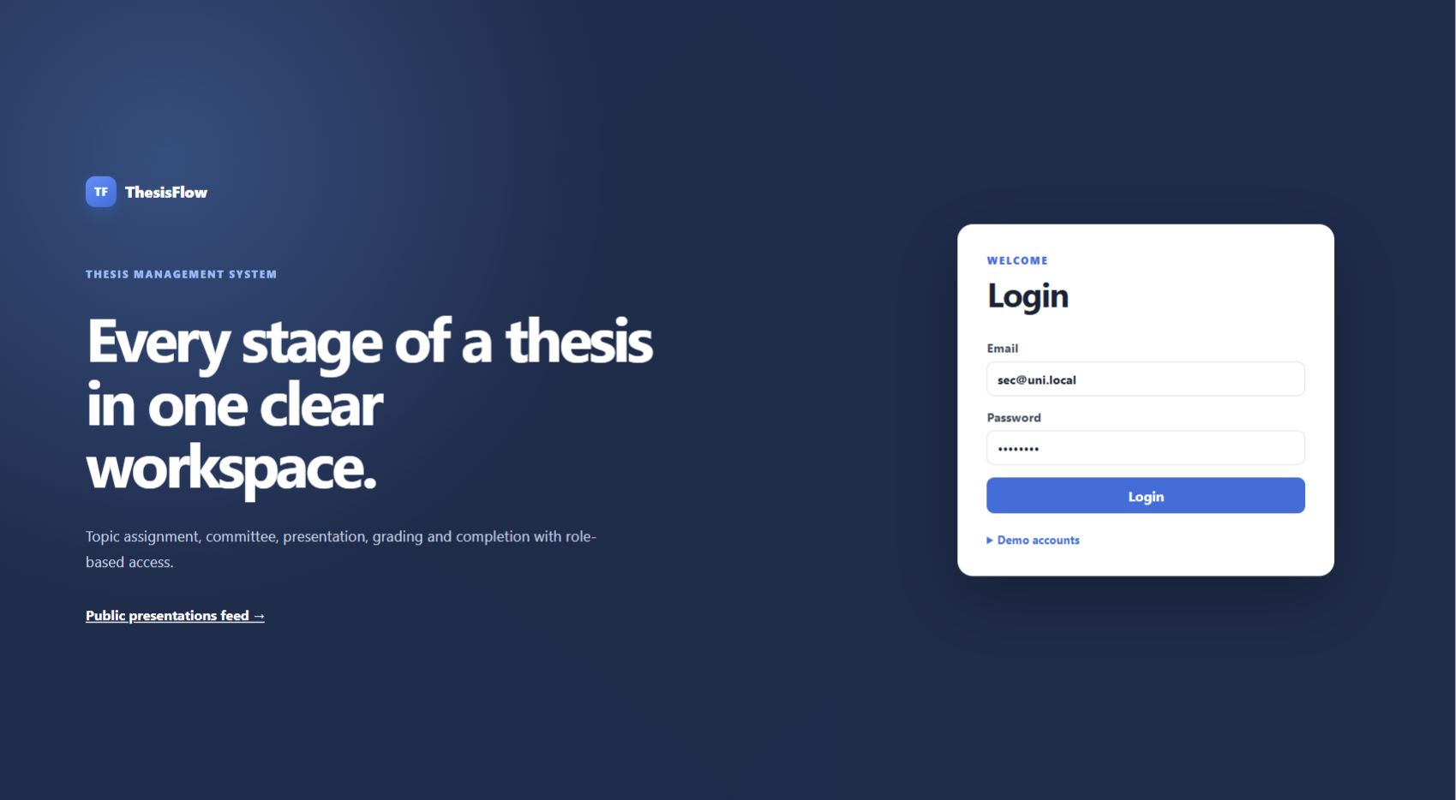
Figure 1. Node.js login page rendered in the live browser.
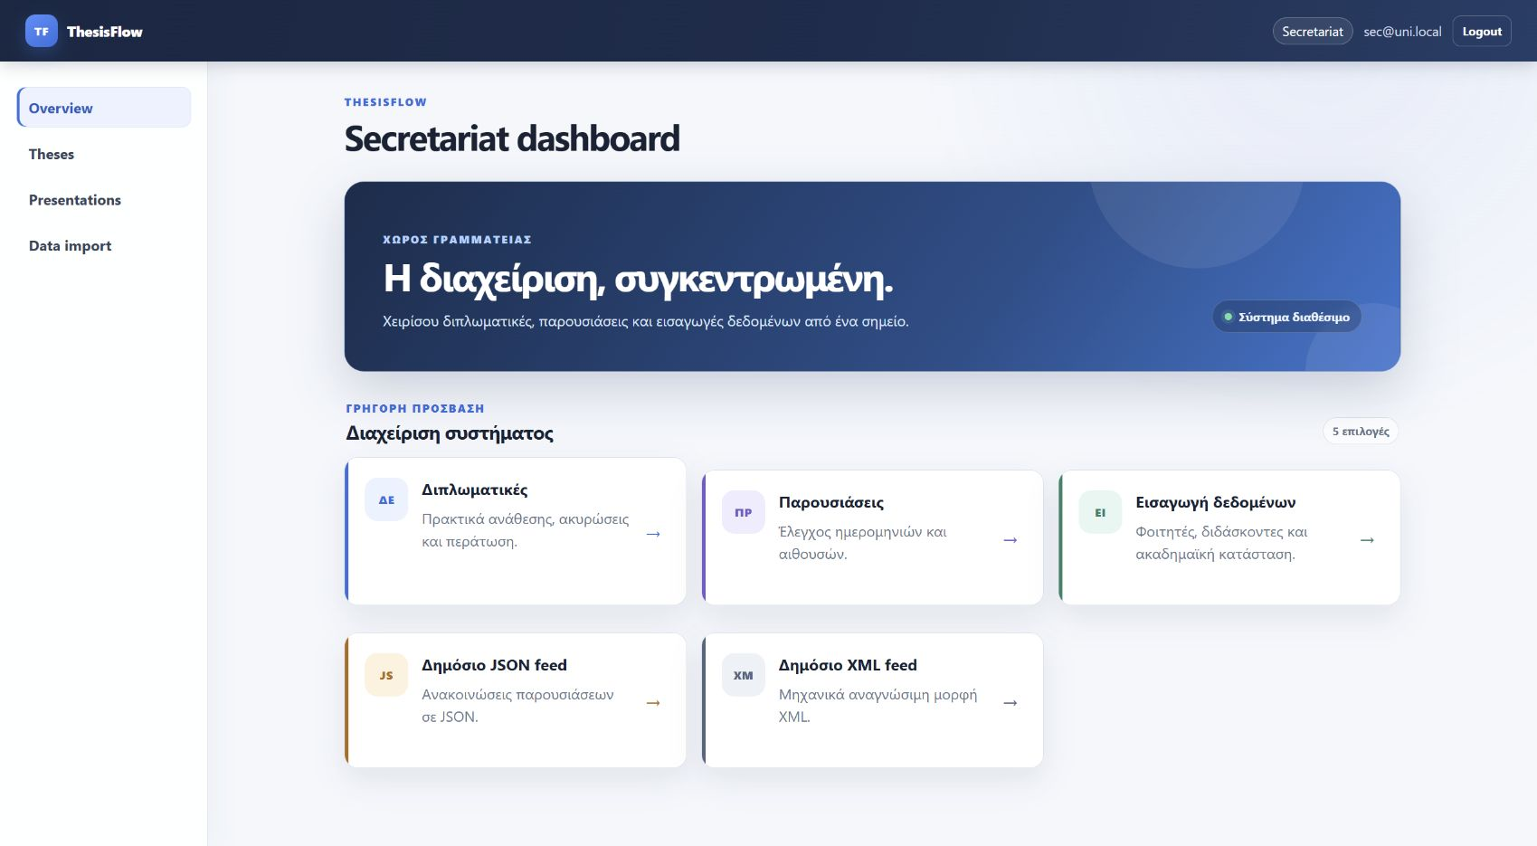
Figure 2. Secretariat dashboard after a successful live login.

LIVE BROWSER EVIDENCE

Thesis management
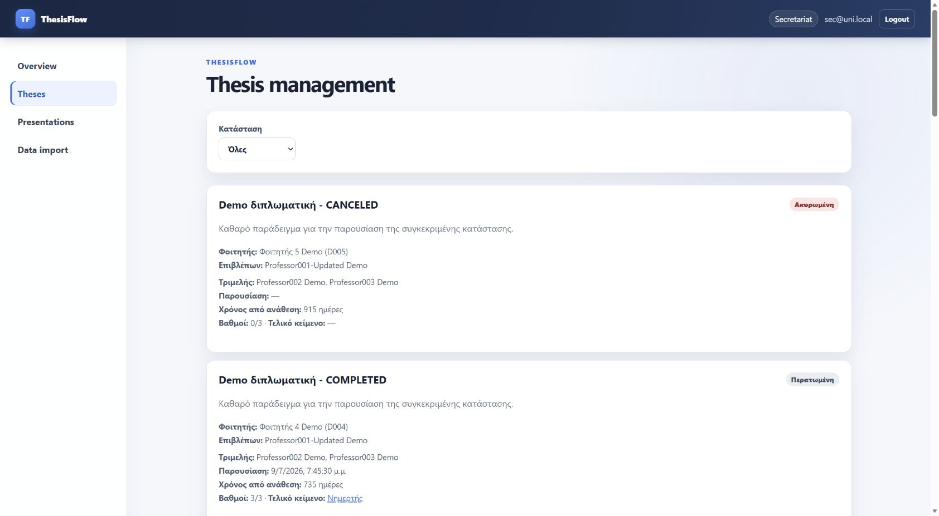
Figure 3. Thesis management data loaded from the Node.js API.
The page displayed all seeded lifecycle states and their context-sensitive actions. The browser console reported no errors or warnings.

RESPONSIVE VERIFICATION

Mobile view at 390 x 844
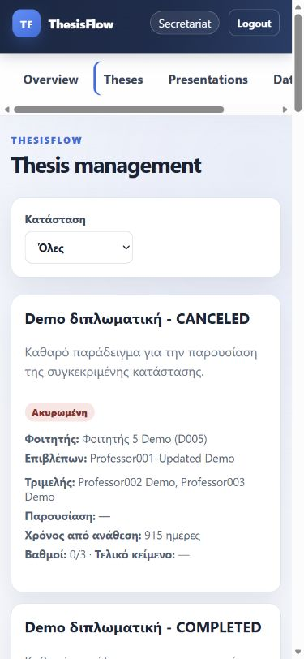
Figure 4. Final mobile layout after correcting the navigation row.
Responsive metric | Measured value
Viewport client width | 375 px
Document scroll width | 375 px
Document-level horizontal overflow | None
Final mobile navigation height | 81 px

LIVE BROWSER EVIDENCE

Professor and student dashboards
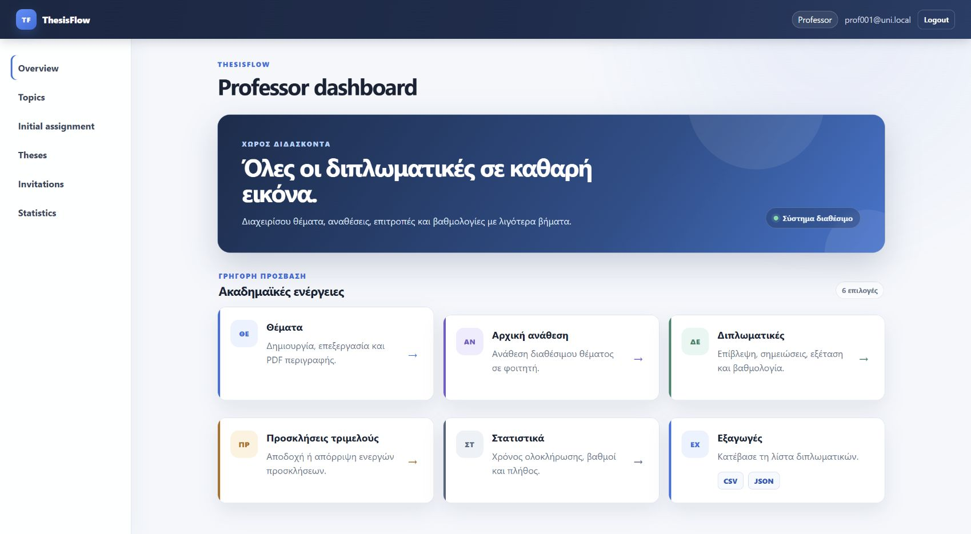
Figure 5. Professor dashboard - six role-specific actions.
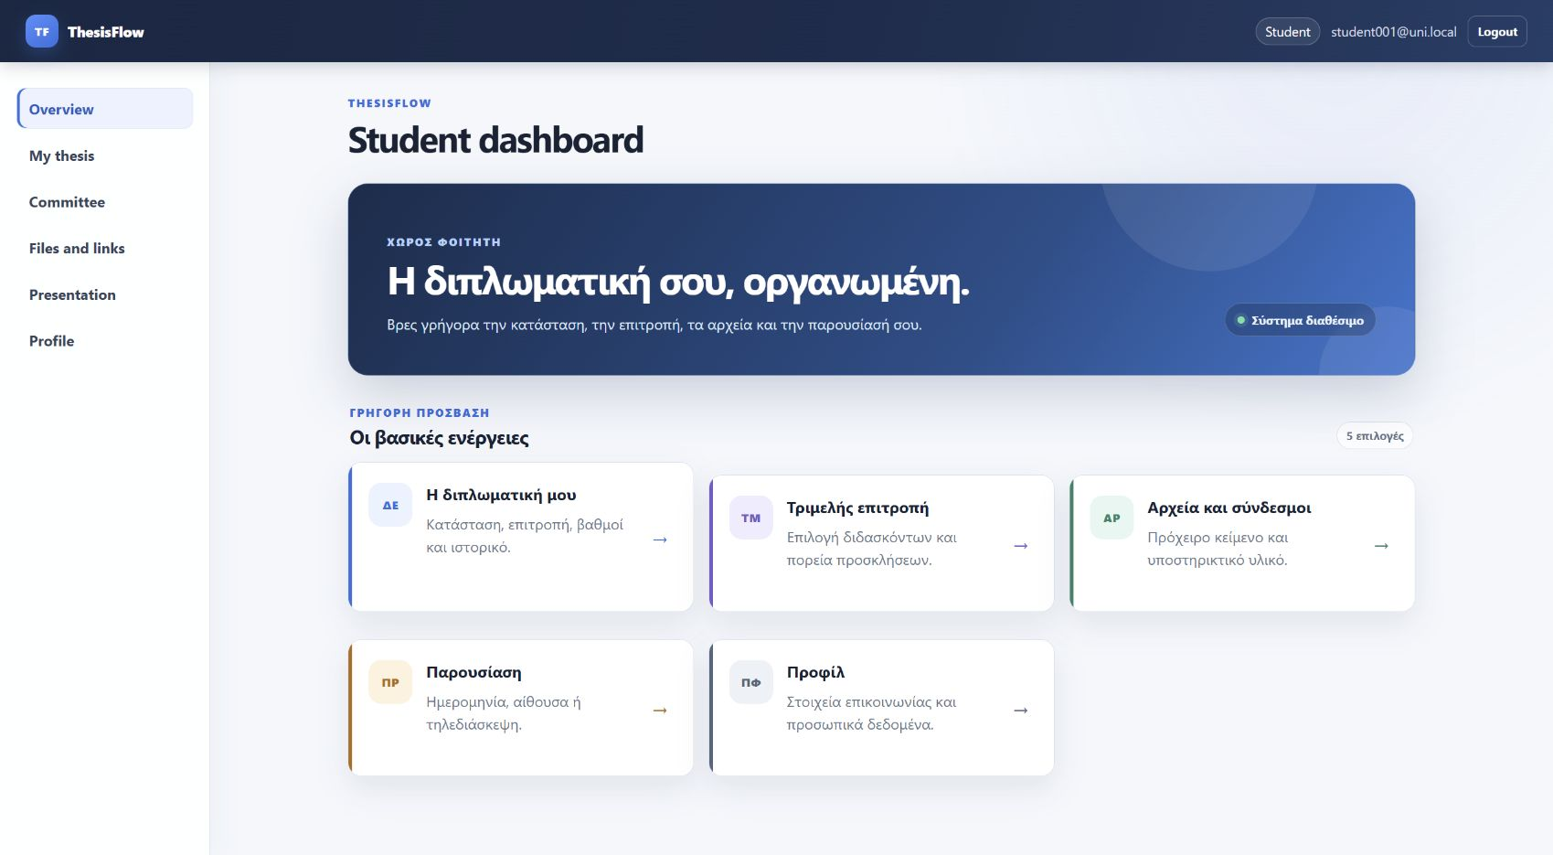
Figure 6. Student dashboard - five role-specific actions.

PRESENTATION HANDOFF

How to run and demonstrate
Step | Command or action
1 | npm install
2 | npm start
3 | Open http://127.0.0.1:5000
4 | Use the demo accounts shown on the login page
5 | Run npm test and npm run db:verify for evidence

Submission cleanup
Keep package.json, package-lock.json, server.js, node_app, web, tests_node, prisma, uploads and the documentation. Exclude node_modules, .venv, caches, legacy_python and legacy_nextjs from the final archive. Dependencies can be recreated with npm install.

Conclusion
The active project now covers the assignment's technical and functional requirements with a deliberately simple architecture: one programming language, a small Node.js server and a vanilla AJAX front end. The final automated and live checks passed.

