CSS (Cascading Style Sheets) allows you to create great looking web pages, but how does it work under the hood? This article explains what CSS is, how the browser turns HTML into a Document Object Model (DOM), how CSS is applied to parts of the DOM, some very basic syntax examples, and what code is used to actually include our CSS in our web page.

As we have mentioned before, CSS is a language for specifying how documents are presented to users — how they are styled, laid out, etc.
A document is usually a text file structured using a markup language — HTML is the most common markup language, but you will also come across other markup languages such as SVGor XML.
Presenting a document to a user means converting it into a usable form for your audience.Browsers, like Firefox, Chrome or Internet Explorer, are designed to present documents visually, for example, on a computer screen, projector or printer.

Web browsers apply CSS rules to a document to affect how they are displayed. A CSS rule is formed from:
- A set of properties, which have values set to update how the HTML content is displayed, for example I want my element's width to be 50% of its parent element, and its background to be red.
- A selector, which selects the element(s) you want to apply the updated property values to. For example, I want to apply my CSS rule to all the paragraphs in my HTML document.
A set of CSS rules contained within a stylesheet determines how a webpage should look. You will learn a lot more about what CSS syntax looks like in the next article of the module — CSS Syntax.

A quick CSS example
The above descriptions may or may not have made sense, so let's make sure things are clear by presenting a quick example. First of all, let's take a simple HTML document, containing an <h1>and a <p> (notice that a stylesheet is applied to the HTML using a <link> element):

How does CSS actually work?
EDIT
When a browser displays a document, it must combine the document's content with its style information. It processes the document in two stages:
- The browser converts HTML and CSS into the DOM (Document Object Model). The DOM represents the document in the computer's memory. It combines the document's content with its style.
- The browser displays the contents of the DOM.
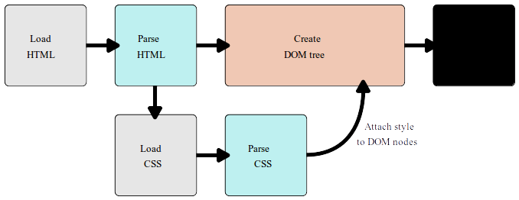

A DOM has a tree-like structure. Each element, attribute and piece of text in the markup language becomes a node/dom in the tree structure. The nodes are defined by their relationship to other DOM nodes. Some elements are parents of child nodes, and child nodes have siblings.
Understanding the DOM helps you design, debug and maintain your CSS because the DOM is where your CSS and the document's content meet up.

DOM representation
Rather than a long, boring explanation, let's take an example to see how the DOM and CSS work together.
P
├─ "Let's use:"
├─ SPAN
| └─ "Cascading"
├─ SPAN
| └─ "Style"
└─ SPAN
└─ "Sheets"

How to apply your CSS to your HTML

There are three different ways to apply CSS to an HTML document that you'll commonly come across, some more useful than others. Here we'll briefly review each one.

External stylesheet
You've already seen external stylesheets in this article, but not by that name. An external stylesheet is when you have your CSS written in a separate file with a .css extension, and you reference it from an HTML <link> element. The HTML file looks something like this:

<!DOCTYPE html>
<html>
<head>
<meta charset="utf-8">
<title>My CSS experiment</title>
<link rel="stylesheet" href="style.css">
</head>
<body>
<h1>Hello World!</h1>
<p>This is my first CSS example</p>
</body>
</html>

This method is arguably the best, as you can use one stylesheet to style multiple documents, and would only need to update the CSS in one place if changes were needed.

Internal stylesheet
An internal stylesheet is where you don't have an external CSS file, but instead place your CSS inside a <style> element, contained inside the HTML head. So the HTML would look like this:
<!DOCTYPE html>
<html>
<head>
<meta charset="utf-8">
<title>My CSS experiment</title>
<style>
h1 {
color: blue;
background-color: yellow;
border: 1px solid black;
}

p {
color: red;
}
</style>
</head>
<body>
<h1>Hello World!</h1>
<p>This is my first CSS example</p>
</body>
</html>
This can be useful in some circumstances (maybe you're working with a content management system where you can't modify the CSS files directly), but it isn't quite as efficient as external stylesheets — in a website, the CSS would need to be repeated across every page, and updated in multiple places if changes were required.

Inline styles
Inline styles are CSS declarations that affect one element only, contained within a styleattribute:
<!DOCTYPE html>
<html>
<head>
<meta charset="utf-8">
<title>My CSS experiment</title>
</head>
<body>
<h1 style="color: blue;background-color: yellow;border: 1px solid black;">Hello World!</h1>
<p style="color:red;">This is my first CSS example</p>
</body>
</html>
Please don't do this, unless you really have to! It is really bad for maintenance (you might have to update the same information multiple times per document), and it also mixes your presentational CSS information with your HTML structural information, making the CSS harder to read and understand. Keeping your different types of code separated and pure makes for a much easier job for all who work on the code.

