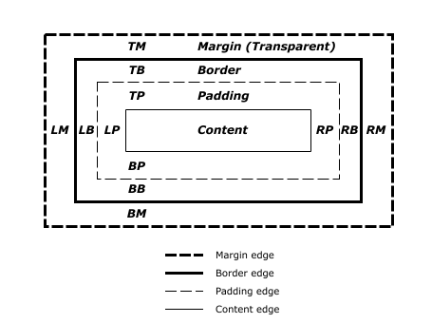

Each HTML element gets its own box to live in.
Display

block: This makes the element a block box. It won't let anything sit next to it on the page! It takes up the full width.
inline-block: This makes the element a block box, but will allow other elements to sit next to it on the same line.
inline: This makes the element sit on the same line as another element, but without formatting it like a block. It only takes up as much width as it needs (not the whole line).
none: This makes the element and its content disappear from the page entirely!
As mentioned, any element that comes in as a block (say, a paragraph) will automatically take up the full width of the page, no matter how much or how little content you put in.

The inline value places all your elements next to one another, but not as blocks: they don't keep their dimensions.

The margin is the space around the element. The larger the margin, the more space between our element and the elements around it. We can adjust the margin to move our HTML elements closer to or farther from each other.
The border is the edge of the element. It's what we've been making visible every time we set the border property.
The padding is the spacing between the content and the border. We can adjust this value with CSS to move the border closer to or farther from the content.
The content is the actual "stuff" in the box. If we're talking about a <p> element, the "stuff" is the text of the paragraph.

Margin:

if we take an HTML element with a specific width (such as our <div> in the editor) and set its margin to auto, this tells the document to automatically put equal left and right margins on our element, centering it on the page.

margin: 1px 2px 3px 4px;

margin-top: /*some value*/
margin-right: /*some value*/
margin-bottom: /*some value*/
margin-left: /*some-value*/

Let's adjust the padding. Remember, the padding is the space between your border and your innermost layer: the actual content.

padding: value value value value;
Did you see that? Your <div> got huge! That's because the background color is the same for the content and the padding.

When you give CSS a positive padding or margin value, it puts that space between the element and its reference: for instance, if you have a <div> and you give it a margin-left of20px, it puts twenty pixels between the left margin of that <div> and the side of the screen. This effectively moves the <div>twenty pixels to the right.
If you want to move an element in the other direction, you can give CSS a negative value:margin-left: -20px will move the element twenty pixels to the left.
Float:
One way is to use floats. When you float an element on the page, you're telling the webpage: "I'm about to tell you where to put this element, but you have to put it into theflow of other elements." This means that if you have several elements all floating, they all know the others are there and don't land on top of each other.
You can think of the HTML page as sort of like a sea, and floating elements as boats on it: all the boats have positions on the sea, and they all see and steer clear of each other.

See your footer (the blue bit between the two columns)? It's stuck back there because we haven't told it something very important: toclear the other elements on the page!
If you tell an element to clear: left, it will immediately move below any floating elements on the left side of the page; it can also clear elements on the right. If you tell it to clear: both, it will get out of the way of elements floating on the left and right!

If you don't specify an element's positioning type, it defaults to static. This just means "where the element would normally go." If you don't tell an element how to position itself, it just plunks itself down in the document.

The first type of positioning is absolutepositioning. When an element is set toposition: absolute, it's then positioned in relation to the first parent element it has thatdoesn't have position: static. If there's no such element, the element with position: absolute gets positioned relative to <html>.
To show you how this works, we've set the#outer div to have absolute positioning. This means that when you position the #inner div, it will be relative to #outer. (If #outer had the default positioning of static, then #innerwould get positioned relative to the entire HTML document.)

Good! Did you notice how the #inner div moved 20 pixels in from the edge of the#outer div? That's absolute positioning at work.
Relative positioning is more straightforward: it tells the element to move relative to where it would have landed if it just had the defaultstatic positioning.
If you give an element relative positioning and tell it to have a margin-top of 10px, it doesn't move down ten pixels from any particular thing—it moves down ten pixels from where itotherwise would have been.

Finally, fixed positioning anchors an element to the browser window—you can think of it as gluing the element to the screen. If you scroll up and down, the fixed element stays put even as other elements scroll past.

The CSS box model
- Display values, including block, inline-block, inline, and none
- Margins, borders, and padding
- Positioning elements with float
- Giving elements absolute, relative, and fixed positioning

