Documentation for the simulation environment in MATLAB

Author: Dion Lavaleije

Date: 16/06/2025

Table of Contents

**No table of contents entries found.**

# Theory:

Consider a Beam and Shaker Structure:

Mechanical governing equation:

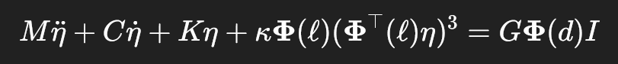

Electrical governing equation (shaker dynamics):

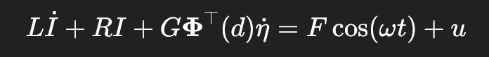

Symbol Definitions:

|  |  |
| --- | --- |
| M: Mass Matrix | I: the mode normalization makes the beam have Identity mass  m: the mass of the shaker applied at x=d (shaker inertia) |
| C: Damping Matrix | : structural damping matrix  c: shaker damping |
| K: Stiffness Matrix | : structural stiffness  k: shaker stiffness |
| $ϕ$: Mode shape vector | Each ϕ1(x) is a scalar function describing the **deflection profile** of the beam when vibrating in mode 1. |
| $η$: Modal Coordinate |  |
| L: shaker coil inductance |  |
| R: shaker coil resistance |  |
| G: Back emf coeff |  |
| F: Forcing Amplitude |  |
| u: control input |  |

# Equations of Motion:



$$\ddot{η}=M^{-1}\left(----\right)$$

# Control Law:

