Licence girl character

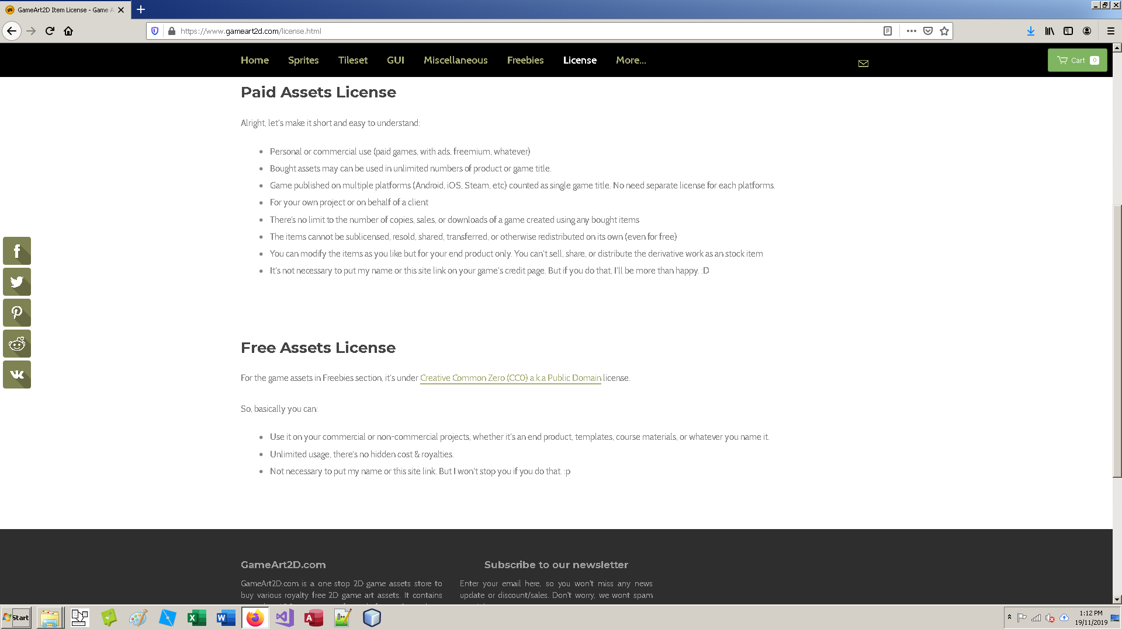

<https://www.gameart2d.com/license.html>