Moustapha Dioume
November 10, 2026
Assignment: My SQL Install

MySQL Installation and SQL Functions

1. Initial MySQL Connection
I installed MySQL Server 8.0.46, connected to the local server as root using MySQL Shell, and switched to SQL mode. The screenshot shows the successful connection and SQL prompt.
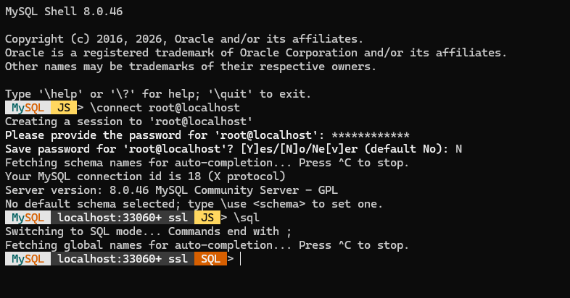

2. Creating the Movies Database
I created a database named movies and checked the available databases to verify that it was created successfully.
CREATE DATABASE movies;
SHOW DATABASES;
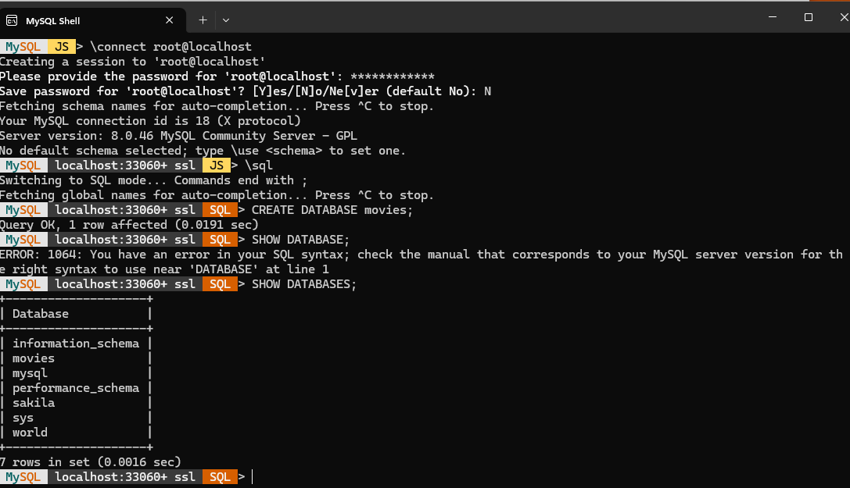

3. SQL Functions

UPPER()
UPPER() converts text to uppercase. I could use it to display course names or categories consistently. The alias Course_Name clearly identifies the result.
SQL statement: SELECT UPPER('database development') AS Course_Name;
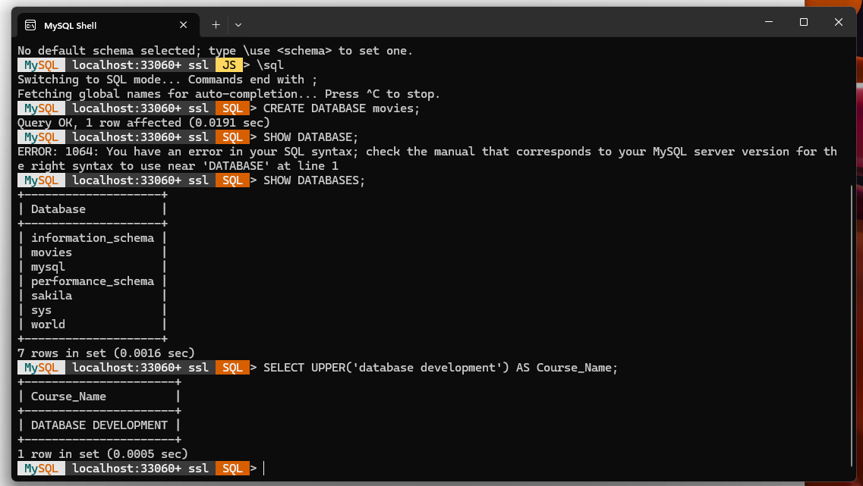

ROUND()
ROUND() rounds a number to a chosen number of decimal places. I used it to show a vehicle price with two decimal places. The alias Vehicle_Price describes the output.
SQL statement: SELECT ROUND(15789.678, 2) AS Vehicle_Price;
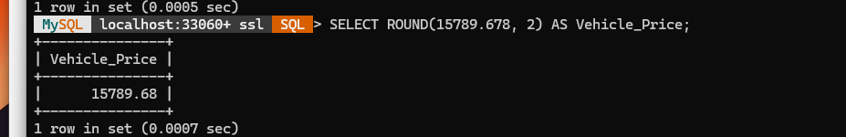

CONCAT()
CONCAT() joins text values into one string. I used it to combine a first name, a space, and a last name. The alias Full_Name makes the result easy to read.
SQL statement: SELECT CONCAT('Moustapha', ' ', 'Dioume') AS Full_Name;
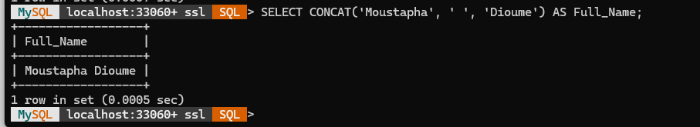

References
https://www.w3schools.com/sql/func_mysql_upper.asp
https://www.w3schools.com/sql/func_mysql_round.asp
https://www.w3schools.com/sql/func_mysql_concat.asp

