



**About this course TM065**



**IBM Monitoring 8.1.1 Implementation and Administration**

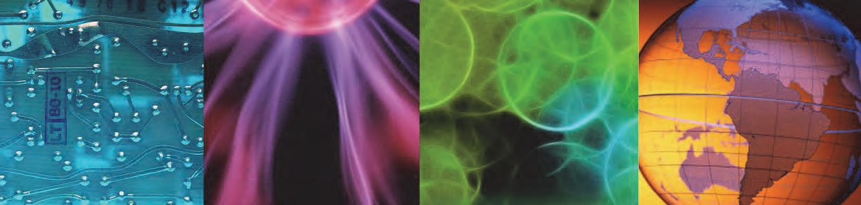

© Copyright IBM Corporation 2015

Course materials may not be reproduced in whole or in part without the prior written permission of IBM.

IBM Monitoring v8.1.1 monitors the performance and availability of computer operating systems and applications. In this 2-day classroom course, you learn about the IBM Monitoring architecture and how to install and configure the product. You learn how to navigate the Performance Management console. You also learn how to manage events and manage user authorities, and how to integrate with other products including with Netcool/OMNIbus, IBM Tivoli Monitoring, and IBM Operations Analytics Log Analysis. This course is designed for users, administrators, and implementers. It is intended to help new users of IBM Monitoring v8.1.1 to use the tools to effectively manage their enterprise monitoring.

The course duration is 2 days. There are six units.

1. Introduction to IBM Monitoring
2. Installation
3. Administer and use IBM Performance Management
4. Managing events and thresholds
5. Integration and advanced configuration
6. Reporting and 7-day comparison

The lab environment for this course uses several platforms:

* SUSE Linux 11
* Red Hat Enterprise Linux 6.6
* Windows Server 2008 R2

For information about other related courses, visit the Cloud & Smarter Infrastructure education training paths website:

ibm.com/software/software/tivoli/education/

**Details**

**Delivery method** Classroom or instructor-led online (ILO)

**Course level** ERC 1.0

This course is a new course.

**Product and version** IBM Monitoring v8.1.1

**Duration** 2 days

**Skill level** Intermediate

# About the student

This course is designed for users, administrators, and implementers. Before taking this course, make sure that you have the following skills:

* The ability to navigate Linux and Windows applications
* A working knowledge of an Internet browser

# Learning objectives



**Objectives**

## In this course, you learn to perform the following tasks:

* Describe the IBM Monitoring architecture.
* Install and configure IBM Monitoring.
* Administer, use, and navigate the Performance Management Console to monitor and manage a monitoring solution that is built with IBM Monitoring.
* Manage events effectively by using facilities that are provided with IBM Monitoring.
* Integrate IBM Monitoring with other products.
* Run reports and a 7-day comparison.

© Copyright IBM Corporation 2015 **2**

*Course agenda*



# Course agenda

The course contains the following units:

1. Introduction to IBM Monitoring

This unit starts with an overview and introduction to IBM Monitoring with a description of the architecture. The agents that are available with IBM Monitoring are explained. The products that IBM Monitoring integrates with are presented.

In these exercises, you verify the lab environment.

1. Installation

This unit covers installation of the Performance Management server and monitoring agents on both the Windows and Linux environments. You learn about packaging, prerequisites, and the step-by-step instructions on how to install the Performance Management server. You also learn how to install and configure monitoring agents.

The exercises guide you through the installation of the Performance Management server and several monitoring agents on both Linux and Windows environments.

1. Administer and use IBM Performance Management

This unit teaches how to manage the components of the Performance Management Server, and also teaches how to use and administer the Performance Management console.

In these exercises, you validate the installation of the Performance Management Server and the Monitoring agents. You create applications that are composed of the data from the monitoring agents. You create new users and assign capabilities to those users. You also explore the Attribute details of various agents and save customized charts with other users.

1. Managing events and thresholds

This unit covers how to create, update, and delete thresholds, which in turn create events. You explore the Threshold Manager, where you create and modify thresholds that in turn create events if the thresholds defined are met. You also learn how to use the resource group manager. The resource group manager determines which agents running on specific servers evaluate the thresholds that are defined.

In these exercises, you learn the relationship between thresholds and events. You create thresholds that test for simple and multiple conditions. You create thresholds that run commands to solve the issue it detected. You adjust resource groups and learn the impact of these adjustments on thresholds and events.

1. Integration and advanced configuration

The Integration and advanced configuration describes how to integrate the products IBM Tivoli Monitoring, Netcool/OMNIbus, IBM Operations Analytics Log Analysis, and Dashboard Application Services Hub. This unit also describes event notification that uses email and other advanced configuration settings.

*Course agenda*

By using agents and advanced configuration, you integrate IBM Monitoring with other products. Advanced configuration is also used for more settings.

In these exercises, you integrate IBM Monitoring with IBM Tivoli Monitoring, IBM Netcool/OMNIbus, and IBM Operations Analytics Log Analysis. You also configure email notification and examine other advanced configuration options.

1. Reporting and 7-day comparison

In this unit, you display the historical 7-day comparison and learn how to install and run reports.

In IBM Monitoring, certain widgets that display information are compared against the same time frames from other days. That is the purpose of Historical 7-Day Comparison.

In these exercises, the objective is to learn how to use the Historical 7-Day Comparison. You make setting changes and examine the results that occur in the widgets.