**Name: - Harsh Gupta**

**Roll No: - 2213571- A**

**Problem Statement- PL/SQL: Implicit and Explicit Cursors and Triggers.**

1. **Write a Trigger for purchase table where total will be calculated when value is inserted in the table.**

**B. 1. Use the table with Product_id , Product_name , Brand_id, Category_id, model_year, list_price**

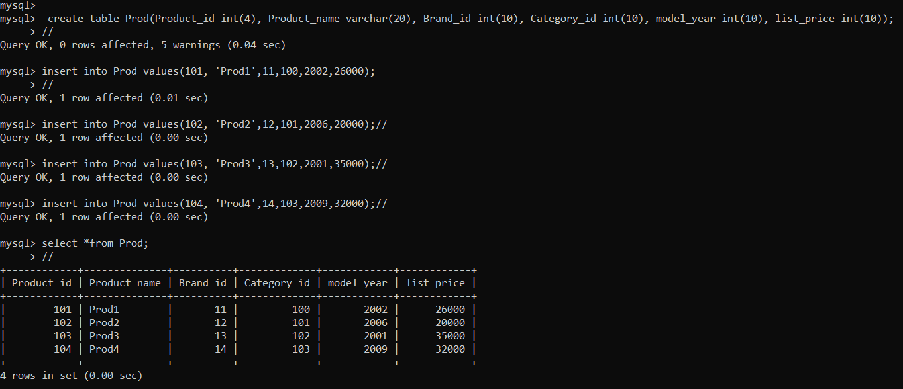

**2. Declare two variables to hold product name and list price, and a cursor to hold the result of a query that retrieves product name and list price from the table.**

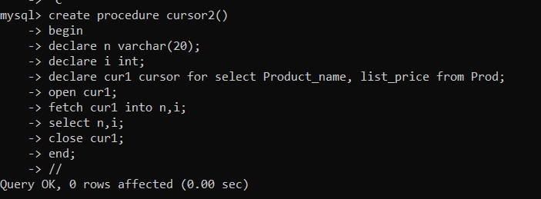

**3. Fetch each row from the cursor and print out the product name and list price.**

