**MIT School of Engineering**

**Department of Computer Science and Engineering**

**Project Synopsis**

**Group ID:7**

**Project Title: College doot (LMS)**

**Group Members:**

|  |  |  |  |  |
| --- | --- | --- | --- | --- |
| **Enrollment Number** | **Roll No.** | **Name of student** | **Email Id** | **Contact Number** |
| **MITU21BTCS0001** | **2213535** | **Diptish Gohane** | **Diptishgohane04@gmail.com** | **8261950281** |
| **MITU21BTCS0051** | **2213537** | **Adrija Santra** | **adrijasantra14@gmail.com** | **9444054143** |
| **MITU21BTCS0191** | **2213575** | **Pradhyum Dhondi** | **pradhyumdhondi@gmail.com** | **9966701124** |
| **MITU21BTCS0222** | **2213571** | **Harsh Gupta** | **harshgupta2502@gmail.com** | **7379373882** |

**Problem Statement:**

In today's educational landscape, effective management and organization play a crucial role in delivering quality learning experiences. However, traditional methods of administering quizzes, setting Courses, and distributing study materials can often be time- consuming, inefﬁcient, and prone to errors. To address these challenges, there is a growing need for a comprehensive software solution that streamlines educational management tasks, ensuring smooth communication and enhanced productivity for both administrators and students.

**Abstract:**

"College Doot" is a pioneering software solution meticulously engineered to revolutionize the landscape of educational management within colleges and institutions. In today's dynamic educational environment, efficient and streamlined administrative processes have become the bedrock of success. "College Doot" addresses this imperative by offering a comprehensive toolkit for administrators while providing students with a centralized platform for academic engagement.

For administrators, "College Doot" offers a powerful toolset that simplifies the management of quizzes, courses, and study materials. The user-friendly interface empowers administrators to effortlessly create and manage quizzes, add courses, and upload study materials. By automating these processes, "College Doot" empowers educational institutions to save valuable time, reduce errors, and create an exceptionally efficient educational environment.

For students, "College Doot" becomes a central hub for academic engagement. It provides students with the convenience of accessing quizzes, enrolling in courses, and effortlessly retrieving study materials. This not only enhances the student experience but also contributes to a more efficient and organized learning environment.

In an era where educational institutions must adapt to digital transformation, "College Doot" stands as a beacon, offering innovative solutions that enhance educational management and overall efficiency.

**Literature Survey: Detail survey done**

.

**Proposed System (Block Diagram):**

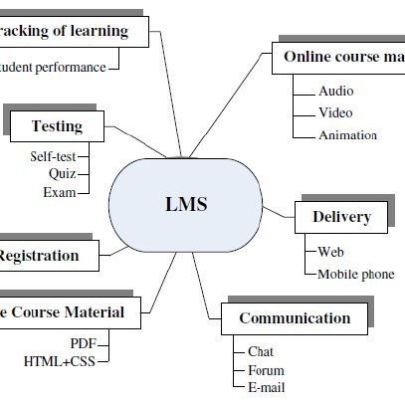

**Conclusion:**

In an era where educational institutions are transitioning into the digital realm, College Doot emerges as a transformative solution designed to streamline educational management within colleges and institutions. With a comprehensive array of tools and features, this platform caters to the diverse needs of both administrators and students.

For administrators, College Doot offers a powerful toolset that simplifies the management of quizzes, courses, and study materials. The intuitive user interface empowers administrators to seamlessly add quizzes, courses, and upload study materials, automating these processes to save valuable time and reduce errors. This automation results in a more efficient educational environment, allowing administrators to focus on improving the overall quality of education.

On the student front, College Doot serves as a centralized hub for academic engagement. Students benefit from the convenience of accessing quizzes, enrolling in courses, and effortlessly retrieving study materials. This platform fosters a more user-friendly and interactive learning experience, providing students with the resources they need to excel in their studies.

Furthermore, College Doot's core functionality, which includes modules for quizzes management, course management, and study materials, ensures that both educators and learners have access to the essential tools required for academic success. The system's secure database management safeguards critical user data and course-related information while enabling seamless data retrieval.

User authentication and authorization mechanisms guarantee secure access to the system, with role-based control for administrators, faculty, and students. An internal communication module facilitates interactions between faculty and students, ensuring that information is shared effectively.

The analytics and reporting capabilities of College Doot provide valuable insights into student performance, course effectiveness, and system usage, enabling informed decision-making by faculty and administrators.

Additionally, the system's mobile access support ensures that users can conveniently engage with College Doot via smartphones and tablets, enhancing accessibility and flexibility.

While implementing College Doot, special attention is paid to security and compliance, safeguarding user data and adhering to relevant regulations governing educational data.

Moreover, the system's integration capabilities allow for seamless connectivity with other educational systems, enhancing functionality and data sharing.