Aim: Study the following terms related to Compiler Designing.

Compiler :
A compiler is a program that translates a source program written in some high-level programming language (such as Java) into machine code for some computer architecture (such as the Intel Pentium architecture). The generated machine code can be later executed many times against different data each time.
The name "compiler" is primarily used for programs that translate source code from a high-level programming language to a lower level language (e.g., assembly language or machine code). It also identify the errors.If the compiled program can run on a computer whose CPU or operating system is different from the one on which the compiler runs, the compiler is known as a cross-compiler.
A compiler is likely to perform many or all of the following operations: lexical analysis, , Syntax analysis, semantic analysis (Syntax-directed translation), Intermediate code generation,code generation, and code optimization.

Structure of a compiler
Compilers bridge source programs in high-level languages with the underlying hardware. A compiler requires 1) determining the correctness of the syntax of programs, 2) generating correct and efficient object code, 3) run-time organization, and 4) formatting output according to assembler and/or linker conventions. A compiler consists of three main parts: the frontend, the middle-end, and the backend.

The front end checks whether the program is correctly written in terms of the programming language syntax and semantics. Here legal and illegal programs are recognized. Errors are reported, if any, in a useful way. Type checking is also performed by collecting type information. The frontend then generates an intermediate representation or IR of the source code for processing by the middle-end.
The middle end is where optimization takes place. Typical transformations for optimization are removal of useless or unreachable code, discovery and propagation of constant values, relocation of computation to a less frequently executed place (e.g., out of a loop), or specialization of computation based on the context. The middle-end generates another IR for the following backend. Most optimization efforts are focused on this part.
The back end is responsible for translating the IR from the middle-end into assembly code. The target instruction(s) are chosen for each IR instruction. Register allocation assigns processor registers for the program variables where possible. The backend utilizes the hardware by figuring out how to keep parallel execution units busy, filling delay slots, and so on. Although most algorithms for optimization are in NP, heuristic techniques are well-developed.
Characteristic of good compiler:
- Compiler should generate accurate code corresponding to the source code provided.
2. Compiler should perform better optimization that would contribute to the improvement of the Performance as well as in conservation of space.
3.Compiler should be bug-free by itself.
4.Output of the compiler should not take much time to run.
Interpreter :
Interpreter is translates a progra line-by-line (statement-by-statement) and carries out the specified actions in sequence.An interpreter allows examination and modification of the program while it is running (Executing).

1. Interpreter Takes Single instruction as input.
2.No Intermediate Object Code is Generated.
3.Conditional Control Statements are Executes slower
4.Memory Requirement is Less .
5. Every time higher level program is converted into lower level program.
6.Errors are displayed for every instruction interpreted (if any).
7.The interpreter can immediately execute high-level programs, thus interpreters are sometimes used during the development of a program, when a programmer wants to add small sections at a time and test them quickly.
8.In addition, interpreters are often used in education because they allow students to program interactively.

Difference between compiler and interpreter

Compiler | Interpreter
- Compiler Takes Entire program as input . | - Interpreter Takes Single instruction as input.
- Intermediate Object Code is generated. | - no Intermediate Object Code is generated.
- Conditional Control statements  are Executes faster | - Conditional Control statements are  Executes slower.
- Memory Requirement : more  (since object Code is Generated). | - Memory Requirement is Less.
- program need not be compiled  every time. | - Every time higher level program is  converted into lower level program
- Errors are displayed after  entire program is checked . | - Errors are displayed for every  instruction interpreted (ii any).
- Example: c compiler | - Example: BASIC

Assembler
Converts assembly language programs into object files.
• Object files contain a combination of machine instructions, data, and information needed to placeinstructions properly in memory.
Assemblers need to
- translate assembly instructions and pseudo-instructions into machine instructions
- Convert decimal numbers, etc. specified by programmer into binary

• Typically, assemblers make two passes over the
assembly file
    - First pass: reads each line and records labels in a symbol table
    - Second pass: use info in symbol table to produce actual machine code for each line.
Example:
a "Load" instruction causes the processor to move a string of bits from a location in the processor's memory to a special holding place called a register. Assuming the processor has at least eight registers, each numbered, the following instruction would move the value (string of bits of a certain length) at memory location 3000 into the holding place called register 8:
L :8,3000
- The programmer can write a program using a sequence of these assembler instructions.
- This sequence of assembler instructions, known as the source code or source program, is then specified to the assembler program when that program is started.
- The assembler program takes each program statement in the source program and generates a corresponding bit stream or pattern (a series of 0's and 1's of a given length).
- The output of the assembler program is called the object code or object program relative to the input source program. The sequence of 0's and 1's that constitute the object program is sometimes called machine code.
- The object program can then be run (or executed) whenever desired.

Linker
• Tool that merges the object files produced by separate compilation or assembly and creates an executable file

• Three tasks
– Searches the program to find library routines used by program, e.g. printf(), math routines,…
– Determines the memory locations that code from each module will occupy and relocates its instructions by adjusting absolute references.
– Resolves references among files.

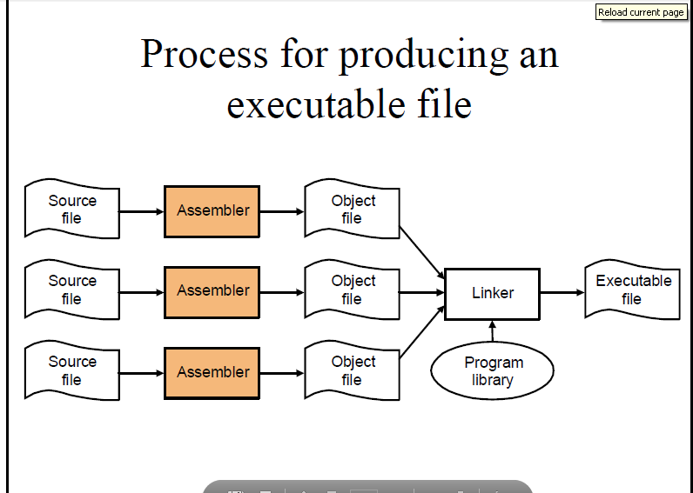

Loader
• Part of the OS that brings an executable file residing on disk into memory and starts it running
• Steps
– Read executable file’s header to determine the size oftext and data segments
– Create a new address space for the program
– Copies instructions and data into address space
– Copies arguments passed to the program on the stack
– Initializes the machine registers including the stack ptr
– Jumps to a startup routine that copies the program’sarguments from the stack to registers and calls the
program’s main routine.

Cross compiler

A cross compiler is a compiler capable of creating executable code for a platform other than the one on which the compiler is running. Cross compiler tools are used to generate executables forembedded system or multiple platforms. It is used to compile for a platform upon which it is not feasible to do the compiling, like microcontrollers that don't support an operating system. It has become more common to use this tool for paravirtualization where a system may have one or more platforms in use.
The fundamental use of a cross compiler is to separate the build environment from target environment. This is useful in a number of situations:
- Embedded computers where a device has extremely limited resources. For example, a microwave oven will have an extremely small computer to read its touchpad and door sensor, provide output to a digital display and speaker, and to control the machinery for cooking food. This computer will not be powerful enough to run a compiler, a file system, or a development environment. Since debugging and testing may also require more resources than are available on an embedded system, cross-compilation can be less involved and less prone to errors than native compilation.
- Compiling for multiple machines. For example, a company may wish to support several different versions of an operating system or to support several different operating systems. By using a cross compiler, a single build environment can be set up to compile for each of these targets.
- Compiling on a server farm. Similar to compiling for multiple machines, a complicated build that involves many compile operations can be executed across any machine that is free, regardless of its underlying hardware or the operating system version that it is running.
- Bootstrapping to a new platform. When developing software for a new platform, or the emulator of a future platform, one uses a cross compiler to compile necessary tools such as the operating system and a native compiler.
- Compiling native code for emulators for older now-obsolete platforms like the Commodore 64 or Apple II by enthusiasts who use cross compilers that run on a current platform (such as Aztec C's MS-DOS 6502 cross compilers running under Windows XP).

single pass compiler

A compiler that passes through the parts of each compilation unit only once, immediately translating each part into its final machine code. This is in contrast to a multi-pass compiler which converts the program into one or more intermediate representations steps in between source code and machine code, and which reprocesses the entire compilation unit in each sequential pass.

multi pass compiler
A multi-pass compiler is a type of compiler that processes the source code or abstract syntax tree of a program several times. This is in contrast to a one-pass compiler, which traverses the program only once. Each pass takes the result of the previous pass as the input, and creates an intermediate output. In this way, the (intermediate) code is improved pass by pass, until the final pass emits the final code.
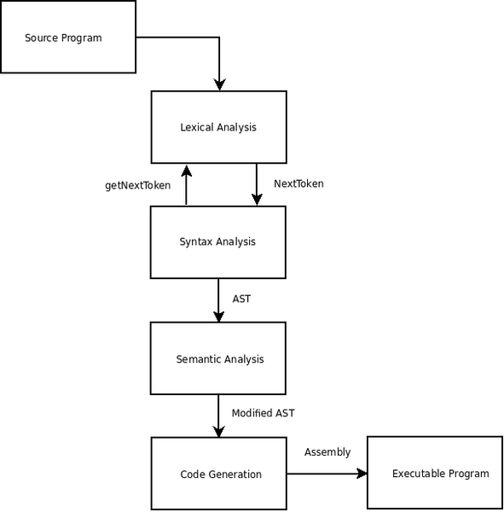
Multi-pass compilers are sometimes called wide compilers, referring to the greater scope of the passes: they can "see" the entire program being compiled, instead of just a small portion of it. The wider scope thus available to these compilers allows better code generation (e.g. smaller code size, faster code) compared to the output of one-pass compilers, at the cost of higher compiler time and memory consumption. In addition, some languages cannot be compiled in a single pass, as a result of their design.

Difference between single pass compiler and multi pass compiler?
- A one-pass compiler is a compiler that passes through the source code of each compilation unit only once. A multi-pass compiler is a type of compiler that processes the source code or abstract syntax tree of a program several times.
- A one-pass compilers is faster than multi-pass compilers
- A one-pass compiler has limited scope of passes but multi-pass compiler has wide scope of passes.
- Multi-pass compilers are sometimes called wide compilers where as one-pass compiler are sometimes called narrow compiler.
- Many programming languages cannot be represented with a single pass compilers, for example Pascal can be implemented with a single pass compiler where as languages likeJava require a multi-pass compiler.
NFA
Nondeterministic finite automaton (NFA) or nondeterministic finite state machine is a finite state machine where from each state and a given input symbol the automaton may jump into several possible next states.
An NFA is represented formally by a 5-tuple, (Q, Σ, Δ, q₀, F), consisting of
- a finite set of states Q
- a finite set of input symbols Σ
- a transition relation Δ : Q × Σ → P(Q).
- an initial (or start) state q₀ ∈ Q
- a set of states F distinguished as accepting (or final) states F ⊆ Q.

DFA
A deterministic finite automaton (DFA)—also known as deterministic finite state machine—is a finite state machine that accepts/rejects finite strings of symbols and only produces a unique computation (or run) of the automaton for each input string.^{[1]} 'Deterministic' refers to the uniqueness of the computation.

EXAMPLE:

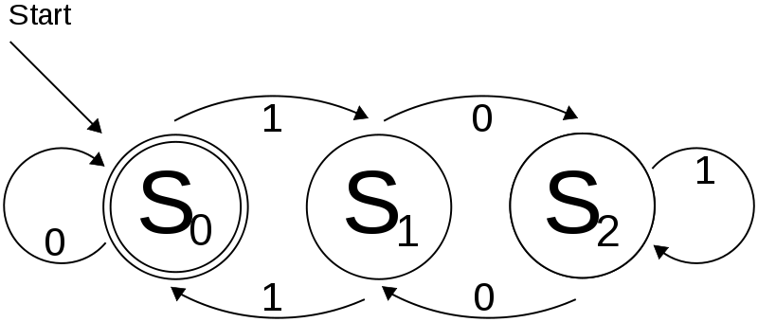

A deterministic finite automaton M is a 5-tuple, (Q, Σ, δ, q₀, F), consisting of
- a finite set of states (Q)
- a finite set of input symbols called the alphabet (Σ)
- a transition function (δ : Q × Σ → Q)
- a start state (q₀ ∈ Q)
- a set of accept states (F ⊆ Q)

FA

finite-state automaton (plural: automata), or simply a state machine, is a mathematical model of computation used to design both computer programs andsequential logic circuits. It is conceived as an abstract machine that can be in one of a finite number of states. The machine is in only one state at a time; the state it is in at any given time is called the current state. It can change from one state to another when initiated by a triggering event or condition; this is called a transition. A particular FSM is defined by a list of its states, and the triggering condition for each transition.

RE
A recursive definition (or inductive definition) is used to define an object in terms of itself
A recursive definition of a function defines values of the functions for some inputs in terms of the values of the same function for other inputs. For example, the factorial function n! is defined by the rules
0! = 1.
(n+1)! = (n+1)·n!.
This definition is valid for all n, because the recursion eventually reaches the base case of 0. The definition may also be thought of as giving a procedure describing how to construct the function n!, starting from n = 0 and proceeding onwards with n = 1, n = 2, n = 3 etc..
That such a definition indeed defines a function can be proved by induction.

