**Bootstrap 4 Exercise**

**NOTE**: full page should be in a container and use maximum class for a design where possible to use.

1. Implement below attached design. four cols on desktop, two cols in tablet view, and for mobile view only one col should be visible in a single row. - (10)

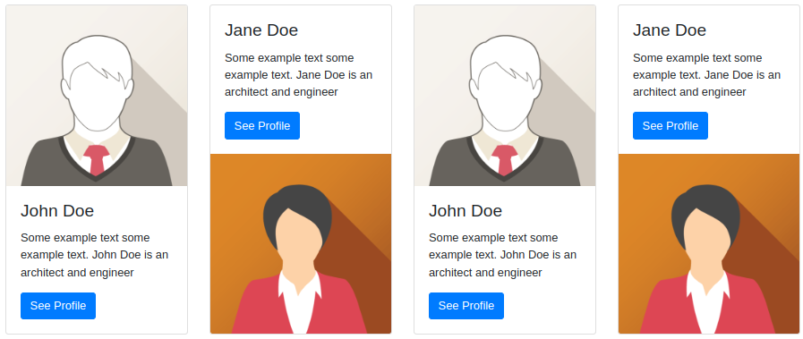



2. Write five lines with the text "Lorem ipsum dolor sit amet" and the background color should be blue, red, yellow, green, and black respectively with the white text color. - (5)

3. implement one table with odd/even row using class only. - (5)

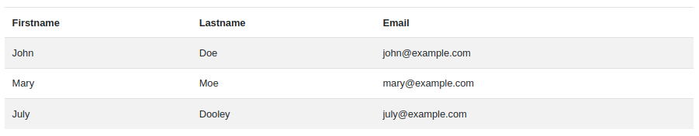

4. implement the below design using class only. - (5)

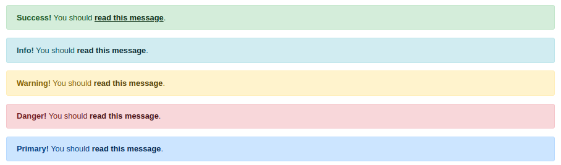

5. implement the below design button group with dropdown using class only. - (5)

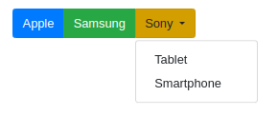

6. implement the below badge design using class only. - (5)



7. implement the below pagination, spinner, nav, progress bar, and tooltip. (5)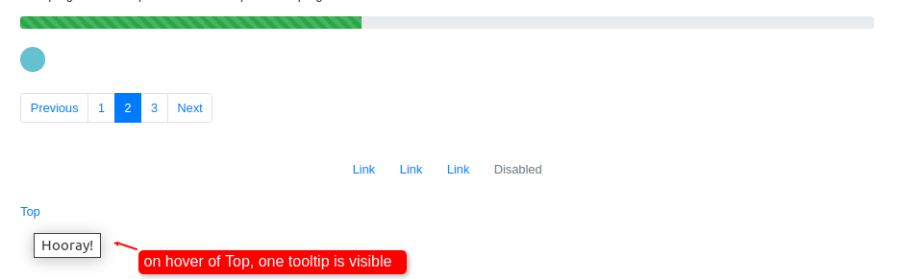

8. implement one checkbox, one radio button, and one selection functionality in Form. - (5)

9. implement one modal which should open on click of the open modal button. - (5)

**Total Hours**: 3 hours

**Total Marks**: 50 Marks