LAB EXAM

MS.Net Technologies

Dipali Shinde

1. Write a program in C# Sharp to display the name of the days of the week using LINQ.

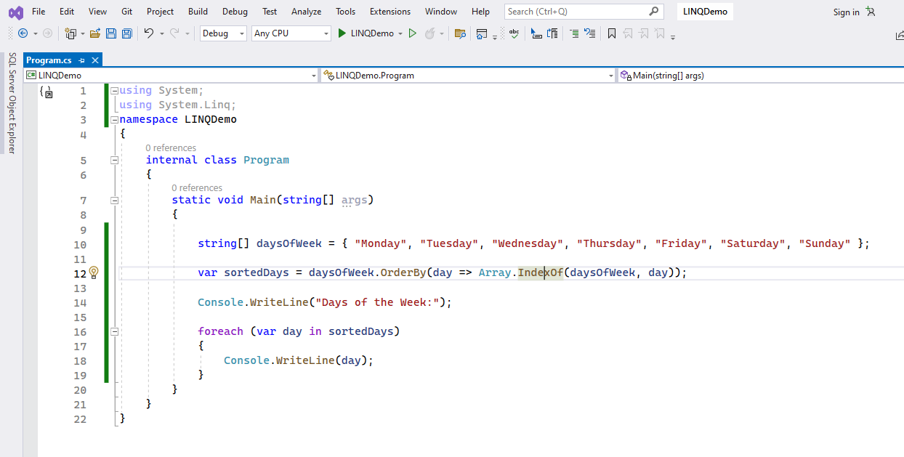

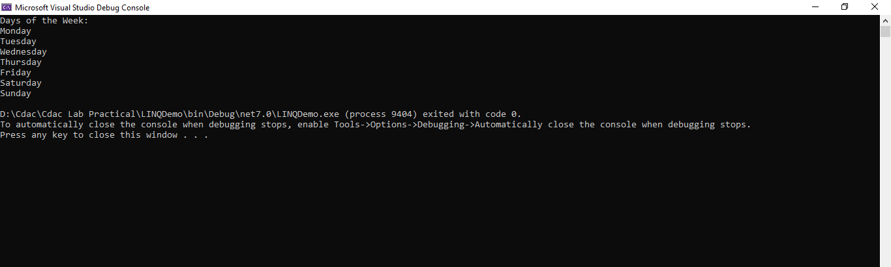

2. Using ASP.Net Core, create an MVC project for a college with the following pages such as Home,

Employee, Student. Create functions such as Index, login and signup. Return the corresponding view

pages and display it in the browser.

