Again, please forgive the repeated inquiries. However, this mission (https://www.dataquest.io/m/210/guided-project%3A-winning-jeopardy/4/answers-in-questions) really needs a lot of work. I recommend seriously looking at this mission as the questions are very poorly worded. When I compared the questions to the answer key, the correlation is quite poor in many places. Furthermore, some of the python in the key has bugs in it. Here’s an example of some code from the answer key (note the highlighted portion):

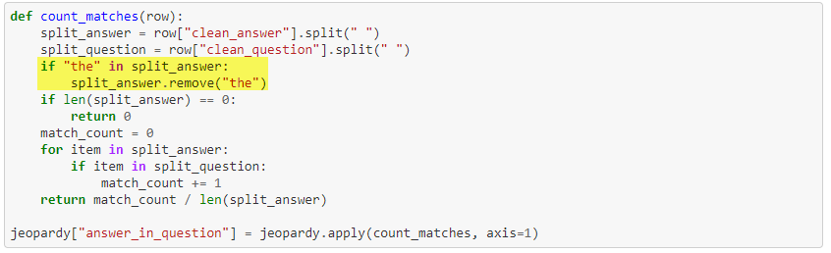

The question states the following: “If **the** is in split_answer, remove it using the remove method on lists. **The** is commonly found in answers and questions, but doesn't have any meaningful use in finding the answer.”

The python in the answer key will only remove the 1st occurrence of the word the. It does not handle cases where the word **the** is found multiple times in the split_answer list. As a result the match_count will be falsely inflated with **the’s.** A simple fix would be to use this code.

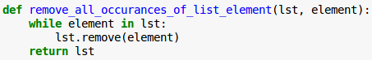

I still think you offer the best product on the market, I am simply trying to show my appreciation by offering recommendations for continued improvements.