Math Refresher

**Calculus for Machine Learning: Linear & Nonlinear Functions**

* **Secant Line**: A line that intersects 2 points on a curve is known as a secant line.
  + A **secant line** is a straight line joining two points on a function. (See below.) It is also equivalent to the **average rate of change**, or simply the **slope** between two points.
  + The **average rate of change**of a function between two points and the **slope** between two points are the same thing.



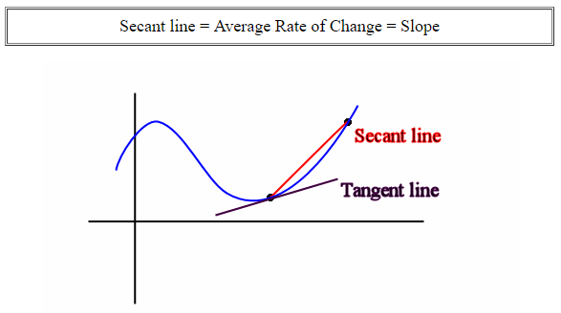

* Tangent Line: unlike the secant line, it only intersects our function at one point. So far, we've been working with secant lines that connect 2 points that are increasingly close together. You can think of the tangent line as the secant line when both points are the same.
  + A **tangent line** is a straight line that touches a function at only one point. (See above.) The tangent line represents the **instantaneous rate of change** of the function at that one point. The slope of the **tangent line** at a point on the function is equal to the **derivative** of the function at the same point (See below.)

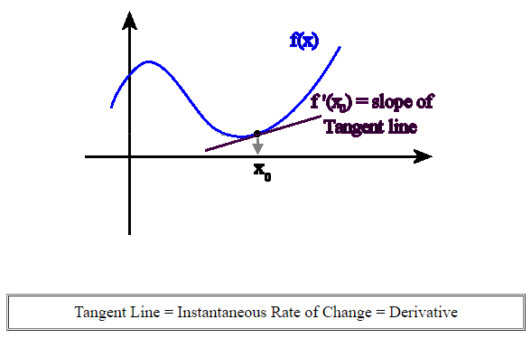

* + As the two points used for the secant line get closer to one another, the average rate of change becomes the instantaneous rate of change and the secant line becomes the tangent line.

**Calculus for Machine Learning: Understanding Limits**

* **Take Home:** Make sure you understand how to use limits to calculate the slope of the tangent line of a given nonlinear function (curve). Note in this chapter we've been solving for the slope at specific points by plugging in the specific x value into the slope equation as expressed as a limit. In the next chapter we’ll learn how to find the general function that describes the slope at any point.
* **Limit**: A limit describes the value a function approaches when the input variable to the function approaches a specific value. In our case, the input variable is x2 and our function is:



The following mathematical notation formalizes the statement, "As x2 approaches 3, the slope between x1 and x2 approaches -3" using a limit:

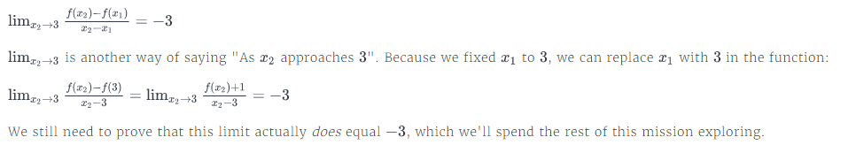

* Defined Limits & Undefined Limits
  + **Undefined Limits**: The limit is undefined if the limit does not exist as described by this technical definition. ... In this example the limit of f(x), as x approaches zero, does not exist since, as x approaches zero, the values of the function get large without bound.
  + **Defined Limits**: A defined limit can be evaluated just by substituting the value into the limit.
* **04_LimitsUsingSymPy**:

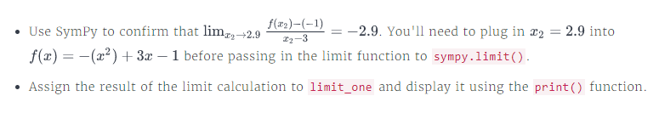

**Calculus for Machine Learning: Finding Extreme Points**

* **Derivative**: A function's derivative can tell us the slope of the tangent line for any x value along the function.
  + So far, we've been solving for the slope at specific points by plugging in the specific x value into the slope equation as expressed as a limit. To find the general function that describes the slope at any point, we need to solve the limit using the original variable instead of replacing with a specific x value.
  + Let's first start by rewriting the slope equation to the more common form. Instead of using *x1* and *x2* in the slope equation, let's use *x* and *x + h*. This version of the slope equation is how most textbooks and resources refer to slope:



* + In this form, *h* represents the distance between the 2 points: *x* and *x+h*. The slope is the value the limit approaches as *h* approaches *0*.
  + Place holder