Practical
Full Name: | DIPAK RAJENDRA POTE
DIV: | IT-G
Roll No.: | 31
PRN: | 12520009
Subject: | Computer Networks
Date of Submission: | 27/08/2026

Aim:
Write a program to find class and type of a given IP address.
Theory:
IP Address Classes
An IP (Internet Protocol) address is a 32-bit numerical label assigned to each device connected to a computer network. IPv4 addresses are divided into five classes (A through E) based on the value of the first octet. Each class defines the range of valid addresses, the default subnet mask, and whether the address is used for unicast, multicast, or experimental purposes.
Class A (1 – 126)
Class A addresses have their first bit set to 0. The first octet ranges from 1 to 126 and identifies the network; the remaining three octets identify the host. The default subnet mask is 255.0.0.0, supporting up to 16,777,214 hosts per network. These addresses are typically assigned to very large organizations. The range 127.x.x.x is reserved for loopback testing.
Class B (128 – 191)
Class B addresses begin with the bit pattern 10. The first two octets identify the network and the last two identify the host. The default subnet mask is 255.255.0.0, allowing up to 65,534 hosts per network. Class B addresses are suited for medium-to-large enterprises.
Class C (192 – 223)
Class C addresses start with 110 in binary. The first three octets denote the network and the last octet identifies the host. The default subnet mask is 255.255.255.0, supporting up to 254 hosts per network. Class C is the most common class for small business and home networks.
Class D (224 – 239) – Multicast
Class D addresses are reserved for multicast groups and are not assigned to individual hosts. There is no subnet mask for Class D. Multicast enables a single packet to be sent to multiple destinations simultaneously, used in streaming and conferencing applications.
Class E (240 – 255) – Experimental
Class E addresses are reserved for experimental and research purposes and are not used in public networking. Like Class D, they have no defined subnet mask.
Private vs. Public IP Addresses
Certain IP ranges are designated as private by RFC 1918 and are used within local networks (LANs). These ranges are: 10.0.0.0 – 10.255.255.255 (Class A), 172.16.0.0 – 172.31.255.255 (Class B), and 192.168.0.0 – 192.168.255.255 (Class C). All other routable IP addresses are considered public and are reachable over the Internet.
Broadcast and Working IP Addresses
Within a subnet, the first IP address is the network address and the last is the broadcast address. The broadcast address is used to send data to all hosts in the subnet simultaneously. The usable (working) host addresses lie between the network address and the broadcast address, so the last usable host address is always one less than the broadcast address.
Algorithm:
Step 1: Read the IP address as four integers a, b, c, d separated by dots.
Step 2: Validate each octet: if any value is outside 0–255, print "Invalid IP Address" and stop.
Step 3: Classify by the first octet (a):
• 1–126 → Class A (Subnet: 255.0.0.0)
• 127 → Loopback
• 128–191 → Class B (Subnet: 255.255.0.0)
• 192–223 → Class C (Subnet: 255.255.255.0)
• 224–239 → Class D (Multicast)
• 240–255 → Class E (Experimental)
Step 4: For Classes A, B, C: print First IP, Last IP, Last Working IP, and Broadcast Address.
Step 5: Determine type: if the IP falls in a private range → "Private"; otherwise → "Public".
Step 6: Stop.
Code:
#include <stdio.h>

int main() {
int a, b, c, d;

printf("Enter IP Address (e.g. 192.168.1.10): ");
scanf("%d.%d.%d.%d", &a, &b, &c, &d);

if (a < 0 || a > 255 || b < 0 || b > 255 ||
c < 0 || c > 255 || d < 0 || d > 255) {
printf("Invalid IP Address\n");
return 0;
}

printf("\n");

if (a >= 1 && a <= 126) {
printf("Class Name : A\n");
printf("Subnet Mask : 255.0.0.0\n");
printf("First IP Address : %d.0.0.0\n", a);
printf("Last IP Address : %d.255.255.255\n", a);
printf("Last Working IP : %d.255.255.254\n", a);
printf("Broadcast Address : %d.255.255.255\n", a);
}
else if (a >= 128 && a <= 191) {
printf("Class Name : B\n");
printf("Subnet Mask : 255.255.0.0\n");
printf("First IP Address : %d.%d.0.0\n", a, b);
printf("Last IP Address : %d.%d.255.255\n", a, b);
printf("Last Working IP : %d.%d.255.254\n", a, b);
printf("Broadcast Address : %d.%d.255.255\n", a, b);
}
else if (a >= 192 && a <= 223) {
printf("Class Name : C\n");
printf("Subnet Mask : 255.255.255.0\n");
printf("First IP Address : %d.%d.%d.0\n", a, b, c);
printf("Last IP Address : %d.%d.%d.255\n", a, b, c);
printf("Last Working IP : %d.%d.%d.254\n", a, b, c);
printf("Broadcast Address : %d.%d.%d.255\n", a, b, c);
}
else if (a >= 224 && a <= 239) {
printf("Class Name : D (Multicast)\n");
}
else if (a >= 240 && a <= 255) {
printf("Class Name : E (Experimental)\n");
} else if (a == 127) {
printf("Class Name : Loopback\n");
}
else {
printf("Invalid IP Address\n");
return 0;
}

if ((a == 10) ||
(a == 172 && b >= 16 && b <= 31) ||
(a == 192 && b == 168))
printf("Type : Private\n");
else
printf("Type : Public\n");

return 0;
}

Output:
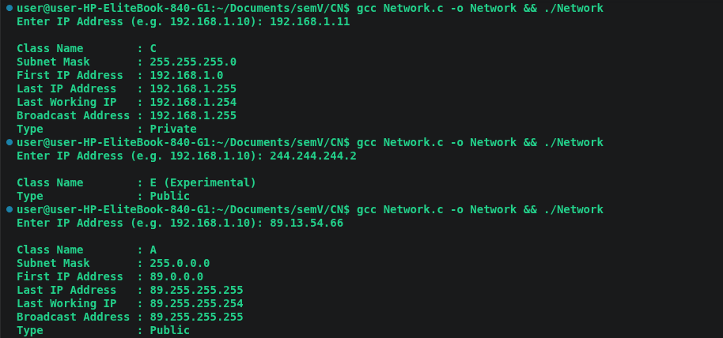
Conclusion:
The program successfully reads an IPv4 address and determines its class (A, B, C, D, or E), subnet mask, network range, broadcast address, and whether it is a private or public address. By checking the first octet against the defined class ranges and applying RFC 1918 private-address rules, the program correctly classifies all three test inputs: 192.168.1.11 as Class C / Private, 244.244.244.2 as Class E / Public, and 89.13.54.66 as Class A / Public. Thus, the aim of the practical is fulfilled.

