Networking Commands

Name: Dipak Rajendra Pote
Roll No: 31
Div: G

1. ping — Test host reachability
Sends ICMP echo requests to check if a host is reachable and measure round-trip latency.
SYNTAX
ping [options] destination

OPTIONS (6)
Option | Description
-c count | Send only a specific number of packets, then stop
-i interval | Wait this many seconds between sending each packet
-s size | Set the number of data bytes to send per packet
-t ttl | Set the IP Time-To-Live (max hops before packet is dropped)
-w deadline | Stop after this many seconds, regardless of packets sent
-q | Quiet mode — only show the summary at the end

EXAMPLE
ping -c 4 -i 1 8.8.8.8

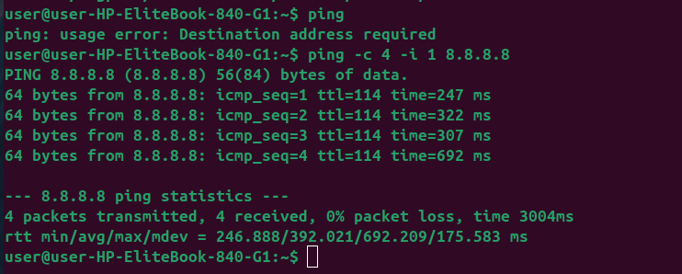
2. traceroute — Trace the path to a host
Shows every network hop (router) a packet passes through on its way to a destination.
SYNTAX
traceroute [options] destination

OPTIONS (6)
Option | Description
-m max_ttl | Set the maximum number of hops to probe
-n | Print hop addresses numerically, skip DNS resolution
-q nqueries | Number of probe packets sent per hop (default 3)
-w waittime | Seconds to wait for a response before timing out
-I | Use ICMP ECHO instead of UDP probes
-T | Use TCP SYN probes (useful when ICMP/UDP is blocked)

EXAMPLE
traceroute -n -m 20 google.com

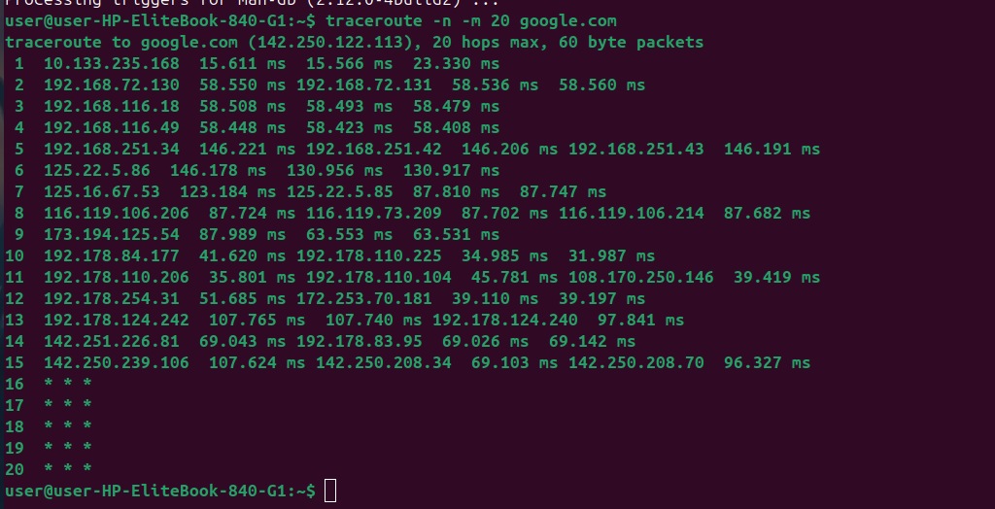
3. ip — Show/configure interfaces & routes
Modern Linux tool for managing interfaces, IP addresses, and routing (replaces ifconfig/route).
SYNTAX
ip [options] object {show|add|del|set} ...

OPTIONS (6)
Option | Description
addr show | Display IP addresses assigned to all interfaces
link set dev up/down | Bring a network interface up or down
route show | Display the current routing table
-4 / -6 | Restrict output to IPv4 or IPv6 only
-s | Show extra statistics (e.g. with link show)
-br | Show brief, condensed output

EXAMPLE
ip -br addr show

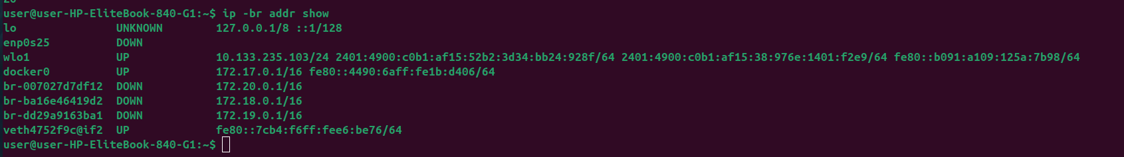
4. netstat — Show connections & listening ports
Displays active network connections, listening ports, and routing/interface statistics.
SYNTAX
netstat [options]

OPTIONS (6)
Option | Description
-t | Show TCP connections
-u | Show UDP connections
-l | Show only listening sockets
-n | Show numeric addresses/ports instead of resolving names
-p | Show the PID and program name using each socket
-r | Display the kernel routing table

EXAMPLE
netstat -tulnp

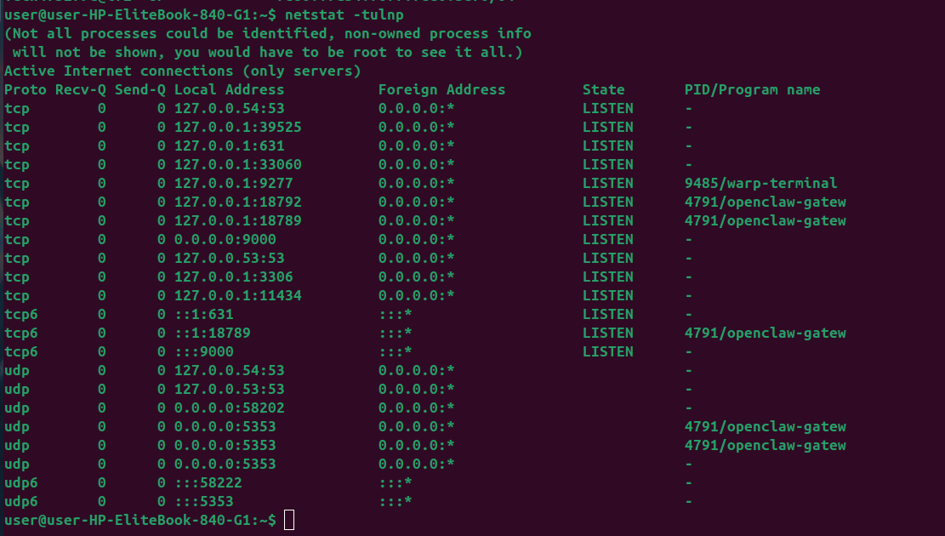
5. ss — Modern socket statistics
Faster, modern replacement for netstat; shows detailed TCP/UDP socket information.
SYNTAX
ss [options]

OPTIONS (6)
Option | Description
-t | Show TCP sockets
-u | Show UDP sockets
-l | Show only listening sockets
-n | Don't resolve service names, show numeric ports
-p | Show the process using each socket
-s | Print summary statistics

EXAMPLE
ss -tulnp

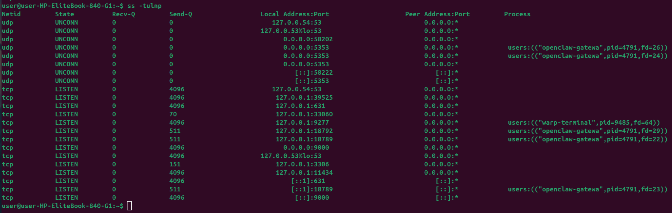
6. nslookup — Query DNS records
Interactive/one-shot tool to query DNS servers for domain name or IP information.
SYNTAX
nslookup [options] host [server]

OPTIONS (6)
Option | Description
-type=A|MX|NS|TXT | Specify which DNS record type to query
-debug | Show detailed query/response information
-timeout=n | Set the timeout (seconds) for each request
-retry=n | Set the number of retries on failure
-port=n | Query a DNS server on a non-standard port
server | Specify which DNS server to query (last argument)

EXAMPLE
nslookup -type=MX google.com 8.8.8.8

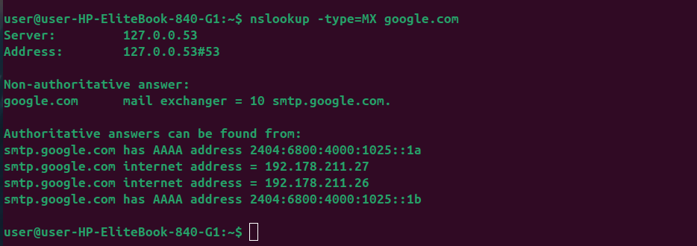
7. dig — Detailed DNS lookup
Flexible DNS lookup tool that returns detailed, authoritative answers; preferred over nslookup on Linux/macOS.
SYNTAX
dig [@server] [options] name [type]

OPTIONS (6)
Option | Description
-x | Perform a reverse DNS lookup (IP to hostname)
+short | Print only the short answer, no extra output
+trace | Trace the resolution path from root DNS servers down
-t type | Specify the DNS record type (A, MX, TXT, etc.)
-p port | Query a DNS server on a specific port
@server | Send the query to a specific DNS server

EXAMPLE
dig @8.8.8.8 +short google.com MX

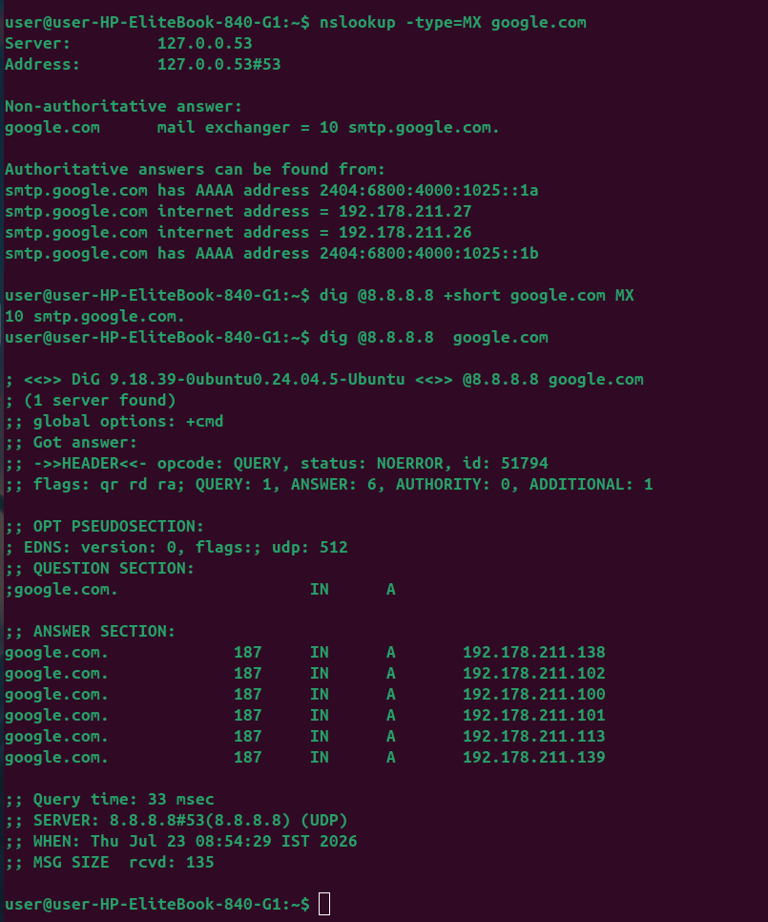
8. ssh — Secure remote shell
Opens an encrypted remote login session or tunnel to another machine.
SYNTAX
ssh [options] user@host

OPTIONS (6)
Option | Description
-p port | Connect to a non-default SSH port
-i identity_file | Use a specific private key for authentication
-L local:host:remote | Forward a local port to a remote address
-R remote:host:local | Forward a remote port back to the local machine
-D port | Create a dynamic SOCKS proxy through the SSH tunnel
-v | Verbose mode, useful for debugging connection issues

EXAMPLE
sudo systemctl status ssh

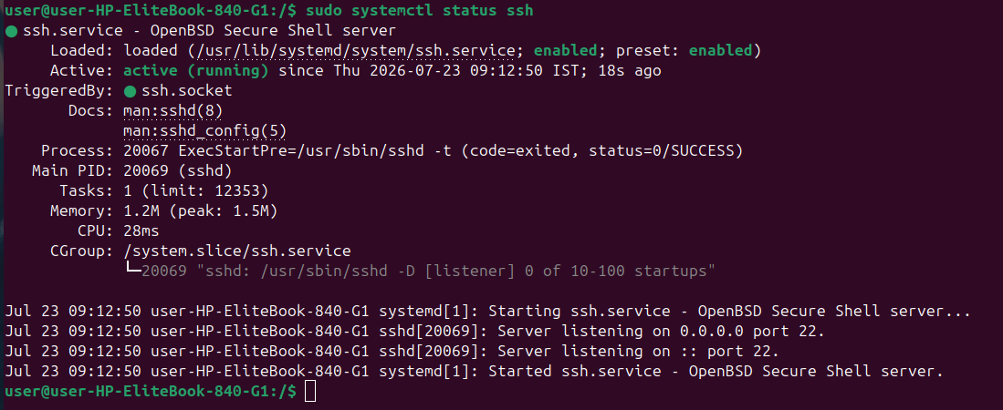
9. scp — Secure copy over SSH
Copies files or directories to/from a remote machine using SSH encryption.
SYNTAX
scp [options] source destination

OPTIONS (6)
Option | Description
-P port | Connect using a non-default SSH port (capital P)
-r | Recursively copy entire directories
-i identity_file | Use a specific private key for authentication
-C | Compress data during transfer
-p | Preserve file modification times and permissions
-v | Verbose mode for troubleshooting transfers

EXAMPLE
scp -P 2222 -r ./project user@host:/var/www/

10. rsync — Efficient file synchronization
Synchronizes files/directories locally or remotely, transferring only the differences.
SYNTAX
rsync [options] source destination

OPTIONS (6)
Option | Description
-a | Archive mode — preserves permissions, timestamps, symlinks
-v | Verbose output showing files being transferred
-z | Compress file data during the transfer
--delete | Delete files at destination that no longer exist at source
-e ssh | Specify the remote shell to use (commonly SSH)
-r | Recurse into directories

EXAMPLE
rsync -avz --delete ./site/ user@host:/var/www/site/

11. curl — Transfer data with URLs
Sends and receives data from servers over HTTP, FTP, and many other protocols.
SYNTAX
curl [options] URL

OPTIONS (6)
Option | Description
-O | Save the output to a file, using the remote filename
-I | Fetch headers only (HEAD request)
-X method | Specify the HTTP request method (GET, POST, etc.)
-H header | Add a custom request header
-d data | Send data in the request body (POST by default)
-L | Follow HTTP redirects automatically

EXAMPLE
curl -X POST -H "Content-Type: application/json" -d '{"a":1}' https://api.example.com

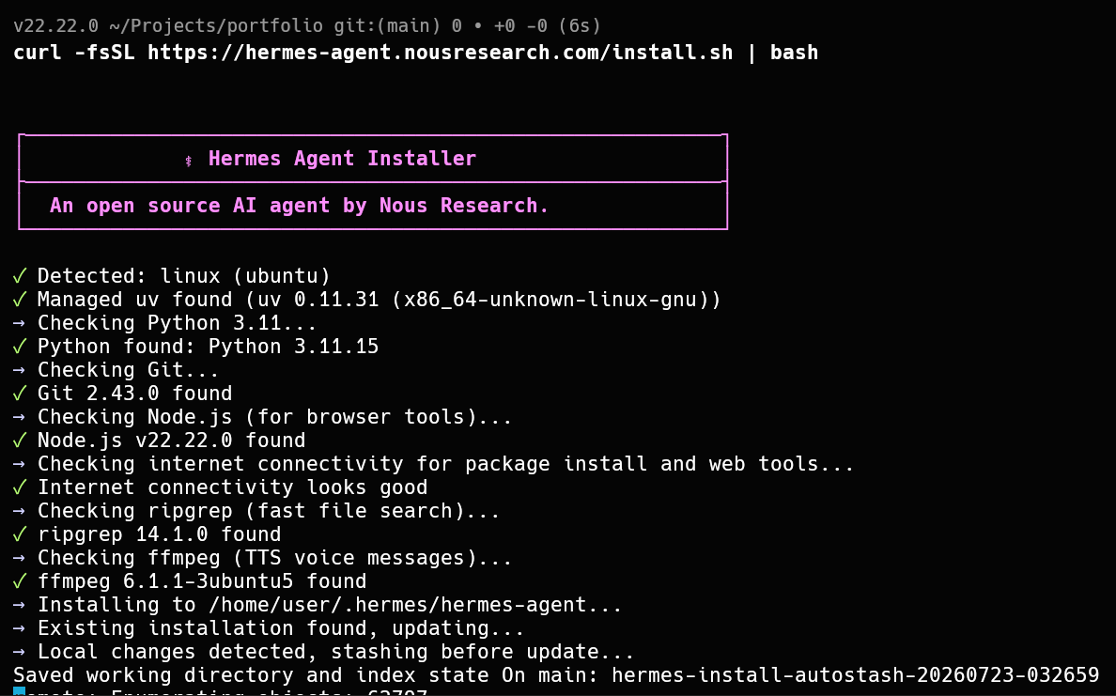
12. wget — Download files from the web
Non-interactive downloader, good for scripting, resuming, and recursive downloads.
SYNTAX
wget [options] URL

OPTIONS (6)
Option | Description
-r | Download recursively (e.g. entire site sections)
-np | Don't ascend to the parent directory when recursing
-c | Continue/resume a partially downloaded file
-q | Quiet mode, suppress output
-O file | Save output with a specific filename
--limit-rate=rate | Limit the download speed (e.g. 200k)

EXAMPLE
wget -c --limit-rate=500k -O file.zip https://example.com/file.zip

13. nmap — Network/port scanner
Scans hosts and networks to discover live systems, open ports, and running services.
SYNTAX
nmap [options] target

OPTIONS (6)
Option | Description
-p range | Scan a specific port or port range
-sV | Detect service/version info on open ports
-sS | Perform a stealthy TCP SYN scan
-O | Attempt operating system detection
-sn | Ping scan only — discover live hosts, skip port scan
-A | Aggressive scan: OS, version, script, and traceroute detection

EXAMPLE
nmap -sV -p 1-1000 192.168.1.0/24

14. tcpdump — Capture and inspect packets
Command-line packet sniffer for capturing and analyzing live network traffic.
SYNTAX
tcpdump [options] [expression]

OPTIONS (6)
Option | Description
-i interface | Capture packets on the specified interface
-w file | Write captured packets to a file
-r file | Read and display packets from a saved capture file
-n | Don't resolve hostnames/ports, show numeric values
-c count | Stop after capturing this many packets
-v | Verbose output with more packet detail

EXAMPLE
tcpdump -i eth0 -n port 443 -c 50

15. iptables — Configure Linux firewall rules
Manages the kernel's netfilter firewall — controls what traffic is allowed in/out.
SYNTAX
iptables [options] -A|-D|-I chain rule-spec

OPTIONS (6)
Option | Description
-L | List current firewall rules
-A chain | Append a new rule to the end of a chain
-D chain | Delete a matching rule from a chain
-F | Flush (remove) all rules in a chain
-P chain policy | Set the default policy for a chain (ACCEPT/DROP)
-I chain | Insert a rule at a specific position in a chain

EXAMPLE
iptables -A INPUT -p tcp --dport 22 -j ACCEPT

16. ufw — Simplified firewall management
User-friendly front-end for iptables, common on Ubuntu/Debian systems.
SYNTAX
ufw [options] command

OPTIONS (6)
Option | Description
allow port/proto | Allow traffic on a port or service
deny port/proto | Block traffic on a port or service
status | Show current firewall status and active rules
enable / disable | Turn the firewall on or off
delete rule | Remove an existing rule
reload | Reload the firewall to apply rule changes

EXAMPLE
ufw allow 443/tcp && ufw enable

17. arp — View/manage the ARP cache
Displays or edits the IP-to-MAC address mapping table used on the local network.
SYNTAX
arp [options] [hostname]

OPTIONS (6)
Option | Description
-a | Display all current ARP table entries
-d hostname | Delete an entry from the ARP table
-s hostname mac | Add a static ARP entry
-n | Show numeric IPs, skip hostname resolution
-v | Verbose output
-i interface | Limit the operation to a specific interface

EXAMPLE
arp -a -n

18. ip route — Manage the routing table
Views and modifies how the system routes outgoing traffic to different networks.
SYNTAX
ip route {show|add|del|get|replace} ...

OPTIONS (6)
Option | Description
show | Display the full routing table
add dest via gw | Add a new route to a destination via a gateway
del dest | Remove a route from the table
get dest | Show which route/interface would be used for a destination
replace dest via gw | Replace an existing route atomically
show table main | Show routes in a specific routing table

EXAMPLE
ip route add 10.0.0.0/24 via 192.168.1.1

19. iperf3 — Measure network throughput
Actively measures achievable bandwidth between two hosts over TCP or UDP.
SYNTAX
iperf3 [options]

OPTIONS (6)
Option | Description
-s | Run in server mode, waiting for a client to connect
-c host | Run in client mode, connecting to the given server
-p port | Use a specific port instead of the default (5201)
-t seconds | Set the test duration in seconds
-u | Use UDP instead of the default TCP
-P n | Run n parallel streams for higher aggregate throughput

EXAMPLE
iperf3 -c 10.0.0.5 -t 30 -P 4

20. nc (netcat) — Read/write over network connections
General-purpose tool for reading, writing, and testing TCP/UDP connections.
SYNTAX
nc [options] host port

OPTIONS (6)
Option | Description
-l | Listen for an incoming connection instead of connecting out
-p port | Specify the local port to use
-v | Verbose mode, prints connection details
-z | Zero-I/O scanning mode — just test if a port is open
-u | Use UDP instead of the default TCP
-w seconds | Set a connection/idle timeout

EXAMPLE
nc -zv 192.168.1.10 20-100

