Sparse Matrix Vector Multiplication on GPU

Dhruv Dogra, Rutgers University

Abstract
In Sparse Matrix Vector Multiplication, we take a sparse matrix (matrix in which most elements are zero) and calculate its product with a vector. Graphics Processing Units (GPUs) have massively parallel architecture consisting of thousands of core which can be utilized to solve multiple tasks in parallel. In this project we look at Segment Scan implementation of SPMV and its performance on different matrices.
1. Segment Scan Implementation
Segment scan implementation is based on parallel prefix sum within a thread warp. Prefix sum scans through a set of numbers and compute sum based on some “predicates”. To understand this suppose we are given a sequence of numbers of X with key K associated with it:
K = { 0 , 0 , 0, 1, 1, 2, 2}
X = {x0, x1, x2, x3, x4, x5, x6}
Then the prefix sum for this input sequence will be as follows:
Y = {x0, x0+x1, x0+x1+x2, x3, x3+x4, x5, x5+x6}
In our implementation row indexes act as a predicate guard which means that only the multiplication value which corresponds to a particular row will be added together. Before implementing the kernel function we had to preprocess the input matrix. We placed all the non-zero elements consecutively using mergesort algorithm. Mergesort has the best possible time complexity for a comparison based sort.
We also used shared memory in order to store intermediate values. This helped in increasing our speed of task as shared memory access are quicker compared to reading from RAM. Once our product is computed we write only once from shared memory to the main memory.
There are few things we need to keep in mind while implementing segment scan. It could be that one row can span multiple warps and it’s not necessary that total threads are a multiple of matrix elements. To handle these cases we used atomicAdd operation and used an if check to ensure we don’t work with uninitialized elements.
Issues faced in our implementation is of two types, namely thread divergence and memory coalescing. Let’s look at them in the next two sections.

1.1. Thread Divergence
This is one of the major problem present in segment scan. All the threads inside a warp execute the same instruction but it may happen that only few of threads are actually doing the work. The rest of threads are idle thereby wasting computational resources. This problem occurs in segment scan due to the control statement present in the kernel code.

Following is the code snippet for segment scan kernel:
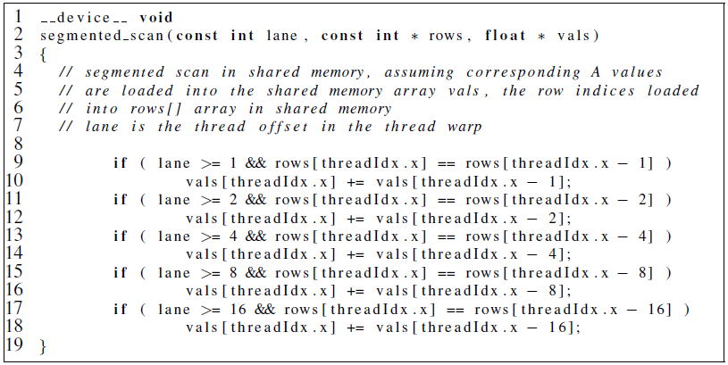

The ‘if’ block causes thread divergence and depending on the number of non-zeroes the workload varies for each thread inside same warp.

1.2 Memory Coalescing
Data is retrieved from RAM in chunks and these memory accesses are costly. In an ideal scenario we would like to minimize the number of memory accesses. This is possible if the data we need is present next to each other in RAM. As we have reordered the matrix, as per row, we face memory coalescing problem when we try to access vector data. The non-zeroes positions vary greatly and depending on these positions we get vector data.

Table 1: Performance on 384 CUDA cores
Matrix | 10*192 | 8*256 | 5*384 | 4*512 | 2*768 | 2*1024
cant | 472 | 461 | 462 | 461 | 461 | 464
cant | 5094 | 2669 | 2858 | 2696 | 3502 | 2776
circuit 5M | 5057 | 5069 | 5180 | 5057 | 4933 | 5064
circuit 5M | 26810 | 23960 | 25966 | 24188 | 31570 | 24787
consph | 749 | 749 | 748 | 745 | 748 | 760
consph | 4181 | 3976 | 4266 | 4012 | 5243 | 4141
pdb1HYS | 534 | 534 | 543 | 534 | 544 | 537
pdb1HYS | 2951 | 2834 | 2977 | 2781 | 3720 | 2850
pwtk | 1446 | 1423 | 1404 | 1445 | 1435 | 1498
pwtk | 7944 | 7454 | 7975 | 7530 | 9880 | 10492
Rail4284 | 3271 | 3281 | 3218 | 3198 | 3335 | 3349
Rail4284 | 15735 | 14724 | 15990 | 14770 | 19117 | 15138
Rma10 | 557 | 575 | 573 | 573 | 576 | 582
Rma10 | 3339 | 3055 | 3249 | 3042 | 3961 | 3220
Watson_2 | 479 | 519 | 485 | 479 | 480 | 479
Watson_2 | 3061 | 2815 | 2847 | 2787 | 3633 | 2832
webbase | 766 | 765 | 767 | 757 | 754 | 764
webbase | 4672 | 4394 | 4722 | 4442 | 5564 | 4518
Fullchip | 7333 | 7434 | 7186 | 7363 | 7409 | 7299
Fullchip | 35676 | 33027 | 37273 | 33460 | 43578 | 34417
mc2depi | 456 | 450 | 459 | 455 | 459 | 458
mc2depi | 3024 | 2864 | 3041 | 2986 | 3766 | 2952
Shipesec1 | 947 | 952 | 941 | 980 | 939 | 952
Shipesec1 | 5417 | 5092 | 5500 | 5384 | 6748 | 5298
Turon_m | 255 | 226 | 226 | 228 | 230 | 228
Turon_m | 1561 | 1830 | 1543 | 1455 | 1809 | 1559
Mac_5000 | 315 | 316 | 318 | 315 | 318 | 316
Mac_5000 | 2115 | 2051 | 2163 | 2047 | 2541 | 2115
We did experiments on two machines with different computational powers and created one table for each. Table 1 results were derived from machine containing GPU model GT 730, while Table 2 were from GPU GT 630. Each matrix has 2 rows indicating timing. The first row has unit in milliseconds and it represents the time it
Table 2: Performance on 192 CUDA cores
Matrix | 10*192 | 8*256 | 5*384 | 4*512 | 2*768 | 2*1024
cant | 532 | 524 | 518 | 530 | 518 | 514
cant | 6760 | 6464 | 4042 | 3962 | 4656 | 4093
circuit 5M | 5829 | 5810 | 5810 | 5821 | 5985 | 5919
circuit 5M | 60304 | 57442 | 35959 | 35662 | 41763 | 36258
consph | 855 | 845 | 848 | 853 | 857 | 861
consph | 10037 | 9616 | 6019 | 5961 | 6966 | 6129
pdb1HYS | 628 | 663 | 613 | 630 | 669 | 631
pdb1HYS | 7100 | 6776 | 4154 | 4083 | 4854 | 4179
pwtk | 1710 | 1646 | 1659 | 1640 | 1713 | 1817
pwtk | 19111 | 18192 | 10890 | 10617 | 12772 | 10835
Rail4284 | 3932 | 4081 | 3945 | 3927 | 3955 | 3906
Rail4284 | 37172 | 35646 | 22197 | 21668 | 25445 | 21944
Rma10 | 649 | 651 | 657 | 661 | 650 | 662
Rma10 | 7720 | 7360 | 4548 | 4452 | 5288 | 4569
watson_2 | 558 | 549 | 541 | 550 | 551 | 532
watson_2 | 6134 | 5850 | 3741 | 3713 | 4181 | 3738
webbase | 863 | 881 | 857 | 851 | 854 | 855
webbase | 9753 | 9330 | 5863 | 5745 | 6701 | 5835
FullChip | 8840 | 8987 | 8683 | 8532 | 8541 | 8551
FullChip | 84597 | 80984 | 50840 | 50067 | 58257 | 51179
mc2depi | 520 | 534 | 516 | 534 | 535 | 508
mc2depi | 6530 | 6199 | 3875 | 3897 | 4523 | 4013
Shipesec1 | 1097 | 1080 | 1053 | 1089 | 1079 | 1059
Shipesec1 | 13027 | 12429 | 7682 | 7514 | 8862 | 7728
Turon_m | 260 | 261 | 262 | 257 | 256 | 250
Turon_m | 3097 | 2938 | 1888 | 1886 | 2164 | 1919
Mac_5000 | 354 | 346 | 347 | 367 | 363 | 365
Mac_5000 | 4404 | 4290 | 2882 | 2809 | 3149 | 2799

took to preprocess data. The second unit is in microseconds and represents kernel time.

We can see from the results mentioned in the tables that Machine 1 performed better than Machine 2. There is marginal improvement in preprocessing time but GPU performance shows massive improvement. The kernel time is almost halved for the configuration 10*192 and 8*256. As the block size increases this difference reduces but still it remains quite high.

1.3 Performance with constant block size

In this section we’ll see what happens when keep the number of threads per block to a constant (256) and try different values for block numbers. We intend to do this for the given sparse matrices on GPUs with distinct computing capabilities.

So CUDA capability with 3.0 and above the maximum number of blocks in x-dimension can be 2^31-1. We shall create graphs to see how the kernel time changes as we increase block number from 2 to highest feasible number.

Let’s take cant matrix to do an in-depth analysis which we can then extend to other matrices. Also please note the units of graphs-
X-axis = Logarithmic base of 2 of block numbers
Y-axis = Time in microseconds

We used block numbers in the power of 2. So 1 on x-axis means that block number was set to 2, 10 implies block number is 2^10 or 1024.
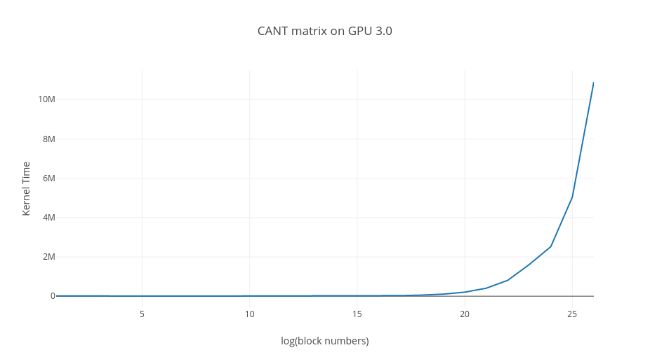
In this graph we can see that as the block numbers increases the time increases exponentially as well. Let’s look at the table using which this graph was created. As we can see the Kernel time decreases at first as the block number increases. But as the block number value goes on increasing exponentially the kernel time increases in the same way. Values marked in red indicate when Errors were getting reported. When block number was set 2^27, the kernel launch was timed out and no result was given back.

Table containing block numbers and kernel time on GPU with CUDA capability 3.0.

Block Number = Power of 2 | Kernel Time
1 | 12108
2 | 6309
3 | 6312
4 | 5204
5 | 5040
6 | 4537
7 | 4588
8 | 4684
9 | 4654
10 | 4785
11 | 4937
12 | 4952
13 | 5679
14 | 7270
15 | 10406
16 | 16708
17 | 29283
18 | 54428
19 | 104722
20 | 205341
21 | 406577
22 | 808924
23 | 1614034
24 | 2520478
25 | 5039325
26 | 10900512

Let’s take a look at a subpart of this graph where we can see the “bathtub” curve.
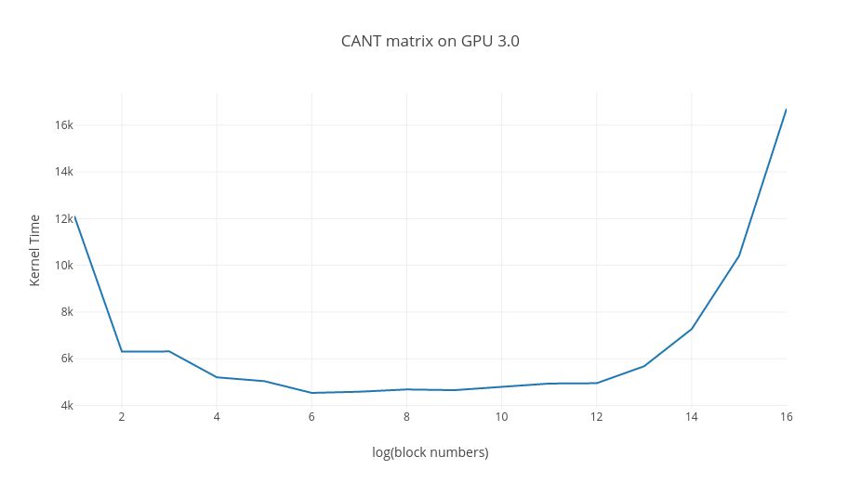
If we zoom in on the first graph and take the range of x-axis from 1 to 16 we get the above graph. This graph shows that we attain the best possible kernel time and then time increases exponentially.

Let’s see the performance of the code on GPU with CUDA capability 3.5. The table shows the data we collected as the block numbers were changed.

Table containing block numbers and kernel time on GPU with CUDA capability 3.5.

Block Number = Power of 2 | Kernel Time
1 | 9510
2 | 4983
3 | 2668
4 | 2756
5 | 2181
6 | 2205
7 | 2084
8 | 2076
9 | 2071
10 | 2071
11 | 2122
12 | 2225
13 | 2461
14 | 3159
15 | 4561
16 | 7346
17 | 12939
18 | 24089
19 | 46451
20 | 91143
21 | 180496
22 | 359280
23 | 716775
24 | 1130790
25 | 2262150
26 | 4519284
27 | 9036377
28 | 18079876
29 | 36180225
30 | 75092652
31 | 148882043

NOTE: In the last row, block number was set to 2^31 – 1 and not 2^31.

For this GPU we managed to launch the kernel with maximum allowable block number (2^31 - 1). The overall behavior on this machine is same as the previous machine. Initially there is a drop in kernel time and then it increases exponentially. In fact the rate at which we achieve the optimum block number value is same but the magnitude varies. In other words, on GPU 3 and 3.5 we get optimum time when block number is 2^6 but the kernel time is different for both the GPUs.

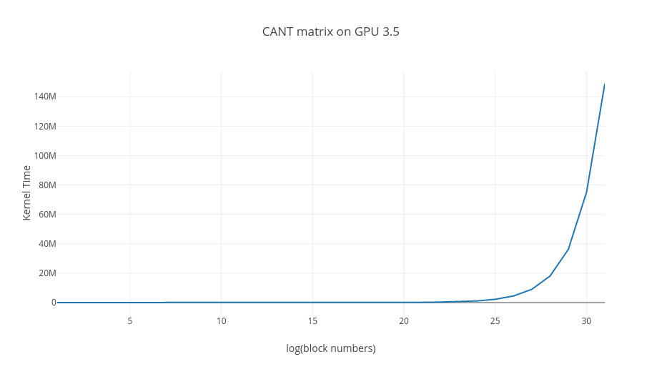

Above is the general graph cant matrix on GPU with CUDA capability 3.5. Below graph is the bathtub version which is obtained when we set x-axis range from 1 to 18.

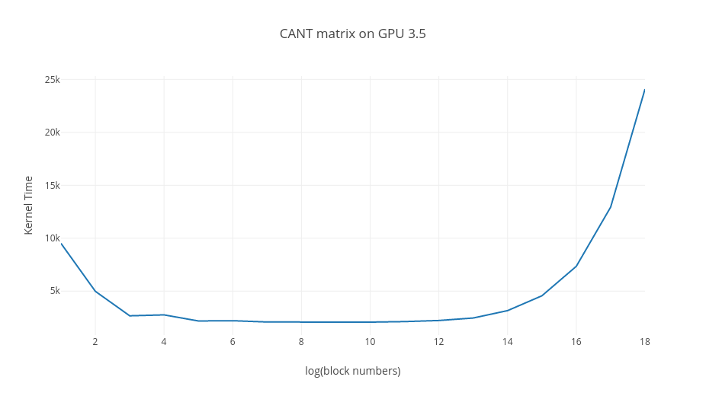

Let’s look at the side by side comparison of cant matrix on two machines.
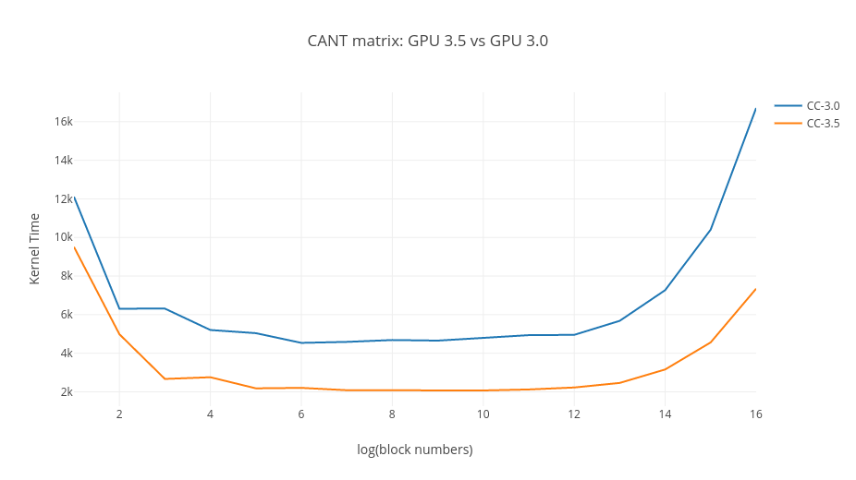

Following are the graphs obtained for the rest of the sparse matrices. We shall only be displaying the comparison graphs for them.

Circuit5M_dc matrix:
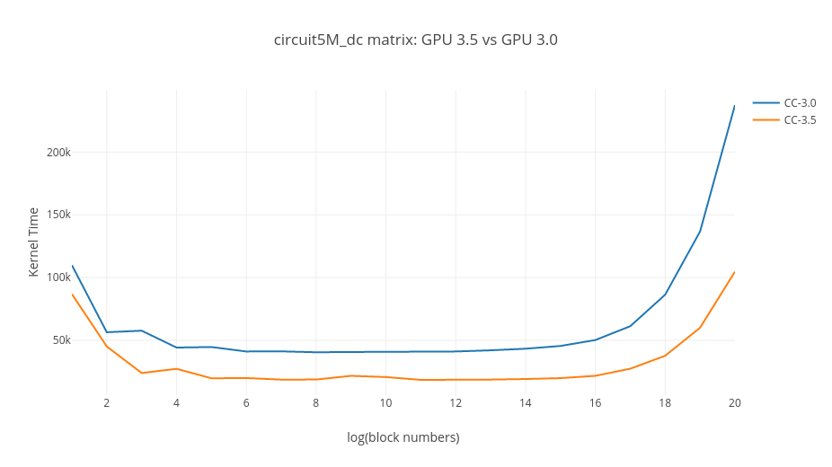.

Consph matrix:
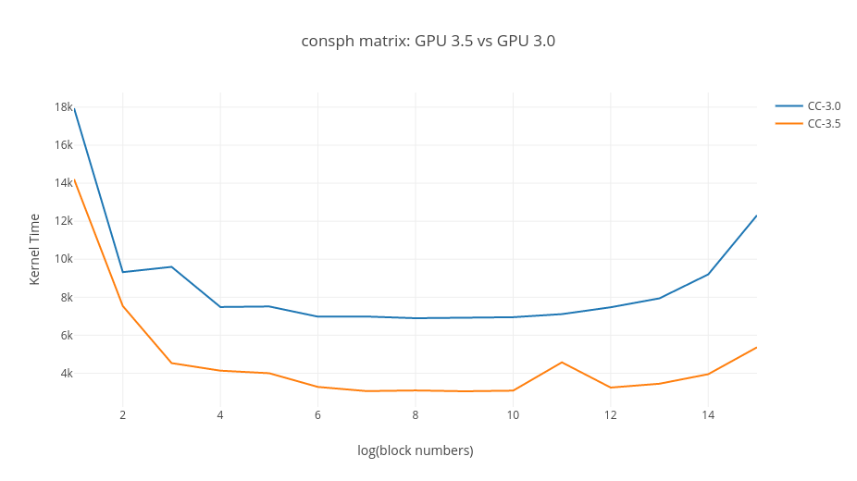
.

FullChip Matrix:

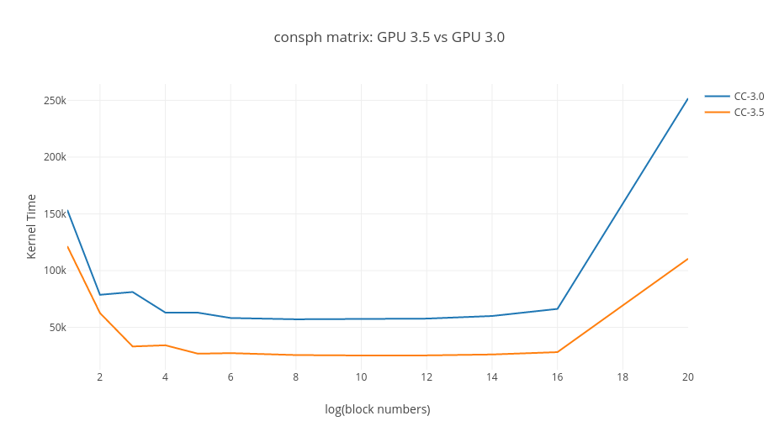

Mac-econ-fwd500 Matrix:
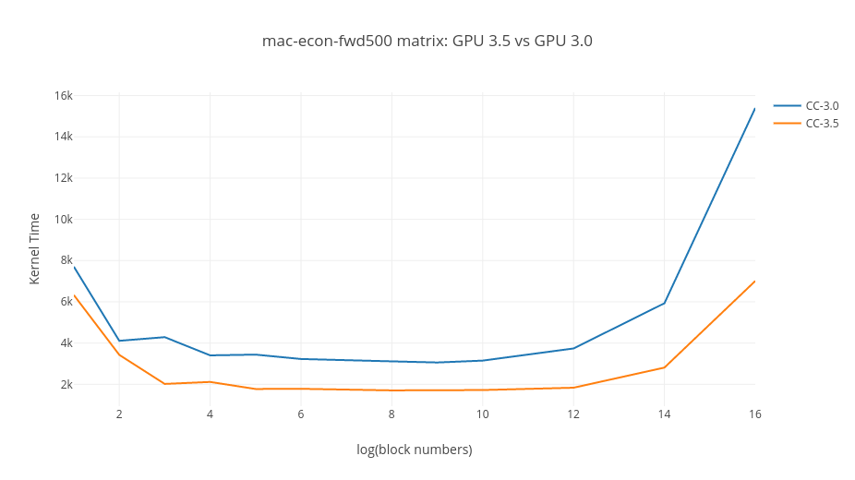

MC2Depi Matrix:

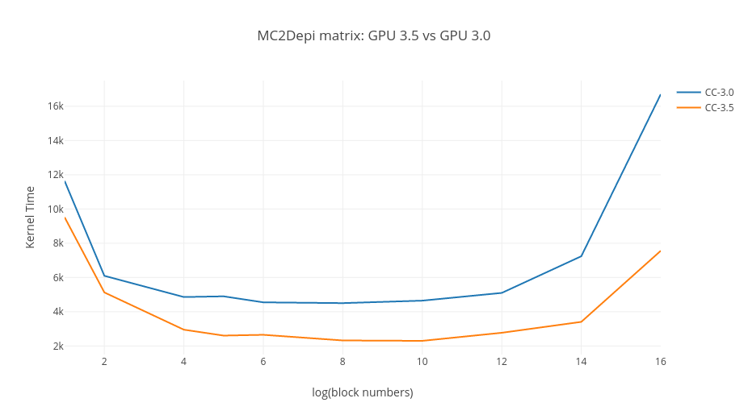

Pdb1HYS Matrix:

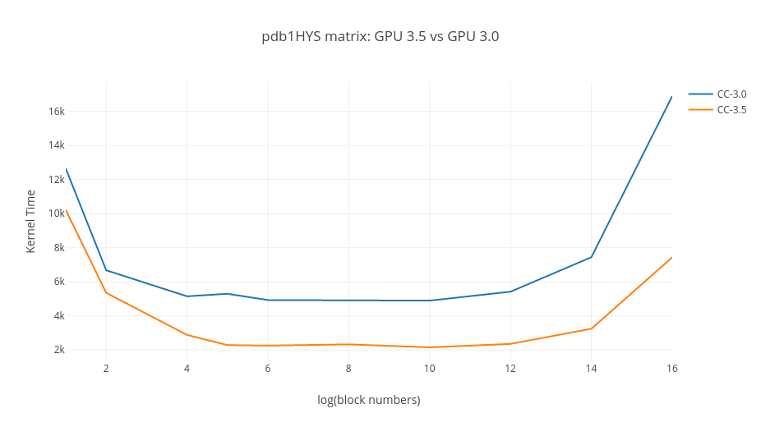

Pwtk Matrix:

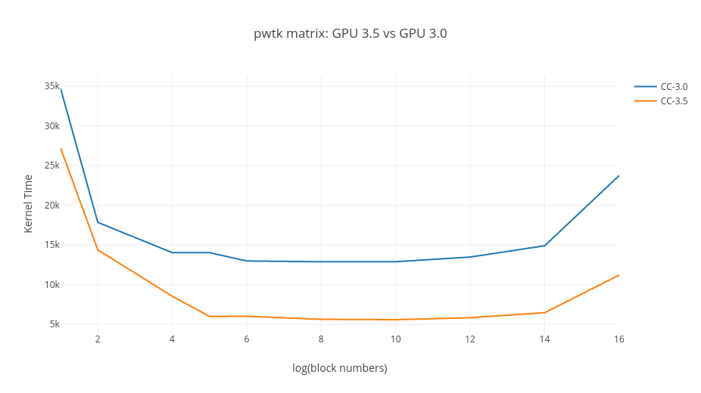

Rails4284 Matrix:

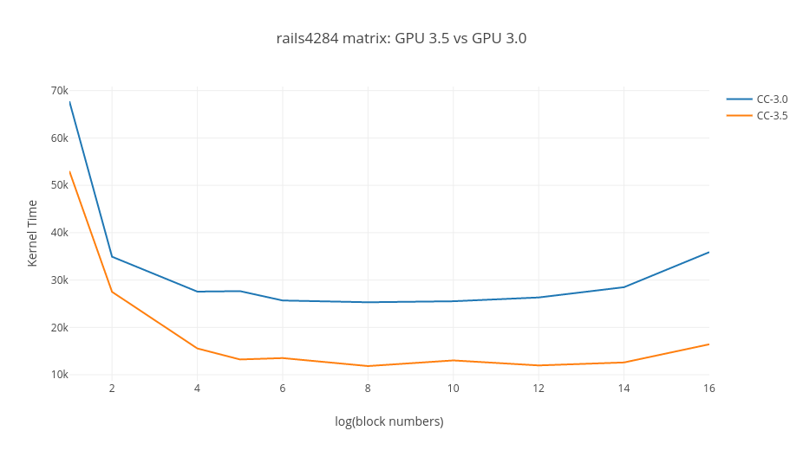

RMA10 Matrix:

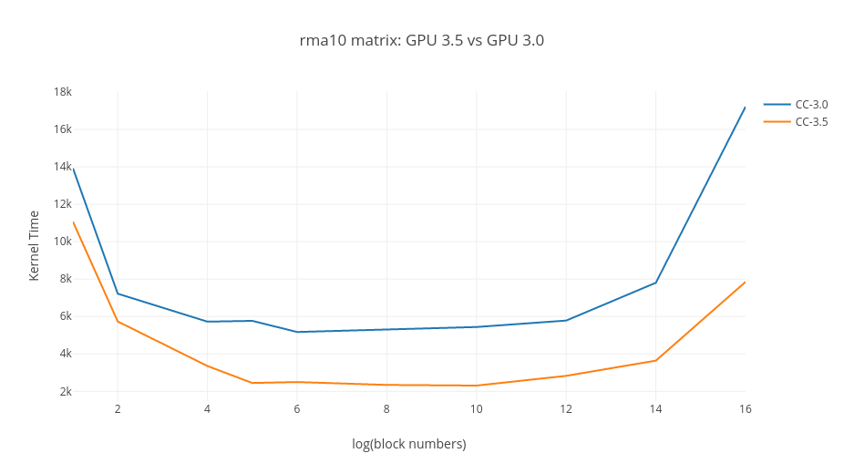

Shipsec1 Matrix:
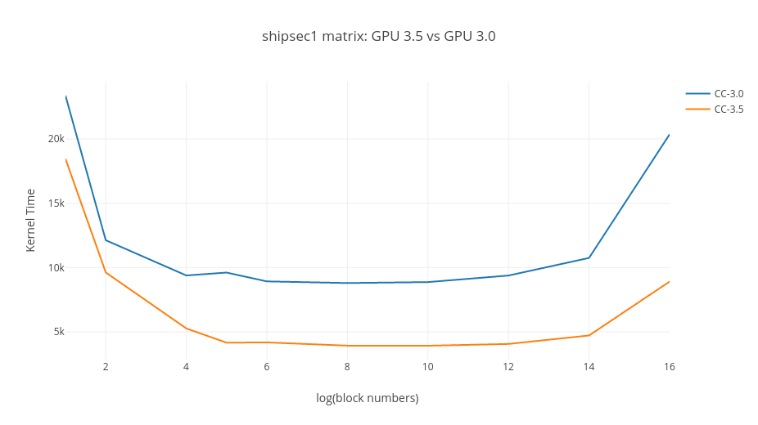
Turon_m Matrix:

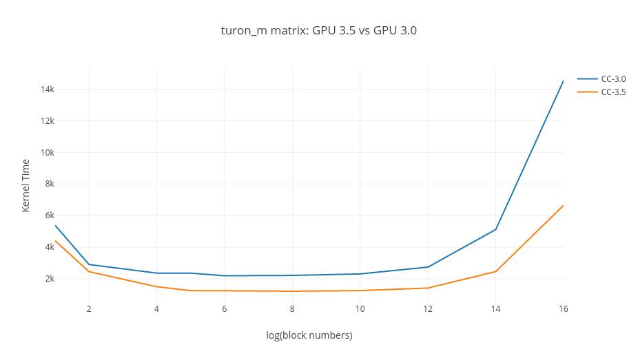

Watson_2 Matrix:

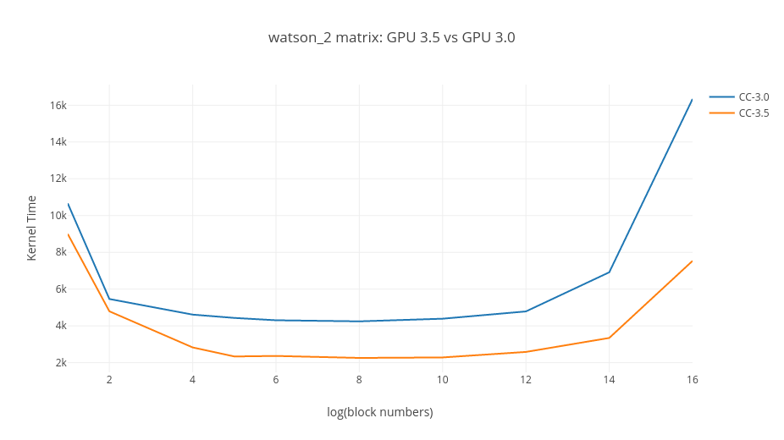

Webbase-1M Matrix:

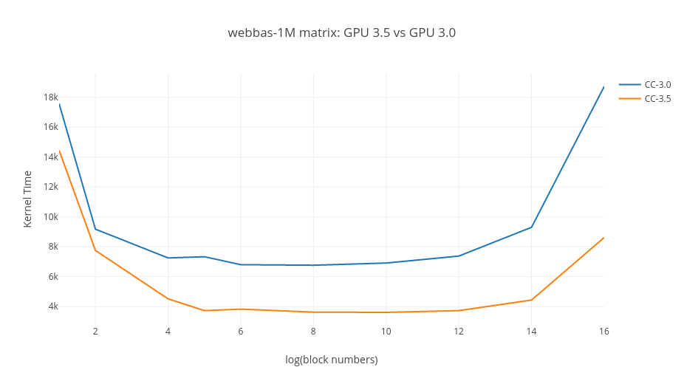

For every matrix max block number GPU 3.0 fails to launch kernel whereas GPU 3.5 reports a back result after significant time but the output received is 100% incorrect.

2. References

- http://docs.nvidia.com/cuda/cuda-c-programming-guide/index.html

- "Efficient Sparse Matrix-Vector Multiplication on CUDA" Nathan Bell and Michael Garland, in, "NVIDIA Technical Report NVR-2008-004",December 2008

- https://www.udacity.com/course/intro-to-parallel-programming--cs344

- Guy E. Blelloch. Prefix sums and their applications. Technical Report CMU-CS-90-190, School of Computer Science, Carnegie Mellon University, November 1990.

