**ACCELERATORS**

SAP Hybris Commerce Accelerator is a ready-to-use web framework that enables you to jumpstart your implementation and easily builds and maintain a feature-rich omni-channel commerce solution.

[**Core Accelerator**](https://help.hybris.com/6.0.0/hcd/6d03965f74b143d4ae45dc978919a84a.html): This document provides a brief, high-level overview of the Core Accelerator.

[**B2B Accelerator**](https://help.hybris.com/6.0.0/hcd/0babdccd1e9b45c4ba67fe84459a5bb7.html): SAP Hybris Commerce B2B Accelerator is a ready-to-use Web framework that enables you to jump-start your B2B implementation and easily build and maintain a feature-rich, omni-channel commerce solution.

[**B2C Accelerator**](https://help.hybris.com/6.0.0/hcd/7c1c7b5650084f7ea2652a6c5d74646f.html)**:** The SAP Hybris Commerce Accelerator is a ready-to-use omni-channel solution that you can use to speed implementation, boost sales, and increase growth across all of your channels.

[**Financial Services Accelerator - Business Guide**](https://help.hybris.com/6.0.0/hcd/50653313e8dc421589d9debdec174586.html)**:** The hybris Financial Services Accelerator is a tailor-made omni-channel solution for direct insurance companies and other financial services providers like retail banks that are looking to develop a more streamlined, seamless, personalized customer experience, while meeting the unique needs of their industry.

[**Telco Accelerator**](https://help.hybris.com/6.0.0/hcd/abd12ec3ef64410a8f0ac8fd831c0154.html)**:** The hybris Telco Accelerator is a ready-to-use Web framework that enables you to sell more online and offline in an intuitive and cost-effective way.

[**SAP Hybris Commerce, China Accelerator**](https://help.hybris.com/6.0.0/hcd/af963cf8796e453e8f5efc21f127b732.html)**:** The China Accelerator for SAP Hybris Commerce delivers a feature-rich omni-channel commerce solution quickly and easily. It takes full advantage of Hybris' unique flexibility and capability.

[**Travel Accelerator**](https://help.hybris.com/6.0.0/hcd/a67f3486657f47ea97127e6c611a4327.html)**:** Deliver Omni-channel Digital Traveller Engagement with SAP Hybris Commerce.

# CORE ACCELERATOR

This document provides a brief, high-level overview of the Core Accelerator.

SAP Hybris Commerce Accelerator is a ready-to-use web framework that delivers a feature-rich omni-channel commerce solution quickly and easily. SAP Hybris Commerce Accelerator takes full advantage of the unique flexibility and capability of SAP Hybris Commerce.

## Why SAP Hybris Commerce Accelerator?

E-Commerce today is a given. Consumers expect to seamlessly purchase products and services online. However, developing a feature-rich, online customer experience is a challenge for many organizations. Implementations are often complex, tedious, and costly. Moving from the single-channel to omni-channel adds further complexity to it.

Furthermore, consumer behavior is rapidly changing. Individuals now purchase products through print catalogs and stores, as well as online and through their mobile devices. To remain competitive, organizations must be adaptable to these changing trends. This requires an omni-channel commerce framework that is easily customized and extended, without restrictions.

All features specifically designed for the B2B, B2C, and other vertical markets are presented in the following documents:

* [B2C](https://help.hybris.com/6.0.0/hcd/8ac61ad386691014b213e7a549671397.html)
* [B2B](https://help.hybris.com/6.0.0/hcd/8ac4bffd86691014a08ba2e65a27f4fd.html)
* [Telco](https://help.hybris.com/6.0.0/hcd/8af76e0086691014b65a94b19f679088.html)

## Use SAP Hybris Commerce Accelerator to...

SAP Hybris Commerce Accelerator enables organizations to easily build a future-proof omni-channel commerce solution. It has all the functionality and business tools necessary to create an engaging customer experience, improve conversion, and simplify management. Built on SAP Hybris Commerce,SAP Hybris Commerce Accelerator allows organizations to extend functionality according to their needs. They can add other modules from SAP Hybris Commerce such as Mobile or Print, there is no limitation.

With its common platform that cohesively integrates across multiple channels, Hybris Commerce Accelerator enriches the customer experience while simplifying IT management. It enables companies to quickly implement best practices in the website design, search and navigation, shopping, checkout, content management, and merchandizing. Hybris Commerce Accelerator's easy-to-use Web framework allows development teams to ramp up quickly, while deploying the solution on a best-practice, step-by-step basis.

Hybris Commerce Accelerator offers the buy online pickup in store functionality, which enables the customers to search for the local stores stocking the products they need and purchase the product online. Additionally, they are able to make PCI-compliant payments on the storefront by posting their payment information directly to the payment service provider. Even more, they can purchase the items searched for using the guest checkout option. This helps to reduce the number of abandoned carts and addresses the customer's desire for privacy. The address verification system protects merchants against fraudulent customers by using the address verification mock as the starting point for integration with an address verification service in their region.

Hybris Commerce Accelerator is available in a traditional OnPremise license or OnDemand way with a monthly fee based on usage or revenue share.

Use of a single URL that is valid across lots of different devices. When the customer accesses the storefront, they are served the most appropriate UI experience for their device. This is based on a device resolution framework Spring Mobile Device. The Spring Mobile Device module provides support for server-side device detection. It is also possible to use the WURFL extendable framework however, it requires general attention while implementing due to a WURFL licensing issue.

All hybris Applications such as B2C Commerce Application, B2B Commerce Application, or Telco Application are delivered with Hybris Commerce Accelerator. Hybris Commerce Accelerator has a dependency to the Web Content Management Module and requires it to run.

## ... Implement Faster...

* A fully working, fully tested, best practice storefront.
* Fully working, fully tested, best practice storefronts for the desktop and mobile experience.
* Structured, standardized platform.
* Based on the best-practice development.
* Source code delivered to enable easy customization.
* Clear documentation, sample data, how-to samples, best-practice guidelines simplify implementation and maintenance.

## ... Sell More...

* Feature-rich and ready-to-use storefront.
* Feature-rich and ready-to-use omni-channel storefronts.
* Best-practice ordering, marketing, and merchandizing capabilities.
* Fully integrated web, order management, and call center functionality.
* Extended B2B-specific functionality.

## ... and Grow

* Multichannel foundation.
* Multichannel platform out-of-the-box.
* Easy to customize and extend.
* Rapid entry into markets.
* Ability to start online and to add other channels from the SAP Hybris Commerce.

## Key Business Challenges

E-Commerce projects can be challenging. Compared to many other commerce solutions, SAP Hybris Commerce Accelerator can be implemented quickly and cost-effectively. With Accelerator, hybris takes this even further. You can jumpstart e-Commerce implementations by using a pre-configured commerce foundation.

# Overview of Modules used by the Hybris Commerce Accelerator

This document provides a high-level overview of the modules used by SAP Hybris Commerce Accelerator.

Hybris Commerce Accelerator is an out-of-the-box, best-practice, e-Commerce implementation powered by SAP Hybris Commerce. Hybris Commerce Accelerator gives enterprises a faster, lower-cost implementation path resulting in a working website with a library of key components. The end-user documentation collected here guides you through Hybris Commerce Accelerator configuration and can help you achieve your day-to-day tasks and objectives.

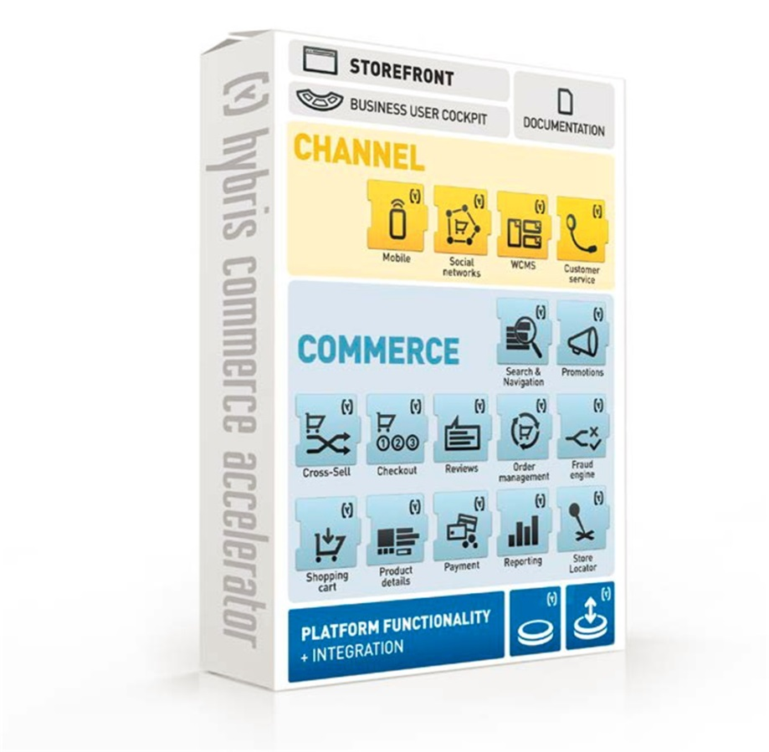

Figure: The SAP Hybris Commerce Accelerator is an out-of-the-box e-Commerce solution.

## Things You Need to Know

## SAP Hybris Commerce Accelerator is built on SAP Hybris Commerce, and offers you the synergy of the following functionality:

|  |  |  |  |
| --- | --- | --- | --- |
| **Module / Functionality** | **Documentation** | **Overview** | **Used to Perform These Tasks** |
| The Hybris Platform | * [Hybris Management Console](https://help.hybris.com/6.0.0/hcd/8bc9d6ba86691014a3ec95a1a2c1e882.html) * [Access Rights](https://help.hybris.com/6.0.0/hcd/8b4aa00e866910148df2920f69d68b27.html) * [The Administration Cockpit Perspectives](https://help.hybris.com/6.0.0/hcd/8b4deab786691014af75e6bcb44795d4.html) | * The Hybris Management Console (HMC) is the administration tool for SAP Hybris Commerce. * As part of SAP Hybris Commerce, it runs in web browsers. * Using the HMC, you can manage business objects of SAP Hybris Commerce such as products, customer data, orders, and access rights. * The Permissions services for SAP Hybris Commerce provide a framework that you can use to define and implement your own access rights policy. * By using permissions services, you can define specific access rights for users and their user groups. * You can manage the access right for types, attributes, or you can assign them globally by defining access rights for the users without referring to any existing types, items, or attributes. * The aim of the Administration Cockpit is to provide functionality similar to the Hybris Management Console(HMC), but in a more intuitive and user-friendly fashion. * The Administration Cockpit is intended to eventually replace the HMC as the central resource to manage your Hybris System. | E-Commerce Manager, Operations Manager, Content Editor, Marketeer, Translator, Publisher |
| The hybris Customer Service Module | * [Customer Service Module](https://help.hybris.com/6.0.0/hcd/8b9ff4ff86691014b69f9086de49923f.html) * [Customer Service Cockpit](https://help.hybris.com/6.0.0/hcd/8acdc6ee866910149489a9ebb1149f80.html) | * The Hybris Customer Service module provides the dedicated solution for the call-center environment. * Using the Hybris Customer Service cockpit, the call-center operator can very quickly perform the operations concerning the customer and order management in the sales and the post-sales processes. | Customer Services Agent, Customer Services Team Leader, Translator |
| The Hybris Order Management Module | * [Order Management Module](https://help.hybris.com/6.0.0/hcd/8c210e988669101496bc90b5fcd73724.html) | * The Hybris Order Management Module is a generic business layer service with the following available use cases: Authorize, capture, partial capture, cancel, follow on refund, and standalone refund. | Operations Manager, Marketing Manager, Product Manager, Customer Services Team Leader |
| The Store Locator functionality | * [Store Locator - Business Guide](https://help.hybris.com/6.0.0/hcd/8c648c0a866910149aaec47d36e8ebb8.html) | * The Hybris Store Locator provides an additional functionality of the Order Management Module. * It helps consumers find stores in the proximity of a postal code or using the Global Positioning System (GPS) information. | E-Commerce Manager, Marketing Manager, Product Manager |
| The WCMS Cockpit | * [Working with the WCMS Cockpit](https://help.hybris.com/6.0.0/hcd/8c81ad70866910149a04c9160ca0430b.html) * [WCMS Cockpit](https://help.hybris.com/6.0.0/hcd/8af99de886691014afb8e5aeeafbf00a.html) | * The Hybris WCMS Module enables end-users to manage website pages, providing them with an intuitive, graphical way of data presentation and management. * You can choose the perspective to work with, according to your needs and knowledge level. | Content Editor, Marketeer, Translator, Publisher |
| The Report Cockpit | * [Working with the Reporting Module](https://help.hybris.com/6.0.0/hcd/8c3cf56a86691014be6cd751d06c4f2a.html) | * The Hybris Reporting Module provides a cockpit where users are able to configure and display graphical statistics and reports in one central location. * The reports are shown using widgets technology. * The result is a dashboard providing users with immediate insight into statistical trends in their business through rich graphical charts. | Operations Manager, Marketing Manager, Marketeer, Product Manager |
| The hybris Payment Module | * [Payment Module](https://help.hybris.com/6.0.0/hcd/8c269fa7866910149b53db2d59417029.html) | * The Hybris Payment Module enables you to use the payment service provider adapters, for example, cybersource extension, in order to integrate payment gateways into the SAP Hybris Commerce. * **Note:** The Cyber Source extension has been removed from the SAP Hybris Commerce distribution. | E-Commerce Manager, Operations Manager, Marketing Manager, Product Manager |
| The Hybris Customer Reviews functionality | * [Moderating Reviews](https://help.hybris.com/6.0.0/hcd/8ae3260e86691014b294f81a34f61071.html) | The SAP Hybris Commerce Accelerator provides customer review functionality on the web front end. | Marketing Manager, Marketeer, Product Manager, Publisher |
| The HybrisSearch&Navigation functionality | * [Search & Navigation Module](https://help.hybris.com/6.0.0/hcd/8b300c4a866910149b55ef7c323ece04.html) * [Hybris Platform Search Mechanisms](https://help.hybris.com/6.0.0/hcd/8be9f4e586691014b318d62074b74ab5.html) | * SAP Hybris Commercecomes with a number of different built-in search mechanisms that allow you to search for items supported by the SAP Hybris Commerce. * The SAP Hybris Commerce Accelerator uses the Solr Facet Search technology, which is based on the multi-dimensional indexing performed by the Solr server. | E-Commerce Manager, Operations Manager, Content Editor, Product Manager, Marketing Manager, Marketeer, Translator |
| The Hybris Product Cockpit Module | * [Working with the Product Cockpit](https://help.hybris.com/6.0.0/hcd/8c31a552866910149fa2ff45929a4bbf.html) * [Product Cockpit](https://help.hybris.com/6.0.0/hcd/8ae7e19c866910149a8ab7ae2ddb9c75.html) | * The Hybris Product Cockpit Module enables cockpit end users to manage and structure product information and catalogs in high-volume and collaborative environments. * It supports them amongst others in a graphical way by dragging and dropping. * Several perspectives let you concentrate on the most important aspects of individual tasks, such as managing product data or structuring categories. | Product Manager, Marketing Manager, Marketeer, Translator, Publisher |

## Hybris Telco Accelerator End User Documentation

|  |  |  |  |
| --- | --- | --- | --- |
| **Module / Functionality** | **Documentation** | **Overview** | **User to Perform These Tasks** |
| [Bundling Module](https://help.hybris.com/6.0.0/hcd/8b6eec0286691014a041e59dc69dc185.html) | [Working with the Bundling Module](https://help.hybris.com/6.0.0/hcd/8b6ec19786691014834689cdbb08ab2b.html) | This documentation describes how to define and manage bundle templates in the Administration Cockpit, and how to enable product and marketing managers to create specific bundles in the Product Cockpit. | System administrators, product managers, marketing managers |
| [Subscriptions Module](https://help.hybris.com/6.0.0/hcd/8c69b65c86691014b915f0f6b049798e.html) | [Working with the Subscriptions Module](https://help.hybris.com/6.0.0/hcd/8c69362d86691014901bb9e9d1cde253.html) | This documentation covers defining subscription terms, usage units, and subscription products entitlements in the Administration Cockpit. It also provides information for product and marketing managers about how to create subscription products, define pricing models, and manage products by assigning entitlements in the Product Cockpit. | System administrators, product managers, marketing managers |
| Telco Accelerator-specific | [hybris Telco Accelerator within the Product Cockpit Tutorial](https://help.hybris.com/6.0.0/hcd/8addd76f86691014a4f7d0ce46e47479.html) | The documentation describes the entire process for providing customers with telco products. It covers the flow available in theProduct Cockpit. | Product managers, marketing managers |

# SYSTEM ARCHITECTURE OF SAP HYBRIS COMMERCE ACCELERATOR

This document introduces the key architecture aspects of SAP Hybris Commerce Accelerator. It is intended as a reference for developers, software architects, system architects, and consultants.

Hybris Commerce Accelerator combines a feature-rich web application with a collection of software components that fulfill many typical use cases that are common requirements on a vast number of hybris implementation projects. This document helps you understand the software as well as understand in more detail the features implemented by the software, how everything fits together, and how you can adapt the code or configure it to fulfill your project's requirements.

This document begins with a brief guide about how to use the document. Following that is a look at the architecture of an Accelerator driven deployment, which is presented to show a broad overview of the components involved. From there, you can pursue any topic, be it a guide to an extension, a guide to some specific functionality, and so on.

## Using this Document

This section guides you about how to use this document.

### Approaching the Documentation

There are two ways you can approach this documentation:

* You can deep-dive into one of the Accelerator extensions to find documentation related to the functionality and software components provided by that extension.
* You can read through specific topic area documentation, where functionality may cross the boundaries of multiple extensions.

The first use case tends to apply to developers who already have the code in front of them and want to understand part of it. The second use case applies to an architect or developer who wishes to understand the big picture of a more specific topic area such as how Advanced Personalization is handled in Accelerator or how Search and Navigation works.

### Understanding Data Model Diagrams

Accelerator uses a flexible type system that lets extensions add additional attributes to existing types. During build time, model objects are generated and compiled from the type system definition, located in the items.xml file, and the result is the complete data model.

Accelerator requires a specific set of extensions out-of-the-box, but like the rest of SAP Hybris Commerce, it does not impose any limitations on further extensions being added that include data model changes.

Unless it is required to improve the clarity of the diagram, all the Accelerator data model diagrams only show the attributes and relationships of types added in the Accelerator extensions. You need to refer to other counterpart documentation to see a fuller picture of the data model. Where a type was extended, the UML stereotypes were used to identify at the class level in which extension the type was added, or at the attribute level which extension added the attribute.

The following diagram shows this:

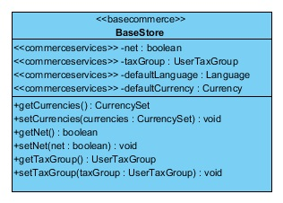

The BaseStore class is declared in the Hybris basecommerce extension. The <net>,<taxGroup>, <defaultCurrency>, and <defaultLanguage> attributes are all declared in thecommerceservices extension.

## Multitier Architecture

There are many types of system and software components that can make up a Hybris system deployment, indeed there is probably not one typical Hybris system deployment. The numbers of servers and components completely differ depending on the implementation requirements. To give you an understanding of the kind of system and software components you typically work with on a project starting with Accelerator as a base, the following section describes how various types of components physically and logically fit together. You can find more details about each component in the counterpart sections of the documentation.

The diagram below shows an example deployment setup of the Accelerator based implementation. The rest of this section provides more details about the deployment presented in the diagram.

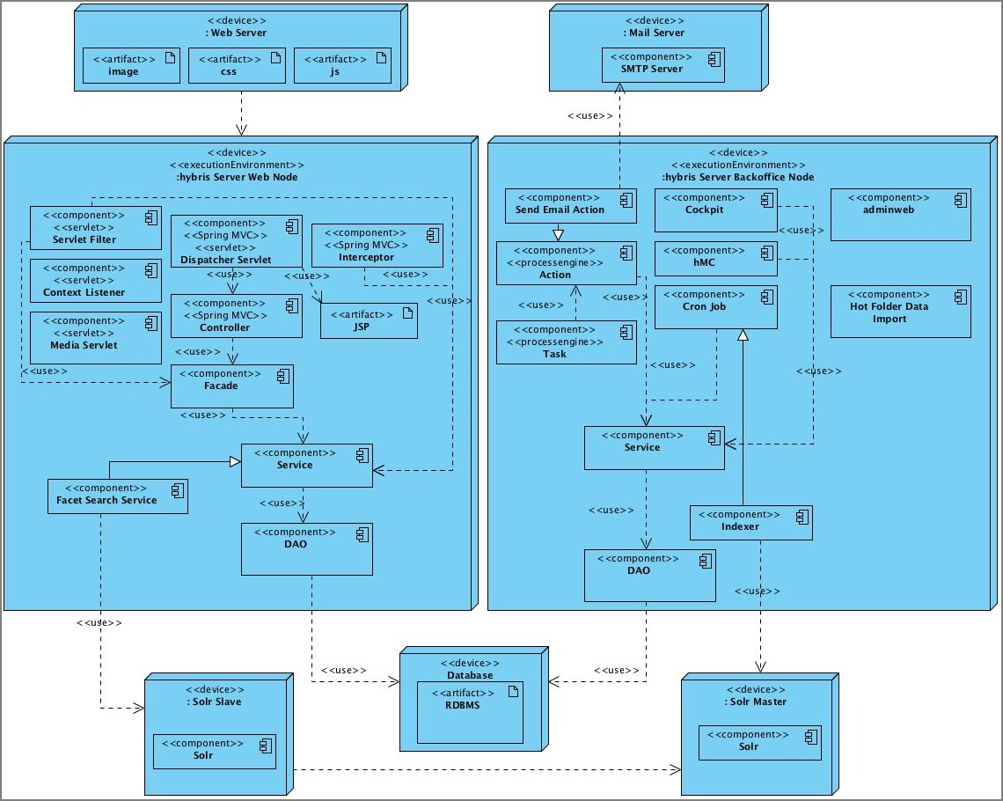

Figure: Example deployment of the SAP Hybris Commerce Accelerator based system.

### Web Server

It is common to use a web server such as Apache to store static assets such as images, CSS, and JavaScript files. This is typically done to ensure the application server resources are not troubled with serving assets that can be served from the web server with greater performance.

### Hybris Application Server Nodes

Although it is possible to install all the software components in Hybris on a single run time, it is more desirable to set up a cluster of servers to separate the functions that are dedicated to serving real-time customer web requests from those that perform asynchronous processes or administration interfaces. This preference is driven by performance, fault-tolerance, and network security reasons.

You can divide the software components that run inside the Hybris run time into separate logical layers. There is a brief description and reference to further information for each layer.

#### Web Request Application Server Node

You can set up one or more application servers to service requests from the web. These could be just requests on the websites or requests from web services. The state is maintained using HTTP sessions. The requests are often proxied through a web server and often a session ID aware load balancer is installed to ensure that load is distributed evenly to all available application servers.

##### **Presentation Layer**

The presentation layer consists of following components:

* **Servlet Components**
  + Filters
  + Listeners
  + Dispatcher Servlet
  + Media Servlet
* **Spring MVC**
  + Dispatcher Servlet
  + Controllers
  + Interceptors
* **View**
  + JSP/JSTL

For more information, see the following:

* [Storefront Web Application Deconstructed](https://help.hybris.com/6.0.0/hcd/8af03fda8669101491e4aac2acaeb2dd.html)
* [mediaweb Extension](https://help.hybris.com/6.0.0/hcd/8c10393c86691014971adc3a6bc9d827.html)
* [ServiceLayer](https://help.hybris.com/6.0.0/hcd/8c5a6a5986691014a65ee480c04c7b28.html)
* [items.xml](https://help.hybris.com/6.0.0/hcd/8bffa9cc86691014bb70ac2d012708bc.html)
* [ServiceLayer Architecture](https://help.hybris.com/6.0.0/hcd/8c59b23586691014a903dc21e06413c4.html)

##### **ServiceLayer**

The ServiceLayer API consist of following components:

* Facades
* Services
* Data Access Objects

Hybris Commerce Accelerator uses services and facades exposed in the commerce services and commerce facades extensions. Both of these extensions contain implementations of commerce-related services and facades, which you can use in different clients that require access to some higher level commerce methods.

The Hybris Commerce Accelerator project also contains two additional modules: accelerator services and accelerator facades. You can place all Accelerator-specific implementations of the service layer in one of these extensions.

##### **Persistence Layer**

The persistence layer is all out-of-the-box and requires very little work on the project side except describing/modifying types in the items.xml file.

##### **Simple Request Interaction Diagram**

The following interaction diagram shows how the application server components interoperate to service a client request:

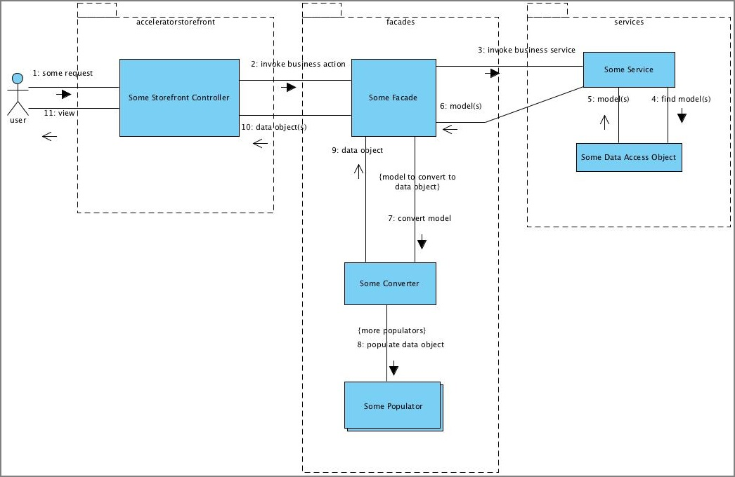

#### Back Office Application Server Node

Back office functions including various administration interfaces can be separated onto different physical application servers. This can simplify security as administrative applications that should not be available across the Internet can simply be installed on a back office machine without Internet access. Back office processes tend to require different types of data to be cached, thus helping to improve cache performance. It can also be desirable to allow for a little downtime possibility on back office nodes, separating the back office process allows you to do this without having downtime on the storefront.

##### **Administration Applications**

The following applications can be used for the administration of your system:

* Management Console
* Administration Web
* Business and Administration Cockpits, for example:
  + Administration Cockpit
  + Product Cockpit
  + WCMS Cockpit
  + Report Cockpit
  + Print Cockpit
* Customer Service Cockpit

For more information, see the following:

* End user documentation:
  + [hMC - End User Guide](https://help.hybris.com/6.0.0/hcd/8bc9d6ba86691014a3ec95a1a2c1e882.html)
  + [hybris Administration Console - End User Guide](https://help.hybris.com/6.0.0/hcd/8be770da8669101487a5b744fb536106.html)
  + [Getting Started with the Administration Cockpit](https://help.hybris.com/6.0.0/hcd/8bc712a5866910148daeb0e866b6409e.html)
  + [Product Cockpit - End User Guide](https://help.hybris.com/6.0.0/hcd/8c31a552866910149fa2ff45929a4bbf.html)
  + [WCMS Cockpit - End User Guide](https://help.hybris.com/6.0.0/hcd/8c81ad70866910149a04c9160ca0430b.html)
  + [Reporting Module - End User Guide](https://help.hybris.com/6.0.0/hcd/8c3cf56a86691014be6cd751d06c4f2a.html)
  + [The Customer Service Cockpit Interface](https://help.hybris.com/6.0.0/hcd/8b9f70d886691014baccd97219480e1f.html)
* Technical documentation:
  + [hmc Extension](https://help.hybris.com/6.0.0/hcd/8bca888b86691014abfbaf7b92c133f0.html)
  + [hac Extension - Technical Guide](https://help.hybris.com/6.0.0/hcd/8bc8817b86691014849da1a8f44f3973.html)
  + [mcc Extension - Technical Guide](https://help.hybris.com/6.0.0/hcd/8c0ea6b1866910149b2fdbdeb90953fc.html)
  + [admincockpit Extension - Technical Guide](https://help.hybris.com/6.0.0/hcd/8b4d920986691014a234c57a82735637.html)
  + [productcockpit Extension - Technical Guide](https://help.hybris.com/6.0.0/hcd/8c335d0786691014886de5b2e6e18406.html)
  + [cmscockpit Extension - Technical Guide](https://help.hybris.com/6.0.0/hcd/8b7d88d286691014908f9e03b4b8b69d.html)
  + [cscockpit Extension - Technical Guide](https://help.hybris.com/6.0.0/hcd/8b9deabf86691014889e906245b4a324.html)

##### **ServiceLayer**

The SAP Hybris Commerce Accelerator and Hybris system are based on the Service Layer API. The following technologies are used within the SAP Hybris Commerce Accelerator:

* Cron Jobs
* Tasks, Processes, and Actions
* Hot Folder Data Importer
* Services
* Data Access Objects
* SOLR Indexer

##### **Persistence Layer**

The persistence layer is all out-of-the-box and requires very little work on the project side except describing/modifying types in the items.xml.

#### Diagram of Logical Organization of Software Components

The following diagram shows how the components are arranged into their logical tiers:

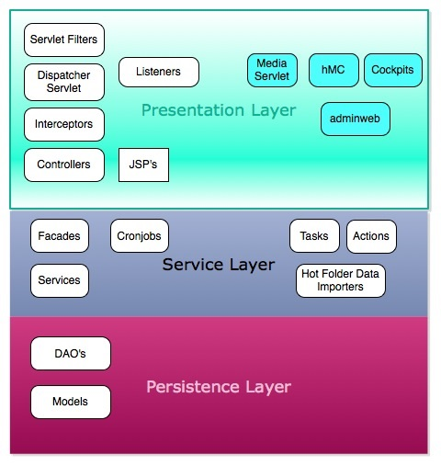

### Solr Standalone

SAP Hybris Commerce packages Solr 5, which doesn't support running Solr in Embedded mode. To assist projects in their development, a number of new Ant Tasks are available. More information is available in [Search & Navigation](https://help.hybris.com/6.0.0/hcd/8b300c4a866910149b55ef7c323ece04.html) document and [solrfacetsearch Extension](https://help.hybris.com/6.0.0/hcd/8c608c75866910148920824064c5b6ba.html" \o "The solrfacetsearch extension provides faceted search and navigation functionality based on the Apache Solr server. It enables you to do a faceted (also called dimensional) search over Hybris items such as products and WCMS contents.) Technical Guide.

### Relational Database

The Hybris system supports a wide range of RDBMS. You can find more information in the [Third-Party Databases](https://help.hybris.com/6.0.0/hcd/8c71816186691014b734cf6c17d0ad0a.html) documentation.

### Other Components Not Covered

* Load Balancers
* VIPs
* Firewalls
* SFTP/FTP Servers
* Media Asset Management Systems
* ERP Systems
* Payment Service Providers
* CRM Systems
* Content Delivery Networks

### Integration Points To Consider

SAP Hybris Commerce Accelerator provides a great deal of functionality straight out-of-the-box, but projects need to consider additional integration points to other external systems. The following deployment diagram identifies integration points to some more common third-party systems that may need additional development effort. This list is not exhaustive, but it is a list of fairly common integration points in a B2C implementation.

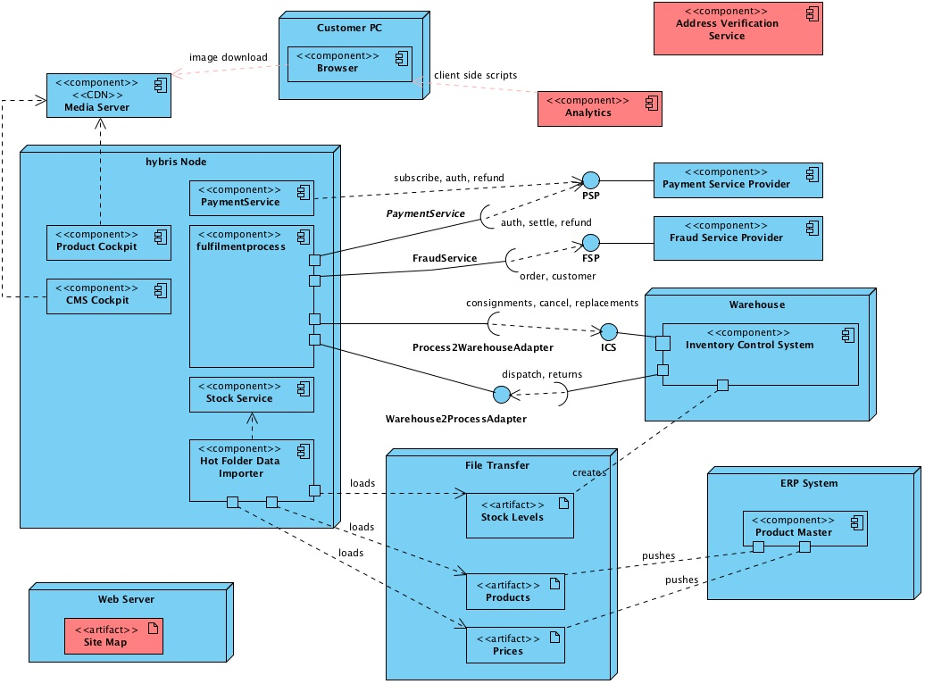

#### ERP as a Product Data Source

If Hybris PCM is not going to be the master for product information, the project's customer usually has one or more existing Enterprise Resource Planning (ERP) systems in place that contain the master product and pricing data. The project customer may also have an existing Enterprise Application Integration (EAI) tool that is used to integrate the company's various systems. It may be the customer doesn't have anything as sophisticated as an ERP - regardless, the point is that a separate system contains the product/pricing master data and this data needs to be integrated with Hybris.

The yacceleratorcore extension provides a Hot Folder Data Import feature based on Spring integration. Out-of-the-box, you can drop CSV files into a hot folder location and you can configure the application to load these files in a batch and update the Hybris system. If the implementation project just requires additional files and attributes and the CSV format is fine, then the level of effort should be quite low. If a project is lucky enough to be able to dictate the file format, then the level of effort is reduced even more.

If updates have to arrive in a different format, then you need to adapt the Data Import feature to work with differing formats by integrating a different ImpexTransformer. Furthermore, if the format is not delivered as a file, then you need to adapt the ServiceActivator to handle the new inbound format, such as ESB Integration, a JMS Message, or a WebService request. In the later case, the software provided by the Hot Folder Data Import feature is little more than a reference of how to use Spring Integration to integrate external data sources into Hybris.

#### Warehouse

Most websites that sell physical products need some direct interaction with a Warehouse Management System (WMS) or a Stock Control System if the Hybris Order Management Module is to be used to control the full fulfillment process.

The template yacceleratorfulfilmentprocess extension provides various stubs where interfaces to a WMS could be implemented for a project. Out-of-the-box, a Warehouse Mock simply pushes the order through the fulfillment process. Effectively, a project needs to replace the Mock with the integration code that interfaces with the WMS. The yacceleratorfulfilmentprocessextension is built using the Hybris Process Engine, so you can adapt it to meet project-specific fulfillment workflows. Generally, interfacing with warehouse systems incurs quite lengthy testing to ensure all the various order process permutations get sufficient coverage, so this would usually require a high level of effort.

#### Payment Service Provider

The yacceleratorstorefront extension takes payment card information and expects a third-party Payment Service Provider (PSP) to support a subscription saved-card based service primarily to ensure that customers sensitive card information, like the number and CVV, do not need to be stored in the Hybris database. The integration with the PSP is a deep integration, in that the web application still receives the full card details and then, in the same request, passes them on to the PSP.

By default, a Mock PSP is enabled, but Accelerator also offers the cyber source extension, which adds a Card Payment Service implementation for cyber source. Accelerator has been tested with cyber source. Using cyber source as the payment service provider is mostly a configuration effort with Cyber Source and therefore has a low effort impact. If a project has to integrate a different payment service provider, then this needs a new CardPaymentService implementation. This entails at least a medium level of effort.

**Note:** The Cyber Source extension has been removed from the SAP Hybris Commerce distribution.

Two different payment flows are present out-of-the-box:

* hosted page: where the user is being redirected to a 3rd party page to enter credit card information
* order post: where a credit card form is rendered in the accelerator and posted directly to the 3rd party

These two solutions have their implementation in cybersource (HOP and SOP) and are supported by Accelerator out-of-the-box.

Other payment providers support the same type of flow and implementing another payment provider entails at least a medium level of effort.

#### Fraud Service Provider

SAP Hybris Commerce Accelerator ships with a score-based extensible Fraud Detection system that allows you to do real-time checks against certain aspects of an order or a customer. Essentially, the checks look for certain symptoms and rank the results with a score. If the result of all the checks is a score that exceeds a tolerance threshold, the order is put on hold.

If a project requires additional fraud checks to be carried out by an external fraud service provider, typically due to a requirement for accessing external information like blacklisted cards or a credit history, then it is possible to plug such a provider directly into the fulfilmentprocess by implementing a new FraudServiceProvider. The new provider can either replace the standard hybris provider or be added as a separate fraud check step.

It is also possible to extend the existing symptom detection logic in the Hybris Fraud Service and add additional rules.

This integration tends to constitute a low level of effort to add a few extra rules, pushing to medium-high to integrate a whole new external fraud provider.

#### Media Server

Hybris provides a Digital Asset Management module. This is not demonstrated with SAP Hybris Commerce Accelerator as it requires installation of third-party software that complicates the basic developer-ready install, but the system is fully compatible with this module. You can integrate it directly into the cockpits to pull media directly from the DAM as well as supporting the creation of automated jobs to pull updated media without any manual intervention. It should be deemed low to medium effort to get this module running.

Content Delivery Networks (CDN) support for images is not explicit, however you can integrate such support into the Facade layer by effectively replacing the Standard ImageConverter. Out-of-the-box, this uses a Media as the source to create the prototype ImageData object. However, you can replace it with one that can generate ImageData objects using another source, for example something as simple as a naming convention. This would be low to medium effort.

#### Analytics

It is common to include analytics on a web site to figure out how your customers are using the site and what pages are popular and unpopular. Typically this involves adding the necessary data you wish to track in the page view and including some JavaScript on each page.

Out-of-the-box the yacceleratorstorefront extension includes integration of Google Analytics via the analytics.tag file. Further implementations can be added through this file or in an AddOn.

#### Site Map

You may want to generate a Search Engine Site Map to place on your website web server. A CronJob is provided that will generate Google-compliant Site Map XMLs and make them available in the standard sitemap.xml file.

#### B2B Commerce Module

The Hybris B2B Commerce Module allows you to leverage the Hybris B2C features in a B2B context. The B2B module is now delivered as a set of AddOns to the base Accelerator. See [List of B2B-Specific Extensions and AddOns](https://help.hybris.com/6.0.0/hcd/8ae0c5ce866910148fe8ac574edab5e4.html) for more information.

The B2B Commerce Module provides an intuitive way to interact with client companies, to assign different prices, allow access to different catalogs, promote special quote negotiations, and extend different credit limits. Additionally, you provide the customers with the tools to manage their own organizations, employees, and company hierarchy. Therefore, to set up a new client, you only need to create a new organization and a new customer in that organization with administration roles. From that point forward the new customer with the administration role can expand, configure, oversee, and maintain the organization.

##### **B2B Organizations**

A client organization is set up to be hierarchical where each node is called a unit. A unit may represent a subdivision such as a department. An individual customer exists as a member of a unit within this hierarchy. Many rules and criteria are derived from the hierarchy, for example the transaction approvers associated with a customer, what credit limits apply, or what cost centers customers may access.

To demonstrate organization setups that clients might have, the power tools store extension in Accelerator provides two fictitious client organizations. Please see the diagram below for more details.

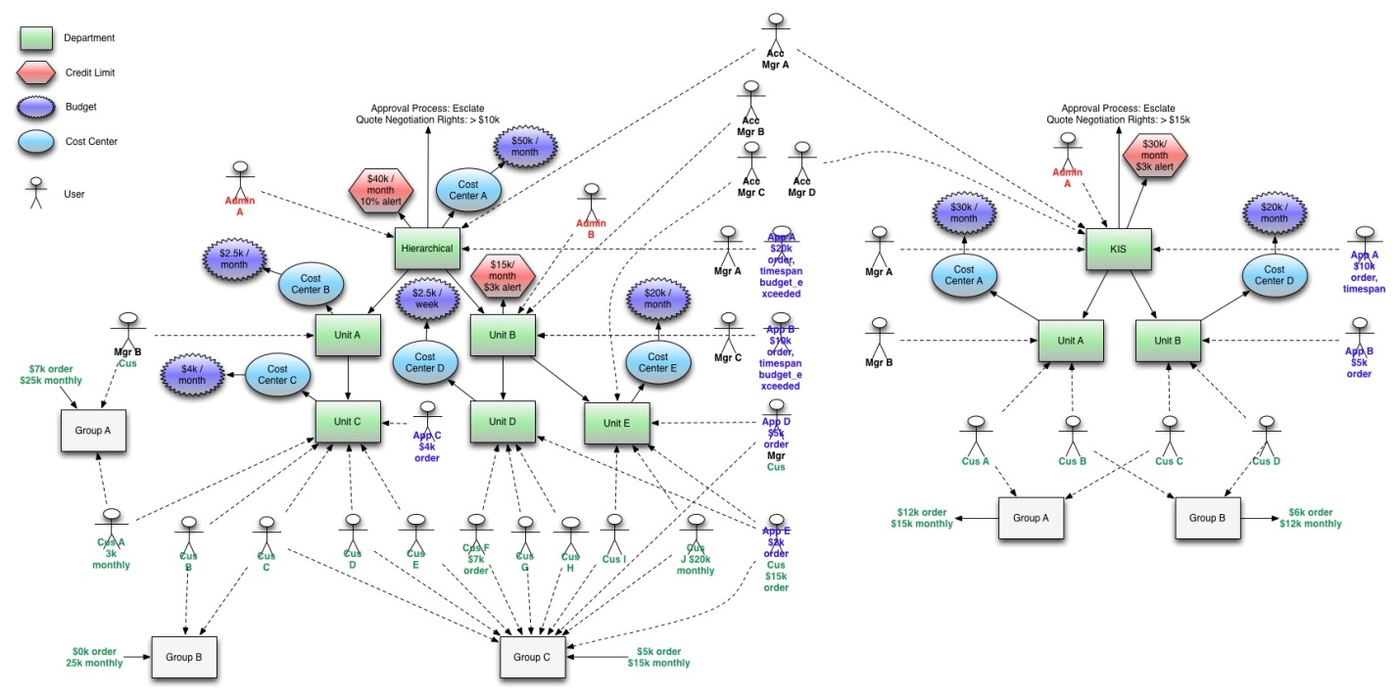

Figure: Reference B2B store, shipped with SAP Hybris Commerce Accelerator.

The reference B2B store available in the Accelerator package has four account managers for various units. The diagram above illustrates the interaction between account managers, the customers, customers in different locations in the company hierarchy, the various purchasing permissions, and the responsibilities and purview of customers with various roles.

##### **B2B Credit Limits**

Within the reference organization, you may find a credit limit of $40 000 a month and a quote negotiation threshold of $10 000. You may impose a credit limit on a company, after which point orders do not go through without the explicit approval of the designated account manager. Additionally, withAccelerator, there is a quote negotiation threshold set up, which permits orders with higher totals to be eligible for price negotiation with an account manager.

##### **Roles and Visibility**

There are four roles with different privileges that you can grant to customers: **Admin**, **Manager**, **Approver** and **Customer**. You give roles to customers by adding them to the following usergroups:**b2badmingroup**, **b2bmanagergroup**, **b2bapprovergroup** and **b2bcustomergroup**. Administrators have many configuration options for their organization. They can designate budgets not to be exceeded, determine different purchasing rules for different staff members, designate approvers, and mandate delivery addresses. Members of **b2bcustomergroup** can make purchases and **b2bapprovalgroup**members can approve orders, other factors notwithstanding.

The unit a customer is a member of in the hierarchy determines his visibility within the organization. Members, even administrators, can only access entities associated with their parent units as well those associated with any of its subunits. In our diagram, a customer **Admin A** presides over an organization of six units or departments. **Admin B** is set up further down in the hierarchy where **Admin B** can manage the immediate unit, as well as all of its subunits, but **Admin B** may not access entities, that is customers, cost centers, and permissions above **Admin B**'s parent unit.

##### **Cost Centers and Budgets**

As customers place purchases against the company account, they must bill them to specific cost centers. Per visibility, they have access to cost centers assigned to their unit, and the cost centers in their branch. Cost centers also dictate the delivery address they may choose. A budget, set up by an administrator, is associated with each cost center. Once purchases against the cost centers exceed the budget, no further purchases are allowed without explicit permission.

##### **Order Permissions and Order Approval Process**

There are three checks that are verified before an order is placed. This is the stock configuration of the b2bapprovalprocess extension. Please refer to documentation about b2bapprovalprocessextension to learn how to configure and create new permissions and approval processes to suit your specific needs. The three implemented permissions are Order Threshold Permission, Order Threshold Timespan Permission, and Budget Exceeded Permissions.

An administrator creates instances of the permissions such as Order Threshold Permission with varying threshold amounts, for example $500, $5000, and so on. These permissions are then either directly assigned to the customers or added to a permission group and the permission group is assigned to a customer.

Upon initiating an order, the approval processes evaluates the order against the customer's permissions. The order gets placed if the customer possesses all three required permissions for that order. If the customer permissions are not sufficient, the b2bapprovalprocess approval strategy searches for approvers assigned directly to the purchaser, then searches the parent unit, and then up the organization units until it finds an approver who possesses the missing permissions to place that order. Once an approver is found, it appears in the approvers Order Approval Dashboard where the approver may add a comment and approve or reject the order.

#### Google Local Shopping Export

SAP Hybris Commerce Accelerator supports exporting product data, prices, and store locations to Google Shopping / Local, so that customers can find products in their local stores via the Google search.

The process of exporting data to Google Local Shopping is split into two separate parts. The first part generates the data file and the second part uploads the data files to the Google servers. Both processes are triggered by a CronJob. The CronJob initiates a spring integration pipeline, which actually does the work.

##### **Generating Export Data**

The DataExportCronJob initiates the process of generating the data files. It executes theDefaultExportDataJobPerformable job and is configured with the following parameters:

|  |  |
| --- | --- |
| **Parameter** | **Description** |
| **baseStore** | The base store to export products and stores from. |
| **cmsSite** | The CMS site used to build links to the online products. |
| **language** | The language for the data to export. |
| **currency** | The currency for the product prices to export. |
| **user** | The user to run the export as, which controls the available products, prices, taxes, and so on. |
| **thirdPartyHost** | The upload location for the generated files. |
| **thirdPartyUsername** | The username of the third party account. |
| **thirdPartyPassword** | The password of the third party account. |
| **dataGenerationPipeline** | The name of the spring integration pipeline that generates the data |

The default Spring integration pipelines for Google Local Shopping export areexportGooglePosPipeline and exportGoogleProductPipeline. TheexportGooglePosPipeline exports all the stores in the selected base store. TheexportGoogleProductPipeline exports all the products in the selected base store. Google suggests the store export be generated at least monthly, and the product export be generated at least weekly. As these two different exports have to be triggered by different cron jobs, it is straight forward to configure them with different schedules.

The generated files are written to the local file system, if Hybris is running in a cluster, then the files are written to the node where the export cron job executes. The export folder location is looked up via the runtime configuration property <acceleratorservices.export.basefolder>, which defaults to ${HYBRIS_BIN_DIR}/ext-accelerator/acceleratorservices/export. The generated files are named to allow the upload process to identify the data export cron job that generated it.

##### **Uploading Data**

The data upload is initiated by a GenericCronJob executing theDefaultUploadDataJobPerformable. This triggers a Spring integration pipeline that looks for generated data files that need to be uploaded. The filename allows the export cron job to be identified and from that the upload configuration can be read. The file it uploaded to the thirdPartyHostusing the thirdPartyUsername and the thirdPartyPassword.

##### **Customizing the Export**

The main aspect of the Google Local Shopping export that you need to customize is the conversion beans that convert the hybris items into the appropriate record format for export to Google:

|  |  |  |  |
| --- | --- | --- | --- |
| **Bean** | **Converter Type** | **Source Type** | **Target Type** |
| exportGooglePOSConverter | **de.hybris.platform.acceleratorservices.dataexport.googlelocal.converter.PosConverter** | **PointOfServiceModel** | Business |
| exportGoogleProductConverter | **de.hybris.platform.acceleratorservices.dataexport.googlelocal.converter.ProductConverter** | **ProductModel** | Product |

#### Store Locator

Store Locator is a functionality that helps consumers find stores in the proximity of a given postal code or city name. The StoreLocatorFacade is exposed in the commercefacades extension, and it uses services from basecommerce module. Searching and returning results is based onPointOfService objects stored in the database.

#### Customer Reviews

Customer reviews is a functionality that allows clients to add a review to a product. In thecommercefacades extension, retrieved product data is filled with reviews that are fetched from database. All service layer functionality related to customer reviews is in customerreviewextension. Search restrictions that limit fetched reviews only to approved and belonging to customer user group is turned on by default and can be deactivated with the property key<customerreview.searchrestrictions.create>.

**AddOn Concept**

AddOns are built on top of the existing SAP Hybris Commerce to extend the functionality of the SAP Hybris Commerce Accelerator. AddOns are a type of extension that allow you to add front-end files (such JSP, HTML, CSS, and JavaScript files, as well as images) from within your own AddOn, instead of modifying the storefront front-end files directly.

The overall extensibility of SAP Hybris Commerce Accelerator is also improved in the following ways:

* You can generate your facade Data Transfer Objects (DTOs) and extend them, even if they are not defined in your own AddOn.
* You can plug populators into existing converters without having to redefine them.
* Some facades and services have been refactored so that they can be easily plugged in and their behavior can be easily modified.

The AddOn concept is described in further detail below. For more information on extensions, see the[Extension Concept in the SAP Hybris Commerce](https://help.hybris.com/6.0.0/hcd/8bbf0b9d866910149688b8d696c8d47e.html).

## OVERVIEW

SAP Hybris Commerce Accelerator is built on an extensive framework that includes a template for storefront implementation. AddOns and extensions provide a well-defined infrastructure for third party developers to plug in their own functionality.

Using AddOns, you can extend the functionality of Hybris Commerce Accelerator without editing the core code base. The core code base in this context means the Hybris Platform, and all additional extensions delivered with Hybris Commerce Accelerator. An AddOn is a regular extension that may, or may not, provide additional front-end components to Hybris Commerce Accelerator.

### Creating Extensions

When creating extensions (including AddOns), it is a good idea to keep the logic and storefront-related features in separate extensions. That is why extensions are organized into the following groups:

* Accelerator project extensions
* Accelerator cockpit extensions
* Accelerator sample and test data
* Commerce storefront API extensions

## AddOn Architecture

An AddOn is a regular Hybris extension that is configured using the extensioninfo.xml file, located in the root folder of the AddOn. Additionally, the storefront extension that is extended by an AddOn has to reference this AddOn in the extensioninfo.xml file. The structure of this file is exactly the same as any regular extension. For more information about this file, see [extensioninfo.xml](https://help.hybris.com/6.0.0/hcd/8bbf6b5e86691014ad49fd1bc0172e5c.html).

### Extensibility of the Framework

The diagram below illustrates the three-layer model of the extensible framework of Hybris Commerce Accelerator:

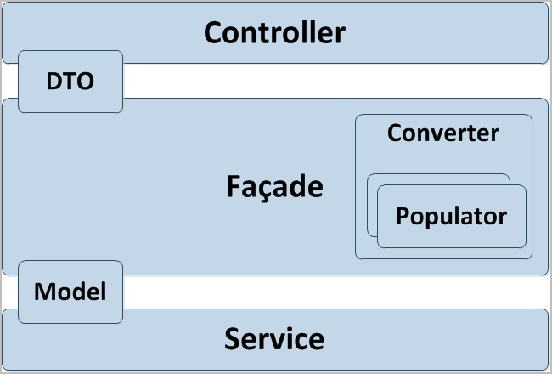

Figure: Three Layer Model.

At the bottom is the **Service** layer, which includes fine-grained business methods, such as the ones responsible for adding promotions to a cart, or for calculating the total value of the cart. These services expose the data **Model**, which persists in the database.

On top of the Service layer, there are **Facades**, which implement specific business use-cases, such as adding a product to a cart, placing an order, or searching for a product. The facades expose the **Data Transfer Objects (DTOs)**, which are completely independent from the underlying storage technology. There may be a one-to-one mapping of the model (such as store products), but there may also be a subset of the model, or aggregated models. The DTOs are not always stored in the database. An example of this is the Solr objects, which are stored in the Solr index.

The **Converters** delegate to **Populators** to convert the DTOs back and forth to models. For example, a product that has basic attributes, such as name, title, and description, can also have classification attributes. Therefore, you might have two populators, one for the basic attributes, and one for the classification attributes.

The facade layer, including the DTOs, represents the Hybris OmniCommerce Connect. This is a business API, and the foundation for the web services.

On the top layer, the **Controllers** take the DTOs and expose them to the view. This is done using the Spring Multi View Controller (MVC), which replaces all the facades, services, and controllers.

### Extensibility of the Front-End

One example of extending the front-end is to enable customer feedback on your storefront. In this scenario, when a customer provides feedback, or rates a certain product, the system would automatically create a Customer Service Cockpit ticket for a customer service representative to review.

## The AddOn Approach

The AddOn concept aims at extending the Accelerator storefront without touching its core code base. For example, you could implement customer feedback functionality on your storefront without editing the source code. Instead, you would plug in all the functionality from within your AddOn.

Continuing with this example, the AddOn would have an additional folder called acceleratoraddon, and the structure of the folders within it mirrors the structure of the folders containing the front-end components of a regular extension, as follows:

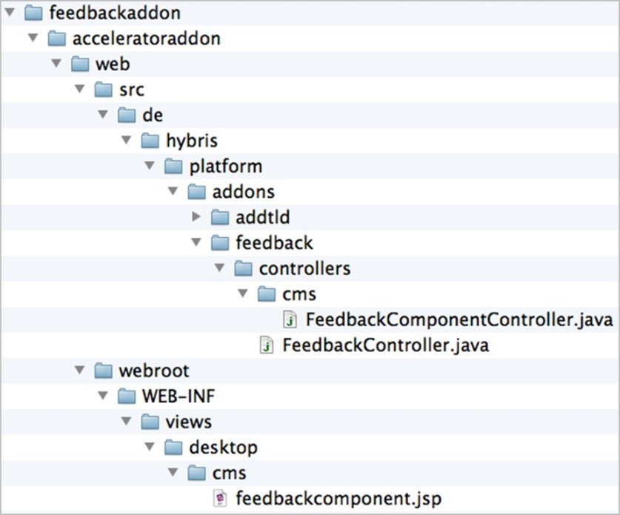

Figure: acceleratoraddon folder structure

In this example, the web folder contains both the src and the webroot subdirectories. After putting all the components you want to add into the proper folders, you need to run the following command on your system: ant build<Enter>.

The system automatically copies the files to the target storefront extension during the build phase, and creates two additional folders containing the imported content:

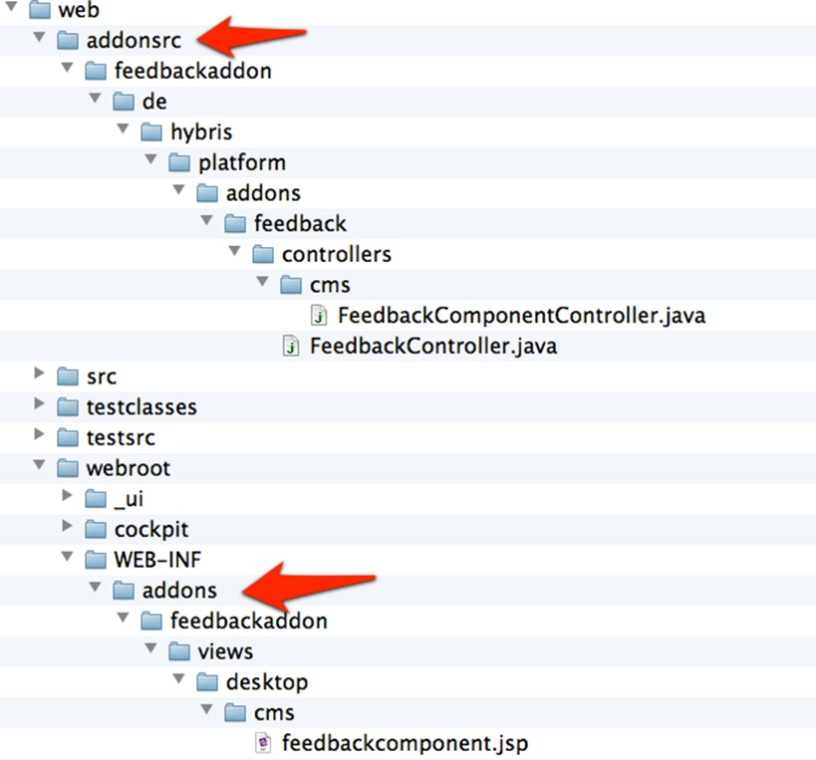

Figure: Folder structure of the target storefront extension.

After the build phase finishes, the target extension contains the following new folders:

* web/addonsrc, which contains the source code for each installed AddOn. This gets compiled automatically.
* web/webroot/WEB-INF/addons, which contains all the front-end components, such as images, JSP files, HTML files, and TAG files.

All the contents of these folders are processed automatically during the development phase. By default, this mechanism is disabled on the production systems so as not to impact the performance of the system. This is because the process continuously checks if the contents of the folders have changed.

## Benefits of the AddOn Approach

The benefits of the AddOn Concept approach are as follows:

* AddOn files are kept separate from the rest of the front-end files.
* When you upgrade the Accelerator, it will not overwrite your files.
* You can easily remove your AddOns without refactoring the code of your whole extension.

### Improved Overall Extensibility

The AddOn approach makes it easier to modify the exposed data model. For example, if you want to add a new attribute to a product , you do not have to subclass the DTO. Instead, you can plug in a new populator, which is responsible for adding the new attribute:

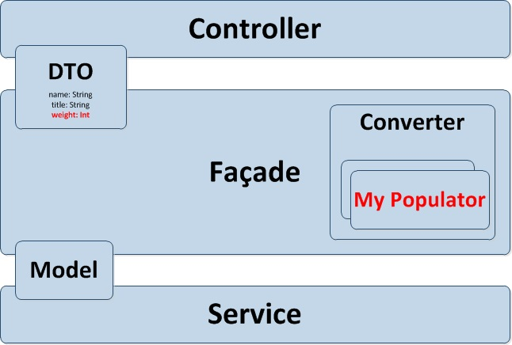

Figure: Adding a new attribute to a product.

Additionally, you can modify multiple extensions at once. Previously, due to Java restrictions, you could only modify the subclass once. Now, you can plug in new data from every extension using a new XML descriptor to generate the DTOs. Each extension can provide such a descriptor. All definitions are merged, so you can add attributes to existing DTOs and fill your attributes with pluggable populators. As a result, you can extend an existing API without needing to replace anything.

The following is an example of an XML descriptor:

<beansxmlns:xsi="http://www.w3.org/2001/XMLSchema instance"xsi:noNamespaceSchemaLocation="beans.xsd">

<bean class="de.hybris.platform.commercefacades.product.data.ProductData">

<property name="weight" type="int" />

<property name="instruction" type="String" />

<propertyname="additionalImage"type="de.hybris.platform.commercefacades.product.data.ImageData" />

</bean>

<enum class="de.hybris.platform.commercefacades.product.ProductOption">

<value>DIMENSIONS</value>

<value>MINIMAL</value>

</enum>

</beans>

Similarly to the item.xml file, the definitions in the beans.xml file are merged automatically. In the example above, the ProductData file is not part of our example extension, but it is extended from thecommerceservices extension. That means that during this process, you extended the API because you modified the data model. You do not need to replace the facade in this instance. All you need to do is plug in the populator from your extension, and it can be done multiple times.

## AddOns Best Practices

It is suggested that you put as much logic into your AddOns as possible. The advantage of this is that whenever you need to upgrade your Accelerator code base, you do not need to merge the changes manually. By having the logic put into the AddOns, you can build a library of self-contained, reusable components that you can use for your future projects.

# B2B Accelerator

SAP Hybris Commerce B2B Accelerator is a ready-to-use Web framework that enables you to jump-start your B2B implementation and easily build and maintain a feature-rich, omni-channel commerce solution

## Integrate Your B2B Processes

SAP Hybris Commerce B2B Accelerator allows B2B organizations to rapidly deploy a best-practice B2B omni-channel commerce solution. Tailored to the unique needs of B2B organizations, the solution delivers all the capabilities you need to manage complex B2B relationships. It automates order processing and provides B2B organizations with the ability to manage numerous B2B accounts on a single platform. It also includes advanced self-service capabilities for the B2B customers where they can manage their users, user groups, permissions, cost centers, budgets, and approval workflows. B2B account managers also benefit from the B2B Admin Perspective in the Administration Cockpit where they can use one wizard to create an organization and another to manage the quote approval process.

The following screenshot is an example of the B2B home page.

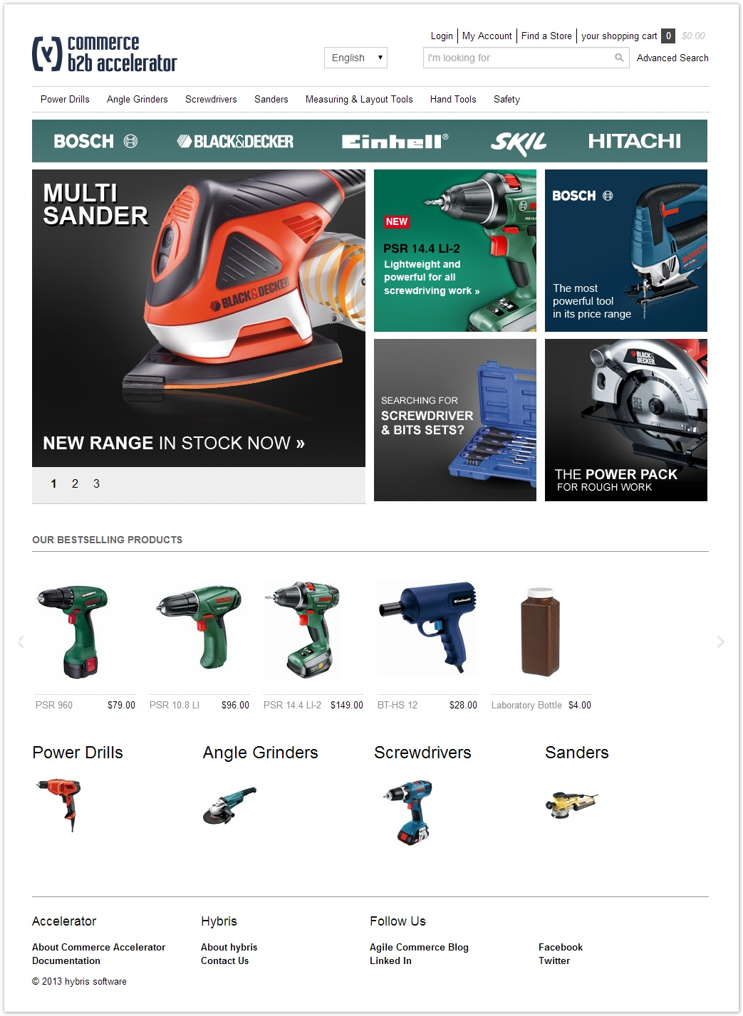

For B2B customers, it is also a rich customer experience. The most important marketing message for customers is how your product or service saves their time, money, and resources. Within Hybris Commerce Accelerator, they can easily track or make changes to various aspects of their B2B orders in the self-service area. If needed, they can manage their quotes (check pending quote statuses, approve or reject quotes, and request new quotes), track their order history, and manage their order replenishment and schedules.

Customer administrators can completely control their organization based on a structure they set up that reflects the company size and complexity. Whenever B2B customers send their approval request, the company approvers are able to easily find and manage orders that need to be approved. It is also possible to select the fully integrated merchandizing tools such as promotions, cross-sells, up-sells, and advanced personalization.

## Key Features

* **Back-office integration.**
* **Self-service account management**. B2B administrators assign rights to employees, set up individual purchasing limits, configure approval rules and workflows, and manage cost centers and budgets. [[More information]](https://help.hybris.com/6.0.0/hcd/8ac27d4d86691014a47588e9126fdf21.html)
* **Online ordering.** Users can place orders online and schedule orders that are automatically replenished. Orders are subject to internal and merchant order approval. Orders can be tracked online. [[More information]](https://help.hybris.com/6.0.0/hcd/8ac2500f8669101493e69e1392b970fd.html)
* **Custom catalogs**. Merchants can customize product lists and search product pages for specific organizations, departments, and customers. [[More information]](https://help.hybris.com/6.0.0/hcd/8c5b1eb586691014a1e6820a672deb23.html)
* **Custom pricing.** Complex B2B pricing models are supported, which are managed either in hybris or in an ERP system. [[More information]](https://help.hybris.com/6.0.0/hcd/8c5af47f8669101488e59df61b2f6ab4.html)
* **Price quote requests.** Purchasers can negotiate the price of an order. Quotes requests can be restricted to a minimum order value. [[More information]](https://help.hybris.com/6.0.0/hcd/8ac2500f8669101493e69e1392b970fd.html)
* **Credit management.** Merchants can assign multiple credit limits with a variety of currency and date range options. [[More information]](https://help.hybris.com/6.0.0/hcd/8c0b369086691014b30bae22facdb2f1.html)
* **Multi-dimensional products.** Products can be defined as having multiple attributes, such as color, size and fit. [[More information]](https://help.hybris.com/6.0.0/hcd/8b6010418669101493e8e0f2ffcfbb89.html)
* **Advanced product search.** Searches can be performed using bar code or product code, and by text or delimited list. [[More information]](https://help.hybris.com/6.0.0/hcd/8ac1a3d586691014911dd58c04389cc3.html)
* **PunchOut support.** The B2B site can be integrated with customer procurement systems. Orders are automatically translated into purchase requisitions that are saved to the customer's procurement system. [[More information]](https://help.hybris.com/6.0.0/hcd/8ac40cf08669101486f5ce44920c3f91.html)
* **Early Login.** Users can be required to log in before being able to view the storefront. [[More information]](https://help.hybris.com/6.0.0/hcd/8ac304ca866910148e908988466c0bd7.html)

## Streamline Your B2C Connections

Omni-channel is more than just e-commerce. Not every solution offers the ability to adopt new business models and channels in order to enable rapid growth and expansion. There are many solutions in the market that are restricted to a single channel. Accordingly, as the organizations grow and move towards omni-channel, they have to start from scratch. They lose their investment, or they end up implementing an inferior solution, which cannot deliver a satisfactory omni-channel solution.

For those companies whose needs are not unique, and who need to get started quickly, SAP Hybris Commerce Accelerator is a perfect ready-to-use solution. It is an omni-commerce system that is fully customizable, including support for Web, mobile, call-center, and order management. Simply rebrand one of the store front templates and use the hybris software to integrate with your order fulfillment system and payment service provider.

Moreover, also included is a fully integrated mobile commerce solution for which you can quickly build mobile-optimized websites or native mobile apps for today's smart phones. Within the multi-step checkout with options such as guest checkout or express checkout in the storefronts, you can clearly point out the benefits to customers.

## Key Features

* Accelerator Web Content Management
* Accelerator Email Communication
* Accelerator Data Import
* Accelerator SEO
* Accelerator Merchandizing
* Accelerator Internationalization
* Accelerator Search and Navigation
* Accelerator Product Details
* Accelerator Store Locator
* Accelerator User Generated Content and Social Network Integration
* Accelerator Shopping Cart
* Accelerator Checkout
* Accelerator Fraud Engine
* Accelerator Order Management
* Accelerator Payment
* Accelerator Customer Service
* Accelerator Reporting
* Accelerator Customer Account Management
* Accelerator Google Shopping and Local
* Accelerator Mobile B2C Storefronts
* Accelerator Google Analytics Integration
* Accelerator Jirafe Analytics Integration
* Accelerator Device Detection
* Accelerator Solr Search Improvements
* Componentization: Product Results as You Type
* Componentization: Cart Page Cross-Sells
* Express Checkout
* Vanilla Look and Feel

# Financial Services Accelerator - Business Guide

The hybris Financial Services Accelerator is a tailor-made omni-channel solution for direct insurance companies and other financial services providers like retail banks that are looking to develop a more streamlined, seamless, personalized customer experience, while meeting the unique needs of their industry.

## About the Financial Services Accelerator

### Industry-Based Challenges

**Tackle the Complexity.** Selling financial services, be it insurance, banking, or anything else, is complex and nuanced business. Between personalized customer experiences (including tailored policies and quotes, or account features) and established internal workflows (featuring face-time with agents and paper-based communication), the level of complexity that goes into each customer engagement is staggering.

**Stability against Agility.** Established backend systems built to support the insurance industry were designed for maximum stability and risk reduction. But as such, they don't always allow for the agility and mobility of today's new generation of consumers. As people's lives become more varied, affecting everything from the cars they drive to the homes they buy, companies face the dilemma of preserving their robust backend systems and internal workflows, while adapting to meet the needs of a new generation.

### Solution Offered by Financial Services Accelerator

The hybris Financial Services Accelerator includes pre-configured reference integrations and storefront templates for property, travel, and event insurance policies, and can be easily customized and extended to meet the needs of other financial service providers, such as banks. Customers are guided through each step of the quote process, with various policies and added options, and are able to enter all relevant data through customized forms, which adapt based on their answers.

Easily set up insurance bundles consisting of plans, associated options, and payment methods in the Product Cockpit. Provide customers with a summary of their choices, and the option to request a quote, issue a policy on the spot, or save for later review.

The Financial Services Accelerator also includes an Assisted Services solution that enables agents to take over customers' online frontends and quotes and offer product support on the spot, or simply complete an order for the customer.

Go to market quickly and meet the changing needs of today's financial consumers.

## Benefits

Financial Services Accelerator enables you to:

* Go to market quickly with a solution that meets the unique needs of financial service providers
* Improve the customer journey and satisfaction by offering an online portal with guided selling capabilities
* Improve selling process by assisting agents in selling services online
* Provide exceptional customer service for complex policies and options through integrated Assisted Service capabilities
* Provide customers with an overview of their existing policies
* Increase conversion rates through easy ordering with dynamic forms
* Generate recurring revenue by offering flexible, subscription-based payment models
* Save marketing funds by optimizing search engine results without having to pay lead fees to the providers or aggregators

## Key Features

You can find below key features of Financial Services Accelerator:

|  |
| --- |
| **Feature** |
| Auto Insurance: Added auto insurance type with alternative payment frequency, if customer requires monthly payment they must agree to having telemetric device installed |
| Auto Insurance: Telemetric device is automatically added to the insurance when customer chooses monthly payment frequency |
| Travel Insurance Quick Quote enhancement - Added Field for cost of travel, and factored into mock quote engine. |
| Modified Mock Quote engine to reference values in the hybris Administration Console. |
| Life Insurance: Added Life insurance type with simple workflow to not allow customer to purchase insurance without providing documentation to seller, and having it approved. |
| Tailor-made omni-channel solution for financial service providers. |
| Customer portals for improved selling. |
| Integrated forms that are easy to create and manage, enabling customers to fill in all relevant data (including field validation) via yForms. |
| Ability to retrieve, save and review quotes on the Quote Review Page in the checkout process. |
| My Account area that summarizes all active or past policies. |
| Pre-integrated reference integrations/storefronts for “Homeowner,” “Renter,” “Travel,” and “Event” insurances. |
| Customizable prices and additional policy options. |
| Guided selling options to guide customers through the ordering process, including the ability to compare different insurance plans. |
| Dynamic forms for complex policy types. |
| Easy-to-configure bundling options (insurance plans, associated options, an so forth). |
| Flexible customer payment options (for example: yearly, quarterly, monthly). |
| Open interfaces for product and quotation engine integration. |
| Integrated Assisted Service Mode for offering product support and completing transaction for complex policies by taking over customers' storefronts. |
| “Find Agent” functionality, enabling customers to quickly find experts in the finance-related field they are interested in, and communicate directly. |

# Telco Accelerator

The hybris Telco Accelerator is a ready-to-use Web framework that enables you to sell more online and offline in an intuitive and cost-effective way.

Only hybris delivers a commerce platform specifically designed to maximize average revenue per user (ARPU) and deliver an omni-channel customer experience that streamlines a complex purchase process. The hybris Telco Accelerator delivers all this and more and enables you to get to market fast, so you can stay ahead of the competition.

## Solution in the Telecommunications Industry

Taking into account today's expectations of e-commerce solutions, hybris gives you a purpose-built platform that enables telecommunication providers to rely on convergent connectivity within reliability, variety, and suitability. The hybris Telco Accelerator is a single platform to sell more phones, plans, and cloud services integrating online and offline marketing.

The hybris Telco Accelerator package answers customer inquiries by enabling:

* Product package sale with promotions and customer discount
* Subscriptions
* Customer personalization
* Contract bundles
* Contract renewal
* Access to digital products and services

The hybris Telco Accelerator with the Subscriptions and Bundling Module enables you to enhance customer satisfaction in an intuitive and cost-effective way. By conducting customer's transactions, Telco can have an overview of trends in the market. In addition, the functional e-commerce storefront customized with languages and currencies can be easily updated frequently with information regarding the products, accessories, and services.

## Assessing Business Opportunities

Within the hybris Telco Accelerator, customer maintaince is:

* Convenient, useful, and suitable. It allows you to focus on customer preferences guaranteeing a higher average lifetime value.
* All-embracing. It leads to customer satisfaction offering a phone with contract discounts, accessories, data plan, voice, text messaging, and all the other products and services.
* Efficient. It gives you a competitive advantage in the business and real customer insight.
* Comprehensive. It ensures the salespeople follow all sales process steps.

As a company with the highest level service, Telco needs to diversify their offerings. The hybris Telco Accelerator brings a new and innovative way to shop and choose services the customer prefers. Having the ability to track customer behaviors and patterns in buying gives a company priceless information about the way to further market a particular product.

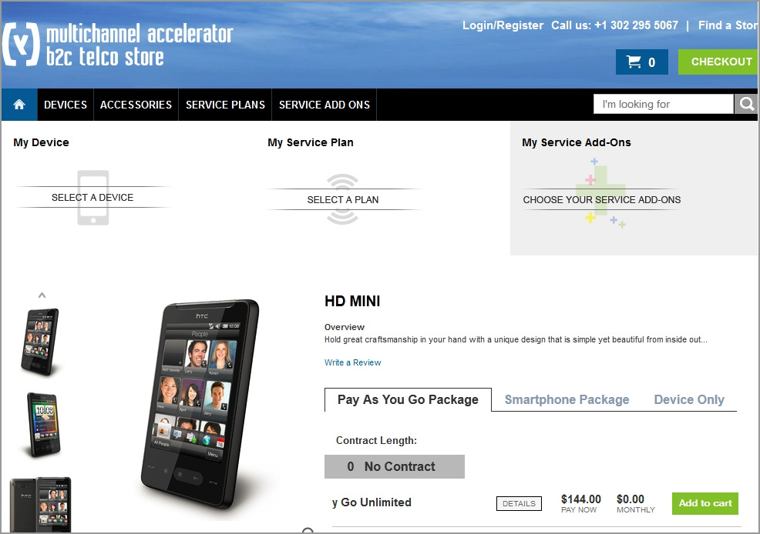

Figure: The hybris Telco Accelerator storefront.

### Key Features

|  |  |
| --- | --- |
| **Feature** | **Released** |
| Complex and complete storefront for products and services |  |
| Management of digital and physical goods package |  |
| Management of selling changing devices, content, and promotions |  |
| Bundling of products and services |  |
| Ready for implementation of initial subscription data to customer invoicing |  |
| Rule-based discounts and bundles |  |
| Possible different scenarios like upgrade of customer account and pre-paid system |  |
| Integration of omni-channels |  |
| Automatic cross and upsells of compatible accessories |  |
| Commerce Search integration and support |  |

# SAP Hybris Commerce, China Accelerator

The China Accelerator for SAP Hybris Commerce delivers a feature-rich omni-channel commerce solution quickly and easily. It takes full advantage of Hybris' unique flexibility and capability.

## Key Business Challenges

E-Commerce projects can be quite challenging. Organizations looking to implement a commerce solution in China have to adapt their commerce platform to meet the unique demands and habits of Chinese consumers. Also, they are looking for feature-rich solutions that can be implemented in a short time-to-market and serve as a basis for sophisticated omni-channel strategies. Consumers expect a seamless shopping experience where they can easily find items and quickly complete purchasing transactions. The consumer expectation is to interact with the retailer whenever and however they want and the retailer needs to respond to this request in a consistent fashion. If not, the consumer will go elsewhere.

These are the typical fears that organizations face when approaching omni-channel projects:

* High deployment time and costs
* Long and tedious implementations
* Risky e-commerce start
* Slow launch of a new online store
* Finding a future-proof solution
* Initial delivery does not live up to the expectations
* Costly re-platform of the existing online store
* Complex process of building and maintaining a feature-rich online shopping experience
* Complex customization
* Complex development

## Why China Accelerator?

The China Accelerator can be implemented very quickly and cost-effectively. Partners can jumpstart omni-channel commerce implementations using a pre-configured commerce foundation. The China Accelerator is a set of localized AddOns that can be plugged into the [SAP Hybris Commerce Accelerator](http://help.sap.com/disclaimer?site=http://www.hybris.com/en/products/product-overview), a production-ready omni-channel commerce system that is fully customizable including support for web and order management. The China Accelerator includes functionality designed to address e-commerce needs specific to China.

The China Accelerator is available in a traditional OnPremise configuration.

## Solution Offered by China Accelerator

Unlike the variety of SAP Hybris Commerce Accelerators that are designed to target some specific industries, or for a broader types of commerce such as B2B or B2C, the China Accelerator adds a splash of Chinese flavor into the suite. The solution includes a set of China specific AddOns that can be plugged into any Accelerator as a package, or individually. The deployment could be purely mixed and matched to add desired China specific features based on the business users’ likings and needs, without the need to depart from the feature-rich core Accelerator.

The China Accelerator package answers customer inquiries by enabling:

* Store locating with Chinese Baidu Map
* Managing user profiles that are of Chinese characteristics
* Sharing products in Chinese social networking sites
* Pluggable Payment Gateways Interface with out-of-the-box Alipay services
* Localized checkout process
* Consumer can request for tax invoice when checkout is made
* Ability to define shipping fees on Province/City/District combination with Chinese location data
* Consumer can requests for a specific delivery time, whether week-day only, week-end only, or any days
* Ability to search product information in Chinese
* New vertical navigation to provide multi-level menus on the homepage to access top brands, hot products and others

The following screenshot is an example of the China Accelerator Storefront Homepage:

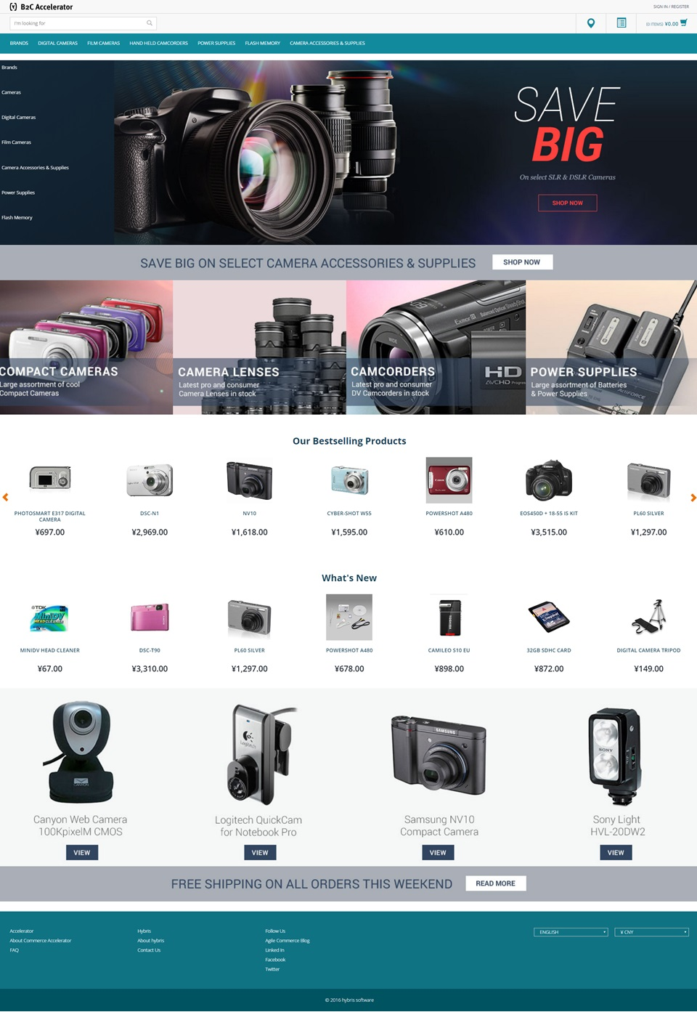

## What's New?

The China Accelerator includes a set of new AddOns designed to address e-commerce needs specific to China. For more information, see:

* [List of China-Specific Extensions and AddOns](https://help.hybris.com/6.0.0/hcd/8b04a13686691014911b887c345b2c60.html)

You can also find information on how to start a successful China Accelerator implementation:

* [China Accelerator Quick Installation Guide Using Installer](https://help.hybris.com/6.0.0/hcd/7e6eef9edbe84a31876aa4710f864313.html)

# Travel Accelerator

Deliver Omni-channel Digital Traveller Engagement with SAP Hybris Commerce.

The digital revolution is fundamentally changing the way we research and book travel. The booking journey is no longer linear as travellers seek inspiration from social media, friends and colleagues. Travellers are hyper-connected and expect a seamless experience throughout their journey as they interact with your brand.

Travel companies face major challenges when competing in a digital world, specifically providing a consistent customer experience across their customer touch points: digital, on-board, call center.

The challenge is that the traditional reservation systems powering in-direct distribution, ticket desks, and call centers, were not designed for a digital world. Disparate systems have evolved to deliver new capability and sales channels. Data is stored in silos and processes are not consistent.

The SAP Hybris Commerce platform is omni-channel at its core and helps integrate digital and physical customer touchpoints onto a single platform. We have enabled this capability for the travel industry with our SAP Hybris Commerce Travel Accelerator. It enables travel providers to deliver market leading customer engagement and integrate to existing reservation, revenue, and loyalty systems.

Once you have purchased SAP Hybris Commerce Travel Accelerator, you can download the software and its documentation from the [SAP marketplace](http://help.sap.com/disclaimer?site=https://support.sap.com/swdc) (navigate to  *Software Downloads*  *By Category*  *SAP HYBRIS COMMERCE PLATFORM & SUITE*  *SAP INDUSTRY PACK. TRAVEL*  *SAP INDUSTRY PACK. TRAVEL 1.0*  *SUPPORT PACKAGES AND PATCHES*  *Downloads* ).

## Solution Description

The SAP Hybris Commerce Travel Accelerator enables travel industry customers to deliver their omni-channel strategies through SAP Hybris Commerce, providing market leading retail capabilities to meet modern travel business demands.

The core of the Travel Accelerator is the data model, specifically designed to provide a reference model that can be extended and adapted to meet the needs of customer implementations. Based on the OTA industry standard it encompasses the main data objects for transport providers: air, rail, bus, cruise & ferry.

The Travel Accelerator provides a pre-configured storefront, based on an airline.com B2C model, containing pages and components that deliver a responsive UI design as well as a complete booking funnel for flights and related products. It provides a suite of business services that can be exposed through any channel to deliver the complete end-to-end customer experience.

The underlying integration capability of SAP Hybris Commerce enables customers to develop connectors to a range of industry reservation and inventory systems.

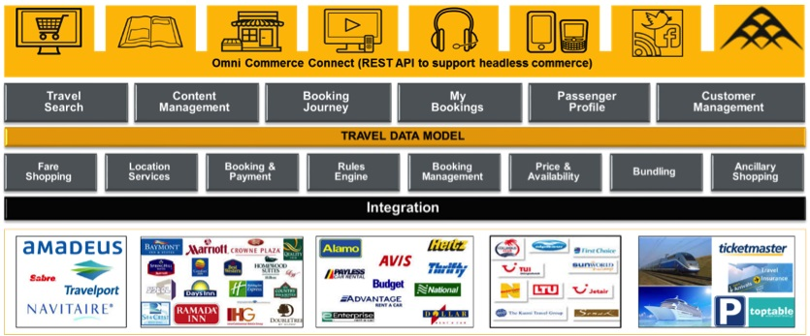

## Summary of Features

* Fully responsive storefront featuring a landing page, travel search, fare selection, ancillaries, customer login, passenger details, payment, booking management, flight status, trip finder, and customer login/registration
* Fare selection page with search results and dynamically updating itinerary basket
* Ancillary selection page with the ability to add supplementary products (flight meal options, seat selector, lounge access, fare upgrades etc.) to the itinerary
* Ability for customers to login or create an account with a passenger profile complete with preferences
* Ability for customers to manage their bookings, check flight status, search for past or upcoming bookings, and update their profile
* Integrated Assisted Service Module (ASM) so customer service agents can offer product support and help complete transactions for customers directly from their basket
* Backoffice cockpits with business administration interfaces for creating and managing products, flight schedules, bundles, promotions, and business rules

## Key Benefits

* A first class, consistent customer experience across all channels with seamless transitions between devices
* Improved conversion rates with fully responsive storefront and context-based content management
* Bundling and promotional capabilities for offers across customer segments and channels
* Ability to develop IATA NDC direct connect initiatives to agencies, corporates, and B2B partners
* Exceptional customer service and support for complex bookings