Task: What is the linux command to

To view what's written in a file.

**cat <file name>**

To change the access permissions of files.

**chmod permission <filename>**

**e.g we have test file and we want to give full permission on test file**

**chmod 777 <file name>**

To check which commands you have run till now.

**history**

To remove a directory/ Folder.

**rmdir <directory name or rm -r <directory name>**

To create a fruits.txt file and to view the content.

**Vi fruits.txt**

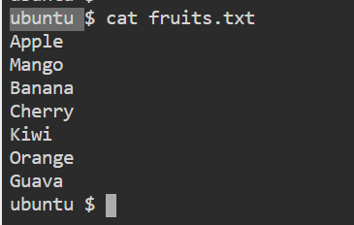

Add content in fruits.txt (One in each line) - Apple, Mango, Banana, Cherry, Kiwi, Orange, Guava.

To Show only top three fruits from the file.

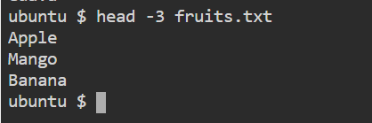

To Show only bottom three fruits from the file.

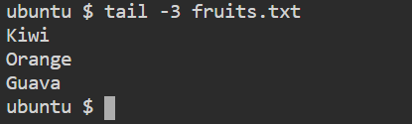

To create another file Colors.txt and to view the content.

created

Add content in Colors.txt (One in each line) - Red, Pink, White, Black, Blue, Orange, Purple, Grey.

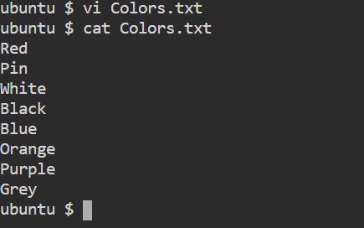

To find the difference between fruits.txt and Colors.txt file.

