**Software Engineering Assignment**

**MODULE : 1**

* **Dipak Solanki**

1. **What is software ? What is software engineering ?**

**Ans.** Software refers to a set of instructions or programs that tell a computer what to do. It’s a collection of data, instructions and algorithms that are used to operate, manage and control computer hardware and other software.

Software Engineering is the application of engineering principles and techniques to design, develop, test, and maintain software systems. Software Engineering use various tools, techniques, and methodologies.

1. **Explain types of software .**

**Ans.** Types of software in computer :

1. **System Software** **:** Operating systems, device drivers, and Inbuilt Software in computer hardware and provide a platform for running applications.
   1. **Operating System** **:** Window, Linux, MacBook
   2. **Driver Software** **:** Connection between Hardware and Software like – Bluetooth, WIFI
2. **Application Software** **:** Programs that perform specific tasks or functions, such as: **Productivity software** (e.g. Microsoft office, Google Docs) **Graphics and Multimedia Software** (e.g. Adobe Photoshop, VLC Media Player) **Games Web browsers** (e.g. Google Chrome, Mozilla Firefox)
3. **Utility Software :** Programs that perform maintenance, optimization, or troubleshooting tasks.
4. **CAM :** Computer Aided Manufacturing. Software Which is use for connection of 3D printers or print 3D images by this software.
5. **CAD :** Computer Aided Designing. Software which is design 3D images.
6. **What is SDLC ? Explain each phase of SDLC.**

**Ans.** The full form of SDLC is Software Development Life Cycle. The Software Development Lifecycle(SDLC) is a process used to plan, design, develop, test and deliver software products. SDLC have total six phases are us under :

1. **Planning :** Define project scope, goals, timelines, budget and resources.
2. **Analysis :** Examine and validate requirements, identify potential issues, and create a detailed specification.
3. **Designing :** Create a detailed design of the software architecture, user interface and system specifications.
4. **Development or Implementation :** Release the software to production, configure environments and train users.
5. **Testing :** Verify that the Software meets requirements through various testing methods.( Manual Testing and Automated Testing )
6. **Maintenance :** Provide ongoing support, fix defects and make updates to ensure the software continues to meet user needs.
7. **What is DFD ? Create a DFD diagram on Flipkart**

**Ans.** A Data Flow Diagram(DFD) is a graphical representation of the flow of data through a system or process. It’s a tool used in software development, systems analysis and business analysis to visualize, design and document the flow of data and its transformations from input to output.

**Flipkart Data Flow Diagram**

**Unregistered Customer Registered Customer**

**Registration**

**Search Product**

**Select Product**

**Order Placement**

**Payment Gateway**

**Payment Process**

1. **What is Flow chart ? Create a Flowchart to make addition of two numbers.**

**Ans.** Flow chart is shows a Travelling of Data Flow. A Data flow chart specifically focuses on the movement and transformation of data through a system or process. It’s a graphical representation of the flow of data, showing how it’s input, processed, stored and output.

**Flowchart to make addition of two numbers**

**Start**

**Num1, Num2, Ans**

**Ans = Num1 + Num2**

**Output**

**End**

1. **What is Use case Diagram ? Create a use-case on bill payment on Paytm.**

**Ans.** A use case Diagram is a graphical representation of how a user might interact with a system. It’s a high level overview of the relationship between a use and systems and is used in the Unified Modelling Language.

* Use Case Diagram On Bill Payment :

**Registration**

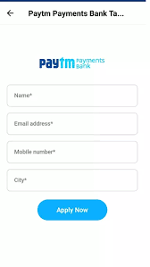

**Select Bill Type**

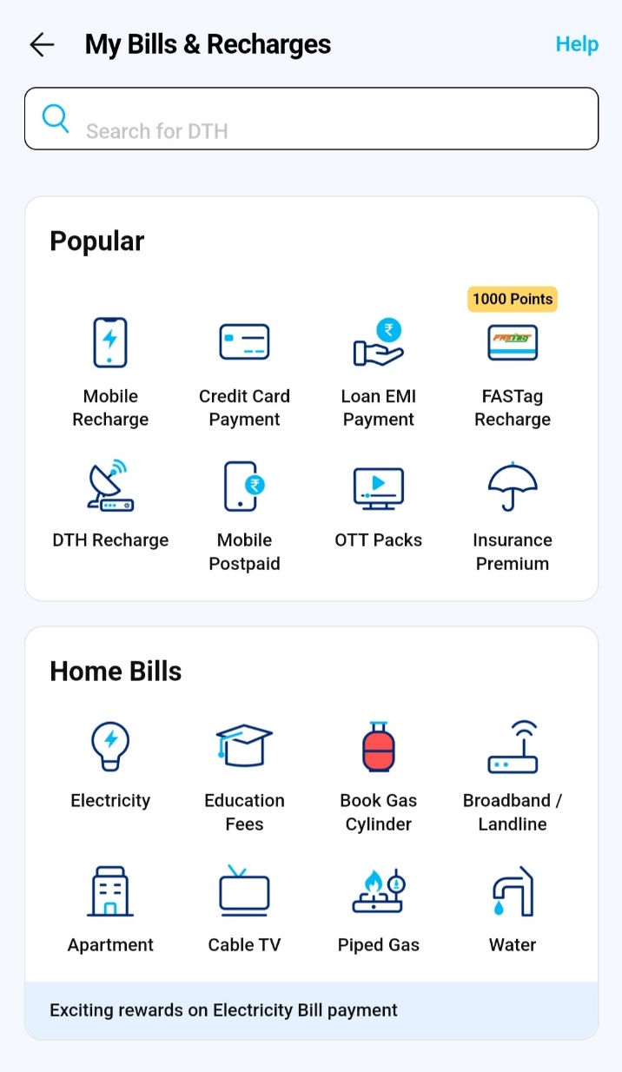

**Bill Details**

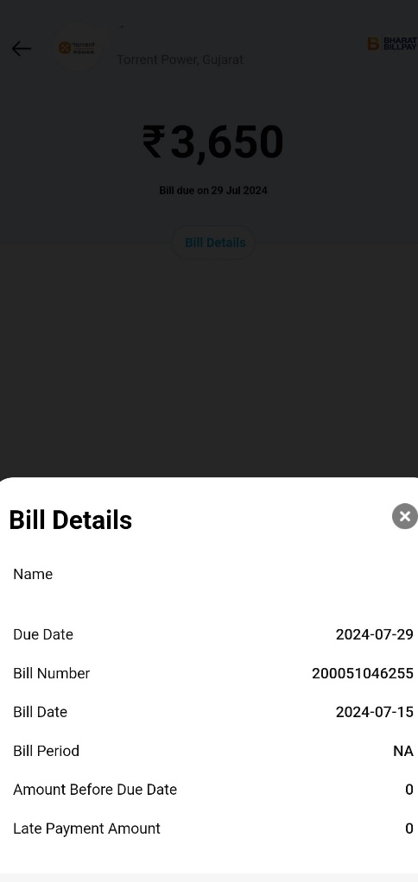

**Payment Method**

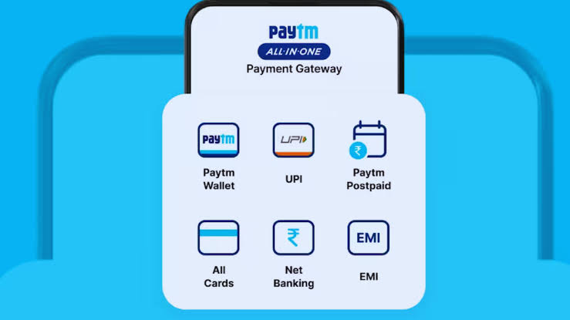

**Payment Gateway**



**Payment Process**

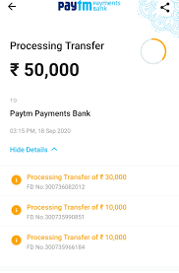

**Payment Confirmation**

