# Trend Analysis Exercise

This is an open ended real life problem. There is no right or wrong answer. The primary objective on this exercise is to understand your thought process and problem solving ability. You are free to refer any resource available to you, but we expect this to be your work.

You can explain your answer in plain English, provide your model, equations, pseudo code or a program (Java, C, C++, JS, Groovy, R etc).

## Question

A currency pair is denoted as EUR-USD, where EUR, USD represents two different currencies. EUR is the base currency and USD is the counter currency. **PLEASE NOTE all graphs are made to scale using R programming language**.

EUR -> Euro

USD -> US Dollar

JPY -> Japanese Yen

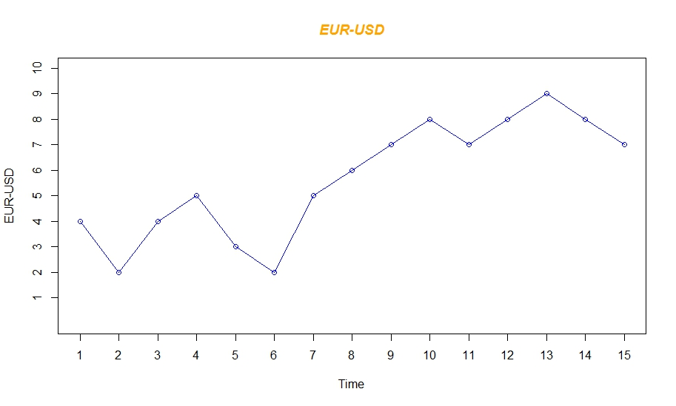

In the chart above, from time 2 to 4 seconds value of EUR increased from 2 to 5 points (i.e. EUR increased by 3 points) conversly USD decreased in value by 3 points. So when graph moves up base currency (In above example EUR) gains in value and counter currency (In above example USD) looses in value.

EUR-USD = (4,2,4,5,3,2,5,6,7,8,7,8,9,8,7)

EUR-JPY = (3,4,2,3,4,3,1,2,4,3,5,7,4,3,4)

USD-JPY = (6,4,1,7,8,7,9,10,7,4,1,3,6,5,9)

Given the data points for three different currency pairs, analyze the trend of each currency.

1. Determine which currency is the best performing currency among the three currencies EUR, USD, JPY?
2. Determine which currency is the worest performing currency among the three currencies EUR, USD, JPY?

Please provide explanation, these are not answer based questions. Explain your thought process. You are welcome to provide pseudo code and working code as well. All graphs are made to the scale for your reference purpose. Providing program shows your ablity to convert real life solution to computer understandable language.

HINT: You can explore various statistical models. If you look at a graph, you can generally say if the graph is in up trend, down trend or no trend. Real life problem - How can you let computer know about the trend of the graph? Is there a universal model for all situations? Are there multiple model for each kind of situation?

