 | Online Tailoring Store  Technical Design Document
 | Prepared By / Last Updated By | Reviewed By | Approved By
Name | Paresh Gaggad
Role
Signature
Date | 06-Mar-2020

Table of Contents

1.0 Introduction 3
1.1 Purpose of this document 3
1.2 Project overview 3
2.0 Solution Summary 3
2.1 Scope 3
2.2 Assumptions 3
2.3 Dependencies 3
2.4 Risks 3
3.0 Schematic Diagram 3
4.0 System Design 4
4.1 Proposed design 4
4.2 Component inventory 4
5.0 Database Design 4
5.1 Data Model 4
5.2 Tables Structure 4
6.0 Appendices 4
6.1 Glossary 4
6.2 Other 5
7.0 Terms & Conditions 5
8.0 Change Log 5

Introduction

Purpose of this document
The purpose of this document is to document the technical design, component details and Database design. This will also capture the scope, assumptions, risk, dependencies of this project.

Project overview
Online Tailoring store is capable of managing various tailoring needs of user’s. Admin, Users and the Tailor are the three main modules of the proposed system. Admin is responsible to add the category and various dress types. Tailor can accept the customers’ orders and can also view the log of orders.

Solution Summary

Scope
The main aim of the online tailoring store is to provide the users with wide variety of options for stitching their clothes ranging from cloth fabric, design and customized sizes. Customers can choose a tailor based on his choice from all the available tailors. Further the Tailor would be able to see all the orders which are ongoing, pending, or previously completed.

Assumptions
No Assumptions are made till now.

Dependencies
Not Applicable.

Risks
Not Applicable.

Schematic Diagram
A schematic, or schematic diagram, is a representation of the elements of a system using abstract, graphic symbols rather than realistic pictures. It gives an overview of overall system

// IN PROGRESS

System Design

Proposed design
The Admin of the Online Tailoring Store will add all the categories and available dress types on the online portal. Further Tailors can register themselves on the site and accept customer’s orders and will further coordinate with customers regarding delivery date and any other changes. Once the user’s register themselves on the site they can login and choose any type of dress they desire with options ranging from design, cloth fabric, sizes etc. The users can choose a tailor from all the available options.

Component inventory
Not Applicable.

Database Design

Data Model

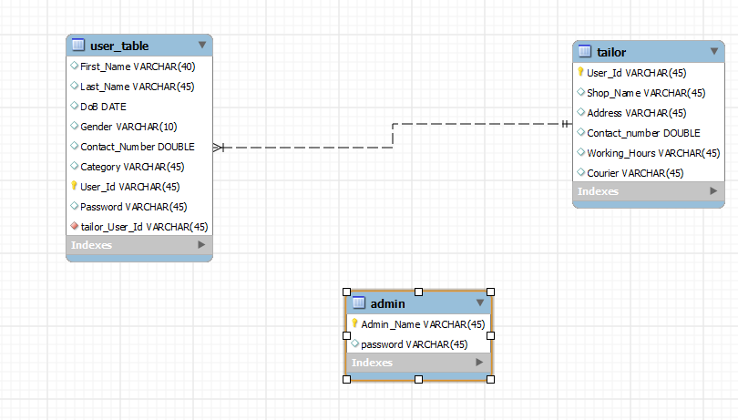

Tables Structure
- Users
Column Name | Data Type | Length | Nulls

Appendices

Glossary
Acronyms | Definitions

Other

Terms & Conditions
Disclaimer: Please do not circulate or distribute this document outside of Cognizant Network, We have a Zero Tolerance Policy. Kindly adhere to 100% Compliance at all times.

Change Log
Please note that this table needs to be maintained even if a Configuration Management tool is used.
Version Number | Changes made
V<n.n> | <If the change details are not explicitly documented in the table below, reference should be provided here>
V<n.n> | Page no | Changed by | Effective date | Changes effected

