* Name: Dipak Shingade
* Roll No.:21102B0029

<https://github.com/Dipakgith/Ml-lab-expriments>

import pandas as pd import numpy as np

from sklearn.model_selection import train_test_split

from sklearn.preprocessing import OneHotEncoder, StandardScaler from sklearn.impute import SimpleImputer

from sklearn.compose import ColumnTransformer from sklearn.pipeline import Pipeline

from sklearn.linear_model import LogisticRegression

from sklearn.metrics import accuracy_score, confusion_matrix, classification_report

import matplotlib.pyplot as plt import seaborn as sns

*# Load the dataset*

train_data = pd.read_csv('train.csv')

*# Select features for the model*

features = ['Pclass', 'Sex', 'Age', 'SibSp', 'Parch', 'Fare', 'Embarked']

X = train_data[features]

y = train_data['Survived']

*# Create preprocessing pipelines for both numeric and categorical data* numeric_features = ['Age', 'SibSp', 'Parch', 'Fare'] categorical_features = ['Pclass', 'Sex', 'Embarked']

numeric_transformer = Pipeline(steps=[ ('imputer', SimpleImputer(strategy='median')), ('scaler', StandardScaler())

])

categorical_transformer = Pipeline(steps=[ ('imputer', SimpleImputer(strategy='constant',

fill_value='missing')),

('onehot', OneHotEncoder(handle_unknown='ignore'))

])

preprocessor = ColumnTransformer( transformers=[

('num', numeric_transformer, numeric_features), ('cat', categorical_transformer, categorical_features)

])

*# Split the data*

X_train, X_test, y_train, y_test = train_test_split(X, y, test_size=0.2, random_state=42)

*# Create a pipeline that preprocesses the data then performs logistic regression*

model = Pipeline(steps=[('preprocessor', preprocessor),

('classifier', LogisticRegression(max_iter=1000))])

*# Fit the model*

model.fit(X_train, y_train)

*# Make predictions*

y_pred = model.predict(X_test)

*# Evaluate the model*

accuracy = accuracy_score(y_test, y_pred) print(f'Model Accuracy: {accuracy:.2f}')

*# Generate a confusion matrix*

cm = confusion_matrix(y_test, y_pred) plt.figure(figsize=(8, 6))

sns.heatmap(cm, annot=True, fmt='d', cmap='Blues') plt.title('Confusion Matrix')

plt.ylabel('Actual') plt.xlabel('Predicted') plt.show()

*# Generate a classification report*

print(classification_report(y_test, y_pred))

*# Interpret the Results*

*# Get feature names after preprocessing*

feature_names = (model.named_steps['preprocessor']

.named_transformers_['cat']

.named_steps['onehot']

.get_feature_names_out(categorical_features)) feature_names = np.concatenate([numeric_features, feature_names])

*# Get model coefficients*

coefficients = model.named_steps['classifier'].coef_[0]

*# Create a dataframe of features and their corresponding coefficients* feature_importance = pd.DataFrame({'feature': feature_names, 'importance': abs(coefficients)})

feature_importance = feature_importance.sort_values('importance', ascending=False)

*# Plot feature importance*

plt.figure(figsize=(10, 6))

sns.barplot(x='importance', y='feature', data=feature_importance) plt.title('Feature Importance')

precision recall f1-score support

plt.show()

*# Print top 5 most important features* print("Top 5 most important features:") print(feature_importance.head())

Model Accuracy: 0.80

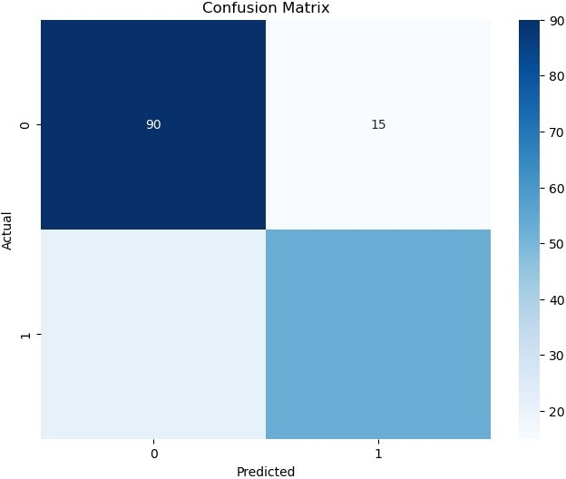

|  |  |  |  |  |
| --- | --- | --- | --- | --- |
| 0 | 0.81 | 0.86 | 0.83 | 105 |
| 1 | 0.78 | 0.72 | 0.75 | 74 |
|  |  |  |  |  |
| accuracy |  |  | 0.80 | 179 |
| macro avg | 0.80 | 0.79 | 0.79 | 179 |
| weighted avg | 0.80 | 0.80 | 0.80 | 179 |

Top 5 most important features: feature importance

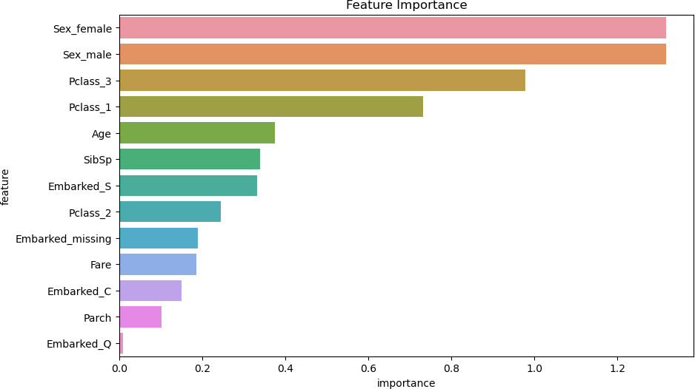

|  |  |  |
| --- | --- | --- |
| 7 | Sex_female | 1.317635 |
| 8 | Sex_male | 1.317533 |
| 6 | Pclass_3 | 0.977835 |
| 4 | Pclass_1 | 0.732311 |
| 0 | Age | 0.374346 |