**Project Name: ScrapWala**

**Project Member:**

**Aviral Kumar Singhal 220943120013**

**Pranali Gaware 220943120079**

**Dipali Sham Patil 220943120025**

**Rohini Amale 220943120086**

**Intorduction of the Project:**

Daily world problems include various problems and one of them is scrap/junk problem. We face many difficulties when we sell our scrap but this application will solve this problem. Its digital world out there so this application provides digital way to sell our scrap. Depending on the type of scrap, it may be re-cycled back into production by the industries. The Scrap deals with various types including Plastics, Clothes, Paper, Metals, Appliances, glasses, footwears, and bags.

**Scrap Wala** Web Application is a common web-based platform for common people as well as for any organization/Industries. This web-based application includes different unique features, which helps people as well as organization in solving their daily based scrap problems. This application Provides faster and reliable response as well as ensures the best solution. Here, the user will schedule the scrap collection place, date and time. The scrap collector will come according to the scheduled meeting and will collect all the scrap which we are willing to sell.

The application is a door-to-door scrap collecting and recycling service. It also provides different sectors which include individual House, Society, Organization, and Industries. This application will try to give away your scrap for recyclables in a most environment friendly manner.

The scrap service provider is one of the most effective uses of the World Wide Web. The primary goal of an e-scrap service site is to make scrap free environment.

This project deals with developing an e-service website for Online Scrap Management. It provides the user with a catalogue of different category of Scraps available for registering in the portal. The system is implemented using a 3-tier approach, with a backend database, a middle tier of Spring Rest API, and web browser as the front-end client.

In order to develop an e- scrap website, a number of Technologies must be studied and understood. These include multi-tiered architecture, server and client - side scripting techniques, implementation technologies such as Spring Rest API, programming language (such as Core Java, Advance Java), relational databases (such as MySQL).

This is a project with the objective to develop a basic website where a costumer is provided with a scrap application. Where the user will be given the power to select the scrap and would be able to schedule a pickup meeting. Thus, resulting in a better communication and trust between the user and the service provider.

**Implementation Technologies:**

1. **Spring Framework:**

Spring Framework is a Java platform that provides comprehensive infrastructure support for developing Java applications. Spring handles the infrastructure so you can focus on your application.

Spring enables you to build applications from “plain old Java objects” (POJOs) and to apply enterprise services non-invasively to POJOs. This capability applies to the Java SE programming model and to full and partial Java EE.

**1.1 Features of Spring Framework:**

**1. Lightweight**

Spring is modular lightweight framework which allows you to selectively use any of its modules on the top of Spring Core.

**2. Inversion of Control (IOC)**

This is another top feature of Spring framework where application dependencies are satisfied by the framework itself. Framework creates the object in runtime and satisfies application dependencies.

**3. Aspect Oriented Programming (AOP)**

Aspect Oriented Programming (AOP) is very popular in programming world and in Spring it is well implemented. Developer can use Aspect Oriented Programming (AOP feature of Spring to develop application in which business logic is separated from system services.

**4. Container**

Spring provides their own container for managing the bean lifecycle.

**5. MVC Framework**

Spring MVC Framework is used for developing MVC based web applications.

**6. Transaction Management**

Spring framework provides generic Transaction Management layer which can be used with or without J2EE(JEE) environment.

**7. JDBC Exception Handling**

Spring provides their own abstraction of JDBC exception which further simplifies the exception handling in program.

**1.2 Advantages of Spring Framework:**

**1. Solving difficulties of Enterprise application development**

Spring is solving the difficulties of development of complex applications, it provides Spring Core, Spring IoC and Spring AOP for integrating various components of business applications.

**2. Support Enterprise application development through POJOs**

Spring supports development of Enterprise application development using the POJO classes which removes the need of importing heavy Enterprise container during development. This makes application testing much easier.

**3. Easy integration other frameworks**

Spring designed to be used with all other frameworks of Java, you can use ORM, Struts, Hibernate and other frameworks of Java together. Spring framework do not impose any restriction on the frameworks to be used together.

**4. Application Testing**

Spring Container can be used to develop and run test cases outside enterprise container which makes testing much easier.

**5. Modularity**

Spring framework is modular framework and it comes with many modules such as Spring MVC, Spring ORM, Spring JDBC, Spring Transactions etc. which can used as per application requirement in modular fashion.

**6. Spring Transaction Management**

Spring Transaction Management interface is very flexible it can configure to use local transactions in small application which can be scaled to JTA for global transactions.

1. **The SpringBoot**

Spring Boot is an open source, microservice-based Java web framework. The Spring Boot framework creates a fully production-ready environment that is completely configurable using its prebuilt code within its codebase.

1. **MySQL**

MySQL, the most popular Open-Source SQL database management system, is developed, distributed, and supported by Oracle Corporation.

**Features of MySQL:**

* **MySQL is a database management system.**

A database is a structured collection of data. It may be anything from a simple shopping list to a picture gallery or the vast amounts of information in a corporate network. To add, access, and process data stored in a computer database, you need a database management system such as MySQL Server. Since computers are very good at handling large amounts of data, database management systems play a central role in computing, as standalone utilities, or as parts of other applications.

* **MySQL databases are relational.**

A relational database stores data in separate tables rather than putting all the data in one big storeroom. The database structures are organized into physical files optimized for speed. The logical model, with objects such as databases, tables, views, rows, and columns, offers a flexible programming environment.

* **MySQL software is Open Source.**

Open Source means that it is possible for anyone to use and modify the software. Anybody can download the MySQL software from the Internet and use it without paying anything.

* **The MySQL Database Server is very fast, reliable, scalable, and easy to use.**

MySQL Server was originally developed to handle large databases much faster than existing solutions and has been successfully used in highly demanding production environments for several years. Although under constant development, MySQL Server today offers a rich and useful set of functions. Its connectivity, speed, and security make MySQL Server highly suited for accessing databases on the Internet.

* **MySQL Server works in client/server or embedded systems.**

The MySQL Database Software is a client/server system that consists of a multithreaded SQL server that supports different back ends, several different client programs and libraries, administrative tools, and a wide range of application programming interfaces (APIs).

1. **Hardware and Software Requirements (Minimum):**

**Hardware:**

1. Intel i3 processor 3rd generation or later / AMD Ryzen 200 2nd generation or later

2. 2 GB ddr3 ram.

3. Windows 7 Home edition or later.

4. 200 GB Sata HDD Space

5. Data Connection 200 kbps

**Software:**

1. Eclipse 4.7 Oxygen
2. MySQL 5.7 with Workbench 8.0
3. Google Chrome version 79.0
4. Apache Tomcat Server 8.5
5. Maven Dependencies
6. **ER Diagram:**

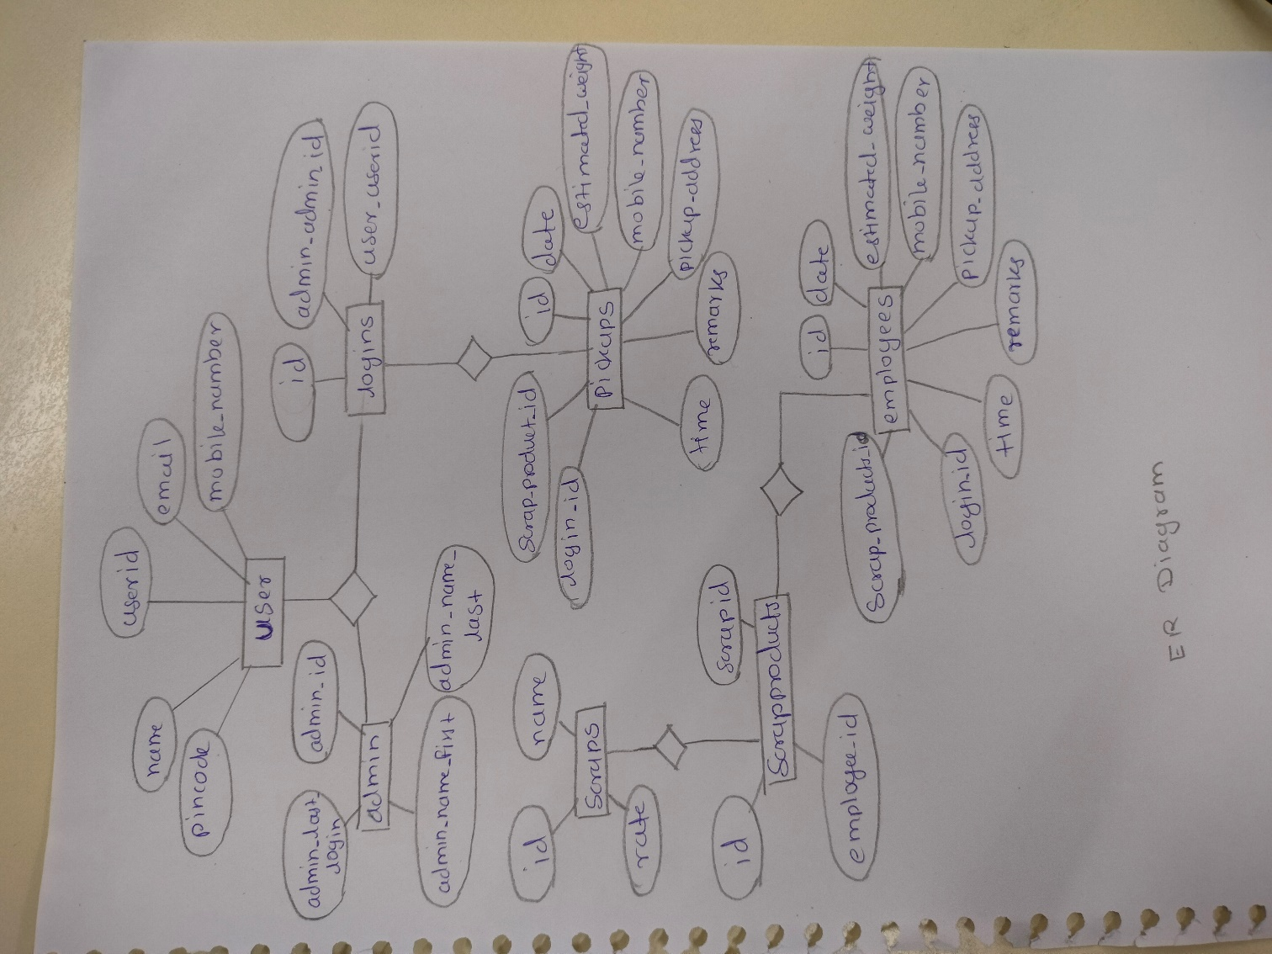

Figure 1: ER Diagram

1. **Table Structures:**
2. **Table name: Admin**

**Field** **Type** **Null** **Key** **Extra**

admin_id int NO PRI auto_increment |

admin_last_login date YES

admin_name_first varchar(255) YES

admin_name_last varchar(255) YES

admin_password varchar(255) YES

1. **Table name: user**

**Field** **Type** **Null** **Key** **Extra**

user_id int NO PRI auto_increment

email varchar (255) YES

mobile_number varchar(255) YES

name varchar(255) YES

pincode int YES

1. **Table name: employees**

**Field Type Null Key Extra**

id int NO PRI auto_increment

contact varchar(255) YES NULL

field varchar(255) YES NULL

first_name varchar(255) YES NULL

last_name varchar(255) YES NULL

1. **Table name: logins**

**Field Type Null Key Extra**

id int NO PRI auto_increment

admin_admin_id int YES MUL

user_user_id int YES MUL

1. **Table name: scraps**

**Field Type Null Key Extra**

id int NO PRI auto_increment

name varchar(255) YES

rate int NO

1. **Table name: pickups**

**Field Type Null Key Extra**

id int NO PRI auto_increment |

date date YES

estimated_weight int NO

mobile_number varchar(255) YES

pickup_address varchar(255) YES

remarks varchar(255) YES

time time YES

login_id int YES MUL

scrap_products_id int YES MUL

1. **Table name: scrapproducts**

**Field Type Null Key Extra**

id int NO PRI auto_increment

employee_id int YES MUL

scraps_id int YES MUL

1. **UML Diagrams:**

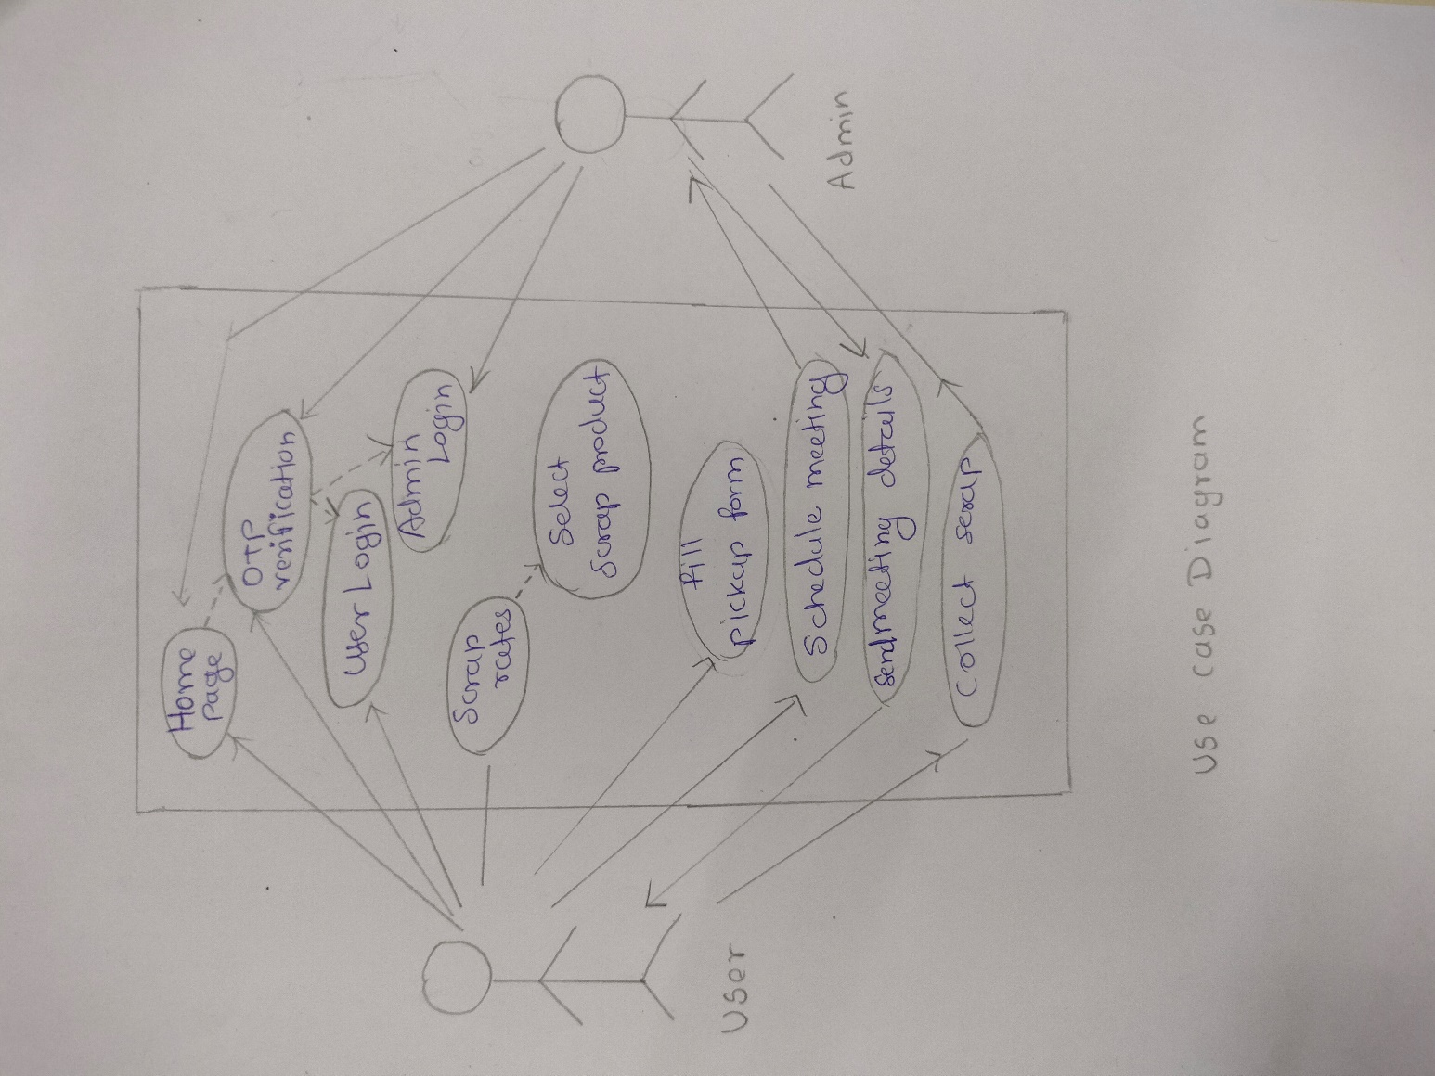

Figure 2: Use Case Diagram

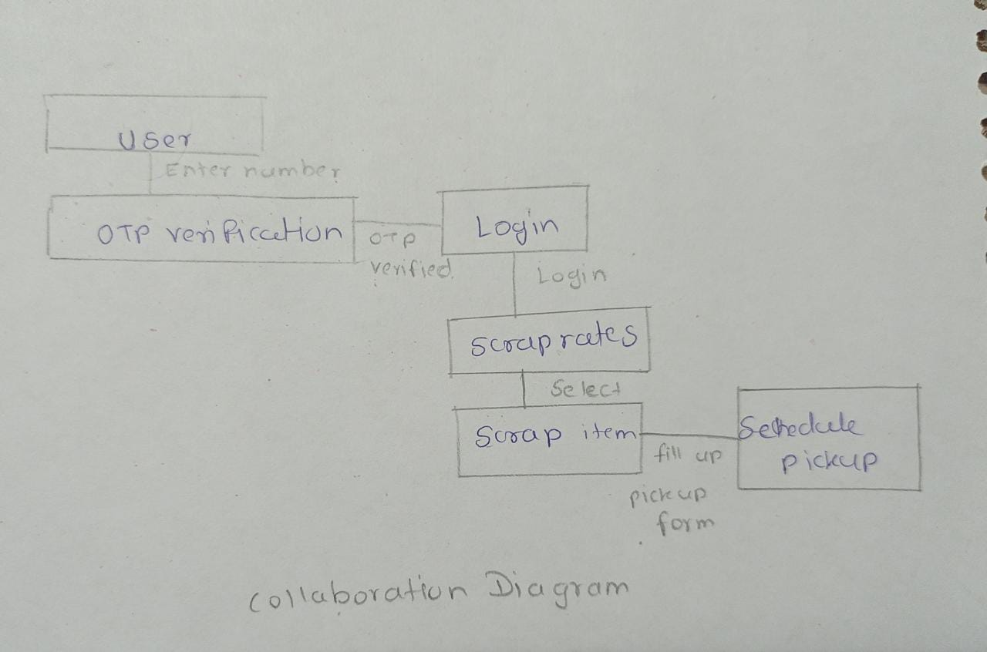

Figure 3: Collaboration Diagram

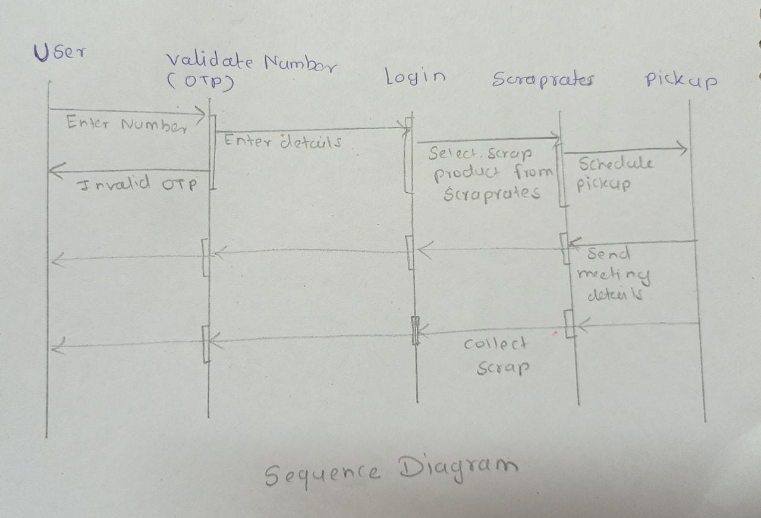

Figure 4: Sequence Diagram

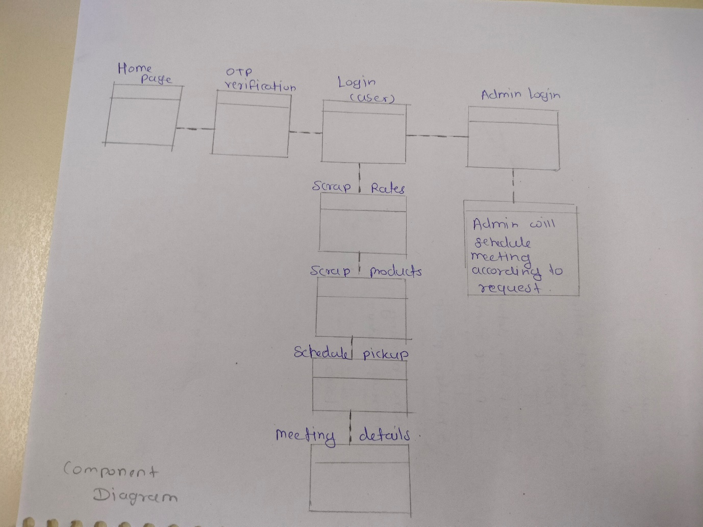

Figure 5: Component Diagram

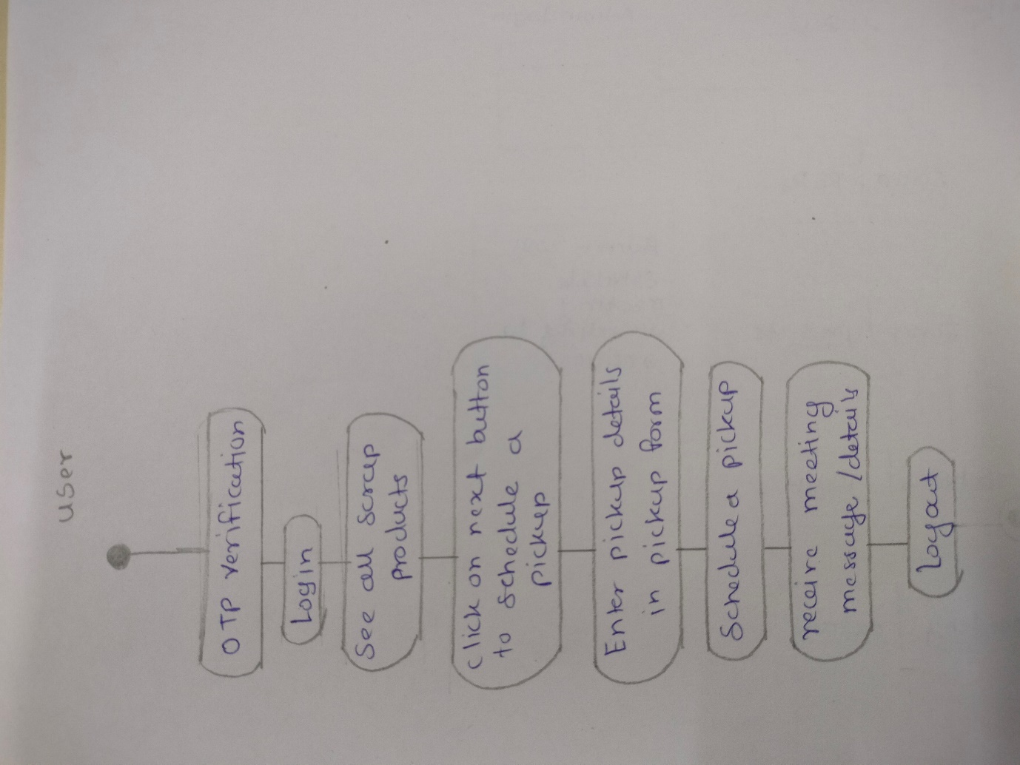

Figure 6: State Diagram

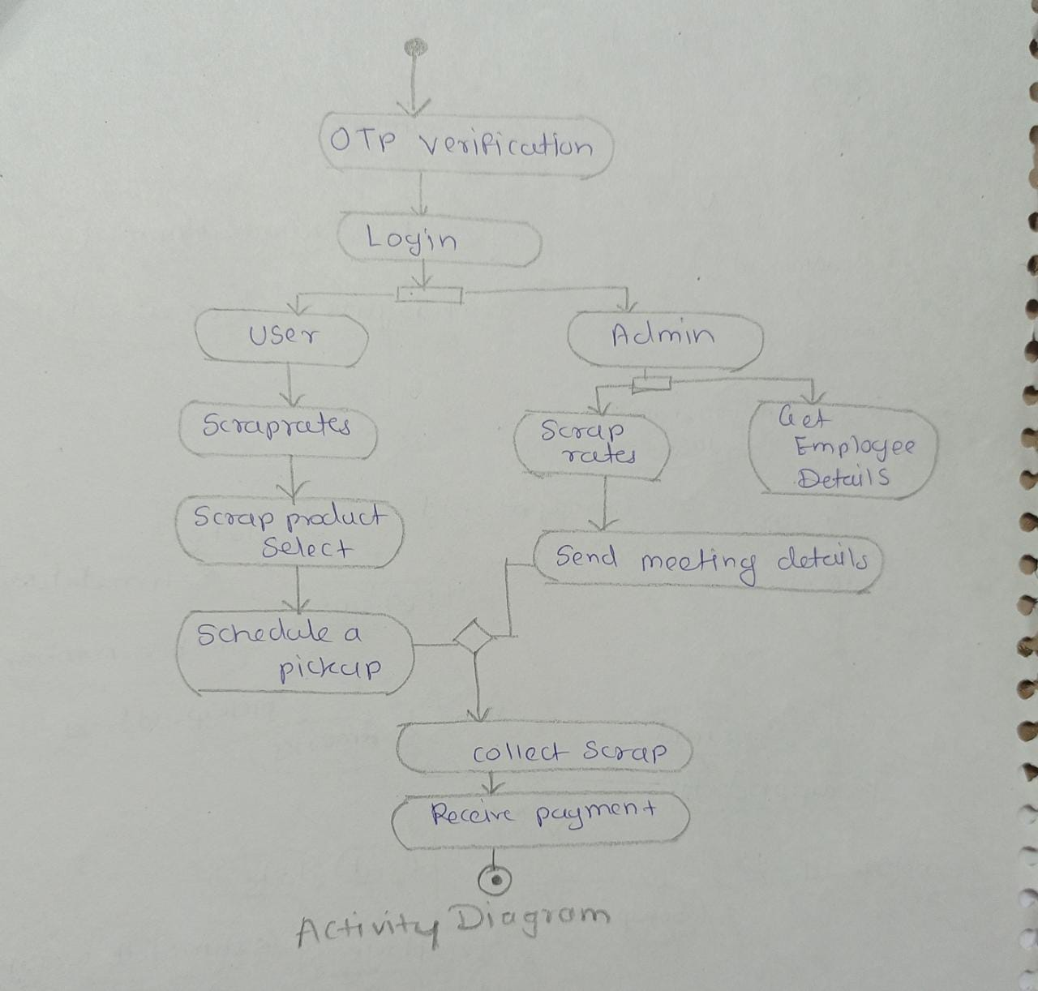

Figure 7: Activity Diagram

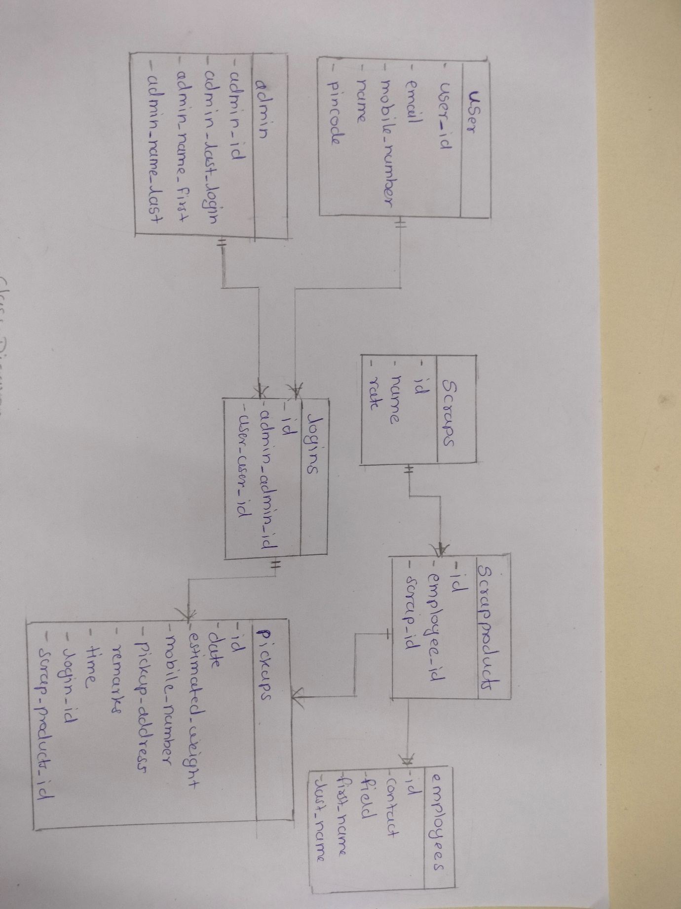

Figure 8: Class Diagram

1. **End to End Flow of Application:**

**User:**

* 1. User will verify his/her OTP through mobile number and then Login to the portal.
  2. After Login User can see the scrap products.
  3. From that page can User can click and select the product.
  4. After selecting the product, User have to fill the Pickup form for the Pickup schedule.
  5. After the Pickup form the user will receive the POP message of Pickup scheduled.

**Admin:**

1. First Admin also have to verify the OTP through mobile number.
2. Admin will login as Admin from the ‘**Admin login**’ page and will be able to see the Users and employees.
3. Admin can get the user details and employees details.
4. It is the job of Admin to assign appropriate employee to the respective scrap products.
5. **Roles and Responsibilities:**

|  |  |  |
| --- | --- | --- |
| **Roles And Responsibilities** | | |
| 1 | Role | BackEnd and Database |
| Member Name | **Aviral Kumar Singhal** |
| PRN No | 220943120013 |
| Description |  |
| 2 | Role | BackEnd and Database |
| Member Name | **Dipali Sham Patil** |
| PRN No | 220943120025 |
| Description |  |
| 3 | Role | FrontEnd |
| Member Name | **Pranali Gaware** |
| PRN No | 220943120079 |
| Description |  |
| 4 | Role | FronEnd |
| Member Name | **Rohini Amale** |
| PRN No | 220943120086 |
| Description |  |

1. **Future Scope of Project**

* In future we can provide live location of the scrap owner for the best navigation for collecting scraps.
* This website in future will be available for more than ten cities.
* In future the user will be able to pay online.

**Thank You!**