**Assignment-5**

**Name : Dipan Mondal**

**Roll : 002211001112**

**—------------------------------------------------------------------------**

**Downloading the input images:**

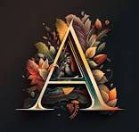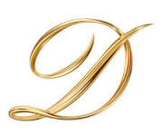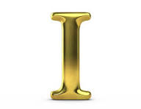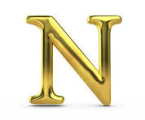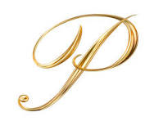

**Step 1 : Importing the library:**

from PIL import Image

import imageio.v2 as imageio

import numpy as np

**Step 2 : Creation of images list to store composite images and letter_images list to store the letter image paths**

images = []

letter_images = [ 'D.png', 'I.png', 'P.png', 'A.png', 'N.png']

**Step 3: Setting the fixed image size of each letter to 100x100 and the total gif file size.**

fixed_width, fixed_height = 100, 100

canvas_width = fixed_width * len(letter_images)

**Step 4 : Now loading the images one by one and appending them to a canvas and then save the frame.**

# Create progressive combinations of letters

for i in range(1, len(letter_images) + 1):

# Create a canvas with a fixed size for all frames

combined_image = Image.new("RGBA", (canvas_width, fixed_height))

x_offset = 0

for j in range(i):

img = Image.open(letter_images[j]).resize((fixed_width, fixed_height)) # Resize to fixed dimensions

combined_image.paste(img, (x_offset, 0))

x_offset += fixed_width

# Save the frame

frame_name = f"frame_{i}.png"

combined_image.save(frame_name)

images.append(imageio.imread(frame_name))

**Step 5: Create and save the gif.**

output_gif = '1112_A3_Ass5_Dipan_Mondal.gif'

imageio.mimsave(output_gif, images, duration=500,loop=0)