Selecting the line tool and drawing the stares:

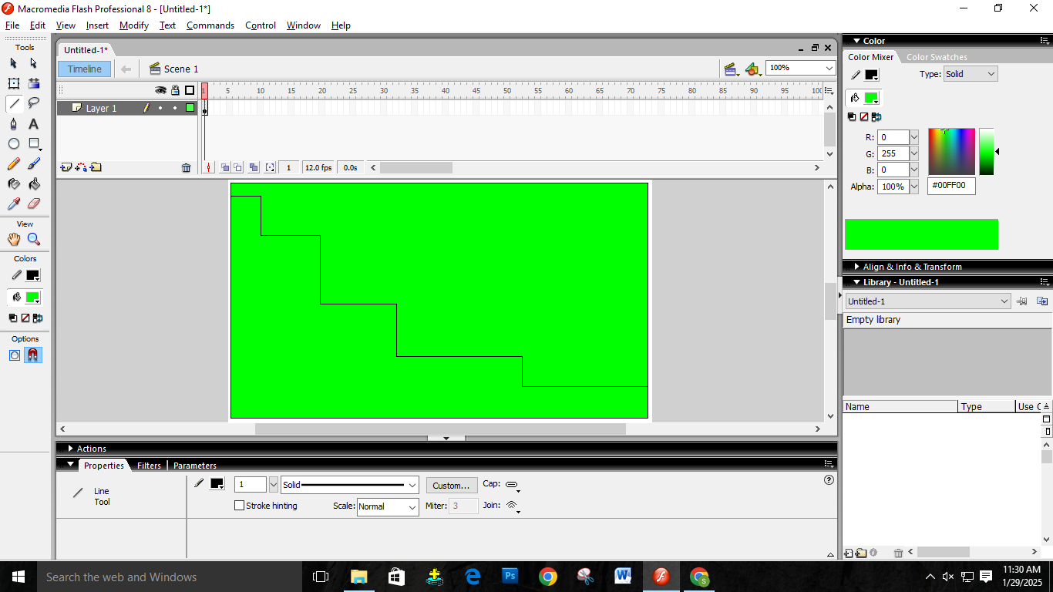

Created a new layer using the selection tool for the bellow the stair. And set the background color to deep blue.

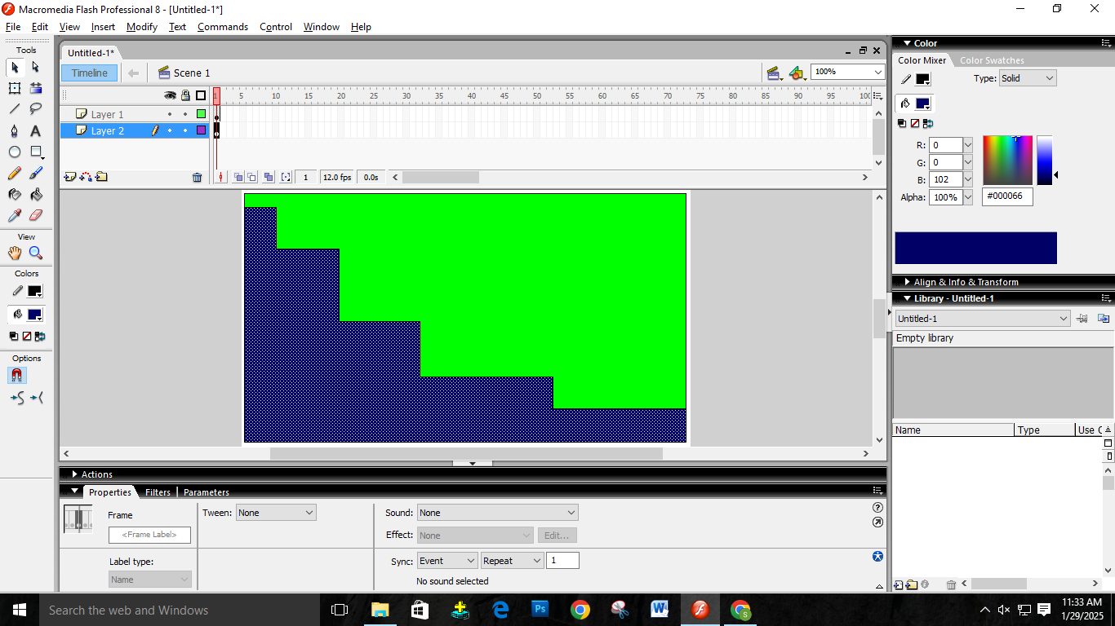

Using the rectangle tool and smoothing the corners to round to 500 and draw a circle and then created a new layer and named it circle. Then used the paint bucket and colored it into a new color.

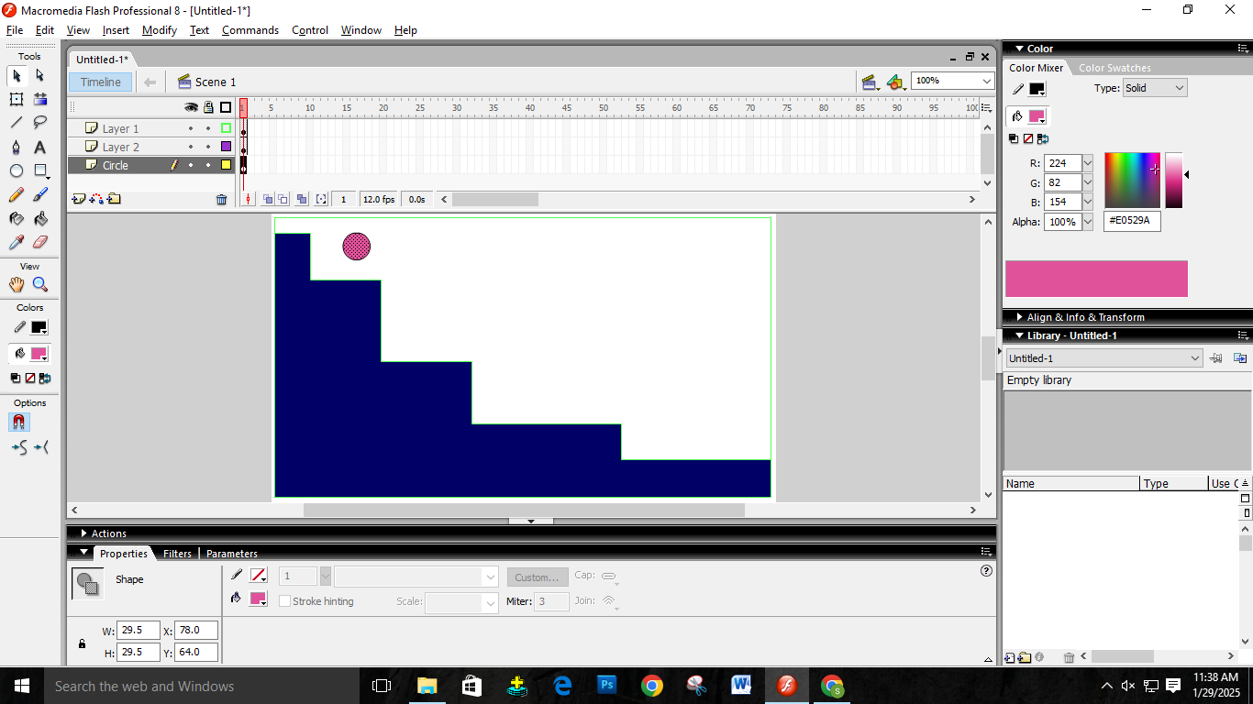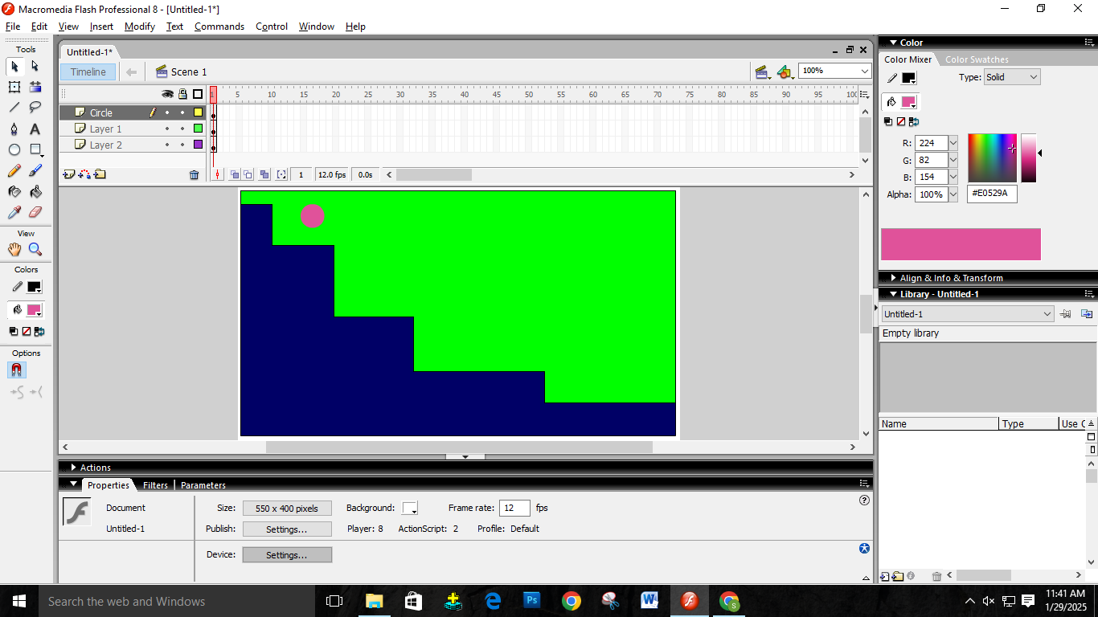

Now I added frame durations and then moved the ball and repeated this step multiple times to create the animation.

