**Assignment - 7**

**Name : Dipan Mondal**

**Roll : 002211001112**

**Sec : A3**

**—----------------------------------------------------------------**

**First took three images of a rotating fan:**

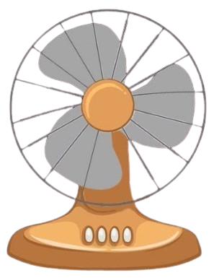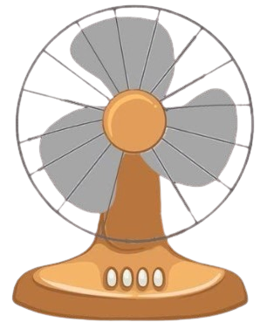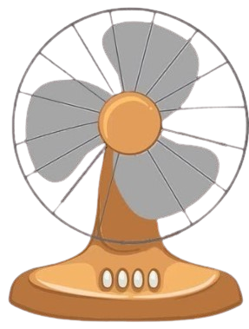

**Then I import on fan on a layer and added them to key frame:**

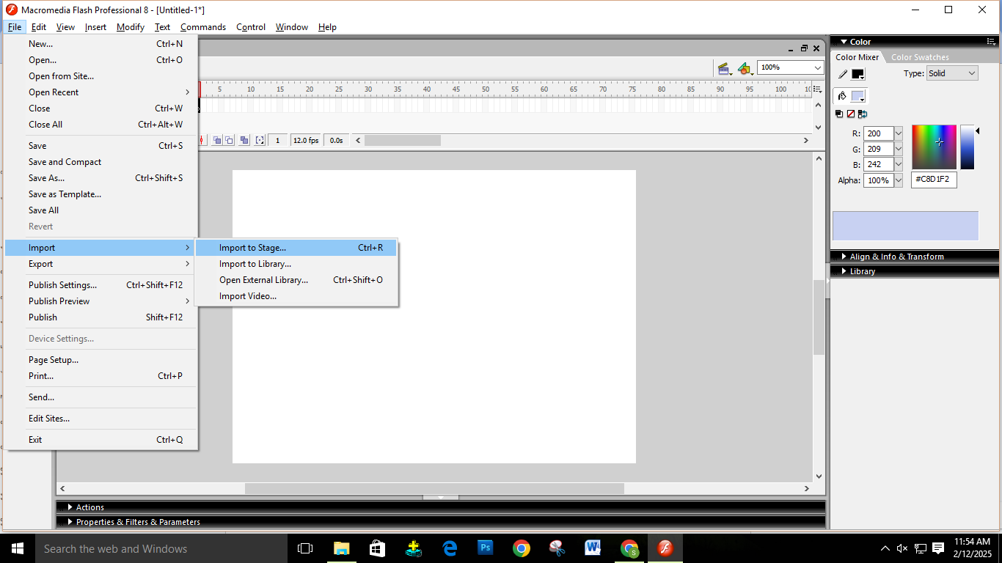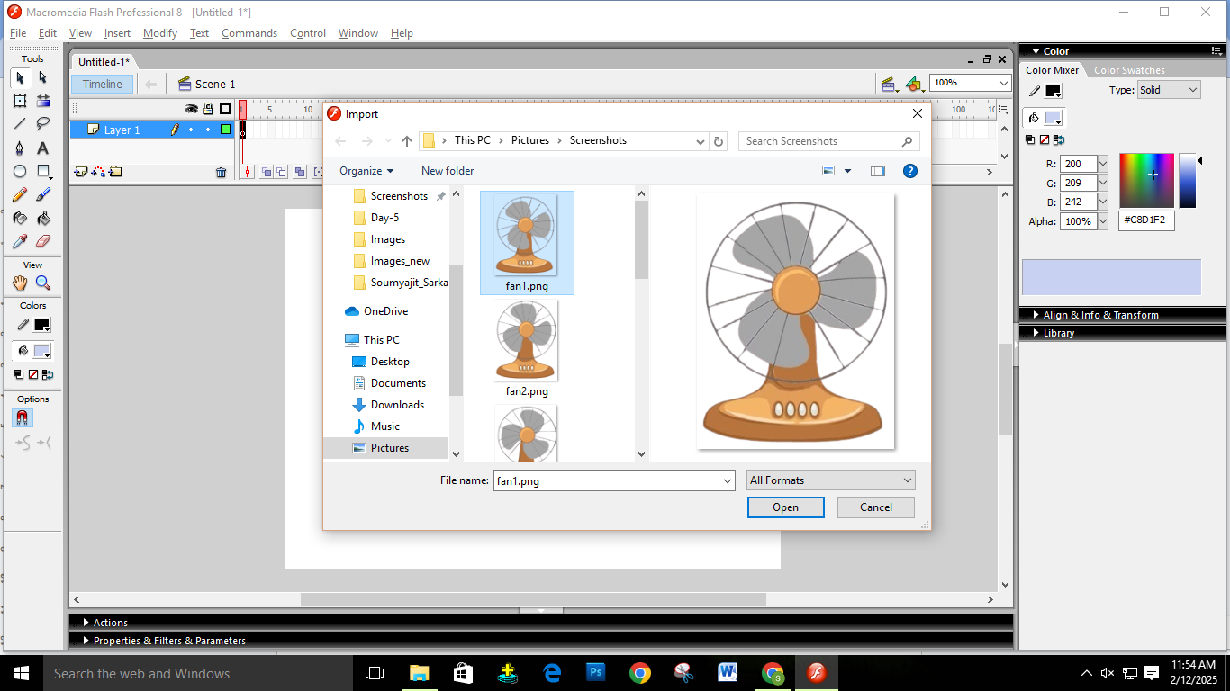

**Then added a new keyframe and add the second image of rotating blade:**

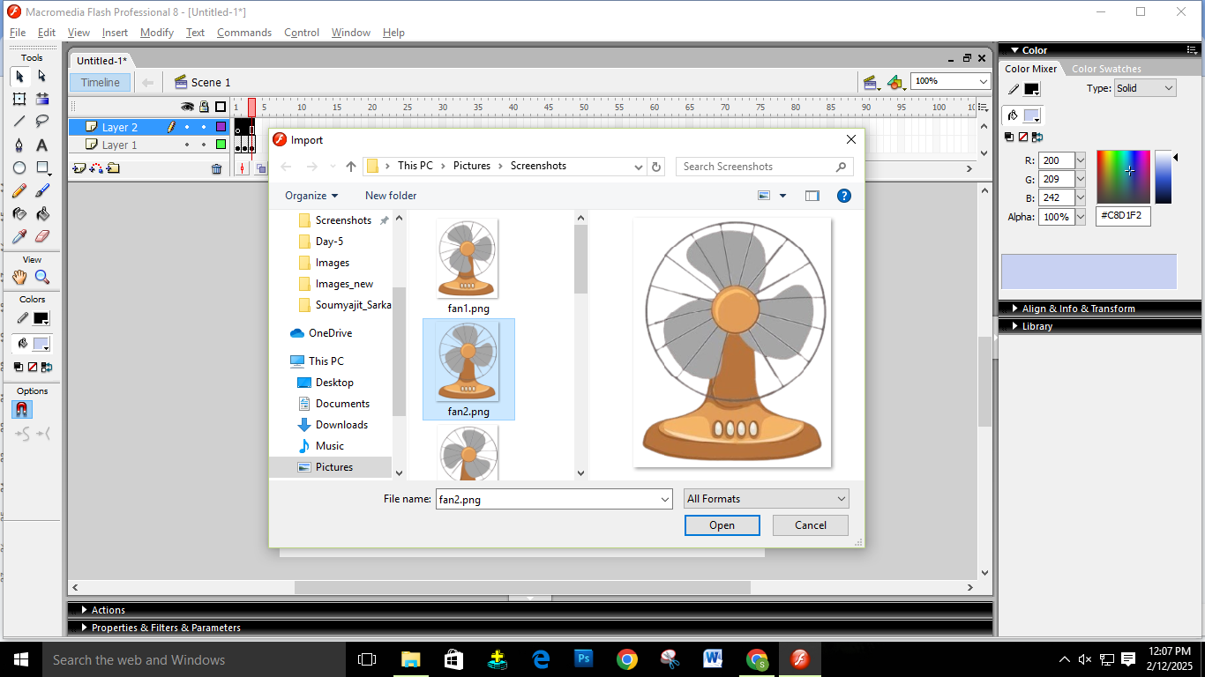

**Similarly we added the third key frame and inserted the third image:**

