**ASSIGNMENT - 8**

**NAME - DIPAN MONDAL**

**ROLL - 002211001112**

**SEC - A3**

**—-------------------------------------------------------**

The given task is to make a comparison between different rle method on multiple parameters. The given two methods are

Method 1:  
Compression Algorithm:

Step-1: Start on the first element of input.

Step -2: Initialize the values with count=1, k=0.

Step-3: Read the first element of input data1.

Step-4: As the value of K is ̳0‘ it will print the input

data1 and then it increments the K value to ̳1‘.

Step-5: Again it goes to step-3 takes the second data2

and next the checks the value of k

Step-6:As the value of k is 1 it now it will checks for

whether data1=data2,if the data1=data2 it will

increment the count value if not equal it prints the

count value after the data1 value and again goes to

step 2.

Method 2:

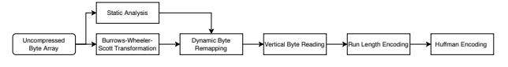

Data:

We have used 2 b&w ,2 grayscale and 2 rgb images.

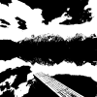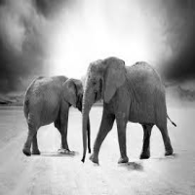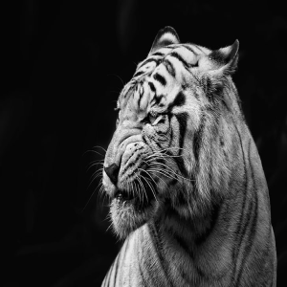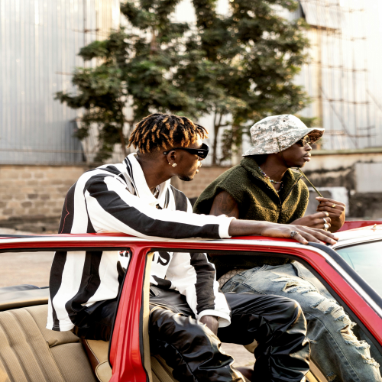

The data previously is not preprocessed to particular sizes.

So we used data preprocessing to resize them  
  
def convert_and_resize(image_name,width,height,output_name):

image = cv2.imread(image_name, cv2.IMREAD_GRAYSCALE)

if image is None:

print("Error: Image not found or unable to read!")

return

_, bw_image = cv2.threshold(image, 127, 255, cv2.THRESH_BINARY)

# Resize the image

resized_image = cv2.resize(bw_image, (width, height), interpolation=cv2.INTER_AREA)

# Save the new image

cv2.imwrite(output_name, resized_image)

print(f"Black and white resized image saved as {output_name}")

image_name = "./data/b&w1.png"

output_name = "./data/b&w1_mod.png"

width=50

height=50

convert_and_resize(image_name,width,height,output_name)

image_name = "./data/b&w2.png"

output_name = "./data/b&w2_mod.png"

width=100

height=100

convert_and_resize(image_name,width,height,output_name)

def grayscale_image_process(input_name, width, height, output_name):

image = cv2.imread(input_name, cv2.IMREAD_GRAYSCALE)

if image is None:

print("Error: Image not found or unable to read!")

return

resized_image = cv2.resize(image, (width, height), interpolation=cv2.INTER_AREA)

cv2.imwrite(output_name, resized_image)

print(f"Resized grayscale image saved as {output_name}")

image_name = "./data/gray1.png"

output_name = "./data/gray1_mod.png"

width=200

height=200

grayscale_image_process(image_name,width,height,output_name)

image_name = "./data/gray2.png"

output_name = "./data/gray2_mod.png"

width=300

height=300

grayscale_image_process(image_name,width,height,output_name)

def rgb_image_process(input_name, width, height, output_name):

image = cv2.imread(input_name, cv2.IMREAD_COLOR)

if image is None:

print("Error: Image not found or unable to read!")

return

resized_image = cv2.resize(image, (width, height), interpolation=cv2.INTER_AREA)

cv2.imwrite(output_name, resized_image)

print(f"Resized RGB image saved as {output_name}")

image_name = "./data/rgb1.png"

output_name = "./data/rgb1_mod.png"

width=400

height=400

rgb_image_process(image_name,width,height,output_name)

image_name = "./data/rgb2.png"

output_name = "./data/rgb2_mod.png"

width=500

height=500

rgb_image_process(image_name,width,height,output_name)

After the pre processing is done we used the two methods mentioned earlier to implement the methods and make the comparison table.  
Method 1 implementation:

**The main method of rle enocde**

def rle_encode(data):

encoded = []

count = 1

k = 0

for i in range(1, len(data)):

if data[i] == data[i - 1]:

count += 1

else:

encoded.append((data[i - 1], count))

count = 1

encoded.append((data[-1], count)) # Add the last sequence

return encoded

**A helper function to process all the images:**

def image_to_rle(image_path, mode='grayscale'):

start_time = time.time()

if mode == 'bw':

image = cv2.imread(image_path, cv2.IMREAD_GRAYSCALE) # Convert to B/W

image = np.where(image > 127, 255, 0).astype(np.uint8)

elif mode == 'grayscale':

image = cv2.imread(image_path, cv2.IMREAD_GRAYSCALE)

elif mode == 'rgb':

image = cv2.imread(image_path, cv2.IMREAD_COLOR)

else:

raise ValueError("Invalid mode. Choose from 'bw', 'grayscale', 'rgb'")

original_size = image.size # Total pixels

if mode == 'rgb':

flattened = image.reshape(-1, 3) # Flatten RGB

encoded = [rle_encode(flattened[:, i]) for i in range(3)] # RLE per channel

else:

flattened = image.flatten()

encoded = rle_encode(flattened)

save_encoded(image_path+"_paper1_encoded.pkl",encoded)

compressed_size = sum(len(enc) for enc in encoded) * 2 # Each (value, count) pair is stored

compression_ratio = (compressed_size / original_size) * 100

space_saving = 100 - compression_ratio

compression_time = (time.time() - start_time) * 1000 # Convert to milliseconds

return original_size, compressed_size, compression_ratio, space_saving, compression_time

**Helper function to make the comparison table:**

def evaluate_images(image_paths, modes=['bw', 'grayscale', 'rgb']):

results = []

for i in range(len(image_paths)):

image_path=image_paths[i]

mode=modes[i//2]

orig_size, comp_size, comp_ratio, space_save, comp_time = image_to_rle(image_path, mode)

results.append([image_path, mode, orig_size, comp_size, comp_ratio, space_save, comp_time])

df = pd.DataFrame(results, columns=['Image', 'Mode', 'Original Size', 'Compressed Size', 'Compression Ratio (%)', 'Space Saving (%)', 'Compression Time (ms)'])

return df

image_paths = ['./data/b&w1_mod.png',

'./data/b&w2_mod.png',

'./data/gray1_mod.png',

'./data/gray2_mod.png',

'./data/rgb1_mod.png',

'./data/rgb2_mod.png']

df1=evaluate_images(image_paths)

**Implementation of second method:**

**Main method to encode rle**

def bitwise_rle_encode(data):

encoded = []

count = 1

prev = data[0]

for i in range(1, len(data)):

if data[i] == prev:

count += 1

else:

encoded.append((prev, count))

prev = data[i]

count = 1

encoded.append((prev, count)) # Add last sequence

return encoded

**Helper method to process all the images:**

def image_to_bitwise_rle(image_path, mode='grayscale'):

start_time = time.time()

if mode == 'bw':

image = cv2.imread(image_path, cv2.IMREAD_GRAYSCALE)

image = np.where(image > 127, 255, 0).astype(np.uint8) # Convert to B/W

elif mode == 'grayscale':

image = cv2.imread(image_path, cv2.IMREAD_GRAYSCALE)

elif mode == 'rgb':

image = cv2.imread(image_path, cv2.IMREAD_COLOR)

else:

raise ValueError("Invalid mode. Choose from 'bw', 'grayscale', 'rgb'")

original_size = image.size # Total pixels

if mode == 'rgb':

flattened = image.reshape(-1, 3) # Flatten RGB

with multiprocessing.Pool(3) as pool:

encoded = pool.map(bitwise_rle_encode, [flattened[:, i] for i in range(3)])

else:

flattened = image.flatten()

encoded = bitwise_rle_encode(flattened)

save_encoded(image_path+"_paper2_encodes.pkl",encoded)

compressed_size = sum(len(enc) for enc in encoded) * 2 # Each (value, count) pair

compression_ratio = (compressed_size / original_size) * 100

space_saving = 100 - compression_ratio

compression_time = (time.time() - start_time) * 1000 # Convert to milliseconds

return original_size, compressed_size, compression_ratio, space_saving, compression_time

**Helper method to save the results:**

def evaluate_bitwise_images(image_paths, modes=['bw', 'grayscale', 'rgb']):

results = []

for i in range(len(image_paths)):

image_path=image_paths[i]

mode=modes[i//2]

orig_size, comp_size, comp_ratio, space_save, comp_time = image_to_bitwise_rle(image_path, mode)

results.append([image_path, mode, orig_size, comp_size, comp_ratio, space_save, comp_time])

df = pd.DataFrame(results, columns=['Image', 'Mode', 'Original Size', 'Compressed Size', 'Compression Ratio (%)', 'Space Saving (%)', 'Compression Time (ms)'])

return df

if __name__ == "__main__":

image_paths = ['./data/b&w1_mod.png',

'./data/b&w2_mod.png',

'./data/gray1_mod.png',

'./data/gray2_mod.png',

'./data/rgb1_mod.png',

'./data/rgb2_mod.png']

df_results = evaluate_bitwise_images(image_paths)

print(df_results)

**Results:**

Paper 1:

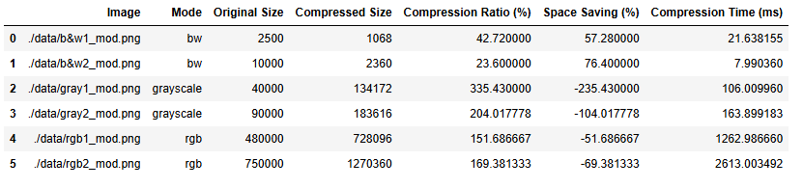

Paper 2:

