**ASSIGNMENT-9**

**NAME : DIPAN MONDAL**

**SEC : A3**

**ROLL : 002211001112**

**—----------------------------------------------------------------**

Used y2mate tool to download 2 musics from youtube in mp3 format: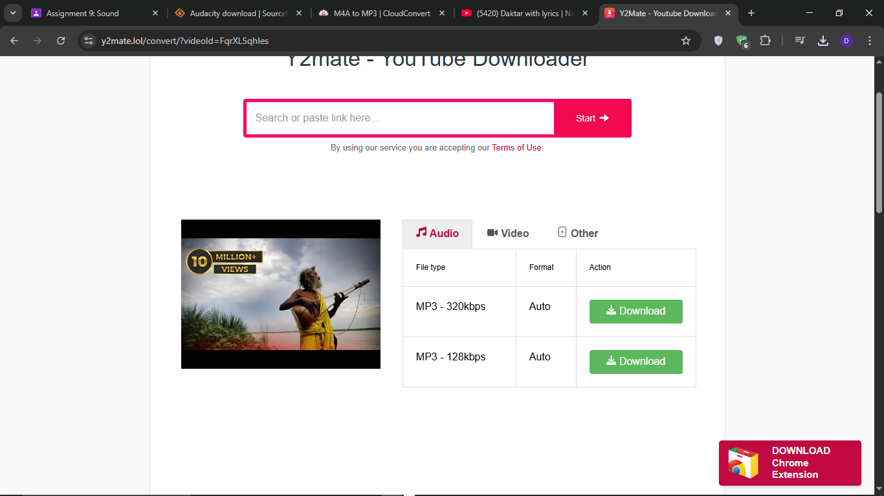

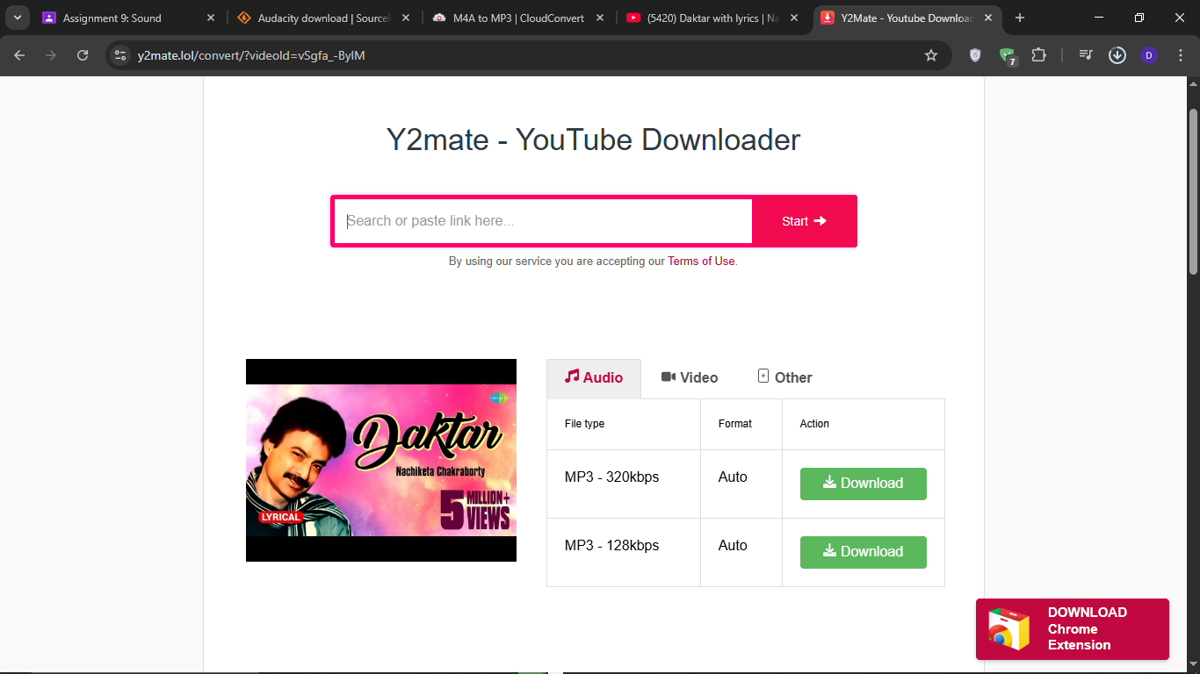

Step 2: Use trim audio tool to trim the songs to 1 min size:

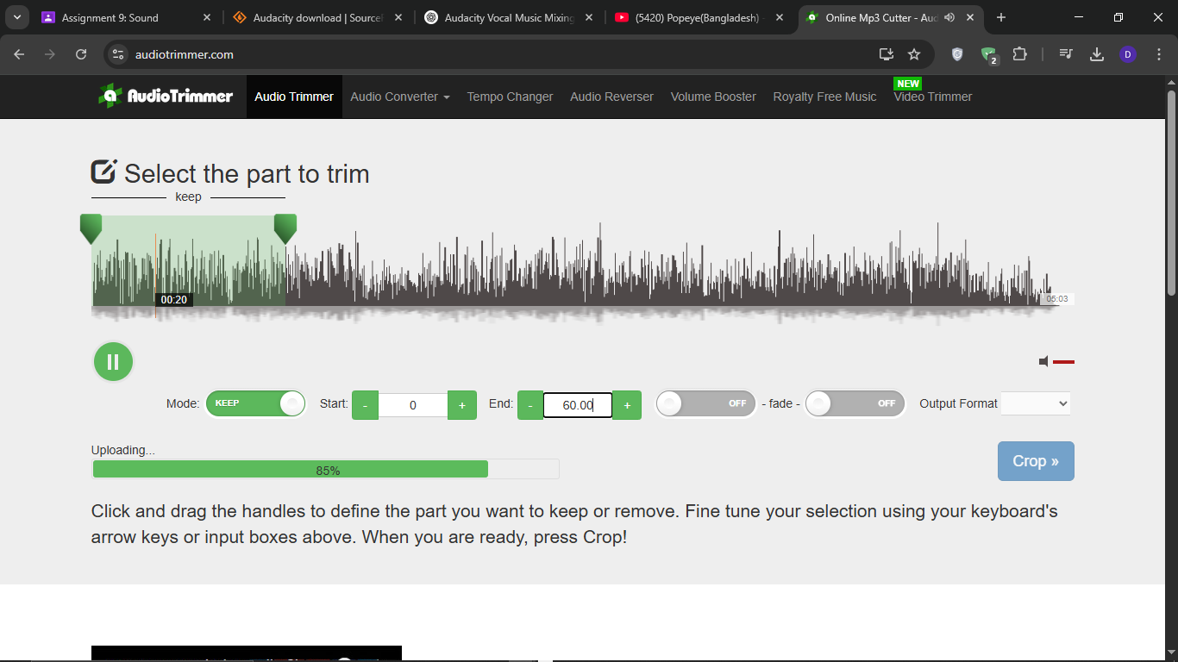

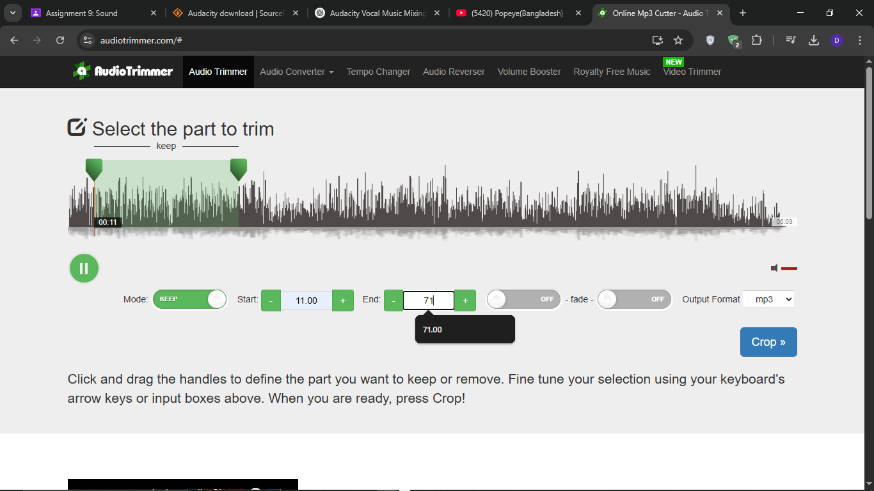

Step 3: Import the two songs.

Click **File** → **Import** → **Audio**.

Select **mon.. (MP3 file)** and click **Open**.

Repeat the same process to import **oDaktar**.

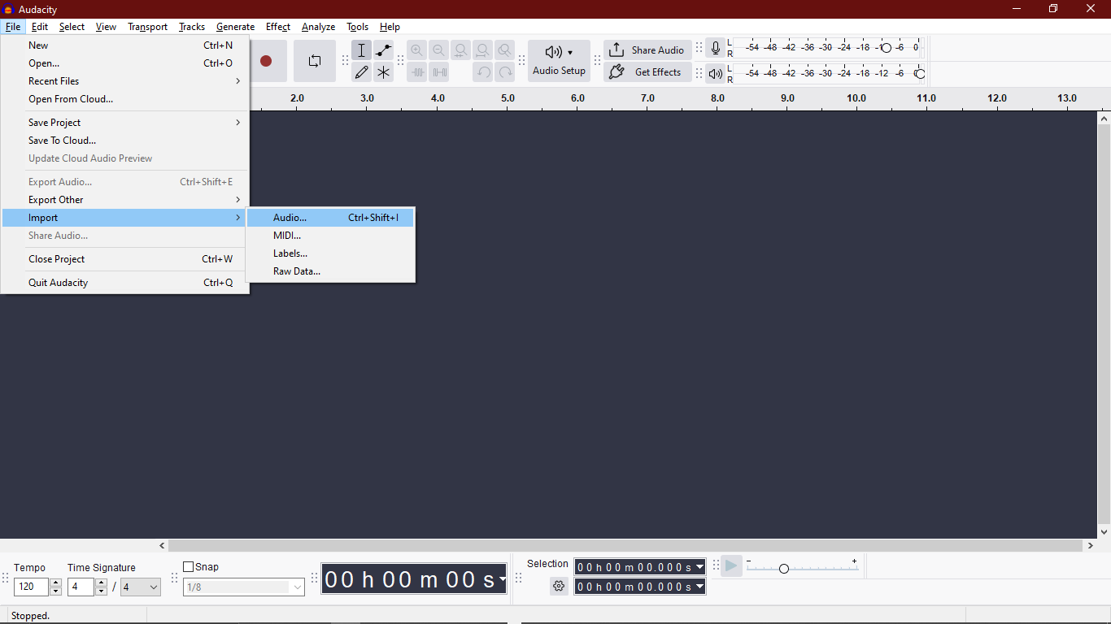

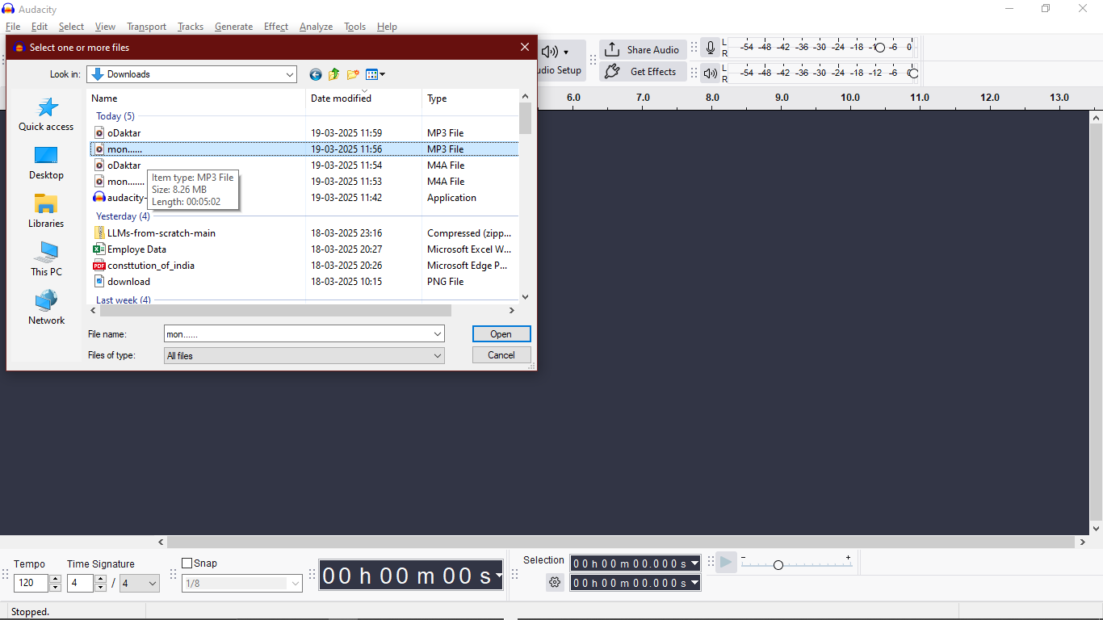

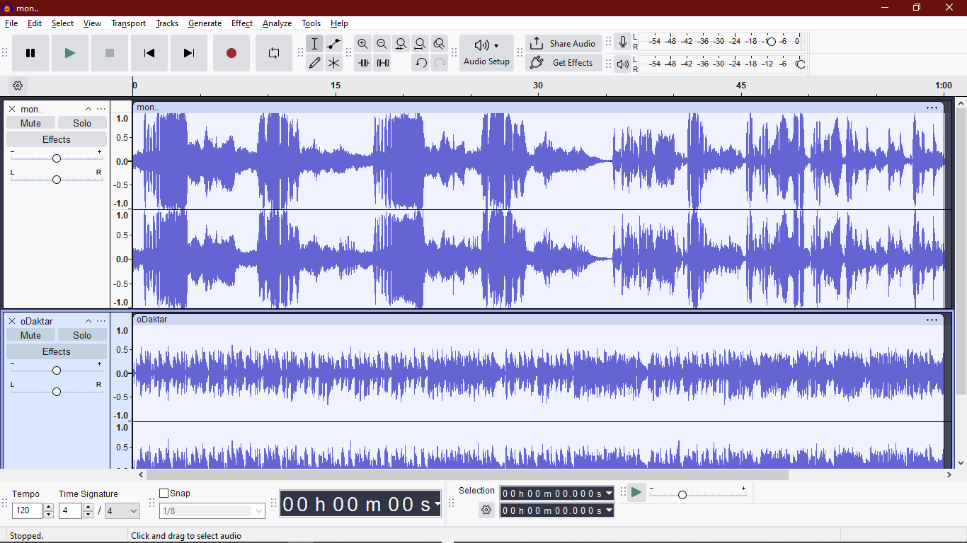

## 

## 

## **Step 3: Extract Vocals and Music Separately**

### **Method 1: Using Audacity's AI Vocal Reduction and Isolation**

1. Click on **Track 1** to select it.
2. Go to **Effect** → **Get AI Effects**

And download the ai extension.

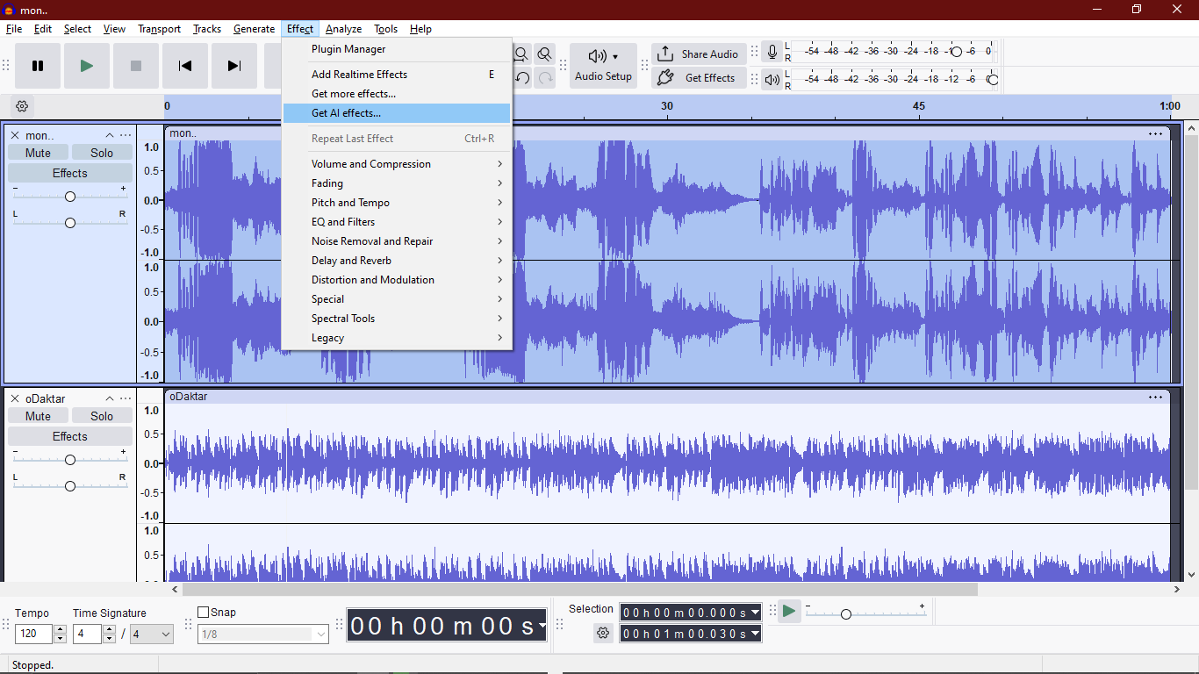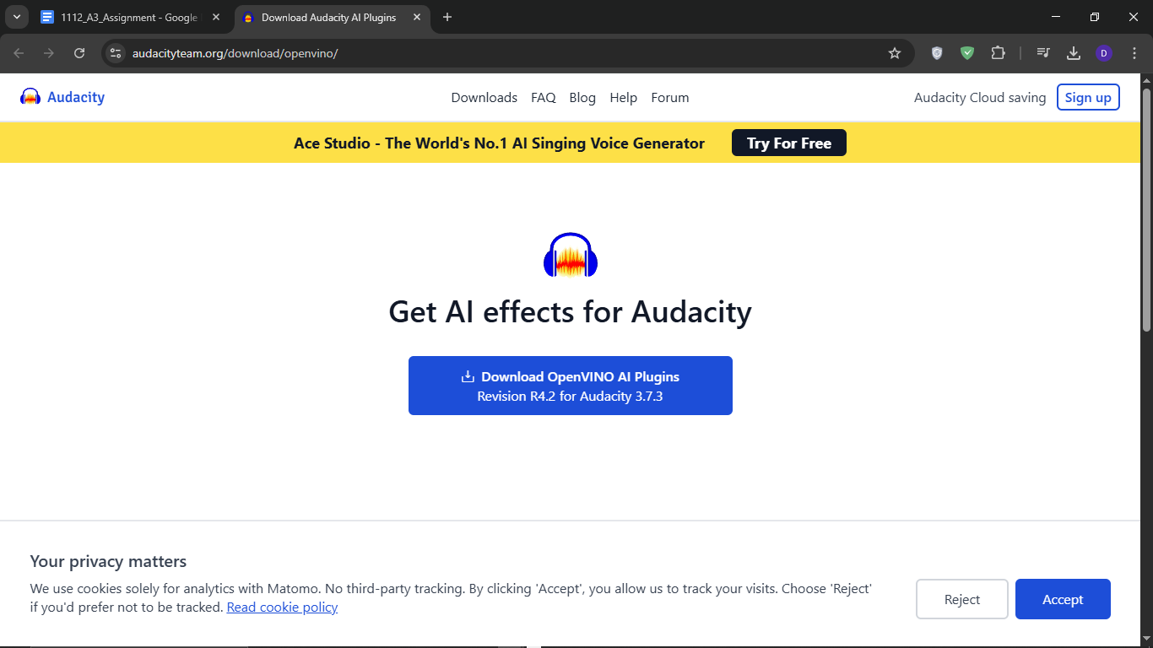

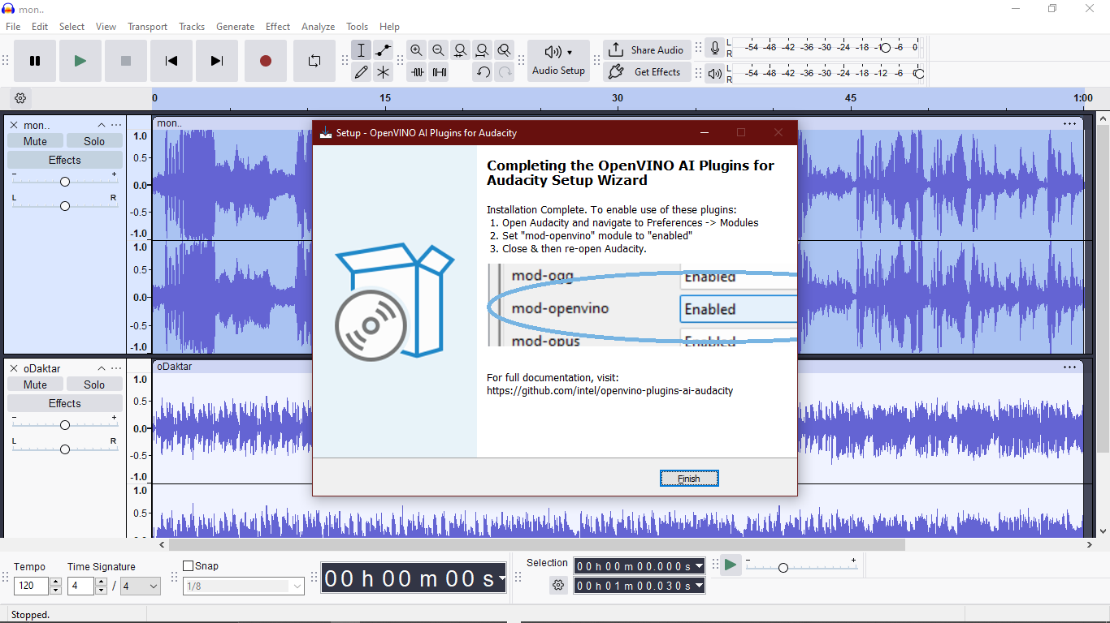

Enabling the extension:

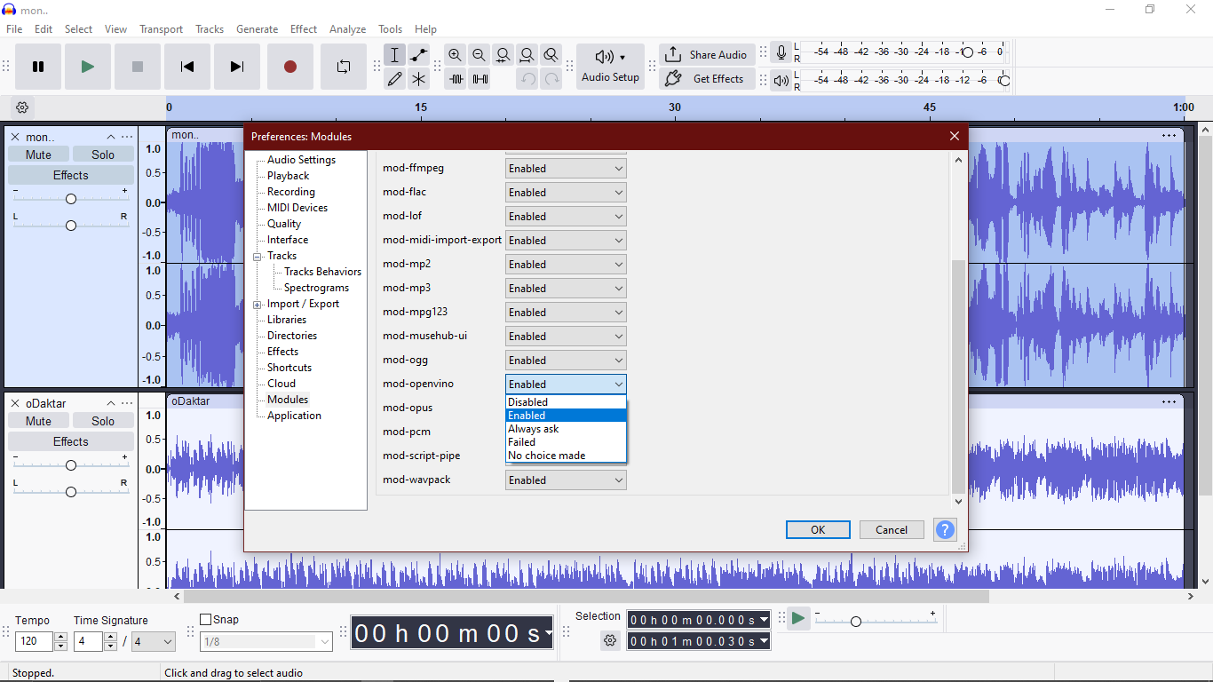

Select one track -> go to **Effects** -> **OpenVINO AI Effects**->**OpenVINO Music Separation.**

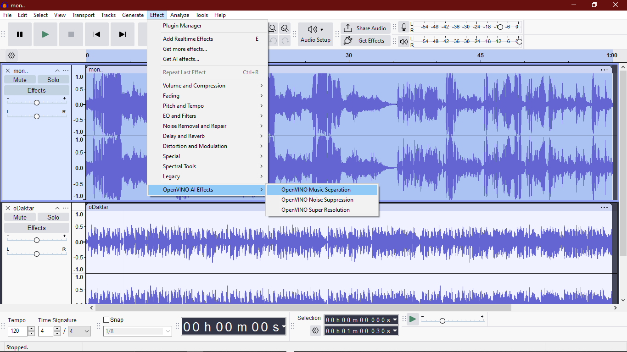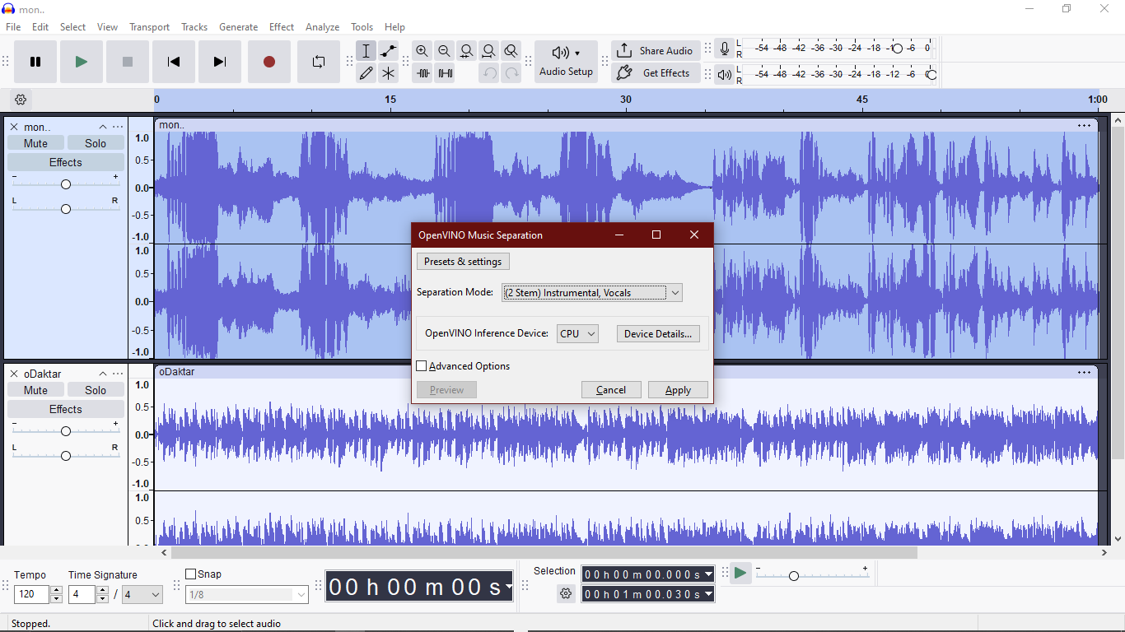

**Then Hit Apply and Wait…..**

The separation is done and repeated on the second song:

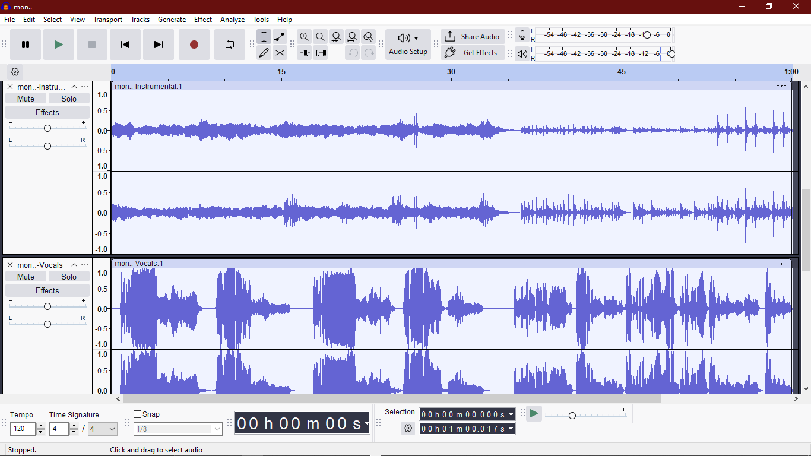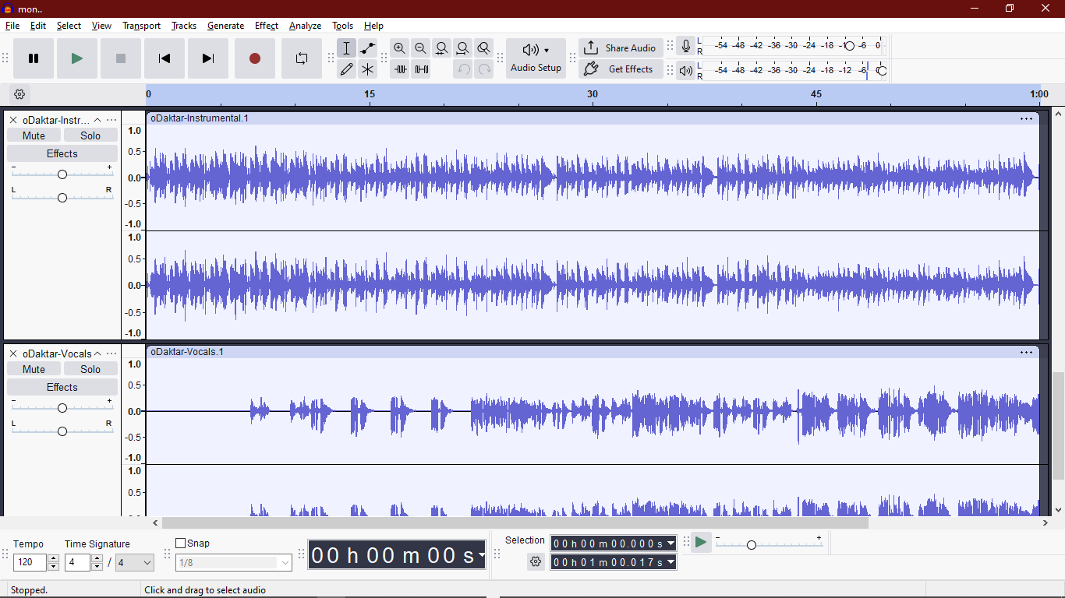

**Step 3 : Split Each musics and added in zig-zag pattern:**

Split:

Split all the vocal and instrumental tracks to 30 2 section

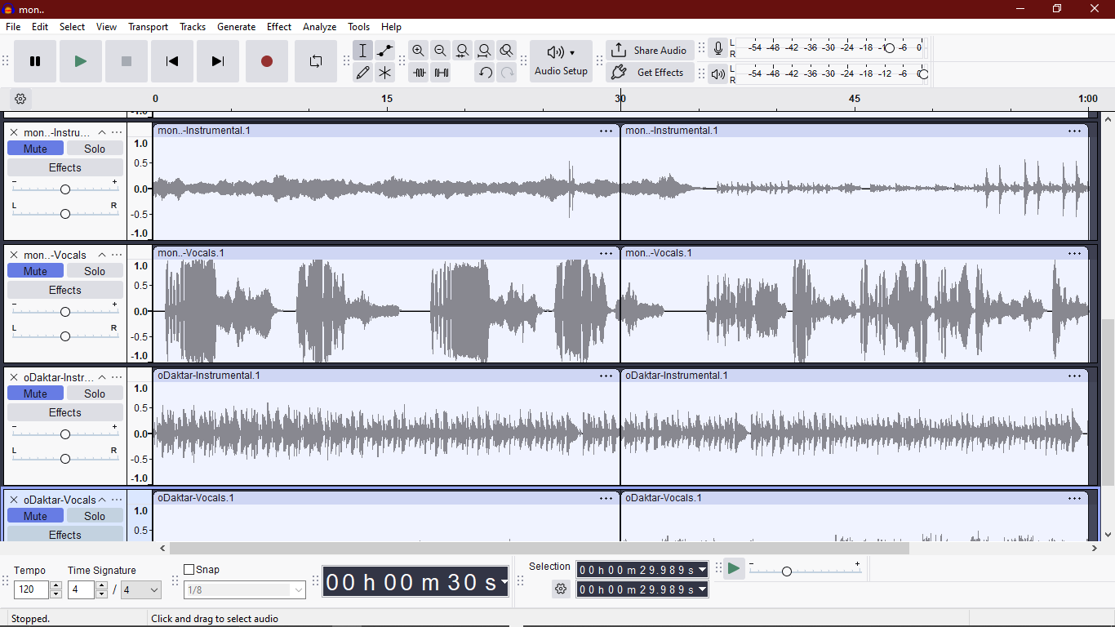

Add two new empty tracks:

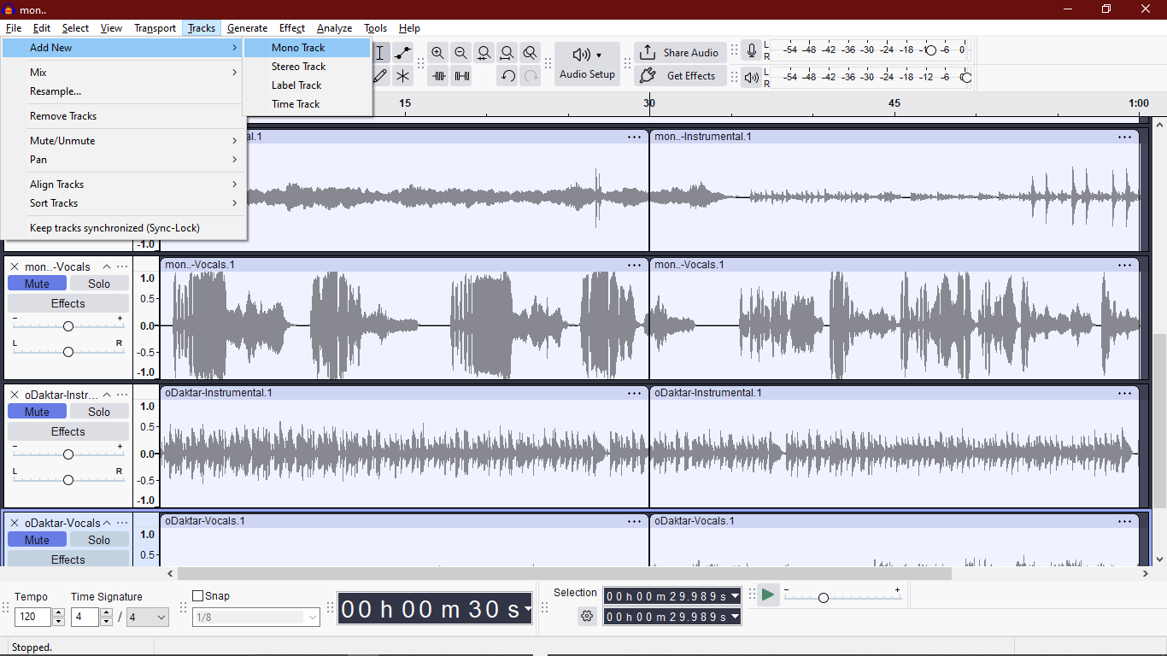

**Step 4: Mixing the tracks:**

Now copy one part of vocals and another part of another son’s instrumentals in a zig zag fomat. Use audio 1 for vocals and audio 2 for instrumentals

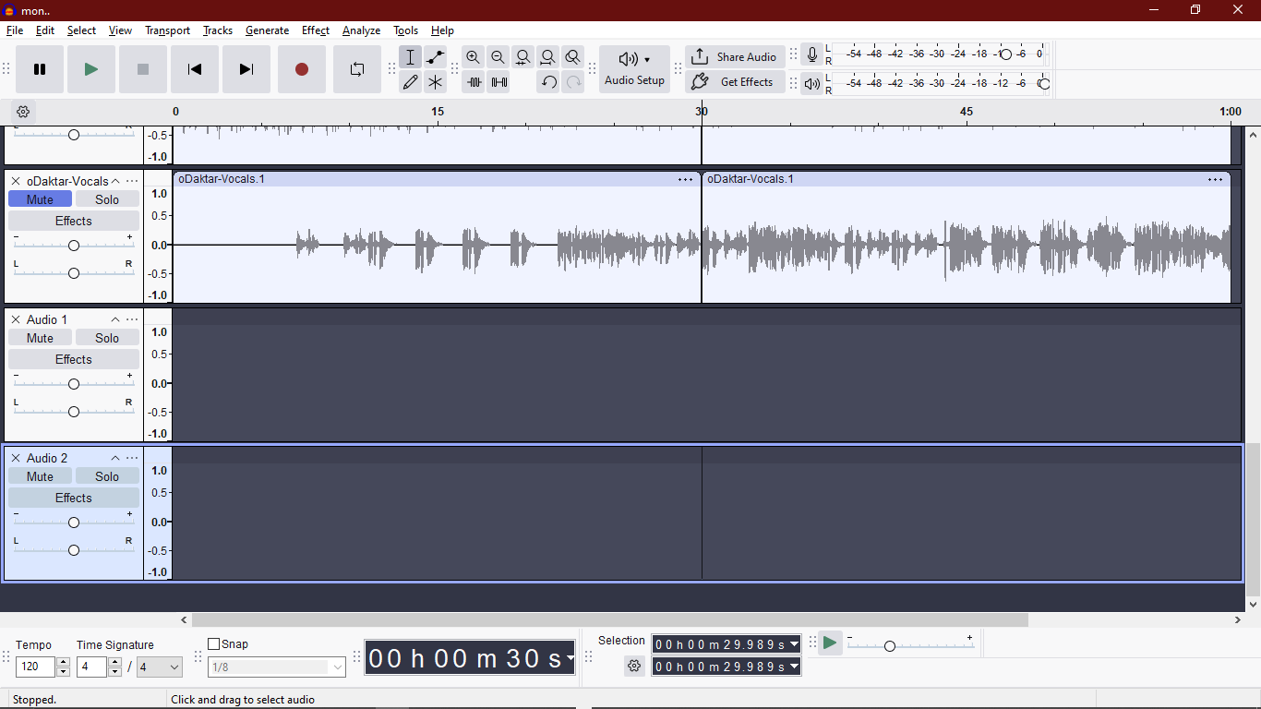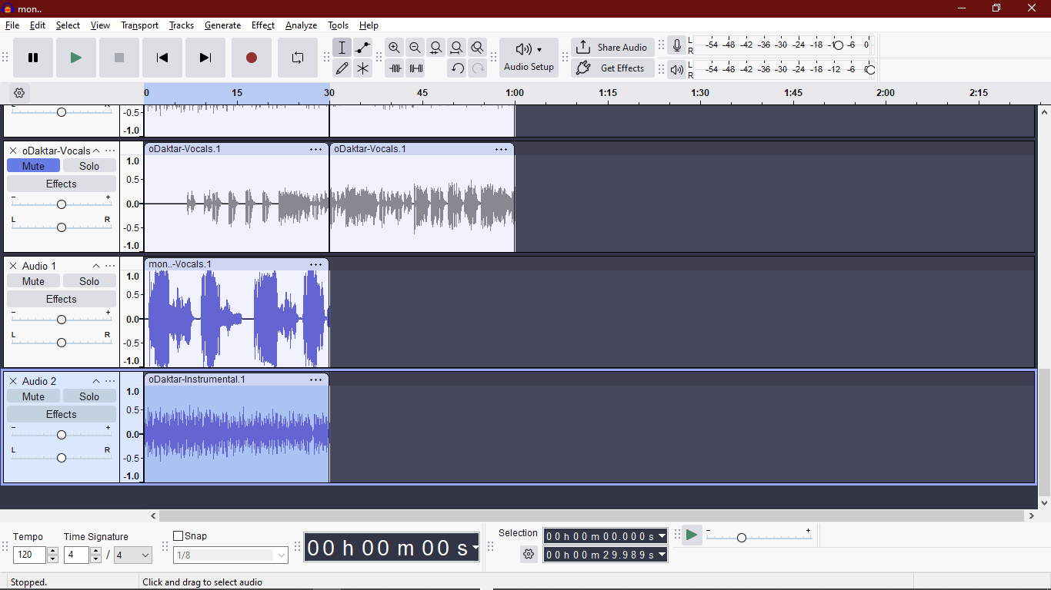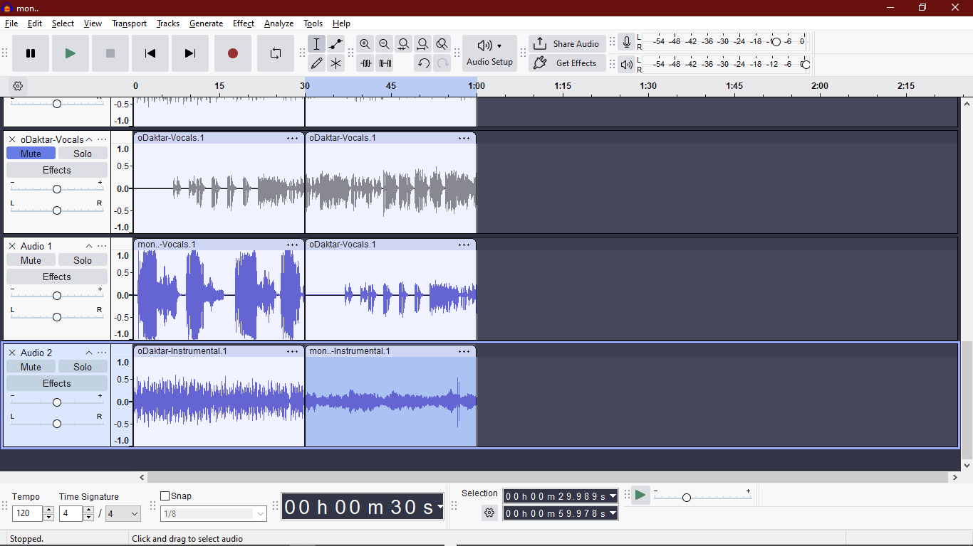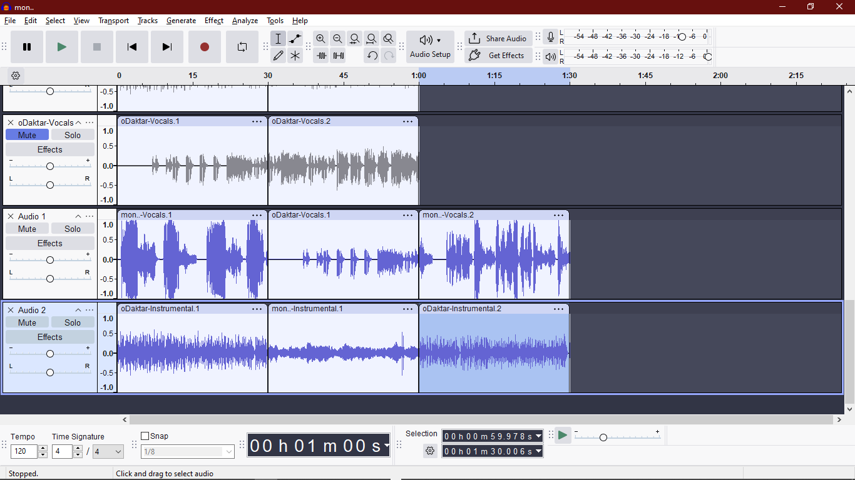

**Step 5 : Downloading the files:**

Select Mix1 -> Go to file -> go to **Export Audio File** ->Select a name for the file and select file extension to MP3-> then press **Export**