Functions

Exercise-1 : Create a scalar function :

CREATE FUNCTION fn_CalculateAnnualSalary (@MonthlySalary DECIMAL(10,2))

RETURNS DECIMAL(12,2)

AS

BEGIN

RETURN (@MonthlySalary * 12);

END;

SELECT

EmployeeID,

FirstName,

LastName,

Salary AS MonthlySalary,

dbo.fn_CalculateAnnualSalary(Salary) AS AnnualSalary

FROM Employees;

Output:

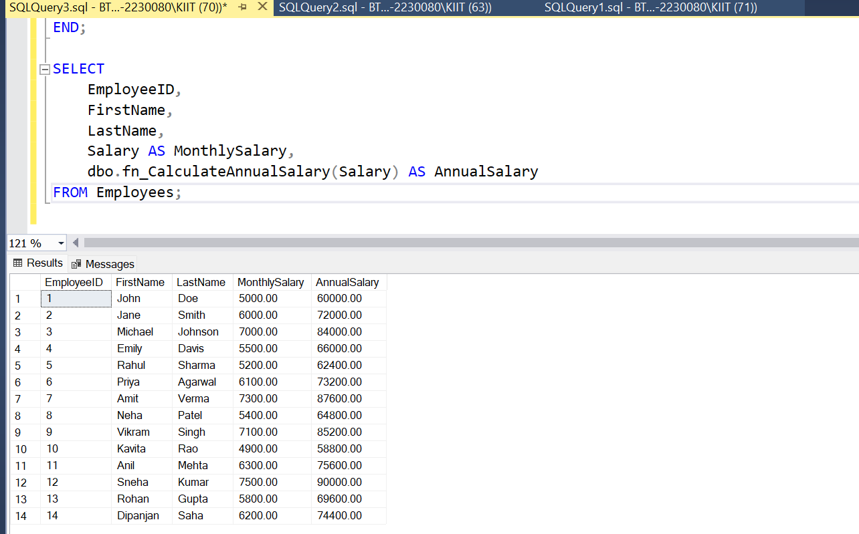

Exercise-2 : Return from a scalar function

SELECT

FirstName,

LastName,

Salary AS MonthlySalary,

dbo.fn_CalculateAnnualSalary(Salary) AS AnnualSalary

FROM Employees

WHERE EmployeeID = 5;

Output:

