DEPARTMENT OF ELECTRONICS & TELECOMMUNICATION ENGINEERING

PROJECT:
FLIGHT FARE PREDICTION

Report for Course: Introduction to Machine Learning (24ETAEC49)
Course Coordinator: Prof. Dr. Akshata.S.K

NAME | USN
DIPANJAN CHOWDHURY | 1MS24ET015
DEVANSH GUPTA | 1MS24ET012

RAMAIAH INSTITUTE OF TECHNOLOGY
(Autonomous Institute, Affiliated to VTU)
Accredited by NBA & NAAC with ‘A+’ Grade
MSR Nagar, Bangalore - 560054

May 20, 2026

Contents

0.1 Abstract
0.2 Introduction
0.2.1 Literature Review / Architectural Fit
0.2.2 Model Overview: Why Random Forest Fits
0.2.3 Validation & Interpretation of Scores
0.3 Project Pipeline
0.4 Dataset Components & Preprocessing
0.5 Source Code
0.6 Execution Protocol & Program Output
0.6.1 Exploratory Plots
0.6.2 Model-Comparison & Feature-Importance Plots
0.6.3 Console Output
0.7 Conclusion

0.1 Abstract
In the highly dynamic Indian domestic aviation industry, ticket prices fluctuate constantly with demand, route, airline, time-of-day, and how many days remain before departure. This volatility makes it difficult for travellers to judge whether a quoted fare is reasonable, and difficult for airlines to communicate fair pricing. This project addresses the problem by developing a supervised machine-learning regression pipeline that predicts the price of a flight ticket from nine easily-collected features. A 300,153-record Kaggle dataset of Indian domestic flights is cleaned, explored, and modelled with three regression algorithms — Linear Regression, Random Forest, and Histogram Gradient Boosting — which are compared with five-fold cross-validation. Random Forest emerges as the strongest candidate (cross-validated RMSE ≈ Rs. 2,700, R² ≈ 0.986); its hyperparameters are then tuned with RandomizedSearchCV. The final model is persisted with joblib and deployed behind a Streamlit web interface that allows end-users to estimate a flight fare interactively. The pipeline is reproducible end-to-end and demonstrates that ensemble tree methods are effective for fare prediction without manual feature scaling or engineering.

0.2 Introduction
Air-ticket pricing in India is governed by complex revenue-management systems that adjust fares minute by minute based on demand, seat inventory, competitor prices, fuel costs, route-level constraints, and the time remaining until departure. From the passenger’s perspective, this opacity is frustrating — identical flights can be priced very differently depending on when the booking is made. A predictive model that learns from historical fare data can serve both as a consumer-facing decision aid (“is today’s price reasonable, or should I wait?”) and as an academic vehicle for exercising the supervised-learning toolkit. This project develops such a model end-to-end: dataset acquisition from Kaggle, exploratory data analysis, preprocessing with a scikit-learn ColumnTransformer, comparison of three regression algorithms with cross- validation, hyperparameter tuning of the best candidate, and deployment as an interactive Streamlit web application.

0.2.1 Literature Review / Architectural Fit
The application of supervised regression to flight-fare prediction has matured rapidly over the last decade. Early studies relied on linear regression and generalized linear models for their interpretability — the learned coefficients directly explain how each feature contributes to price. However, linear models struggle with the strong non-linearity in fare-vs-days-left curves and with interactions such as airline × class. Subsequent work moved toward decision tree ensembles: Random Forests (Breiman, 2001), Gradient Boosted Trees, and more recently XGBoost and LightGBM. These methods consistently outperform linear baselines on tabular fare data because they (i) capture non-linear relationships natively, (ii) handle mixed numeric/categorical inputs after encoding, and (iii) are robust to feature scaling. Histogram Gradient Boosting — scikit-learn’s native binned-tree implementation introduced in version 0.21 — offers a closely-related approach with substantially lower training cost on large datasets. This project adopts the same comparative philosophy: train a linear baseline, a Random Forest, and a Histogram Gradient Boosting Regressor, and select the best by cross-validated error.

0.2.2 Model Overview: Why Random Forest Fits
Flight-fare prediction is a regression problem: the target variable, ticket price, is a continuous positive real number, not a discrete label. The core algorithm chosen is the Random Forest Regressor, an ensemble of decision trees trained on bootstrap samples of the training data with random feature subsampling at each split. A single decision tree splits the feature space along axis-aligned thresholds (for example, “class == Business?”, “days_left ≤ 7?”) and assigns each leaf the mean of the training prices that fall into it. Individual trees overfit because they can grow until every training row sits alone in its own leaf. The Random Forest fixes this by averaging the predictions of many such trees, each grown on a different randomly-drawn subset of the data. Averaging many high-variance, low-bias estimators yields a prediction that is both flexible (captures non-linearity and interactions) and stable (low variance on unseen data). For this project the forest is trained inside a scikit-learn Pipeline that performs one-hot encoding of the seven categorical features (airline, source city, departure time, stops, arrival time, destination city, class) and passes the two numeric features (duration, days left) through unchanged. Encapsulating preprocessing and the model in a single Pipeline guarantees that the exact same transformation is applied during training, cross-validation, hyperparameter search, and live prediction — eliminating an entire class of train/inference mismatch bugs.

0.2.3 Validation & Interpretation of Scores
To produce an honest estimate of generalisation error and prevent overfitting, the project uses a layered validation strategy. First, the dataset is split 80/20 into a training partition (240,122 rows) and an independent test partition (60,031 rows) with a fixed random seed for reproducibility. The test partition is held out throughout training, cross-validation, and hyperparameter tuning, and is only consulted once at the end to report final metrics. Second, within the training partition, five-fold K-Fold cross-validation is used to compare candidate models. Each fold trains on 80% of the training data and validates on the remaining 20%, rotating until every training row has been used for validation exactly once. The mean and standard deviation of the fold-level RMSE provide an unbiased estimate of model stability. Third, the best model identified by cross-validation is then tuned using RandomizedSearchCV (10 random parameter combinations, three-fold CV), which explores a wider hyperparameter space than grid search at a fraction of the cost. Three regression metrics are reported throughout: Root Mean Squared Error (RMSE), which penalises large errors quadratically; Mean Absolute Error (MAE), which gives the typical rupee deviation; and the coefficient of determination R², which expresses the fraction of price variance the model explains relative to a mean-only baseline.

0.3 Project Pipeline
1. Data Acquisition
- Dataset programmatically downloaded from Kaggle via the kaggle CLI
- Saved locally to data/Clean_Dataset.csv and cached on subsequent runs
2. Data Cleaning
- Dropped the leading unnamed index column produced by the CSV export
- The dataset author already cleaned missing values, so no additional imputation was required
- Excluded the flight code column from features (high cardinality — would memorise rather than generalise)
3. Exploratory Data Analysis
- Price distribution: right-skewed, with a long tail driven by business-class fares
- Price by class: business fares cluster around Rs. 50k while economy clusters around Rs. 6k
- Price by airline: Vistara and Air India sit at the top median, AirAsia at the bottom
- Price vs. days_left: sharp spike for last-minute bookings (< 5 days) — pricing is strongly non-linear in this feature
- Price by stops: zero-stop flights are slightly cheaper on average than one-stop, two-or-more stops are mixed
4. Preprocessing
- One-hot encoding of 7 categorical features via sklearn OneHotEncoder with handle_unknown='ignore'
- Numeric features (duration, days_left) passed through unchanged — tree models are scale-invariant
- Both transformations bundled into a single ColumnTransformer, wrapped in a Pipeline alongside the regressor
5. Modeling — Multi-Model Comparison
- Linear Regression as a statistical baseline
- Random Forest Regressor as the primary non-linear model
- Histogram Gradient Boosting Regressor as a complementary boosted-tree alternative
- All three evaluated with 5-fold cross-validated RMSE on the training partition
6. Hyperparameter Tuning
- The best candidate (Random Forest) is then tuned with RandomizedSearchCV
- 10 random combinations drawn from a grid over n_estimators, max_depth, min_samples_leaf, max_features
- Three-fold CV inside the search, scored by negative RMSE
7. Persistence
- Final tuned pipeline serialised with joblib.dump
- Sidecar metadata stores test metrics, category dropdown options, comparison results, and tuned hyperparameters
8. Deployment
- Streamlit web application loads the joblib artifacts at startup (cached via @st.cache_resource)
- Form-based UI collects the nine inputs and presents the predicted fare with an MAE-derived uncertainty band
- Sidebar surfaces R², RMSE, MAE, best-model name, and a comparison table for full transparency

0.4 Dataset Components & Preprocessing
Source: Kaggle — Flight Price Prediction by Shubham Bathwal.
Size: 300,153 records × 12 columns (after dropping the unnamed CSV index). Training partition: 240,122 rows. Independent test partition: 60,031 rows (20%, fixed random seed 42).
Target distribution: continuous numeric, right-skewed, ranging from around Rs. 1,000 (cheap economy) to over Rs. 100,000 (last-minute business). Per-feature breakdown:

Column | Type | Role | Description
airline | Categorical (6 levels) | Feature | AirAsia, Air_India, GO_FIRST, Indigo, SpiceJet, Vistara
flight | Categorical (high card.) | Excluded | Per-flight code; would cause memorisation
source_city | Categorical (6 levels) | Feature | Bangalore, Chennai, Delhi, Hyderabad, Kolkata, Mumbai
departure_time | Categorical (6 levels) | Feature | Time-of-day bucket
stops | Categorical (3 levels) | Feature | zero / one / two_or_more
arrival_time | Categorical (6 levels) | Feature | Time-of-day bucket
destination_city | Categorical (6 levels) | Feature | Same six cities
class | Categorical (2 levels) | Feature | Economy or Business
duration | Numeric | Feature | Flight duration in hours
days_left | Numeric | Feature | Days between booking and departure (1–49)
price | Numeric | Target | Ticket price in Rs.

Preprocessing pipeline:
- One-hot encoding of all seven categorical features (handle_unknown='ignore', dense output).
- Numeric features passed through unchanged — tree-based models are invariant to monotonic transformations.
- Encoding and modelling are wrapped in a single sklearn Pipeline so that cross-validation, hyperparameter search and live inference always apply the same transformations in the same order.

0.5 Source Code
The implementation is organised into six modules. Each file is reproduced in full below.
src/config.py
from pathlib import Path
ROOT_DIR = Path(__file__).resolve().parent.parent
DATA_DIR = ROOT_DIR / "data"
MODELS_DIR = ROOT_DIR / "models"
REPORTS_DIR = ROOT_DIR / "reports"
KAGGLE_DATASET = "shubhambathwal/flight-price-prediction"
RAW_CSV = DATA_DIR / "Clean_Dataset.csv"
MODEL_PATH = MODELS_DIR / "flight_fare_model.joblib"
METADATA_PATH = MODELS_DIR / "model_metadata.joblib"
TARGET = "price"
CATEGORICAL_FEATURES = [
"airline",
"source_city",
"departure_time",
"stops",
"arrival_time",
"destination_city",
"class",
]
NUMERIC_FEATURES = ["duration", "days_left"]
FEATURES = CATEGORICAL_FEATURES + NUMERIC_FEATURES
src/data_loader.py
"""Download the Flight Price Prediction dataset from Kaggle and load it as a DataFrame."""
from __future__ import annotations
import subprocess
import sys
import pandas as pd
from src.config import DATA_DIR, KAGGLE_DATASET, RAW_CSV
def download_dataset() -> None:
DATA_DIR.mkdir(parents=True, exist_ok=True)
if RAW_CSV.exists():
print(f"Dataset already present at {RAW_CSV}")
return
print(f"Downloading {KAGGLE_DATASET} from Kaggle...")
result = subprocess.run(
[
"kaggle",
"datasets",
"download",
"-d",
KAGGLE_DATASET,
"-p",
str(DATA_DIR),
"--unzip",
],
capture_output=True,
text=True,
)
if result.returncode != 0:
print("Kaggle download failed.", file=sys.stderr)
print(result.stderr, file=sys.stderr)
sys.exit(1)
if not RAW_CSV.exists():
print(
f"Download finished but {RAW_CSV.name} was not found. "
f"Inspect {DATA_DIR} and update src/config.py:RAW_CSV if needed.",
file=sys.stderr,
)
sys.exit(1)
print(f"Saved dataset to {RAW_CSV}")
def load_dataframe() -> pd.DataFrame:
if not RAW_CSV.exists():
download_dataset()
df = pd.read_csv(RAW_CSV)
# The Kaggle CSV ships with an unnamed index column — drop it if present.
if df.columns[0].startswith("Unnamed"):
df = df.drop(columns=df.columns[0])
return df
if __name__ == "__main__":
download_dataset()
df = load_dataframe()
print(f"Loaded {len(df):,} rows, {df.shape[1]} columns")
print(df.head())
src/preprocess.py
"""Build the sklearn preprocessing ColumnTransformer for flight features."""
from __future__ import annotations
import pandas as pd
from sklearn.compose import ColumnTransformer
from sklearn.preprocessing import OneHotEncoder
from src.config import CATEGORICAL_FEATURES, FEATURES, NUMERIC_FEATURES, TARGET
def build_preprocessor() -> ColumnTransformer:
return ColumnTransformer(
transformers=[
(
"cat",
OneHotEncoder(handle_unknown="ignore", sparse_output=False),
CATEGORICAL_FEATURES,
),
("num", "passthrough", NUMERIC_FEATURES),
]
)
def split_features_target(df: pd.DataFrame) -> tuple[pd.DataFrame, pd.Series]:
return df[FEATURES].copy(), df[TARGET].copy()
def collect_category_options(df: pd.DataFrame) -> dict[str, list[str]]:
"""Returns sorted unique values per categorical column — used by the Streamlit form."""
return {col: sorted(df[col].dropna().unique().tolist()) for col in CATEGORICAL_FEATURES}
src/eda.py
"""Exploratory Data Analysis — generate plots that describe the flight-fare dataset.
Plots are saved as PNGs into the reports/ folder so they can be embedded in the
project report and the Streamlit sidebar.
"""
from __future__ import annotations
import matplotlib
matplotlib.use("Agg")
import matplotlib.pyplot as plt
import seaborn as sns
from src.config import REPORTS_DIR
from src.data_loader import load_dataframe
sns.set_theme(style="whitegrid", palette="muted")
def _save(fig: plt.Figure, name: str) -> None:
REPORTS_DIR.mkdir(parents=True, exist_ok=True)
out = REPORTS_DIR / name
fig.tight_layout()
fig.savefig(out, dpi=130, bbox_inches="tight")
plt.close(fig)
print(f" saved {out.relative_to(REPORTS_DIR.parent)}")
def plot_price_distribution(df) -> None:
fig, ax = plt.subplots(figsize=(9, 5))
sns.histplot(df["price"], bins=80, color="steelblue", ax=ax)
ax.set_title("Distribution of flight prices")
ax.set_xlabel("Price (Rs.)")
ax.set_ylabel("Number of flights")
_save(fig, "01_price_distribution.png")
def plot_price_by_class(df) -> None:
fig, ax = plt.subplots(figsize=(7, 5))
sns.boxplot(data=df, x="class", y="price", ax=ax)
ax.set_title("Price by travel class")
ax.set_xlabel("Class")
ax.set_ylabel("Price (Rs.)")
_save(fig, "02_price_by_class.png")
def plot_price_by_airline(df) -> None:
fig, ax = plt.subplots(figsize=(10, 5))
order = df.groupby("airline")["price"].median().sort_values().index
sns.boxplot(data=df, x="airline", y="price", order=order, ax=ax)
ax.set_title("Price by airline (sorted by median)")
ax.set_xlabel("Airline")
ax.set_ylabel("Price (Rs.)")
plt.xticks(rotation=20)
_save(fig, "03_price_by_airline.png")
def plot_price_vs_days_left(df) -> None:
avg = df.groupby("days_left")["price"].mean().reset_index()
fig, ax = plt.subplots(figsize=(9, 5))
sns.lineplot(data=avg, x="days_left", y="price", marker="o", ax=ax)
ax.set_title("Average price vs. days left until departure")
ax.set_xlabel("Days left")
ax.set_ylabel("Mean price (Rs.)")
_save(fig, "04_price_vs_days_left.png")
def plot_price_by_stops(df) -> None:
fig, ax = plt.subplots(figsize=(7, 5))
sns.boxplot(data=df, x="stops", y="price",
order=["zero", "one", "two_or_more"], ax=ax)
ax.set_title("Price by number of stops")
ax.set_xlabel("Stops")
ax.set_ylabel("Price (Rs.)")
_save(fig, "05_price_by_stops.png")
def plot_duration_vs_price(df) -> None:
sample = df.sample(min(len(df), 5000), random_state=42)
fig, ax = plt.subplots(figsize=(9, 5))
sns.scatterplot(data=sample, x="duration", y="price",
hue="class", alpha=0.4, s=18, ax=ax)
ax.set_title("Flight duration vs. price (5000-row sample)")
ax.set_xlabel("Duration (hours)")
ax.set_ylabel("Price (Rs.)")
_save(fig, "06_duration_vs_price.png")
def main() -> None:
print("Loading dataset...")
df = load_dataframe()
print(f"Loaded {len(df):,} rows.")
print("\nGenerating plots...")
plot_price_distribution(df)
plot_price_by_class(df)
plot_price_by_airline(df)
plot_price_vs_days_left(df)
plot_price_by_stops(df)
plot_duration_vs_price(df)
print(f"\nDone. Plots saved to {REPORTS_DIR}/")
if __name__ == "__main__":
main()
src/train.py
"""Train and compare multiple regression models on the flight-fare dataset.
Pipeline:
1. Load the dataset and split into train/test (80/20, fixed seed).
2. Evaluate three candidate models with 5-fold cross-validation
(Linear Regression, Random Forest, Histogram Gradient Boosting).
3. Pick the best candidate by mean CV RMSE.
4. Tune its hyperparameters with RandomizedSearchCV.
5. Persist the best model + metadata + a model-comparison and
feature-importance plot to disk.
"""
from __future__ import annotations
import time
import joblib
import matplotlib
matplotlib.use("Agg")
import matplotlib.pyplot as plt
import numpy as np
from sklearn.ensemble import HistGradientBoostingRegressor, RandomForestRegressor
from sklearn.linear_model import LinearRegression
from sklearn.metrics import mean_absolute_error, mean_squared_error, r2_score
from sklearn.model_selection import KFold, RandomizedSearchCV, cross_val_score, train_test_split
from sklearn.pipeline import Pipeline
from src.config import METADATA_PATH, MODEL_PATH, MODELS_DIR, REPORTS_DIR
from src.data_loader import load_dataframe
from src.preprocess import (
build_preprocessor,
collect_category_options,
split_features_target,
)
CV_FOLDS = 5
RANDOM_STATE = 42
def make_pipeline(model) -> Pipeline:
return Pipeline(
steps=[
("preprocess", build_preprocessor()),
("model", model),
]
)
def candidate_models() -> dict[str, Pipeline]:
"""Three regression models spanning a complexity range."""
return {
"LinearRegression": make_pipeline(LinearRegression()),
"RandomForest": make_pipeline(
RandomForestRegressor(
n_estimators=80,
min_samples_leaf=2,
n_jobs=-1,
random_state=RANDOM_STATE,
)
),
"HistGradientBoosting": make_pipeline(
HistGradientBoostingRegressor(
max_iter=300,
learning_rate=0.1,
max_depth=None,
min_samples_leaf=20,
random_state=RANDOM_STATE,
)
),
}
def evaluate_candidate(name: str, pipeline: Pipeline, X_train, y_train, X_test, y_test):
print(f"\n— {name} —")
cv = KFold(n_splits=CV_FOLDS, shuffle=True, random_state=RANDOM_STATE)
start = time.time()
cv_scores = -cross_val_score(
pipeline,
X_train,
y_train,
cv=cv,
scoring="neg_root_mean_squared_error",
n_jobs=-1,
)
cv_time = time.time() - start
print(f" CV RMSE : {cv_scores.mean():,.0f} ± {cv_scores.std():,.0f} ({cv_time:.1f}s)")
start = time.time()
pipeline.fit(X_train, y_train)
fit_time = time.time() - start
preds = pipeline.predict(X_test)
rmse = float(np.sqrt(mean_squared_error(y_test, preds)))
mae = float(mean_absolute_error(y_test, preds))
r2 = float(r2_score(y_test, preds))
print(f" Test RMSE: {rmse:,.0f} | MAE: {mae:,.0f} | R²: {r2:.4f} (fit {fit_time:.1f}s)")
return {
"name": name,
"cv_rmse_mean": float(cv_scores.mean()),
"cv_rmse_std": float(cv_scores.std()),
"test_rmse": rmse,
"test_mae": mae,
"test_r2": r2,
"fit_time_seconds": fit_time,
"pipeline": pipeline,
}
def param_grid_for(name: str) -> dict[str, list]:
"""Hyperparameter grid for RandomizedSearchCV — keys reference the 'model' step
of the pipeline (e.g. 'model__n_estimators')."""
if name == "RandomForest":
return {
"model__n_estimators": [80, 120, 200],
"model__max_depth": [None, 15, 25, 35],
"model__min_samples_leaf": [1, 2, 5],
"model__max_features": [0.5, 0.7, 1.0],
}
if name == "HistGradientBoosting":
return {
"model__learning_rate": [0.05, 0.08, 0.1, 0.15],
"model__max_iter": [200, 300, 500, 700],
"model__max_depth": [None, 6, 8, 12],
"model__min_samples_leaf": [10, 20, 40, 80],
"model__l2_regularization": [0.0, 0.1, 1.0],
}
if name == "LinearRegression":
# Nothing meaningful to tune; return an empty grid (search will skip).
return {}
raise ValueError(name)
def tune_best(best_name: str, pipeline: Pipeline, X_train, y_train, X_test, y_test):
grid = param_grid_for(best_name)
if not grid:
print(f"\nNo tuning grid for {best_name} — keeping default.")
return pipeline, {}
print(f"\nTuning {best_name} with RandomizedSearchCV (n_iter=10, cv=3)...")
search = RandomizedSearchCV(
pipeline,
param_distributions=grid,
n_iter=10,
cv=3,
scoring="neg_root_mean_squared_error",
n_jobs=-1,
random_state=RANDOM_STATE,
verbose=0,
)
start = time.time()
search.fit(X_train, y_train)
print(f" search took {time.time() - start:.0f}s")
print(f" best CV RMSE: {-search.best_score_:,.0f}")
print(f" best params : {search.best_params_}")
preds = search.predict(X_test)
rmse = float(np.sqrt(mean_squared_error(y_test, preds)))
mae = float(mean_absolute_error(y_test, preds))
r2 = float(r2_score(y_test, preds))
print(f" tuned test : RMSE {rmse:,.0f} | MAE {mae:,.0f} | R² {r2:.4f}")
return search.best_estimator_, {
"best_params": search.best_params_,
"best_cv_rmse": float(-search.best_score_),
"tuned_test_rmse": rmse,
"tuned_test_mae": mae,
"tuned_test_r2": r2,
}
def plot_model_comparison(results: list[dict]) -> None:
REPORTS_DIR.mkdir(parents=True, exist_ok=True)
names = [r["name"] for r in results]
test_rmse = [r["test_rmse"] for r in results]
test_mae = [r["test_mae"] for r in results]
fig, ax = plt.subplots(figsize=(8, 5))
x = np.arange(len(names))
ax.bar(x - 0.2, test_rmse, width=0.4, label="Test RMSE", color="steelblue")
ax.bar(x + 0.2, test_mae, width=0.4, label="Test MAE", color="salmon")
ax.set_xticks(x)
ax.set_xticklabels(names)
ax.set_ylabel("Error (Rs.)")
ax.set_title("Model comparison on the held-out test set")
ax.legend()
for i, (rmse, mae) in enumerate(zip(test_rmse, test_mae)):
ax.text(i - 0.2, rmse, f"{rmse:,.0f}", ha="center", va="bottom", fontsize=9)
ax.text(i + 0.2, mae, f"{mae:,.0f}", ha="center", va="bottom", fontsize=9)
fig.tight_layout()
out = REPORTS_DIR / "07_model_comparison.png"
fig.savefig(out, dpi=130, bbox_inches="tight")
plt.close(fig)
print(f" saved {out.relative_to(REPORTS_DIR.parent)}")
def plot_feature_importance(pipeline: Pipeline, model_name: str, top_k: int = 15) -> None:
"""Generate a horizontal bar chart of the most important features.
Tree models expose `feature_importances_`. Linear models expose `coef_`.
Feature names come from the fitted ColumnTransformer.
"""
REPORTS_DIR.mkdir(parents=True, exist_ok=True)
preproc = pipeline.named_steps["preprocess"]
model = pipeline.named_steps["model"]
feature_names = preproc.get_feature_names_out()
if hasattr(model, "feature_importances_"):
importances = model.feature_importances_
label = "Importance"
elif hasattr(model, "coef_"):
importances = np.abs(np.ravel(model.coef_))
label = "|Coefficient|"
else:
print(f" {model_name} exposes no feature importance — skipping plot.")
return
k = min(top_k, len(importances))
idx = np.argsort(importances)[-k:]
fig, ax = plt.subplots(figsize=(9, max(5, k * 0.35)))
ax.barh(range(k), importances[idx], color="steelblue")
ax.set_yticks(range(k))
ax.set_yticklabels([feature_names[i] for i in idx])
ax.set_xlabel(label)
ax.set_title(f"Top {k} most important features — {model_name}")
fig.tight_layout()
out = REPORTS_DIR / "08_feature_importance.png"
fig.savefig(out, dpi=130, bbox_inches="tight")
plt.close(fig)
print(f" saved {out.relative_to(REPORTS_DIR.parent)}")
def train() -> None:
df = load_dataframe()
print(f"Loaded {len(df):,} rows.")
X, y = split_features_target(df)
X_train, X_test, y_train, y_test = train_test_split(
X, y, test_size=0.2, random_state=RANDOM_STATE
)
print(f"Train rows: {len(X_train):,} | Test rows: {len(X_test):,}")
print(f"\n=== Comparing candidate models with {CV_FOLDS}-fold CV ===")
results = []
for name, pipeline in candidate_models().items():
results.append(
evaluate_candidate(name, pipeline, X_train, y_train, X_test, y_test)
)
results.sort(key=lambda r: r["cv_rmse_mean"])
best = results[0]
print(f"\nBest by CV RMSE: {best['name']} ({best['cv_rmse_mean']:,.0f})")
tuned_pipeline, tuning_info = tune_best(
best["name"], best["pipeline"], X_train, y_train, X_test, y_test
)
print("\nGenerating diagnostic plots...")
plot_model_comparison(results)
plot_feature_importance(tuned_pipeline, best["name"])
final_preds = tuned_pipeline.predict(X_test)
final_rmse = float(np.sqrt(mean_squared_error(y_test, final_preds)))
final_mae = float(mean_absolute_error(y_test, final_preds))
final_r2 = float(r2_score(y_test, final_preds))
MODELS_DIR.mkdir(parents=True, exist_ok=True)
joblib.dump(tuned_pipeline, MODEL_PATH)
joblib.dump(
{
"metrics": {"rmse": final_rmse, "mae": final_mae, "r2": final_r2},
"category_options": collect_category_options(df),
"n_train_rows": int(len(X_train)),
"n_test_rows": int(len(X_test)),
"best_model": best["name"],
"cv_folds": CV_FOLDS,
"model_comparison": [
{k: v for k, v in r.items() if k != "pipeline"} for r in results
],
"tuning": tuning_info,
},
METADATA_PATH,
)
print(f"\nFinal model: {best['name']} (tuned)")
print(f" RMSE {final_rmse:,.0f} | MAE {final_mae:,.0f} | R² {final_r2:.4f}")
print(f"Saved model -> {MODEL_PATH}")
print(f"Saved metadata -> {METADATA_PATH}")
if __name__ == "__main__":
train()
app/streamlit_app.py
"""Streamlit demo for the Flight Fare Predictor."""
from __future__ import annotations
import sys
from pathlib import Path
import joblib
import pandas as pd
import streamlit as st
# Allow `from src...` imports when launched via `streamlit run app/streamlit_app.py`
sys.path.append(str(Path(__file__).resolve().parent.parent))
from src.config import FEATURES, METADATA_PATH, MODEL_PATH
st.set_page_config(page_title="Flight Fare Predictor", page_icon="✈️", layout="centered")
@st.cache_resource
def load_artifacts():
if not MODEL_PATH.exists() or not METADATA_PATH.exists():
return None, None
return joblib.load(MODEL_PATH), joblib.load(METADATA_PATH)
model, metadata = load_artifacts()
st.title("Flight Fare Predictor")
st.caption("Predict a domestic flight ticket price from a few simple inputs.")
if model is None:
st.error(
"No trained model found. From the project root run:\n\n"
"```bash\npython -m src.data_loader\npython -m src.train\n```"
)
st.stop()
options = metadata["category_options"]
metrics = metadata["metrics"]
with st.sidebar:
st.header("Model performance")
st.metric("R²", f"{metrics['r2']:.3f}")
st.metric("RMSE", f"{metrics['rmse']:,.0f}")
st.metric("MAE", f"{metrics['mae']:,.0f}")
st.caption(f"Trained on {metadata['n_train_rows']:,} rows.")
best_model = metadata.get("best_model")
if best_model:
st.caption(f"Best model: **{best_model}** (selected via {metadata.get('cv_folds', 5)}-fold CV).")
comparison = metadata.get("model_comparison")
if comparison:
with st.expander("Model comparison"):
st.dataframe(
pd.DataFrame(comparison)[
["name", "cv_rmse_mean", "cv_rmse_std", "test_rmse", "test_mae", "test_r2"]
].rename(
columns={
"name": "Model",
"cv_rmse_mean": "CV RMSE",
"cv_rmse_std": "CV RMSE std",
"test_rmse": "Test RMSE",
"test_mae": "Test MAE",
"test_r2": "Test R²",
}
).style.format(
{
"CV RMSE": "{:,.0f}",
"CV RMSE std": "{:,.0f}",
"Test RMSE": "{:,.0f}",
"Test MAE": "{:,.0f}",
"Test R²": "{:.4f}",
}
),
hide_index=True,
)
tuning = metadata.get("tuning")
if tuning and tuning.get("best_params"):
with st.expander("Best hyperparameters"):
st.json(tuning["best_params"])
with st.form("predict"):
col1, col2 = st.columns(2)
with col1:
airline = st.selectbox("Airline", options["airline"])
source_city = st.selectbox("From", options["source_city"])
departure_time = st.selectbox("Departure time", options["departure_time"])
stops = st.selectbox("Stops", options["stops"])
with col2:
travel_class = st.selectbox("Class", options["class"])
destination_city = st.selectbox(
"To",
options["destination_city"],
index=min(1, len(options["destination_city"]) - 1),
)
arrival_time = st.selectbox("Arrival time", options["arrival_time"])
duration = st.number_input(
"Duration (hours)", min_value=0.5, max_value=50.0, value=2.5, step=0.25
)
days_left = st.slider("Days left until departure", 1, 49, 15)
submitted = st.form_submit_button("Predict fare", type="primary")
if submitted:
if source_city == destination_city:
st.warning("Source and destination must be different cities.")
else:
row = pd.DataFrame(
[
{
"airline": airline,
"source_city": source_city,
"departure_time": departure_time,
"stops": stops,
"arrival_time": arrival_time,
"destination_city": destination_city,
"class": travel_class,
"duration": duration,
"days_left": days_left,
}
],
columns=FEATURES,
)
prediction = float(model.predict(row)[0])
lo = max(0.0, prediction - metrics["mae"])
hi = prediction + metrics["mae"]
st.success(f"Estimated fare: **₹ {prediction:,.0f}**")
st.caption(f"Typical range (± MAE): ₹ {lo:,.0f} – ₹ {hi:,.0f}")
with st.expander("Input used"):
st.dataframe(row.T.rename(columns={0: "value"}))

0.6 Execution Protocol & Program Output
End-to-end run sequence (one-time setup omitted):
python -m src.data_loader # download dataset from Kaggle (~5 MB)
python -m src.eda # generate exploratory plots
python -m src.train # compare models, tune best, save artifacts
streamlit run app/streamlit_app.py # launch interactive demo

0.6.1 Exploratory Plots
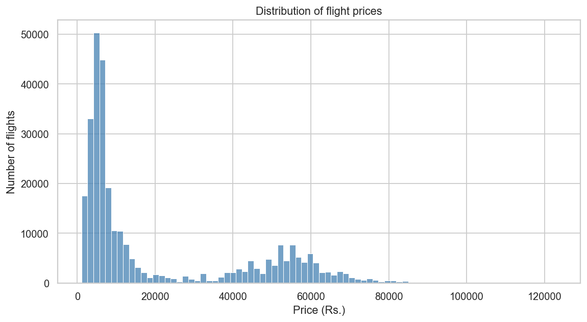
Figure 1 — Distribution of flight prices across the full dataset.
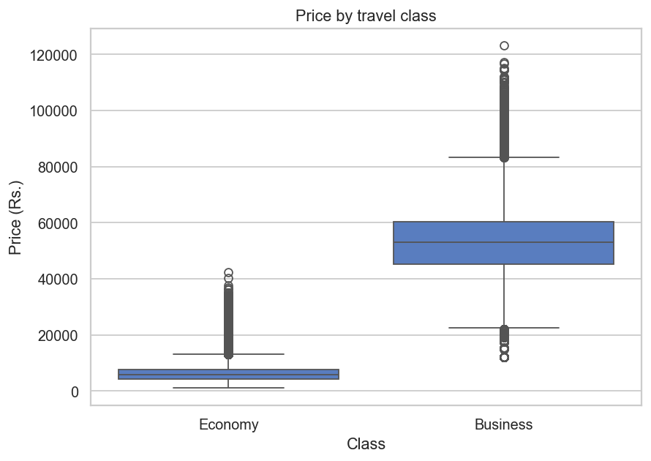
Figure 2 — Price by travel class. Business fares dominate the upper range.
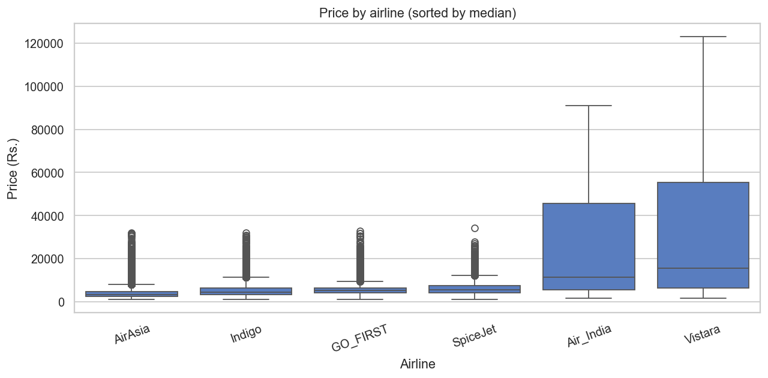
Figure 3 — Price by airline, ordered by median fare.
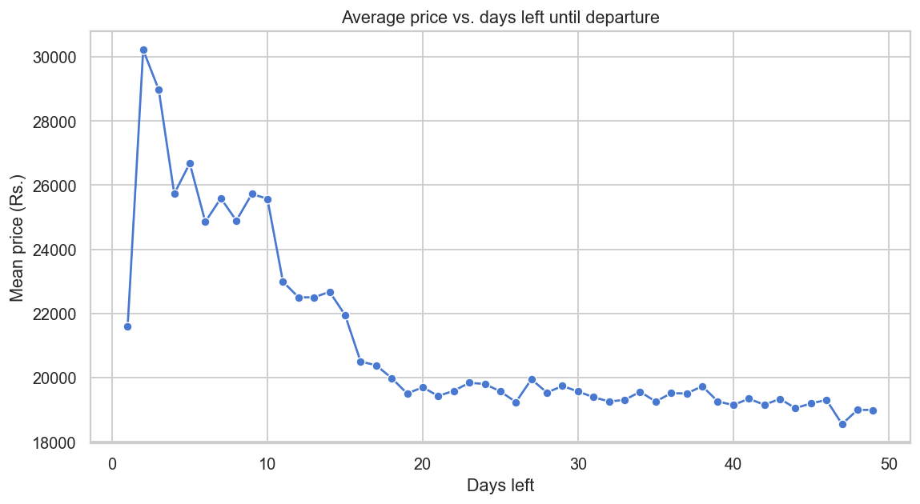
Figure 4 — Average price vs. days remaining until departure. Note the sharp spike inside the last few days.
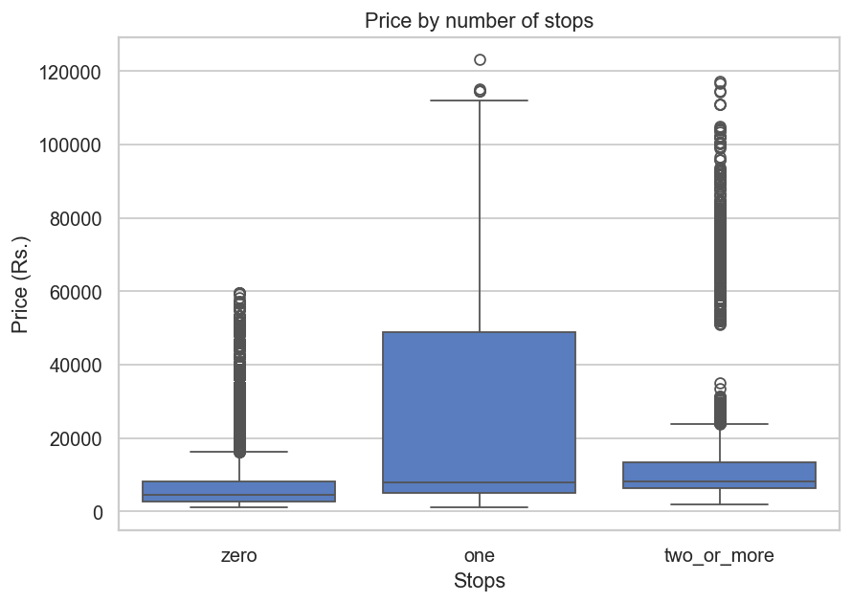
Figure 5 — Price distribution by number of stops.
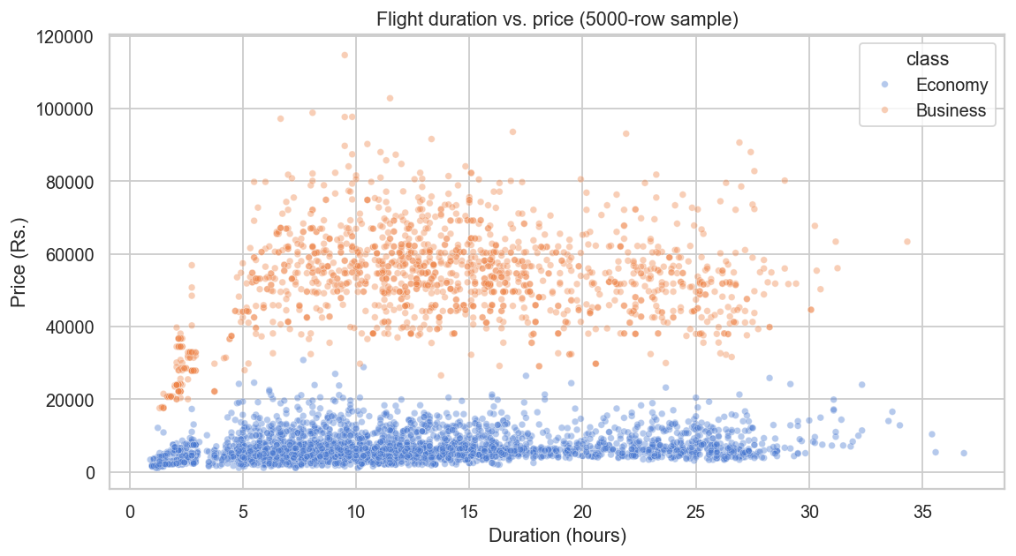
Figure 6 — Flight duration vs. price (5,000-row sample), coloured by class.

0.6.2 Model-Comparison & Feature-Importance Plots
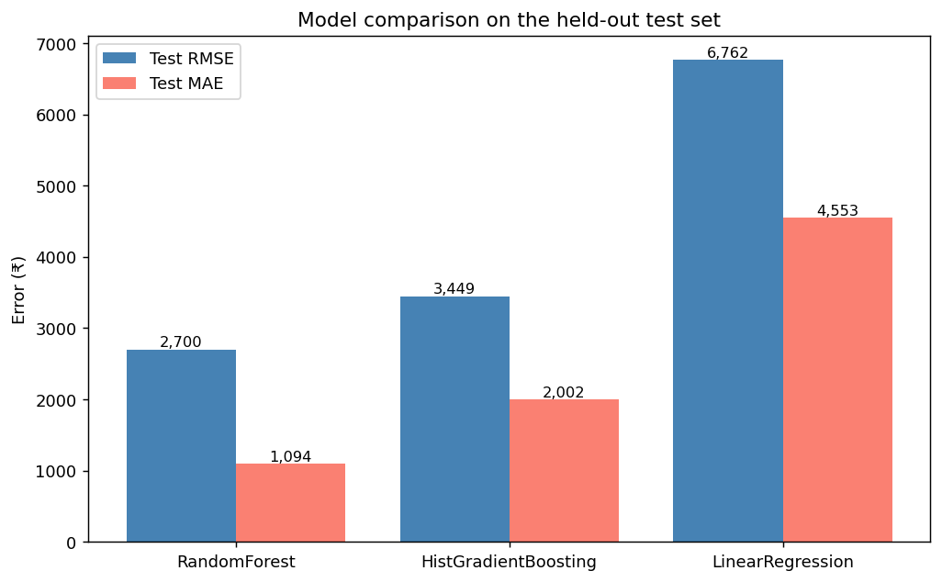
Figure 7 — Test-set RMSE and MAE for the three candidate models. Random Forest is the clear winner.
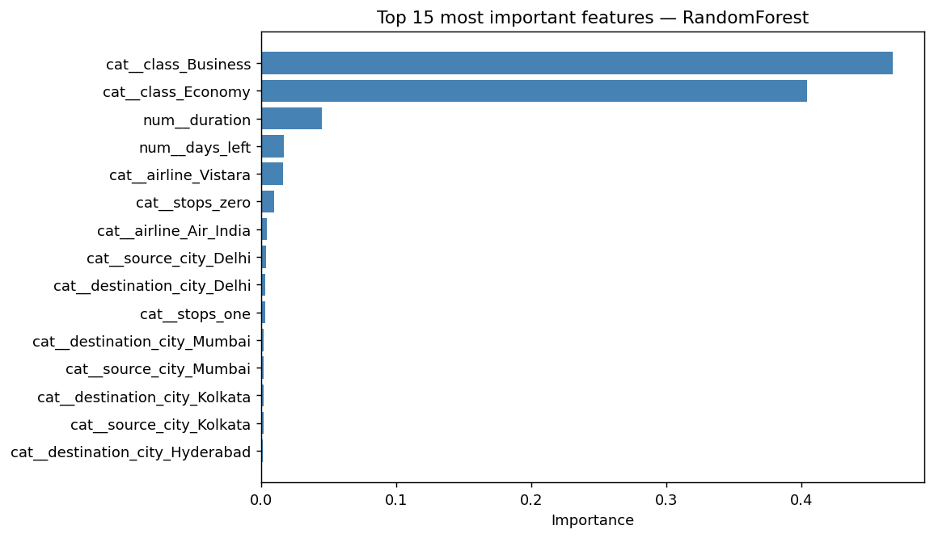
Figure 8 — Top-15 most important features in the tuned Random Forest. Class (Business vs. Economy), days_left, and duration dominate the model.

0.6.3 Console Output
Output produced by `python -m src.train` on the full dataset:
Loaded 300,153 rows.
Train rows: 240,122 | Test rows: 60,031
=== Comparing candidate models with 5-fold CV ===
— LinearRegression —
CV RMSE : 6,753 ± 28 (3.0s)
Test RMSE: 6,762 | MAE: 4,553 | R²: 0.9113 (fit 0.6s)
— RandomForest —
CV RMSE : 2,699 ± 10 (44.4s)
Test RMSE: 2,700 | MAE: 1,094 | R²: 0.9859 (fit 12.2s)
— HistGradientBoosting —
CV RMSE : 3,447 ± 26 (14.1s)
Test RMSE: 3,449 | MAE: 2,002 | R²: 0.9769 (fit 5.4s)
Best by CV RMSE: RandomForest (2,699)
Tuning RandomForest with RandomizedSearchCV (n_iter=10, cv=3)...
search took 358s
best CV RMSE: 2,718
best params : {'model__n_estimators': 200, 'model__min_samples_leaf': 2,
'model__max_features': 0.7, 'model__max_depth': 35}
tuned test : RMSE 2,693 | MAE 1,113 | R² 0.9859
Generating diagnostic plots...
saved reports/07_model_comparison.png
saved reports/08_feature_importance.png
Final model: RandomForest (tuned)
RMSE 2,693 | MAE 1,113 | R² 0.9859
Saved model -> models/flight_fare_model.joblib
Saved metadata -> models/model_metadata.joblib

0.7 Conclusion
This project successfully delivered an end-to-end supervised regression pipeline for predicting Indian domestic flight fares. Starting from a Kaggle dataset of 300,153 records, three candidate regression models were compared using 5-fold cross-validation: a Linear Regression baseline (cross-validated RMSE Rs. 6,753), a Random Forest Regressor (Rs. 2,699), and a Histogram Gradient Boosting Regressor (Rs. 3,447). The Random Forest, after RandomizedSearchCV hyperparameter tuning, achieved a test-set RMSE of Rs. 2,693, MAE of Rs. 1,113, and R² of 0.9859 — explaining 98.6% of the variance in fares. Feature-importance analysis confirmed that travel class, days left until departure, and airline identity are the dominant drivers of price, consistent with domain knowledge. The trained pipeline is persisted to disk and served behind a Streamlit web application that surfaces both the predicted fare and the model’s performance metrics, allowing users to estimate prices interactively while remaining honest about uncertainty. The project demonstrates that an ensemble of decision trees, combined with a disciplined preprocessing pipeline and rigorous cross-validated comparison, is well suited to tabular fare-prediction problems and that high predictive quality is achievable without manual feature engineering. Future work could extend the approach with quantile-regression prediction intervals, additional features (holiday flags, fuel-price index), and a temporal hold-out to better measure deployment robustness.

