
Project Report on
FLIGHT FARE PREDICTION
Submitted to
Ramaiah Institute of Technology, Bangalore
(Autonomous Institute Affiliated to VTU)
In partial fulfilment of the requirement for the award of degree of
BACHELOR OF ENGINEERING
IN
ELECTRONICS & TELECOMMUNICATION ENGINEERING
For the Course “Introduction to Machine Learning (24ETAEC49)”
Academic Year 2025-2026
Submitted by
Dipanjan Chowdhury - 1MS24ET015
Devansh Gupta - 1MS24ET012

Course Coordinator
Prof. Dr. Akshata S K
Department of Electronics & Telecommunication Engineering
MSRIT, Bangalore-560054
RAMAIAH INSTITUTE OF TECHNOLOGY
(Autonomous Institute, Affiliated to VTU)
Accredited by NBA & NAAC with ‘A+’ Grade
Department of Electronics & Telecommunication Engineering
MSR Nagar, Bangalore-560054
May 2026


RAMAIAH INSTITUTE OF TECHNOLOGY
(Autonomous Institute Affiliated to VTU)
Department of Electronics & Telecommunication Engineering
CERTIFICATE
Certified that the project work entitled “FLIGHT FARE PREDICTION” carried out by Dipanjan Chowdhury (USN 1MS24ET015) and Devansh Gupta (USN 1MS24ET012), bonafide students of Ramaiah Institute of Technology, Bangalore, in partial fulfilment for the award of Bachelor of Engineering in Electronics & Telecommunication Engineering of the Visvesvaraya Technological University, Belagavi during the academic year 2025-2026. It is certified that all corrections/suggestions indicated for Internal Assessment have been incorporated in the report. The project report has been approved as it satisfies the academic requirements in respect of the project work for the course “Introduction to Machine Learning” (24ETAEC49) prescribed for the said degree.

Prof. Dr. Akshata S K
Course Coordinator
Dept. of ETE, RIT

External Viva
Name of the Examiners | Signature with Date
1.
2.


RAMAIAH INSTITUTE OF TECHNOLOGY
(Autonomous Institute Affiliated to VTU)
MSR Nagar, Bangalore-560054, Karnataka
Department of Electronics & Telecommunication Engineering
DECLARATION
We hereby declare that the project entitled “FLIGHT FARE PREDICTION” has been carried out independently by us, under the guidance of Prof. Dr. Akshata S K, Department of Electronics & Telecommunication Engineering, Ramaiah Institute of Technology, Bangalore. This report has been submitted in partial fulfilment for the award of grades in the course “Introduction to Machine Learning” (24ETAEC49) during the academic year 2025-2026.

Student Names:
Dipanjan Chowdhury - 1MS24ET015
Devansh Gupta - 1MS24ET012

Electronics & Telecommunication Engg., RIT,
Bangalore-560054
Place: Bangalore
Date:

ACKNOWLEDGEMENT
It is with profound gratitude that we express our indebtedness to all who have guided us to complete this project successfully.
We extend our sincere thanks to the management of MSRIT for providing us with excellent infrastructure and computing facilities to carry out this work.
We are grateful to the Head of the Department of Electronics & Telecommunication Engineering for allowing us to undertake this project work and for providing constant support.
The valuable guidance, exemplary support, and timely suggestions made available to us by our course coordinator Prof. Dr. Akshata S K, Department of Electronics & Telecommunication Engineering, MSRIT, went a long way in the completion of this project. We sincerely acknowledge her help and constant support throughout the project work.
We also thank our friends, the staff members of the Electronics & Telecommunication Department, and our families for the help and support provided in the successful completion of this project.

Dipanjan Chowdhury
Devansh Gupta

ABSTRACT
In the highly dynamic Indian domestic aviation industry, ticket prices fluctuate constantly with demand, route, airline, time of day, and the number of days remaining before departure. This volatility makes it difficult for travellers to judge whether a quoted fare is reasonable, and difficult for airlines to communicate fair pricing.
This project addresses the problem by developing a supervised machine-learning regression pipeline that predicts the price of a flight ticket from nine easily collected features. A Kaggle dataset of 300,153 Indian domestic flight records is cleaned, explored, and modelled with three regression algorithms — Linear Regression, Random Forest, and Histogram Gradient Boosting — which are compared using five-fold cross-validation.
Random Forest emerges as the strongest candidate, with a cross-validated RMSE of approximately Rs. 2,700 and an R² of about 0.986. Its hyperparameters are then tuned with RandomizedSearchCV. The final model is persisted with joblib and deployed behind a Streamlit web interface that allows end-users to estimate a flight fare interactively. The pipeline is reproducible end to end and demonstrates that ensemble tree methods are effective for fare prediction without manual feature scaling or engineering.

TABLE OF CONTENTS
1. INTRODUCTION
2. LITERATURE REVIEW
3. MODEL OVERVIEW
3.1 Why Random Forest Fits
3.2 The Pipeline Design
4. VALIDATION AND INTERPRETATION
4.1 Train-Test Split
4.2 Cross-Validation and Tuning
4.3 Evaluation Metrics
5. PROJECT PIPELINE
6. DATASET COMPONENTS AND PREPROCESSING
7. SOURCE CODE
8. EXECUTION PROTOCOL AND PROGRAM OUTPUT
8.1 Exploratory Plots
8.2 Model Comparison and Feature Importance
8.3 Console Output
8.4 Streamlit Web Application
9. CONCLUSION

1. INTRODUCTION
Air-ticket pricing in India is governed by complex revenue-management systems that adjust fares minute by minute based on demand, seat inventory, competitor prices, fuel costs, route-level constraints, and the time remaining until departure. From the passenger's perspective, this opacity is frustrating, because identical flights can be priced very differently depending on when the booking is made.
A predictive model that learns from historical fare data can serve both as a consumer-facing decision aid — helping a traveller judge whether today's price is reasonable or whether it is worth waiting — and as an academic vehicle for exercising the supervised-learning toolkit. This project develops such a model end to end: dataset acquisition from Kaggle, exploratory data analysis, preprocessing with a scikit-learn ColumnTransformer, comparison of three regression algorithms with cross-validation, hyperparameter tuning of the best candidate, and deployment as an interactive Streamlit web application.
The objective is to predict the price of a flight ticket from nine easily collected features: the airline, source city, departure time, number of stops, arrival time, destination city, travel class, flight duration, and the number of days left until departure.

2. LITERATURE REVIEW
The application of supervised regression to flight-fare prediction has matured rapidly over the last decade. Early studies relied on linear regression and generalised linear models for their interpretability, because the learned coefficients directly explain how each feature contributes to price. However, linear models struggle with the strong non-linearity in the fare-versus-days-left curve and with interactions such as airline combined with travel class.
Subsequent work moved toward decision-tree ensembles: Random Forests (Breiman, 2001), Gradient Boosted Trees, and more recently XGBoost and LightGBM. These methods consistently outperform linear baselines on tabular fare data because they capture non-linear relationships natively, handle mixed numeric and categorical inputs after encoding, and are robust to feature scaling. Histogram Gradient Boosting, scikit-learn's native binned-tree implementation, offers a closely related approach with substantially lower training cost on large datasets.
This project adopts the same comparative philosophy: it trains a linear baseline, a Random Forest, and a Histogram Gradient Boosting Regressor, and selects the best model by cross-validated error.

3. MODEL OVERVIEW

3.1 Why Random Forest Fits
Flight-fare prediction is a regression problem: the target variable, ticket price, is a continuous positive real number, not a discrete label. The core algorithm chosen is the Random Forest Regressor, an ensemble of decision trees trained on bootstrap samples of the training data with random feature subsampling at each split.
A single decision tree splits the feature space along axis-aligned thresholds — for example, “is the class Business?” or “is days_left at most 7?” — and assigns each leaf the mean of the training prices that fall into it. Individual trees overfit because they can grow until every training row sits alone in its own leaf. The Random Forest fixes this by averaging the predictions of many such trees, each grown on a different randomly drawn subset of the data. Averaging many high-variance, low-bias estimators yields a prediction that is both flexible, capturing non-linearity and interactions, and stable, with low variance on unseen data.
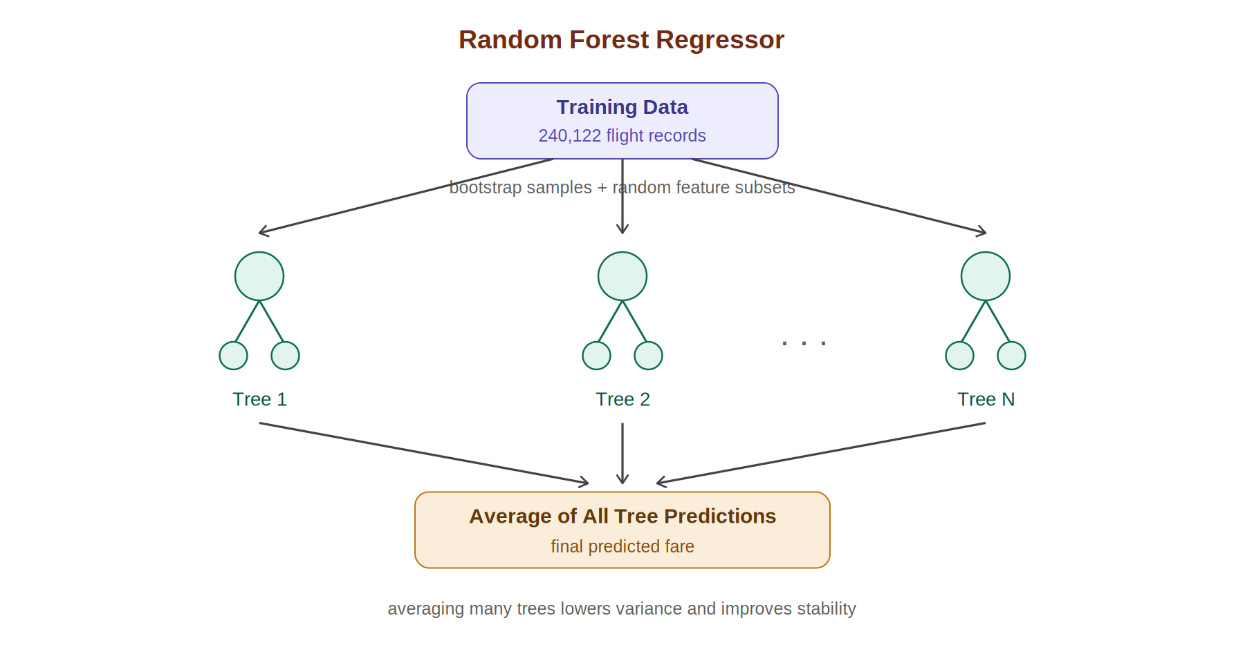
Figure 1: The Random Forest averages the predictions of many decision trees

3.2 The Pipeline Design
The forest is trained inside a scikit-learn Pipeline that performs one-hot encoding of the seven categorical features (airline, source city, departure time, stops, arrival time, destination city, and class) and passes the two numeric features (duration and days left) through unchanged. Encapsulating preprocessing and the model in a single Pipeline guarantees that the exact same transformation is applied during training, cross-validation, hyperparameter search, and live prediction, eliminating an entire class of train/inference mismatch bugs.

4. VALIDATION AND INTERPRETATION
To produce an honest estimate of generalisation error and to prevent overfitting, the project uses a layered validation strategy.

4.1 Train-Test Split
The dataset is split 80/20 into a training partition of 240,122 rows and an independent test partition of 60,031 rows, with a fixed random seed for reproducibility. The test partition is held out throughout training, cross-validation, and hyperparameter tuning, and is consulted only once at the end to report the final metrics.
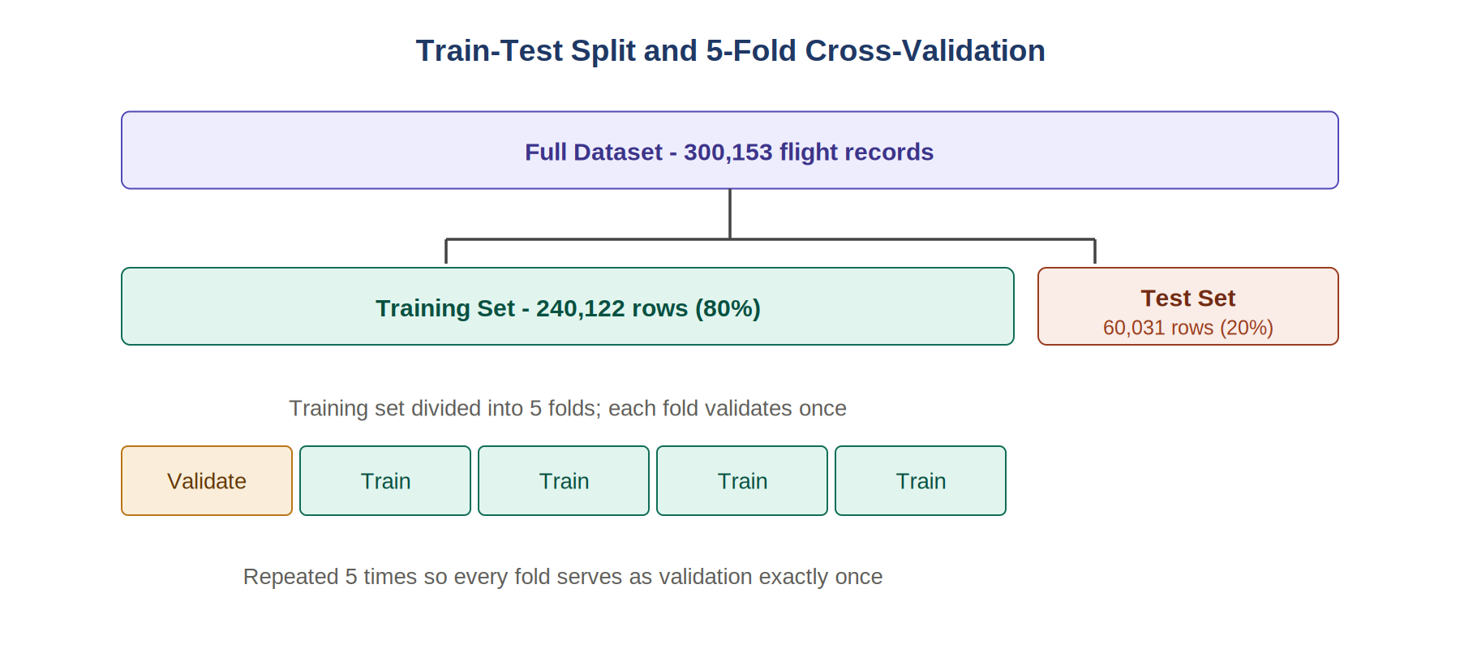
Figure 2: The 80/20 train-test split and 5-fold cross-validation strategy

4.2 Cross-Validation and Tuning
Within the training partition, five-fold K-Fold cross-validation is used to compare the candidate models. Each fold trains on 80% of the training data and validates on the remaining 20%, rotating until every training row has been used for validation exactly once. The mean and standard deviation of the fold-level RMSE provide an unbiased estimate of model stability.
The best model identified by cross-validation is then tuned using RandomizedSearchCV with 10 random parameter combinations and three-fold cross-validation, which explores a wider hyperparameter space than grid search at a fraction of the cost.

4.3 Evaluation Metrics
Three regression metrics are reported throughout. Root Mean Squared Error (RMSE) penalises large errors quadratically. Mean Absolute Error (MAE) gives the typical rupee deviation. The coefficient of determination R² expresses the fraction of price variance the model explains relative to a mean-only baseline.

5. PROJECT PIPELINE
The project follows a structured, eight-stage pipeline that progresses from raw data acquisition to an interactive deployed application.
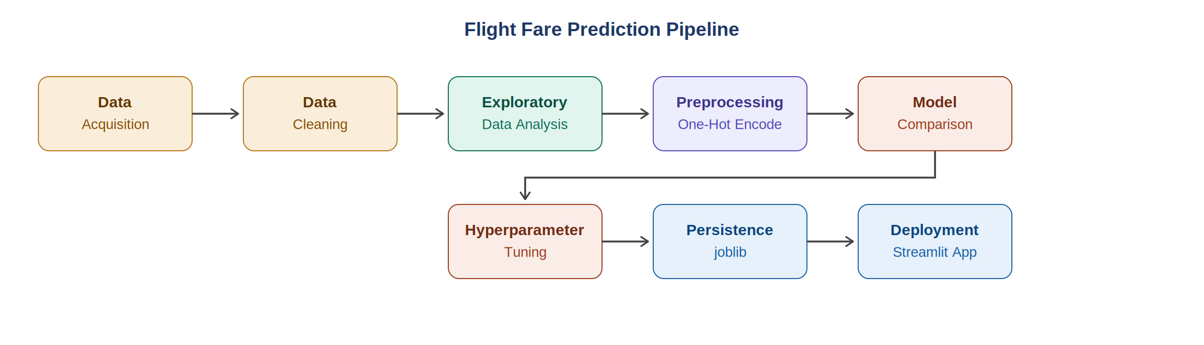
Figure 3: End-to-end pipeline of the Flight Fare Prediction project
The eight stages are summarised below:
- Data Acquisition — the dataset is programmatically downloaded from Kaggle via the kaggle CLI and cached locally for subsequent runs.
- Data Cleaning — the leading unnamed index column produced by the CSV export is dropped, and the high-cardinality flight-code column is excluded so the model generalises rather than memorises.
- Exploratory Data Analysis — the price distribution and its relationship to class, airline, days left, and stops are visualised.
- Preprocessing — the seven categorical features are one-hot encoded and the two numeric features are passed through, all bundled into a single ColumnTransformer.
- Model Comparison — Linear Regression, Random Forest, and Histogram Gradient Boosting are evaluated with five-fold cross-validated RMSE.
- Hyperparameter Tuning — the best candidate is tuned with RandomizedSearchCV over n_estimators, max_depth, min_samples_leaf, and max_features.
- Persistence — the final tuned pipeline is serialised with joblib, alongside sidecar metadata storing test metrics and category options.
- Deployment — a Streamlit web application loads the artifacts at startup and presents a form-based interface for interactive fare estimation.

6. DATASET COMPONENTS AND PREPROCESSING
The project uses the public Flight Price Prediction dataset by Shubham Bathwal, hosted on Kaggle. It contains 300,153 records across 12 columns after the unnamed CSV index is dropped. The data is split into a training partition of 240,122 rows and an independent test partition of 60,031 rows, using a fixed random seed of 42. The target variable, price, is continuous and right-skewed, ranging from around Rs. 1,000 for cheap economy tickets to over Rs. 100,000 for last-minute business fares. The per-feature breakdown is given below.
Column | Type | Role | Description
airline | Categorical (6) | Feature | AirAsia, Air_India, GO_FIRST, Indigo, SpiceJet, Vistara
flight | Categorical (high) | Excluded | Per-flight code; would cause memorisation
source_city | Categorical (6) | Feature | Bangalore, Chennai, Delhi, Hyderabad, Kolkata, Mumbai
departure_time | Categorical (6) | Feature | Time-of-day bucket
stops | Categorical (3) | Feature | zero / one / two_or_more
arrival_time | Categorical (6) | Feature | Time-of-day bucket
destination_city | Categorical (6) | Feature | Same six cities
class | Categorical (2) | Feature | Economy or Business
duration | Numeric | Feature | Flight duration in hours
days_left | Numeric | Feature | Days between booking and departure (1-49)
price | Numeric | Target | Ticket price in Rs.
In preprocessing, all seven categorical features are one-hot encoded with the handle_unknown option set to ignore, producing dense output. The numeric features are passed through unchanged, since tree-based models are invariant to monotonic transformations. The encoding and modelling steps are wrapped in a single scikit-learn Pipeline so that cross-validation, hyperparameter search, and live inference always apply the same transformations in the same order.

7. SOURCE CODE
The implementation is organised into modular components covering configuration, data loading, preprocessing, exploratory analysis, model training, and the deployed application. Each module is reproduced in full below.
src/config.py
from pathlib import Path

ROOT_DIR = Path(__file__).resolve().parent.parent
DATA_DIR = ROOT_DIR / "data"
MODELS_DIR = ROOT_DIR / "models"
REPORTS_DIR = ROOT_DIR / "reports"

KAGGLE_DATASET = "shubhambathwal/flight-price-prediction"
RAW_CSV = DATA_DIR / "Clean_Dataset.csv"

MODEL_PATH = MODELS_DIR / "flight_fare_model.joblib"
METADATA_PATH = MODELS_DIR / "model_metadata.joblib"

TARGET = "price"

CATEGORICAL_FEATURES = [
"airline",
"source_city",
"departure_time",
"stops",
"arrival_time",
"destination_city",
"class",
]
NUMERIC_FEATURES = ["duration", "days_left"]
FEATURES = CATEGORICAL_FEATURES + NUMERIC_FEATURES
src/data_loader.py
"""Download the Flight Price Prediction dataset from Kaggle and load it as a DataFrame."""
from __future__ import annotations

import subprocess
import sys

import pandas as pd

from src.config import DATA_DIR, KAGGLE_DATASET, RAW_CSV

def download_dataset() -> None:
DATA_DIR.mkdir(parents=True, exist_ok=True)
if RAW_CSV.exists():
print(f"Dataset already present at {RAW_CSV}")
return

print(f"Downloading {KAGGLE_DATASET} from Kaggle...")
result = subprocess.run(
[
"kaggle",
"datasets",
"download",
"-d",
KAGGLE_DATASET,
"-p",
str(DATA_DIR),
"--unzip",
],
capture_output=True,
text=True,
)
if result.returncode != 0:
print("Kaggle download failed.", file=sys.stderr)
print(result.stderr, file=sys.stderr)
sys.exit(1)

if not RAW_CSV.exists():
print(
f"Download finished but {RAW_CSV.name} was not found. "
f"Inspect {DATA_DIR} and update src/config.py:RAW_CSV if needed.",
file=sys.stderr,
)
sys.exit(1)
print(f"Saved dataset to {RAW_CSV}")

def load_dataframe() -> pd.DataFrame:
if not RAW_CSV.exists():
download_dataset()
df = pd.read_csv(RAW_CSV)
# The Kaggle CSV ships with an unnamed index column — drop it if present.
if df.columns[0].startswith("Unnamed"):
df = df.drop(columns=df.columns[0])
return df

if __name__ == "__main__":
download_dataset()
df = load_dataframe()
print(f"Loaded {len(df):,} rows, {df.shape[1]} columns")
print(df.head())
src/preprocess.py
"""Build the sklearn preprocessing ColumnTransformer for flight features."""
from __future__ import annotations

import pandas as pd
from sklearn.compose import ColumnTransformer
from sklearn.preprocessing import OneHotEncoder

from src.config import CATEGORICAL_FEATURES, FEATURES, NUMERIC_FEATURES, TARGET

def build_preprocessor() -> ColumnTransformer:
return ColumnTransformer(
transformers=[
(
"cat",
OneHotEncoder(handle_unknown="ignore", sparse_output=False),
CATEGORICAL_FEATURES,
),
("num", "passthrough", NUMERIC_FEATURES),
]
)

def split_features_target(df: pd.DataFrame) -> tuple[pd.DataFrame, pd.Series]:
return df[FEATURES].copy(), df[TARGET].copy()

def collect_category_options(df: pd.DataFrame) -> dict[str, list[str]]:
"""Returns sorted unique values per categorical column — used by the Streamlit form."""
return {col: sorted(df[col].dropna().unique().tolist()) for col in CATEGORICAL_FEATURES}
src/eda.py
"""Exploratory Data Analysis — generate plots that describe the flight-fare dataset.

Plots are saved as PNGs into the reports/ folder so they can be embedded in the
project report and the Streamlit sidebar.
"""
from __future__ import annotations

import matplotlib

matplotlib.use("Agg")
import matplotlib.pyplot as plt
import seaborn as sns

from src.config import REPORTS_DIR
from src.data_loader import load_dataframe

sns.set_theme(style="whitegrid", palette="muted")

def _save(fig: plt.Figure, name: str) -> None:
REPORTS_DIR.mkdir(parents=True, exist_ok=True)
out = REPORTS_DIR / name
fig.tight_layout()
fig.savefig(out, dpi=130, bbox_inches="tight")
plt.close(fig)
print(f" saved {out.relative_to(REPORTS_DIR.parent)}")

def plot_price_distribution(df) -> None:
fig, ax = plt.subplots(figsize=(9, 5))
sns.histplot(df["price"], bins=80, color="steelblue", ax=ax)
ax.set_title("Distribution of flight prices")
ax.set_xlabel("Price (Rs.)")
ax.set_ylabel("Number of flights")
_save(fig, "01_price_distribution.png")

def plot_price_by_class(df) -> None:
fig, ax = plt.subplots(figsize=(7, 5))
sns.boxplot(data=df, x="class", y="price", ax=ax)
ax.set_title("Price by travel class")
ax.set_xlabel("Class")
ax.set_ylabel("Price (Rs.)")
_save(fig, "02_price_by_class.png")

def plot_price_by_airline(df) -> None:
fig, ax = plt.subplots(figsize=(10, 5))
order = df.groupby("airline")["price"].median().sort_values().index
sns.boxplot(data=df, x="airline", y="price", order=order, ax=ax)
ax.set_title("Price by airline (sorted by median)")
ax.set_xlabel("Airline")
ax.set_ylabel("Price (Rs.)")
plt.xticks(rotation=20)
_save(fig, "03_price_by_airline.png")

def plot_price_vs_days_left(df) -> None:
avg = df.groupby("days_left")["price"].mean().reset_index()
fig, ax = plt.subplots(figsize=(9, 5))
sns.lineplot(data=avg, x="days_left", y="price", marker="o", ax=ax)
ax.set_title("Average price vs. days left until departure")
ax.set_xlabel("Days left")
ax.set_ylabel("Mean price (Rs.)")
_save(fig, "04_price_vs_days_left.png")

def plot_price_by_stops(df) -> None:
fig, ax = plt.subplots(figsize=(7, 5))
sns.boxplot(data=df, x="stops", y="price",
order=["zero", "one", "two_or_more"], ax=ax)
ax.set_title("Price by number of stops")
ax.set_xlabel("Stops")
ax.set_ylabel("Price (Rs.)")
_save(fig, "05_price_by_stops.png")

def plot_duration_vs_price(df) -> None:
sample = df.sample(min(len(df), 5000), random_state=42)
fig, ax = plt.subplots(figsize=(9, 5))
sns.scatterplot(data=sample, x="duration", y="price",
hue="class", alpha=0.4, s=18, ax=ax)
ax.set_title("Flight duration vs. price (5000-row sample)")
ax.set_xlabel("Duration (hours)")
ax.set_ylabel("Price (Rs.)")
_save(fig, "06_duration_vs_price.png")

def main() -> None:
print("Loading dataset...")
df = load_dataframe()
print(f"Loaded {len(df):,} rows.")

print("\nGenerating plots...")
plot_price_distribution(df)
plot_price_by_class(df)
plot_price_by_airline(df)
plot_price_vs_days_left(df)
plot_price_by_stops(df)
plot_duration_vs_price(df)

print(f"\nDone. Plots saved to {REPORTS_DIR}/")

if __name__ == "__main__":
main()
src/train.py
"""Train and compare multiple regression models on the flight-fare dataset.

Pipeline:
1. Load the dataset and split into train/test (80/20, fixed seed).
2. Evaluate three candidate models with 5-fold cross-validation
(Linear Regression, Random Forest, Histogram Gradient Boosting).
3. Pick the best candidate by mean CV RMSE.
4. Tune its hyperparameters with RandomizedSearchCV.
5. Persist the best model + metadata + a model-comparison and
feature-importance plot to disk.
"""
from __future__ import annotations

import time

import joblib
import matplotlib

matplotlib.use("Agg")
import matplotlib.pyplot as plt
import numpy as np
from sklearn.ensemble import HistGradientBoostingRegressor, RandomForestRegressor
from sklearn.linear_model import LinearRegression
from sklearn.metrics import mean_absolute_error, mean_squared_error, r2_score
from sklearn.model_selection import KFold, RandomizedSearchCV, cross_val_score, train_test_split
from sklearn.pipeline import Pipeline

from src.config import METADATA_PATH, MODEL_PATH, MODELS_DIR, REPORTS_DIR
from src.data_loader import load_dataframe
from src.preprocess import (
build_preprocessor,
collect_category_options,
split_features_target,
)

CV_FOLDS = 5
RANDOM_STATE = 42

def make_pipeline(model) -> Pipeline:
return Pipeline(
steps=[
("preprocess", build_preprocessor()),
("model", model),
]
)

def candidate_models() -> dict[str, Pipeline]:
"""Three regression models spanning a complexity range."""
return {
"LinearRegression": make_pipeline(LinearRegression()),
"RandomForest": make_pipeline(
RandomForestRegressor(
n_estimators=80,
min_samples_leaf=2,
n_jobs=-1,
random_state=RANDOM_STATE,
)
),
"HistGradientBoosting": make_pipeline(
HistGradientBoostingRegressor(
max_iter=300,
learning_rate=0.1,
max_depth=None,
min_samples_leaf=20,
random_state=RANDOM_STATE,
)
),
}

def evaluate_candidate(name: str, pipeline: Pipeline, X_train, y_train, X_test, y_test):
print(f"\n— {name} —")
cv = KFold(n_splits=CV_FOLDS, shuffle=True, random_state=RANDOM_STATE)
start = time.time()
cv_scores = -cross_val_score(
pipeline,
X_train,
y_train,
cv=cv,
scoring="neg_root_mean_squared_error",
n_jobs=-1,
)
cv_time = time.time() - start
print(f" CV RMSE : {cv_scores.mean():,.0f} ± {cv_scores.std():,.0f} ({cv_time:.1f}s)")

start = time.time()
pipeline.fit(X_train, y_train)
fit_time = time.time() - start
preds = pipeline.predict(X_test)
rmse = float(np.sqrt(mean_squared_error(y_test, preds)))
mae = float(mean_absolute_error(y_test, preds))
r2 = float(r2_score(y_test, preds))
print(f" Test RMSE: {rmse:,.0f} | MAE: {mae:,.0f} | R²: {r2:.4f} (fit {fit_time:.1f}s)")

return {
"name": name,
"cv_rmse_mean": float(cv_scores.mean()),
"cv_rmse_std": float(cv_scores.std()),
"test_rmse": rmse,
"test_mae": mae,
"test_r2": r2,
"fit_time_seconds": fit_time,
"pipeline": pipeline,
}

def param_grid_for(name: str) -> dict[str, list]:
"""Hyperparameter grid for RandomizedSearchCV — keys reference the 'model' step
of the pipeline (e.g. 'model__n_estimators')."""
if name == "RandomForest":
return {
"model__n_estimators": [80, 120, 200],
"model__max_depth": [None, 15, 25, 35],
"model__min_samples_leaf": [1, 2, 5],
"model__max_features": [0.5, 0.7, 1.0],
}
if name == "HistGradientBoosting":
return {
"model__learning_rate": [0.05, 0.08, 0.1, 0.15],
"model__max_iter": [200, 300, 500, 700],
"model__max_depth": [None, 6, 8, 12],
"model__min_samples_leaf": [10, 20, 40, 80],
"model__l2_regularization": [0.0, 0.1, 1.0],
}
if name == "LinearRegression":
# Nothing meaningful to tune; return an empty grid (search will skip).
return {}
raise ValueError(name)

def tune_best(best_name: str, pipeline: Pipeline, X_train, y_train, X_test, y_test):
grid = param_grid_for(best_name)
if not grid:
print(f"\nNo tuning grid for {best_name} — keeping default.")
return pipeline, {}

print(f"\nTuning {best_name} with RandomizedSearchCV (n_iter=10, cv=3)...")
search = RandomizedSearchCV(
pipeline,
param_distributions=grid,
n_iter=10,
cv=3,
scoring="neg_root_mean_squared_error",
n_jobs=-1,
random_state=RANDOM_STATE,
verbose=0,
)
start = time.time()
search.fit(X_train, y_train)
print(f" search took {time.time() - start:.0f}s")
print(f" best CV RMSE: {-search.best_score_:,.0f}")
print(f" best params : {search.best_params_}")

preds = search.predict(X_test)
rmse = float(np.sqrt(mean_squared_error(y_test, preds)))
mae = float(mean_absolute_error(y_test, preds))
r2 = float(r2_score(y_test, preds))
print(f" tuned test : RMSE {rmse:,.0f} | MAE {mae:,.0f} | R² {r2:.4f}")
return search.best_estimator_, {
"best_params": search.best_params_,
"best_cv_rmse": float(-search.best_score_),
"tuned_test_rmse": rmse,
"tuned_test_mae": mae,
"tuned_test_r2": r2,
}

def plot_model_comparison(results: list[dict]) -> None:
REPORTS_DIR.mkdir(parents=True, exist_ok=True)
names = [r["name"] for r in results]
test_rmse = [r["test_rmse"] for r in results]
test_mae = [r["test_mae"] for r in results]

fig, ax = plt.subplots(figsize=(8, 5))
x = np.arange(len(names))
ax.bar(x - 0.2, test_rmse, width=0.4, label="Test RMSE", color="steelblue")
ax.bar(x + 0.2, test_mae, width=0.4, label="Test MAE", color="salmon")
ax.set_xticks(x)
ax.set_xticklabels(names)
ax.set_ylabel("Error (Rs.)")
ax.set_title("Model comparison on the held-out test set")
ax.legend()
for i, (rmse, mae) in enumerate(zip(test_rmse, test_mae)):
ax.text(i - 0.2, rmse, f"{rmse:,.0f}", ha="center", va="bottom", fontsize=9)
ax.text(i + 0.2, mae, f"{mae:,.0f}", ha="center", va="bottom", fontsize=9)
fig.tight_layout()
out = REPORTS_DIR / "07_model_comparison.png"
fig.savefig(out, dpi=130, bbox_inches="tight")
plt.close(fig)
print(f" saved {out.relative_to(REPORTS_DIR.parent)}")

def plot_feature_importance(pipeline: Pipeline, model_name: str, top_k: int = 15) -> None:
"""Generate a horizontal bar chart of the most important features.

Tree models expose `feature_importances_`. Linear models expose `coef_`.
Feature names come from the fitted ColumnTransformer.
"""
REPORTS_DIR.mkdir(parents=True, exist_ok=True)
preproc = pipeline.named_steps["preprocess"]
model = pipeline.named_steps["model"]
feature_names = preproc.get_feature_names_out()

if hasattr(model, "feature_importances_"):
importances = model.feature_importances_
label = "Importance"
elif hasattr(model, "coef_"):
importances = np.abs(np.ravel(model.coef_))
label = "|Coefficient|"
else:
print(f" {model_name} exposes no feature importance — skipping plot.")
return

k = min(top_k, len(importances))
idx = np.argsort(importances)[-k:]
fig, ax = plt.subplots(figsize=(9, max(5, k * 0.35)))
ax.barh(range(k), importances[idx], color="steelblue")
ax.set_yticks(range(k))
ax.set_yticklabels([feature_names[i] for i in idx])
ax.set_xlabel(label)
ax.set_title(f"Top {k} most important features — {model_name}")
fig.tight_layout()
out = REPORTS_DIR / "08_feature_importance.png"
fig.savefig(out, dpi=130, bbox_inches="tight")
plt.close(fig)
print(f" saved {out.relative_to(REPORTS_DIR.parent)}")

def train() -> None:
df = load_dataframe()
print(f"Loaded {len(df):,} rows.")

X, y = split_features_target(df)
X_train, X_test, y_train, y_test = train_test_split(
X, y, test_size=0.2, random_state=RANDOM_STATE
)
print(f"Train rows: {len(X_train):,} | Test rows: {len(X_test):,}")

print(f"\n=== Comparing candidate models with {CV_FOLDS}-fold CV ===")
results = []
for name, pipeline in candidate_models().items():
results.append(
evaluate_candidate(name, pipeline, X_train, y_train, X_test, y_test)
)

results.sort(key=lambda r: r["cv_rmse_mean"])
best = results[0]
print(f"\nBest by CV RMSE: {best['name']} ({best['cv_rmse_mean']:,.0f})")

tuned_pipeline, tuning_info = tune_best(
best["name"], best["pipeline"], X_train, y_train, X_test, y_test
)

print("\nGenerating diagnostic plots...")
plot_model_comparison(results)
plot_feature_importance(tuned_pipeline, best["name"])

final_preds = tuned_pipeline.predict(X_test)
final_rmse = float(np.sqrt(mean_squared_error(y_test, final_preds)))
final_mae = float(mean_absolute_error(y_test, final_preds))
final_r2 = float(r2_score(y_test, final_preds))

MODELS_DIR.mkdir(parents=True, exist_ok=True)
joblib.dump(tuned_pipeline, MODEL_PATH)
joblib.dump(
{
"metrics": {"rmse": final_rmse, "mae": final_mae, "r2": final_r2},
"category_options": collect_category_options(df),
"n_train_rows": int(len(X_train)),
"n_test_rows": int(len(X_test)),
"best_model": best["name"],
"cv_folds": CV_FOLDS,
"model_comparison": [
{k: v for k, v in r.items() if k != "pipeline"} for r in results
],
"tuning": tuning_info,
},
METADATA_PATH,
)
print(f"\nFinal model: {best['name']} (tuned)")
print(f" RMSE {final_rmse:,.0f} | MAE {final_mae:,.0f} | R² {final_r2:.4f}")
print(f"Saved model -> {MODEL_PATH}")
print(f"Saved metadata -> {METADATA_PATH}")

if __name__ == "__main__":
train()
app/streamlit_app.py
"""Streamlit demo for the Flight Fare Predictor."""
from __future__ import annotations

import sys
from pathlib import Path

import joblib
import pandas as pd
import streamlit as st

# Allow `from src...` imports when launched via `streamlit run app/streamlit_app.py`
sys.path.append(str(Path(__file__).resolve().parent.parent))

from src.config import FEATURES, METADATA_PATH, MODEL_PATH

st.set_page_config(page_title="Flight Fare Predictor", page_icon="✈️", layout="centered")

@st.cache_resource
def load_artifacts():
if not MODEL_PATH.exists() or not METADATA_PATH.exists():
return None, None
return joblib.load(MODEL_PATH), joblib.load(METADATA_PATH)

model, metadata = load_artifacts()

st.title("Flight Fare Predictor")
st.caption("Predict a domestic flight ticket price from a few simple inputs.")

if model is None:
st.error(
"No trained model found. From the project root run:\n\n"
"```bash\npython -m src.data_loader\npython -m src.train\n```"
)
st.stop()

options = metadata["category_options"]
metrics = metadata["metrics"]

with st.sidebar:
st.header("Model performance")
st.metric("R²", f"{metrics['r2']:.3f}")
st.metric("RMSE", f"{metrics['rmse']:,.0f}")
st.metric("MAE", f"{metrics['mae']:,.0f}")
st.caption(f"Trained on {metadata['n_train_rows']:,} rows.")

best_model = metadata.get("best_model")
if best_model:
st.caption(f"Best model: **{best_model}** (selected via {metadata.get('cv_folds', 5)}-fold CV).")

comparison = metadata.get("model_comparison")
if comparison:
with st.expander("Model comparison"):
st.dataframe(
pd.DataFrame(comparison)[
["name", "cv_rmse_mean", "cv_rmse_std", "test_rmse", "test_mae", "test_r2"]
].rename(
columns={
"name": "Model",
"cv_rmse_mean": "CV RMSE",
"cv_rmse_std": "CV RMSE std",
"test_rmse": "Test RMSE",
"test_mae": "Test MAE",
"test_r2": "Test R²",
}
).style.format(
{
"CV RMSE": "{:,.0f}",
"CV RMSE std": "{:,.0f}",
"Test RMSE": "{:,.0f}",
"Test MAE": "{:,.0f}",
"Test R²": "{:.4f}",
}
),
hide_index=True,
)

tuning = metadata.get("tuning")
if tuning and tuning.get("best_params"):
with st.expander("Best hyperparameters"):
st.json(tuning["best_params"])

with st.form("predict"):
col1, col2 = st.columns(2)
with col1:
airline = st.selectbox("Airline", options["airline"])
source_city = st.selectbox("From", options["source_city"])
departure_time = st.selectbox("Departure time", options["departure_time"])
stops = st.selectbox("Stops", options["stops"])
with col2:
travel_class = st.selectbox("Class", options["class"])
destination_city = st.selectbox(
"To",
options["destination_city"],
index=min(1, len(options["destination_city"]) - 1),
)
arrival_time = st.selectbox("Arrival time", options["arrival_time"])
duration = st.number_input(
"Duration (hours)", min_value=0.5, max_value=50.0, value=2.5, step=0.25
)

days_left = st.slider("Days left until departure", 1, 49, 15)
submitted = st.form_submit_button("Predict fare", type="primary")

if submitted:
if source_city == destination_city:
st.warning("Source and destination must be different cities.")
else:
row = pd.DataFrame(
[
{
"airline": airline,
"source_city": source_city,
"departure_time": departure_time,
"stops": stops,
"arrival_time": arrival_time,
"destination_city": destination_city,
"class": travel_class,
"duration": duration,
"days_left": days_left,
}
],
columns=FEATURES,
)
prediction = float(model.predict(row)[0])
lo = max(0.0, prediction - metrics["mae"])
hi = prediction + metrics["mae"]

st.success(f"Estimated fare: **₹ {prediction:,.0f}**")
st.caption(f"Typical range (± MAE): ₹ {lo:,.0f} – ₹ {hi:,.0f}")
with st.expander("Input used"):
st.dataframe(row.T.rename(columns={0: "value"}))

8. EXECUTION PROTOCOL AND PROGRAM OUTPUT
The project is executed in four steps from the project root: downloading the dataset from Kaggle, generating the exploratory plots, comparing and tuning the models, and finally launching the Streamlit demo. The output of each stage is described below.

8.1 Exploratory Plots
Exploratory data analysis produced six plots that describe the structure of the flight-fare dataset and the relationships between the features and the target price.
Figure 4 shows the overall distribution of flight prices. The distribution is strongly right-skewed: most flights cluster below Rs. 10,000, with a long secondary hump in the Rs. 40,000–70,000 range driven by business-class fares.
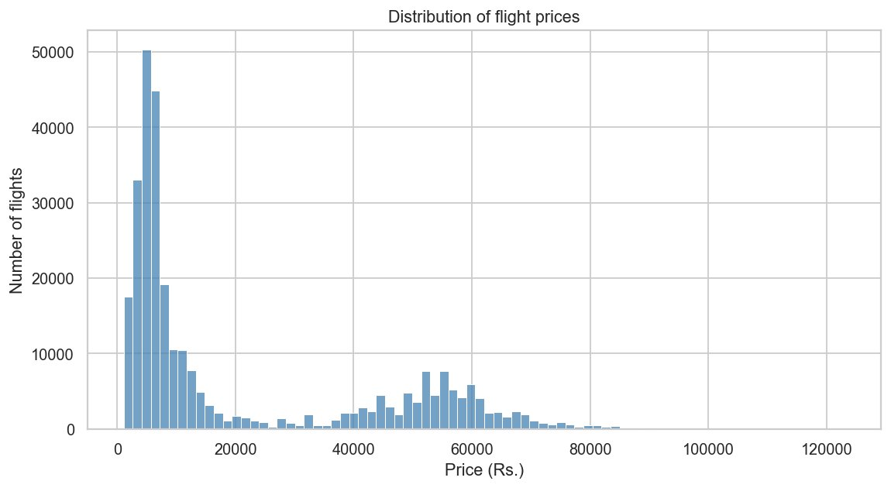
Figure 4: Distribution of flight prices across the full dataset
Figure 5 compares price by travel class. Business fares cluster around Rs. 50,000 while economy fares cluster near Rs. 6,000, making class the single sharpest divider of price.
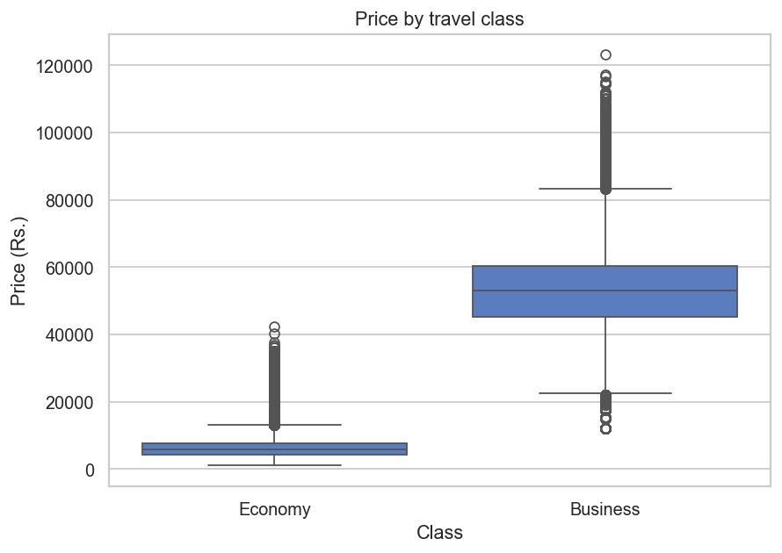
Figure 5: Price by travel class
Figure 6 shows price by airline, ordered by median fare. Vistara and Air India sit at the top of the range, while AirAsia, Indigo, GO FIRST, and SpiceJet have substantially lower and tighter fare distributions.
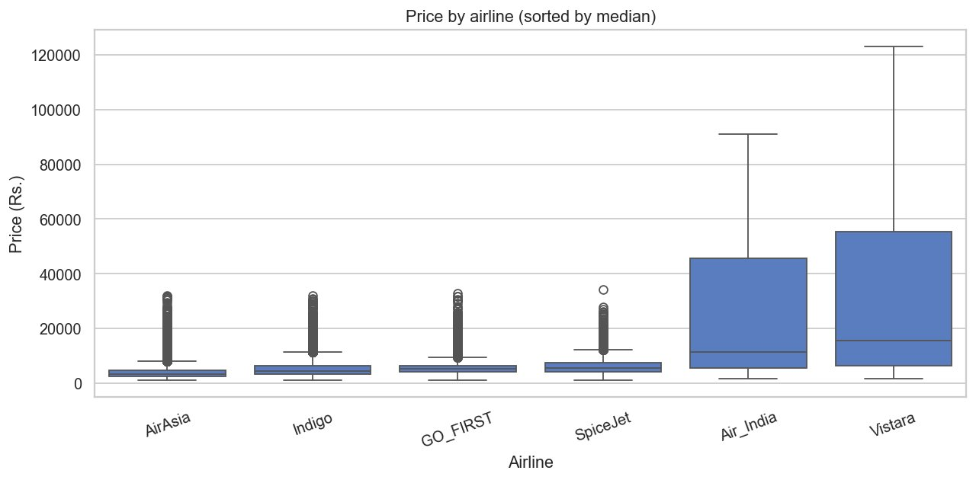
Figure 6: Price by airline, ordered by median fare
Figure 7 plots the average fare against the number of days remaining until departure. The sharp upward spike inside the final few days confirms that pricing is strongly non-linear in the days-left feature — last-minute bookings are heavily penalised.
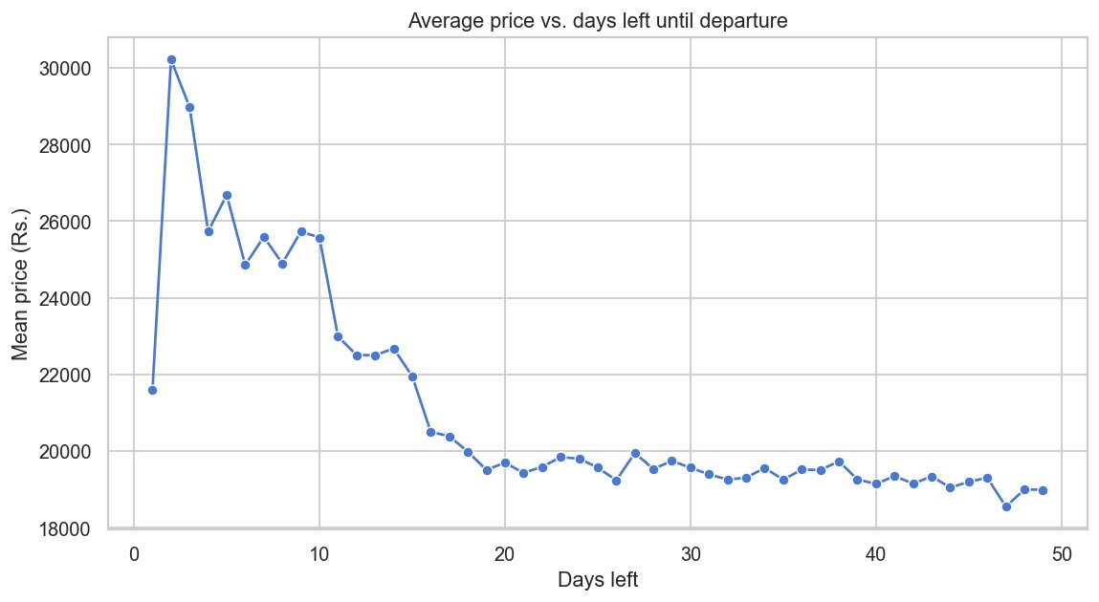
Figure 7: Average price vs. days left until departure
Figure 8 shows price by number of stops. One-stop flights show the widest spread, while zero-stop flights are generally cheaper on average.
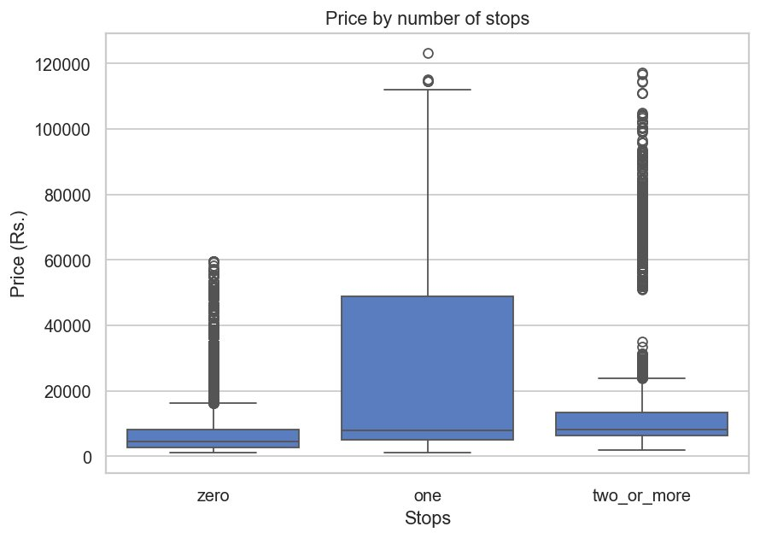
Figure 8: Price distribution by number of stops
Figure 9 is a scatter of flight duration against price for a 5,000-row sample, coloured by class. The two classes form clearly separated bands, reinforcing that class dominates price far more than duration does.
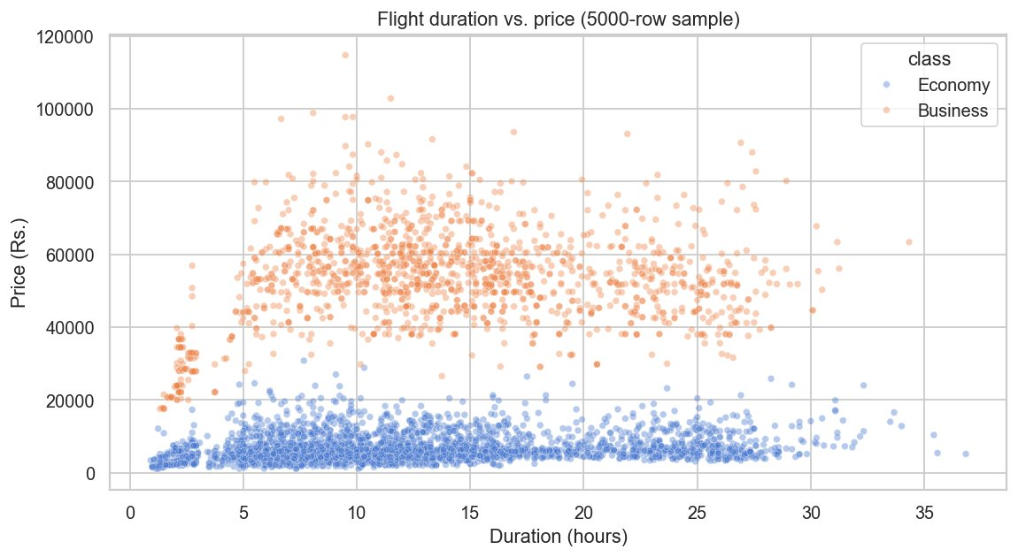
Figure 9: Flight duration vs. price (5,000-row sample), coloured by class

8.2 Model Comparison and Feature Importance
The three candidate models were evaluated on the held-out test set. The results are summarised in the table below.
Model | CV RMSE (Rs.) | Test RMSE (Rs.) | Test MAE (Rs.) | Test R²
Linear Regression | 6,753 | 6,762 | 4,553 | 0.9113
Random Forest | 2,699 | 2,700 | 1,094 | 0.9859
Histogram Gradient Boosting | 3,447 | 3,449 | 2,002 | 0.9769
Random Forest (tuned) | 2,718 | 2,693 | 1,113 | 0.9859
Random Forest is the clear winner, reducing the cross-validated RMSE to less than half that of the Linear Regression baseline. After RandomizedSearchCV tuning, the final Random Forest achieves a test RMSE of Rs. 2,693, an MAE of Rs. 1,113, and an R² of 0.9859, meaning it explains 98.6% of the variance in fares.
Figure 10 compares the test-set RMSE and MAE of the three candidate models, showing visually how far ahead Random Forest is.
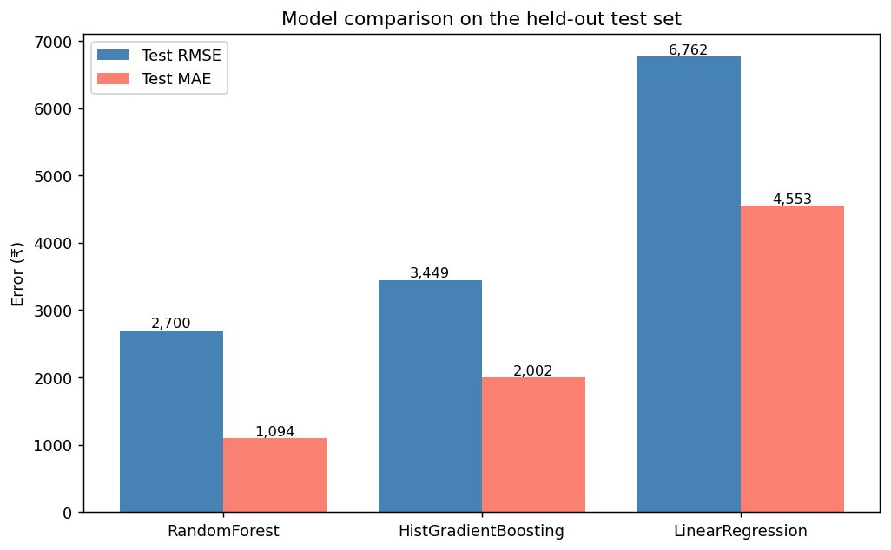
Figure 10: Test-set RMSE and MAE for the three candidate models
Figure 11 shows the 15 most important features in the tuned Random Forest. The feature-importance analysis confirms that travel class (Business versus Economy), flight duration, and the number of days left until departure are the dominant drivers of price, which is consistent with domain knowledge.
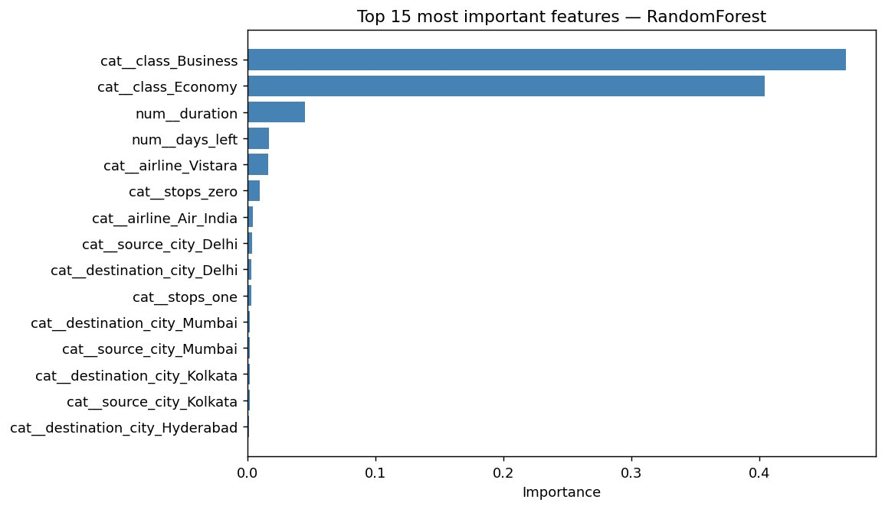
Figure 11: Top 15 most important features in the tuned Random Forest

8.3 Console Output
The console output produced by the training script on the full dataset is reproduced below.
Loaded 300,153 rows.
Train rows: 240,122 | Test rows: 60,031

=== Comparing candidate models with 5-fold CV ===

LinearRegression: CV RMSE 6,753 | Test RMSE 6,762 | MAE 4,553 | R2 0.9113
RandomForest: CV RMSE 2,699 | Test RMSE 2,700 | MAE 1,094 | R2 0.9859
HistGradientBoosting: CV RMSE 3,447 | Test RMSE 3,449 | MAE 2,002 | R2 0.9769

Best by CV RMSE: RandomForest (2,699)

Tuning RandomForest with RandomizedSearchCV (n_iter=10, cv=3)...
best CV RMSE: 2,718
best params : {'model__n_estimators': 200, 'model__min_samples_leaf': 2,
'model__max_features': 0.7, 'model__max_depth': 35}
tuned test : RMSE 2,693 | MAE 1,113 | R2 0.9859

Final model: RandomForest (tuned)
RMSE 2,693 | MAE 1,113 | R2 0.9859
Saved model -> models/flight_fare_model.joblib
Saved metadata -> models/model_metadata.joblib

8.4 Streamlit Web Application
The final tuned model is deployed behind an interactive Streamlit web application. The application loads the persisted joblib artifacts at startup and presents a form-based interface where the user selects the airline, route, timing, stops, duration, and days left, then receives an estimated fare together with an uncertainty band derived from the model's MAE. A sidebar surfaces the model's performance metrics for full transparency.
Figure 12 shows the application predicting an economy-class fare for a Bangalore to Kolkata flight on AirAsia, booked five days before departure. The model estimates a fare of Rs. 6,430, with a typical range of Rs. 5,317 to Rs. 7,544.
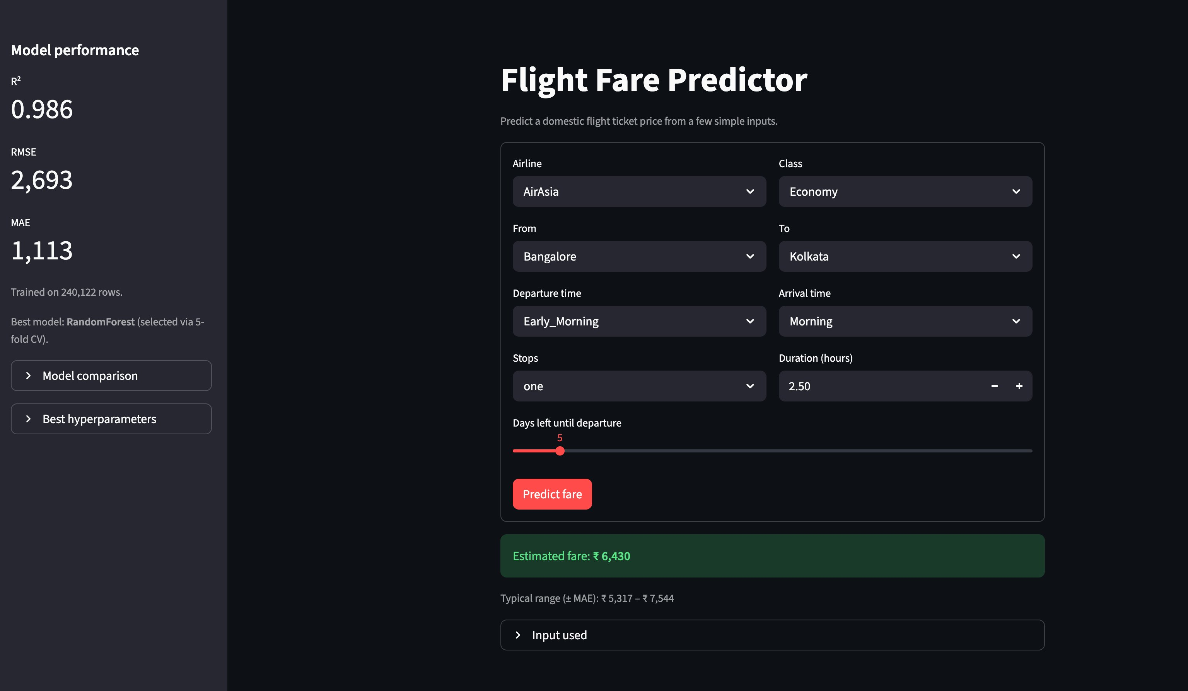
Figure 12: The Streamlit web application predicting an economy-class fare
Figure 13 shows the corresponding “Input used” panel, which echoes back the exact nine feature values passed to the model for that prediction.
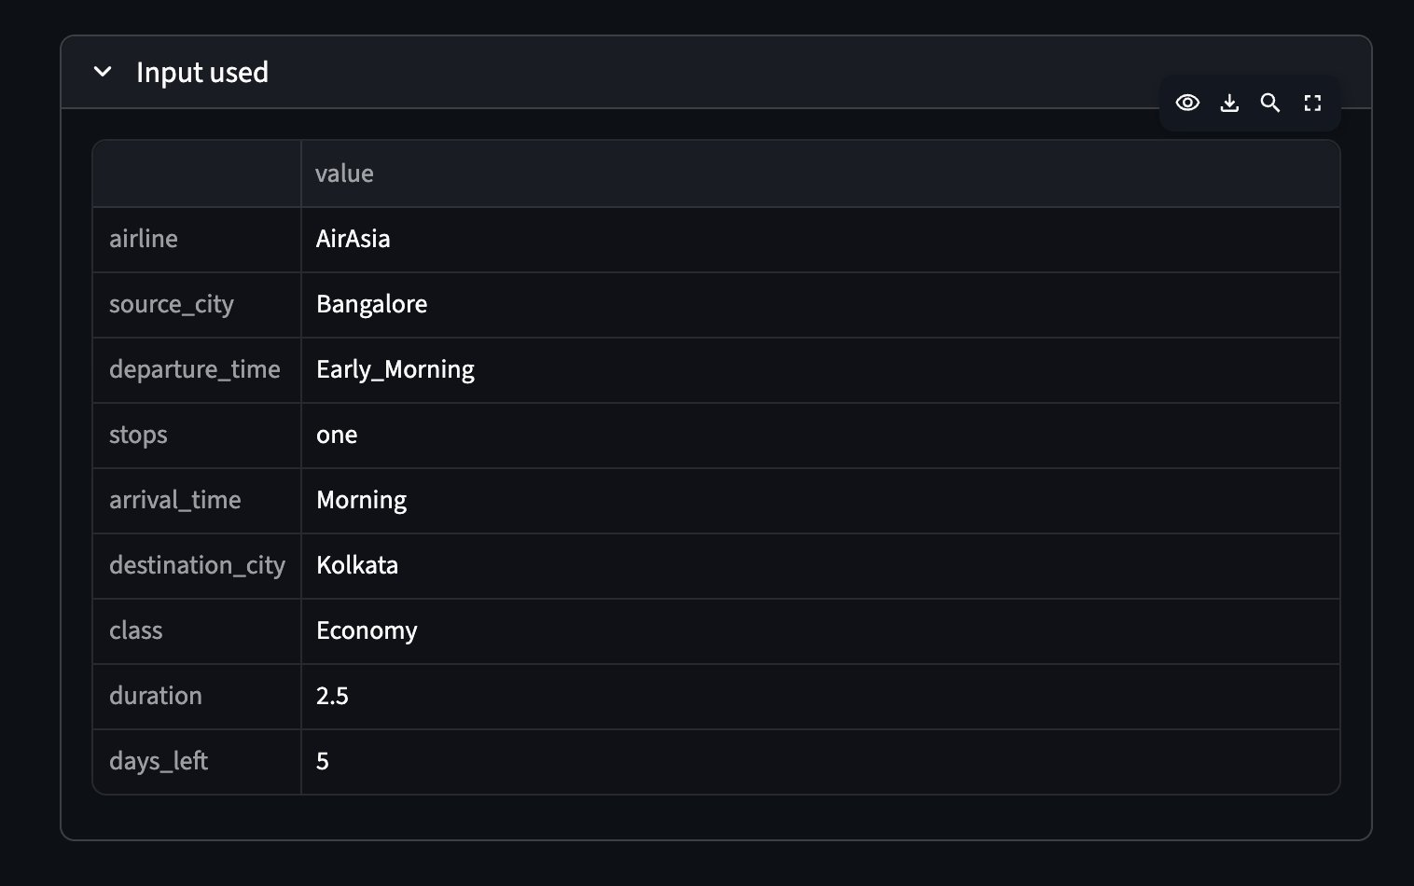
Figure 13: The input values used for the economy-class prediction
Figure 14 shows the same application predicting a business-class fare for a Bangalore to Delhi flight, again booked five days before departure. With only the class and destination changed, the estimated fare rises sharply to Rs. 32,255, demonstrating how strongly travel class drives the predicted price — consistent with the feature-importance analysis in Section 8.2.
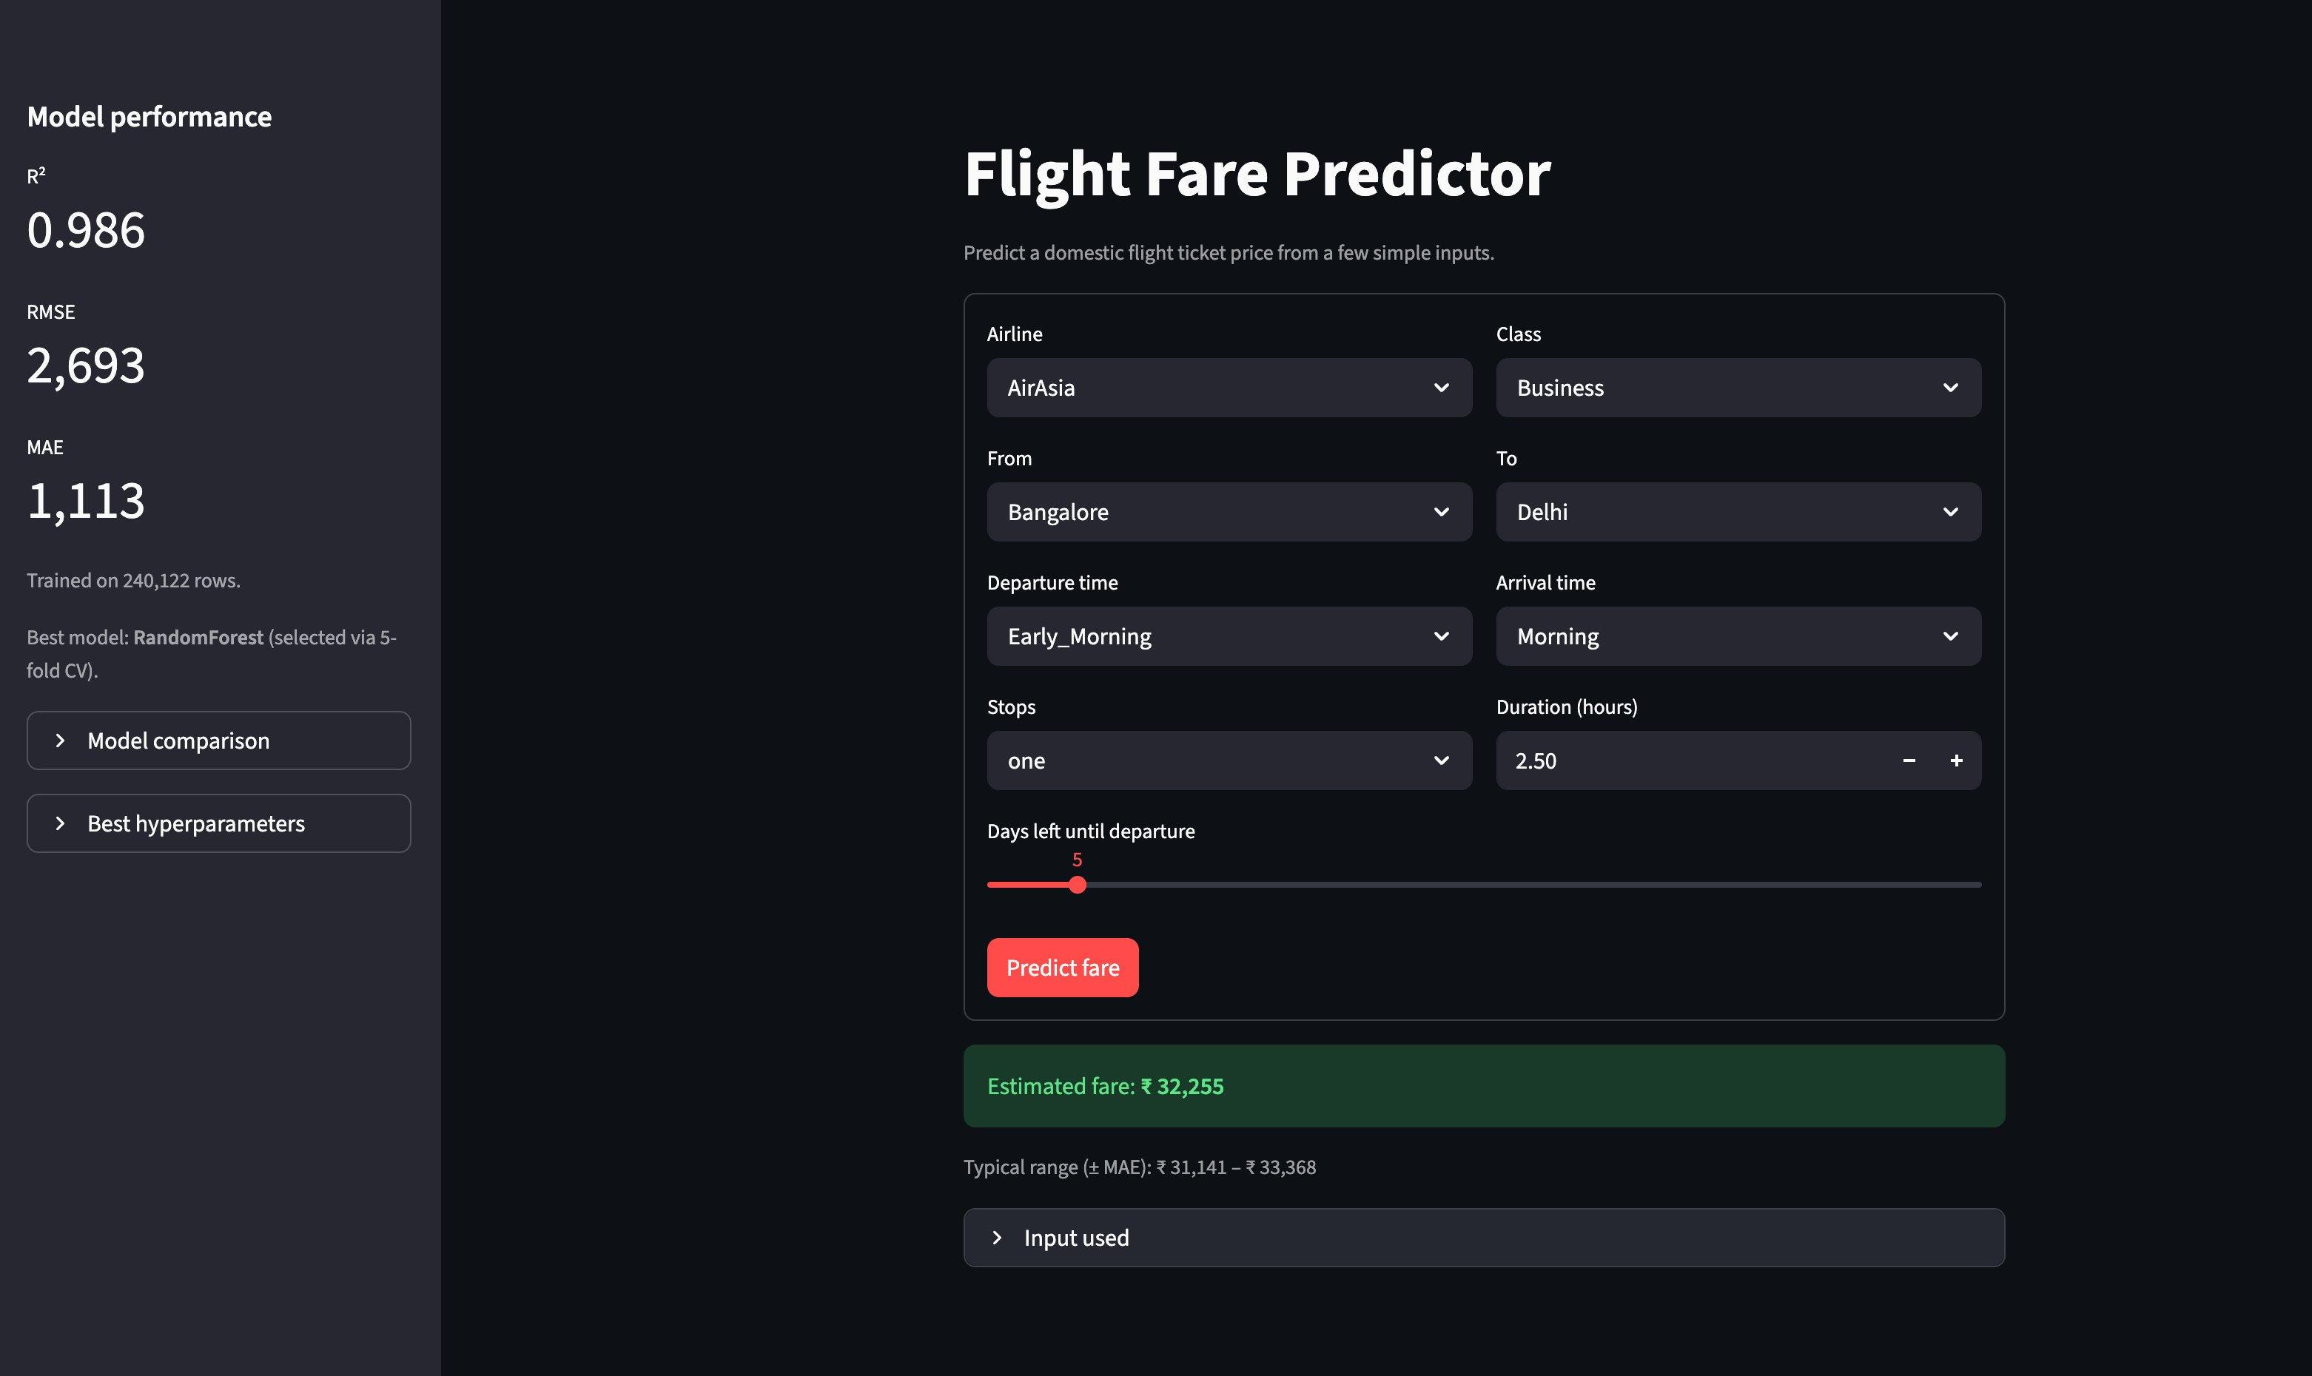
Figure 14: The Streamlit web application predicting a business-class fare
Figure 15 shows the input panel for the business-class prediction.
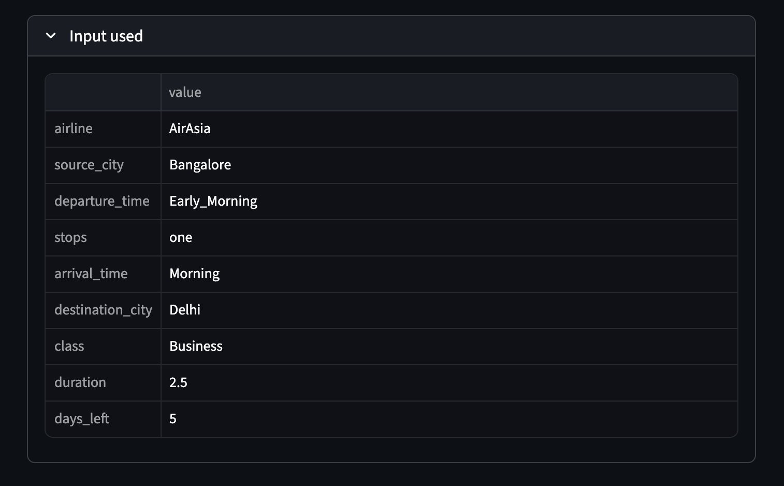
Figure 15: The input values used for the business-class prediction

9. CONCLUSION
This project successfully delivered an end-to-end supervised regression pipeline for predicting Indian domestic flight fares. Starting from a Kaggle dataset of 300,153 records, three candidate regression models were compared using five-fold cross-validation: a Linear Regression baseline with a cross-validated RMSE of Rs. 6,753, a Random Forest Regressor at Rs. 2,699, and a Histogram Gradient Boosting Regressor at Rs. 3,447.
The Random Forest, after RandomizedSearchCV hyperparameter tuning, achieved a test-set RMSE of Rs. 2,693, an MAE of Rs. 1,113, and an R² of 0.9859, explaining 98.6% of the variance in fares. Feature-importance analysis confirmed that travel class, days left until departure, and airline identity are the dominant drivers of price, consistent with domain knowledge.
The trained pipeline is persisted to disk and served behind a Streamlit web application that surfaces both the predicted fare and the model's performance metrics, allowing users to estimate prices interactively while remaining honest about uncertainty. The project demonstrates that an ensemble of decision trees, combined with a disciplined preprocessing pipeline and rigorous cross-validated comparison, is well suited to tabular fare-prediction problems, and that high predictive quality is achievable without manual feature engineering. Future work could extend the approach with quantile-regression prediction intervals, additional features such as holiday flags and a fuel-price index, and a temporal hold-out to better measure deployment robustness.

