**ASSIGNMENT 11:**

**Problem Statement: Build Scaling plans in AWS that balance load on different EC2 instances.**

**Procedure:**

1. At first log into your AWS account, then go to EC2.

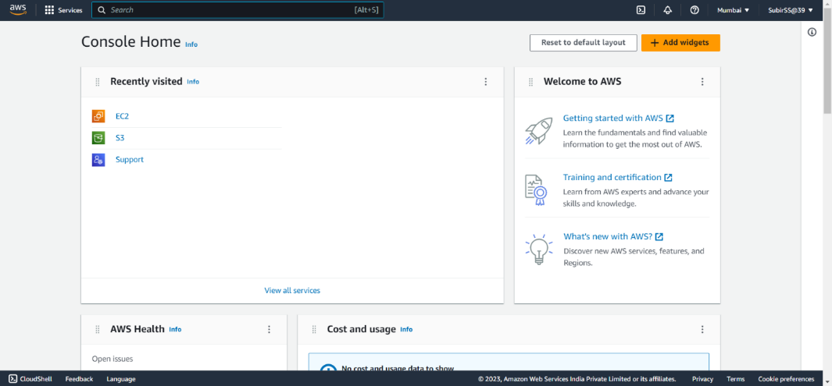

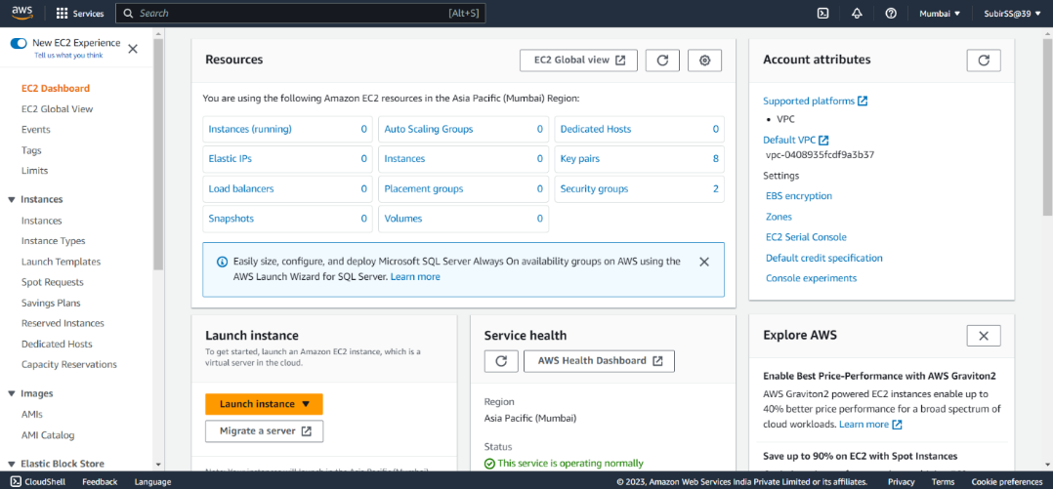

1. Go to launch template in the left-hand side, then click on ‘Create Launch template’. Create a new template with name,description and other properties.

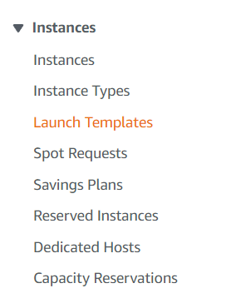

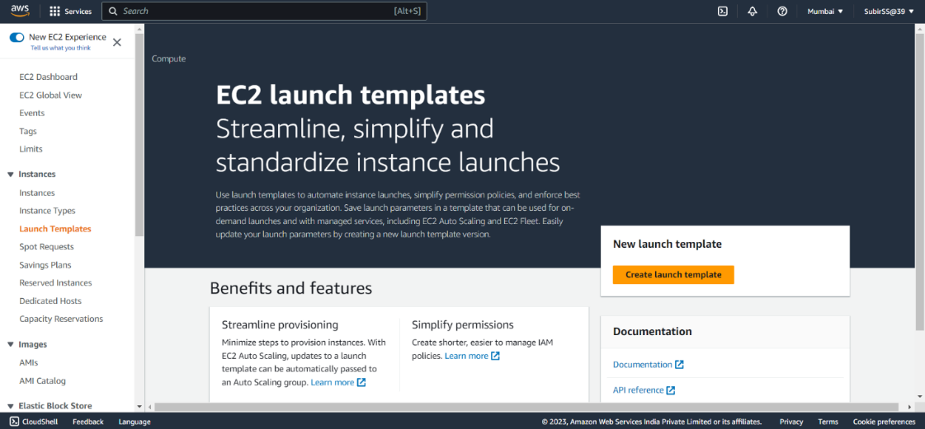

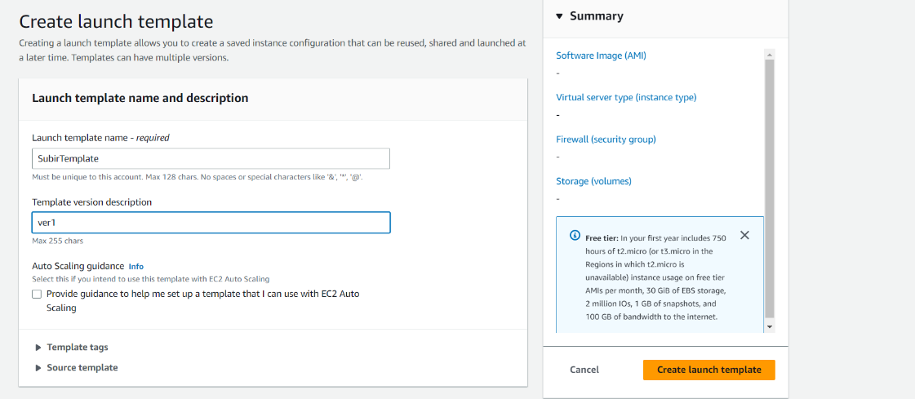

1. In ‘Application and OS Images (Amazon Machine Image)**’** region select Quick Start.Then select the OS:Ubuntu and under Instance type select:t2.micro.Then create a key pair or select an existing one.

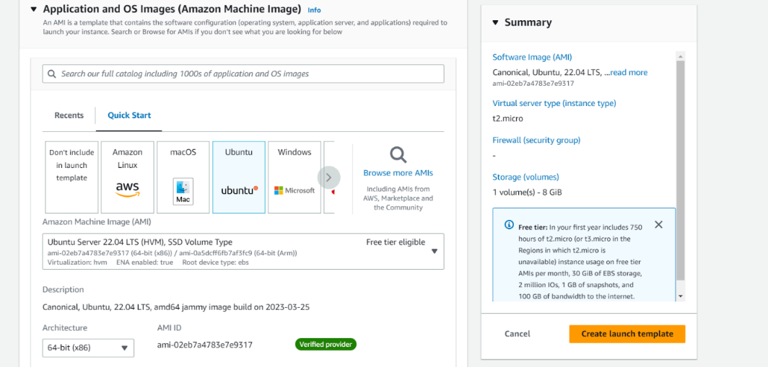

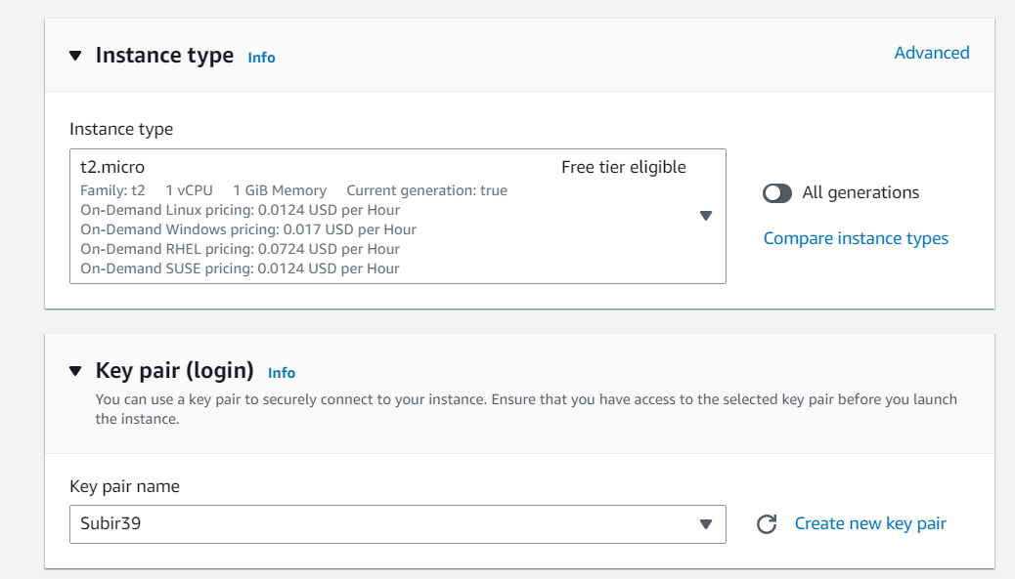

1. In Network Settings, select the created Security Group.

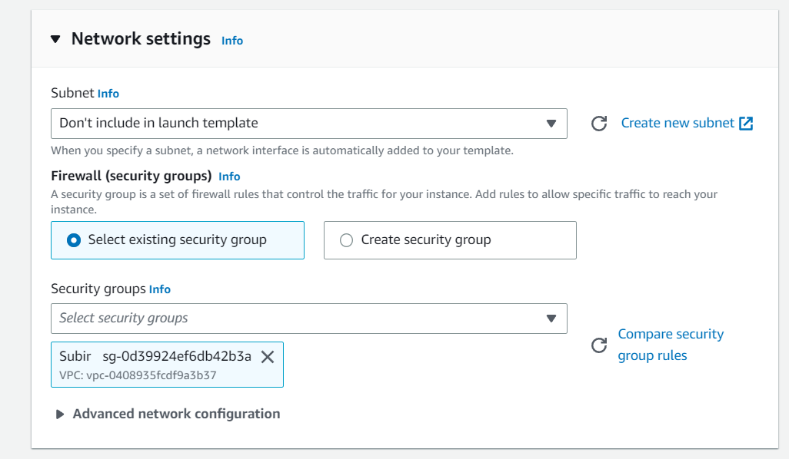

1. In Advanced details, enter User data -

**#!/bin/bash**

**apt-get update**

**apt-get install -y nginx**

**systemctl start nginx**

**systemctl enable nginx**

**apt-get install -y git**

**curl -sL https://deb.nodesource.com/setup_18.x | sudo -E bash -**

**apt-get install -y nodejs**

**git clone repo link**

**cd repo name**

**npm install**

**node index.js**

Then click on ‘Create Launch template’ option.

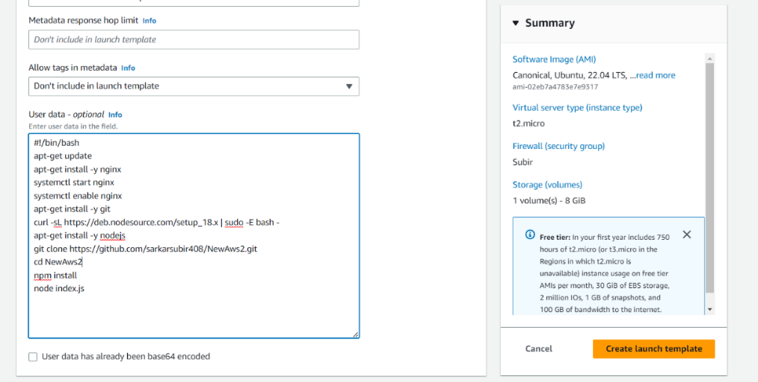

1. Now go to EC2 dashboard,then go to Auto Scaling groups and select Create Auto Scaling group.

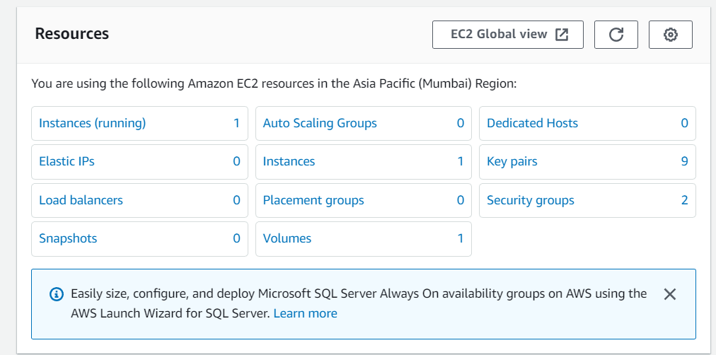



1. Now we have to create a new AutoScaling group with name,template and template version: Latest(1).Then click on Next.

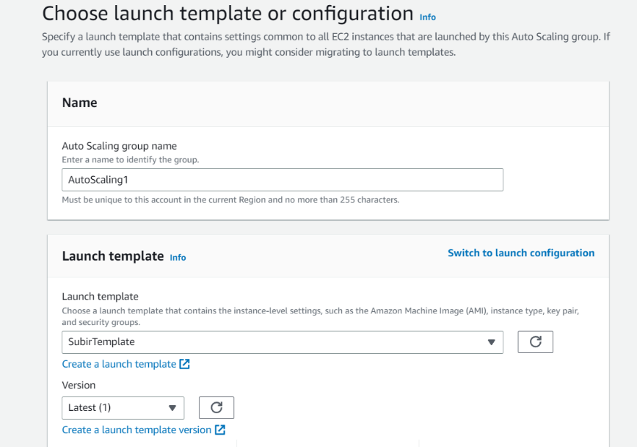

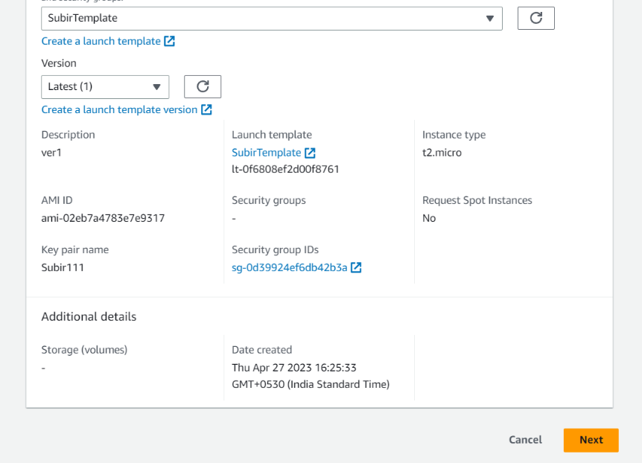

1. Next select all the Availability zones and subnets.

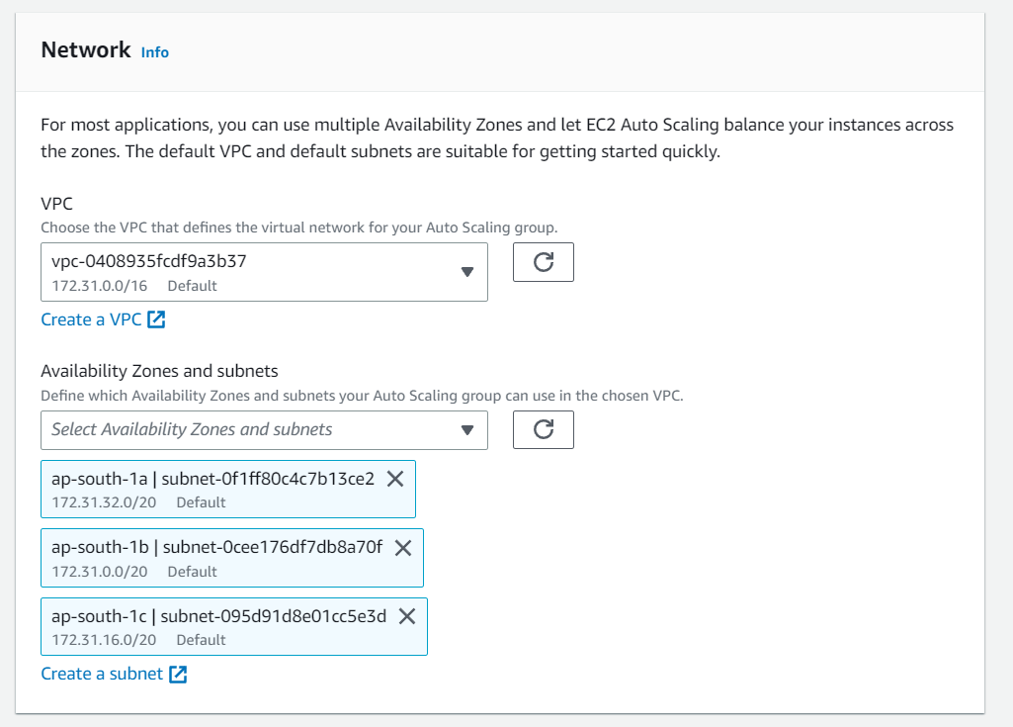

1. Next Attach to a new load balancer. Load balancer scheme: Internet-facing. In Listeners and routing select :Port - 4000 ,Default routing : Create a target group. Then Next.

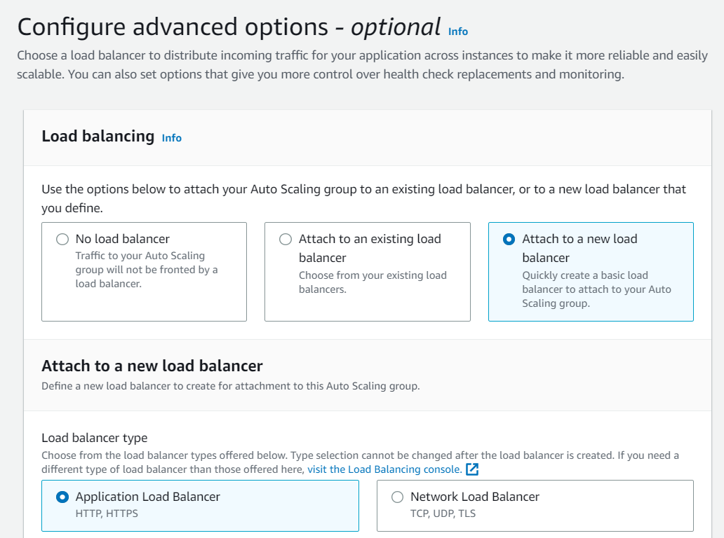

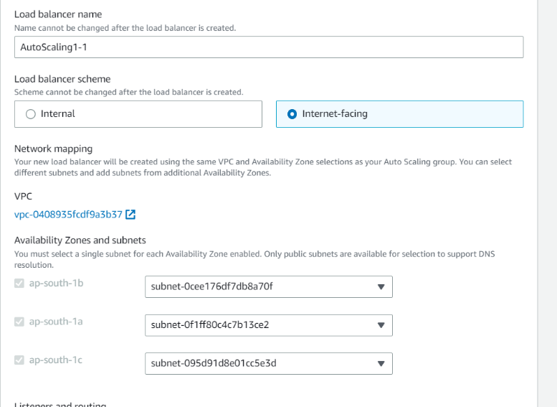

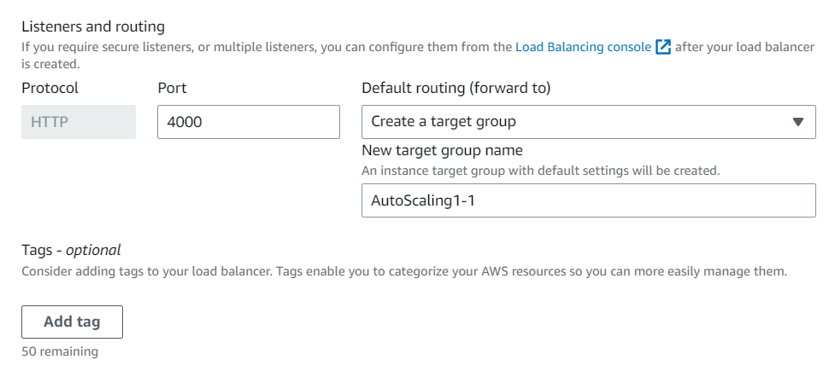

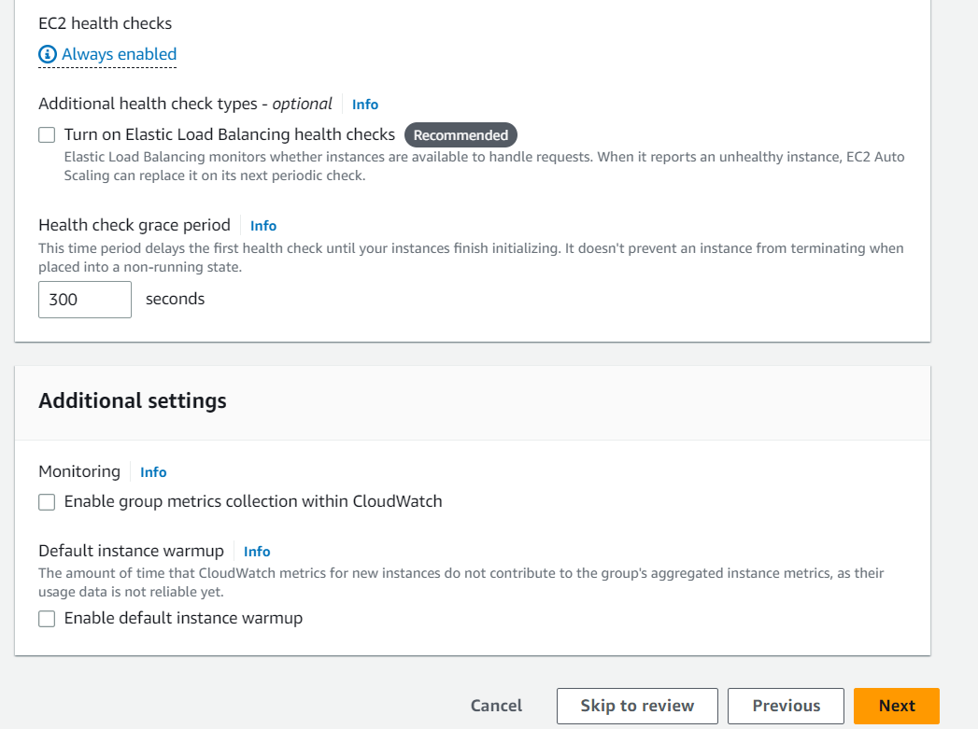

1. Select Group size: Desired capacity:2, Minimum capacity:2 & Maximum capacity:3. In Scaling policies select Target tracking scaling policy.Set Target value :50, Instances need:300. Next. Then click on ‘Next’ for all the other pages and at the last page click on Create Auto Scaling group.

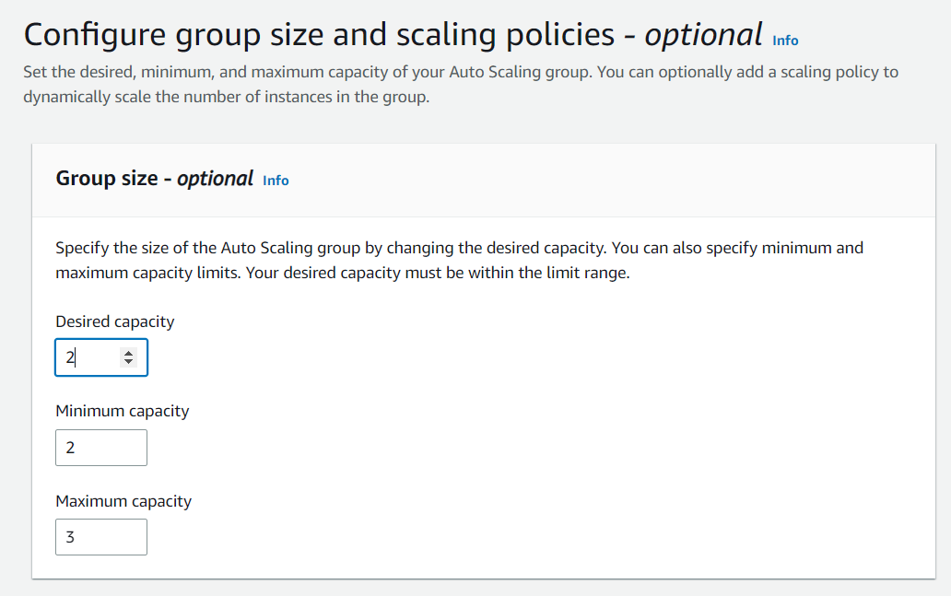

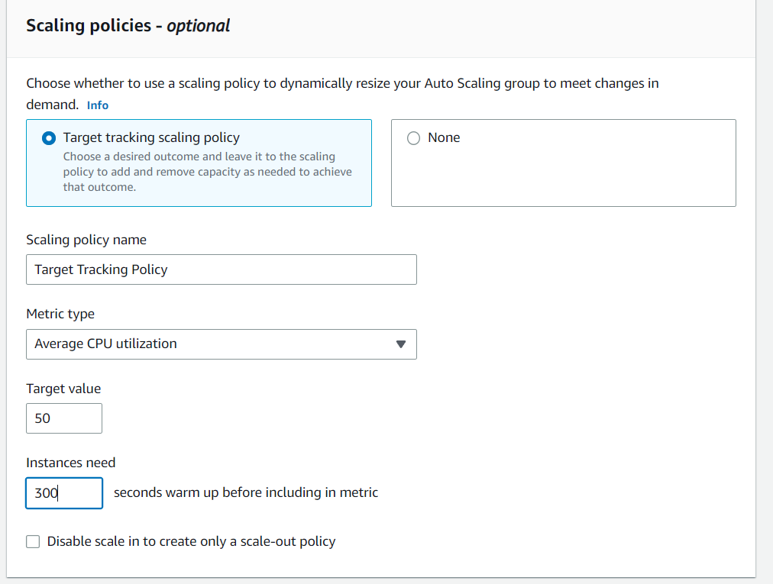

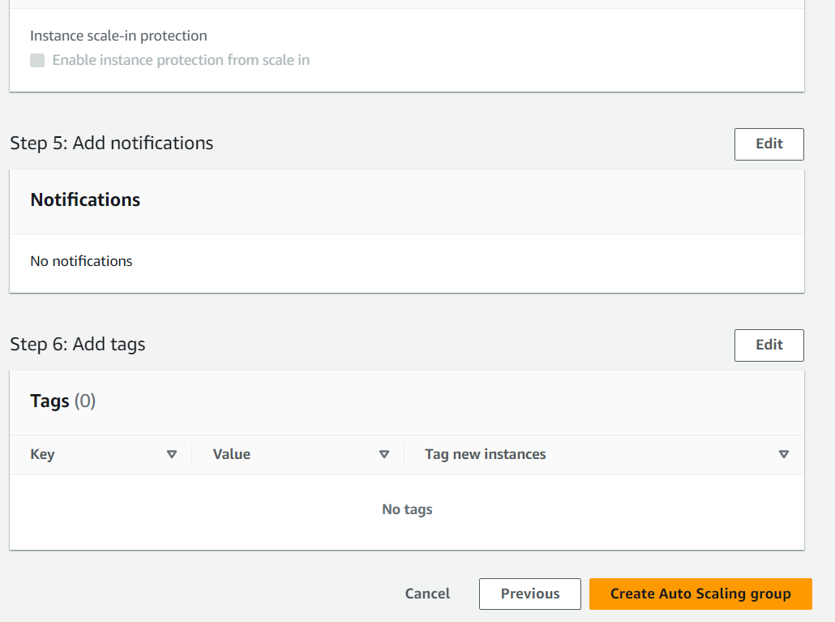

1. Now your auto scaling group is created. Go to EC2 Instances, you can see two instances are created automatically.

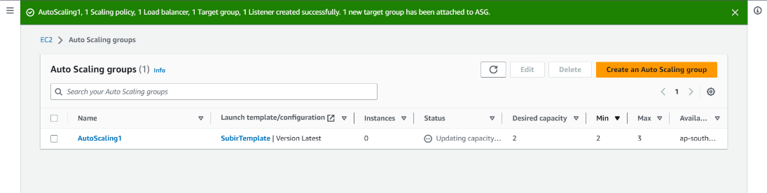

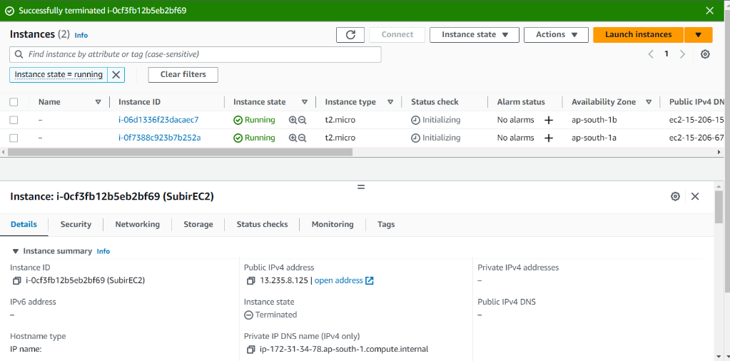

1. Now run the public IPv4 address of the 1st instance.

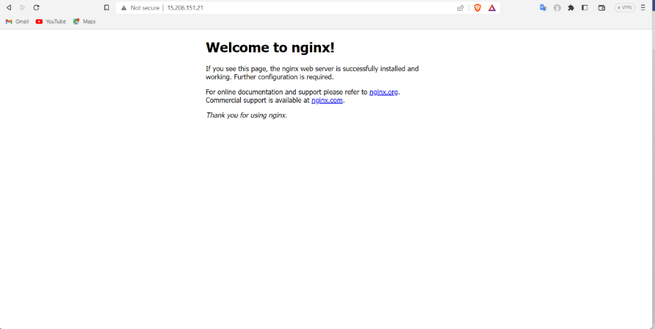

1. Now terminate both the instances.After some time you can see 2 instances are created automatically.

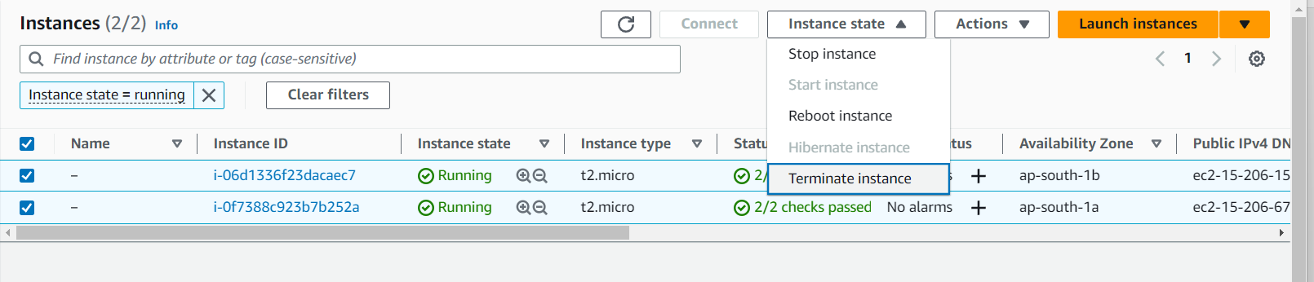

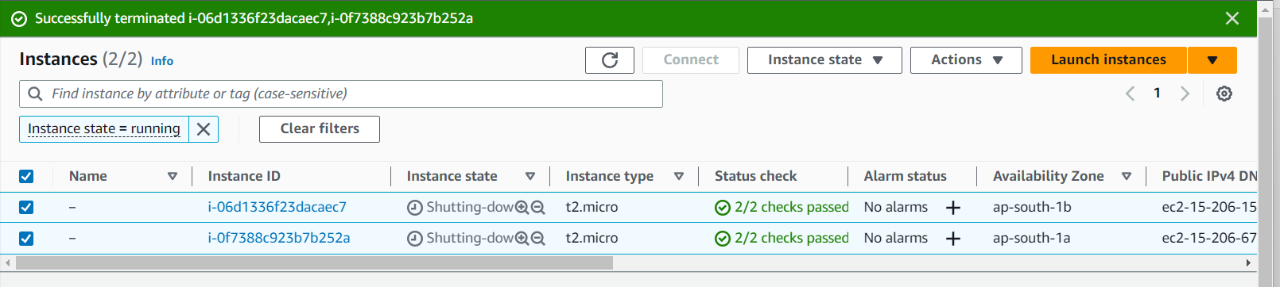

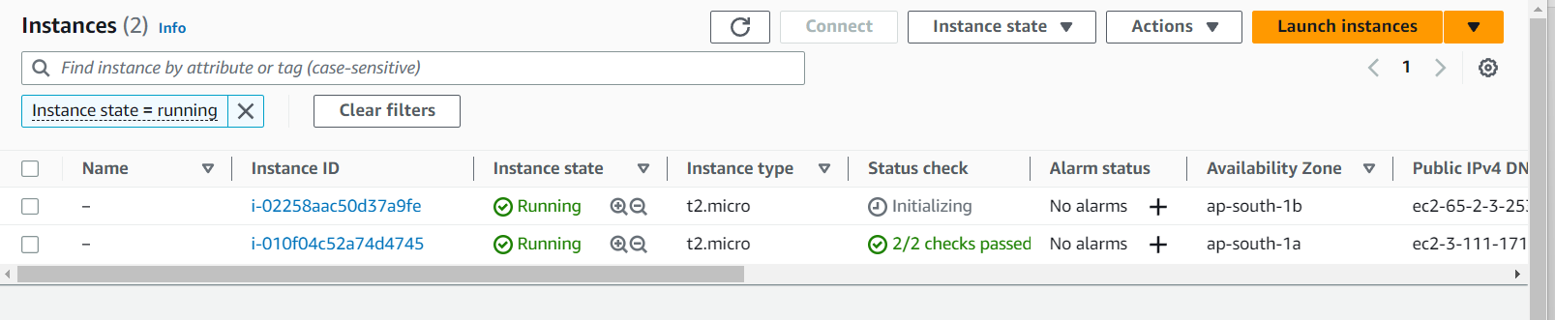

1. Now copy the Public IPv4 address of the newly created first instance and connect it with Bitvise SSH Client.

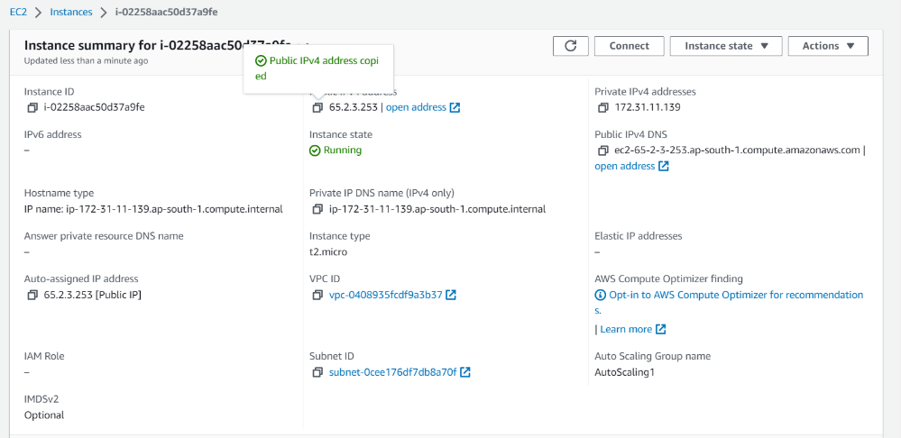

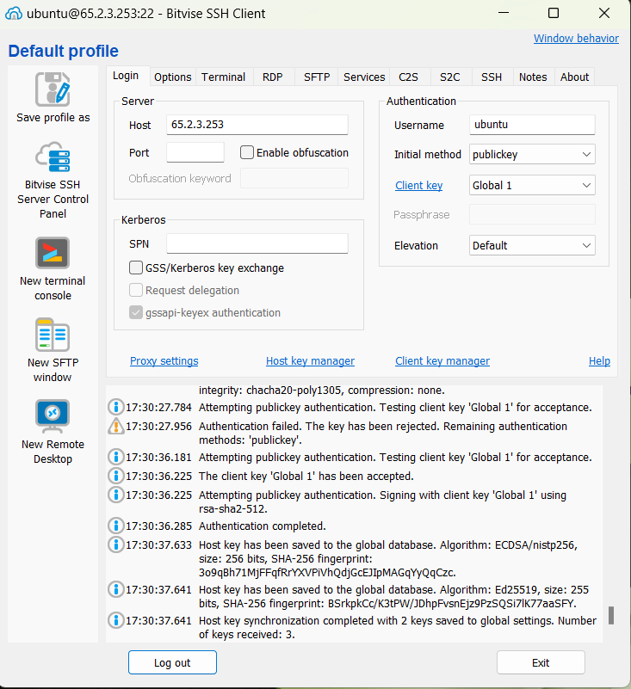

1. Open the New terminal console. Write the infinite loop code mentioned below. permission (chmod +x infi1.sh).

**#!/bin/bash**

**while true**

**do**

**echo "Looping forever"**

**# Add other commands to run in the loop here**

**Done**

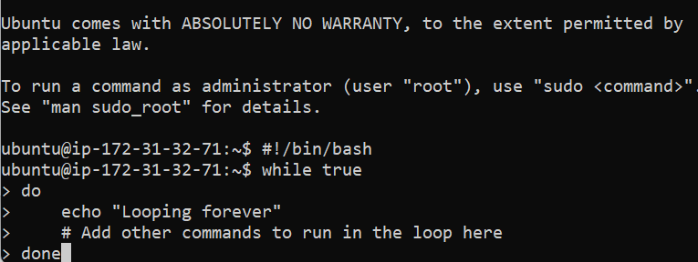

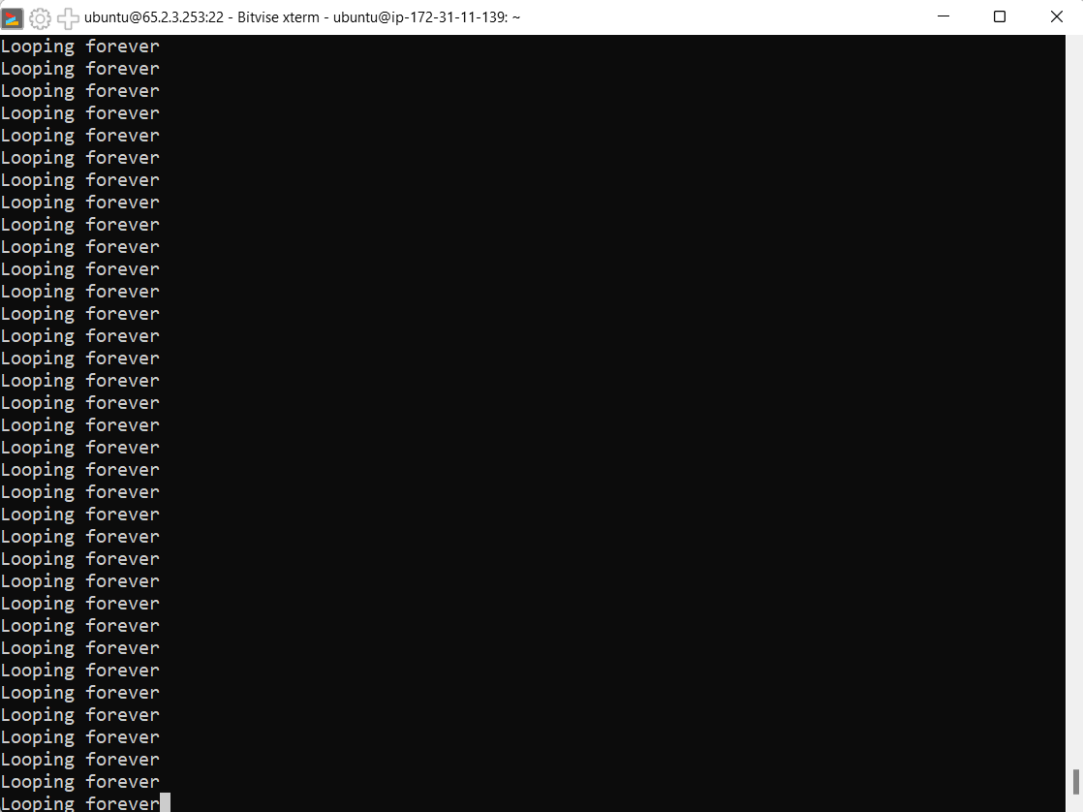

1. Do the step-15 for the second instance also.
2. After that server get overloaded and new instance is created.
3. Now check the CPU utilization of the 3 instances.

