**Assignment 14:**

**Problem Statement: Create an Elastic IP for an Instance.**

**Procedure:**

1. At first create an EC2 instance normally and check its Public IPv4 address.

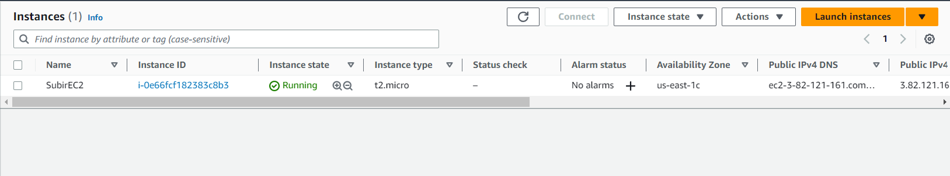

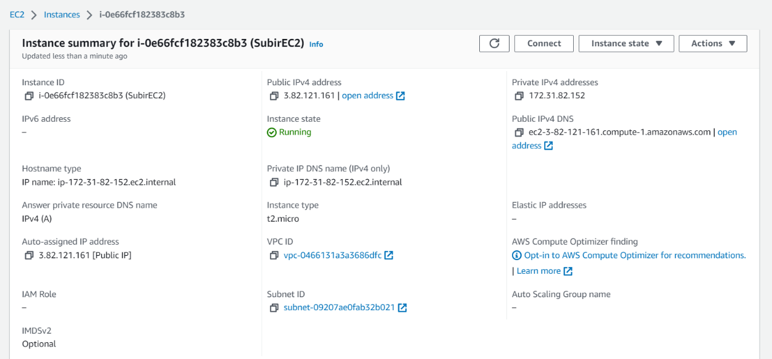

1. Stop the instance and restart it.You can see the Public Ipv4 address has changed.

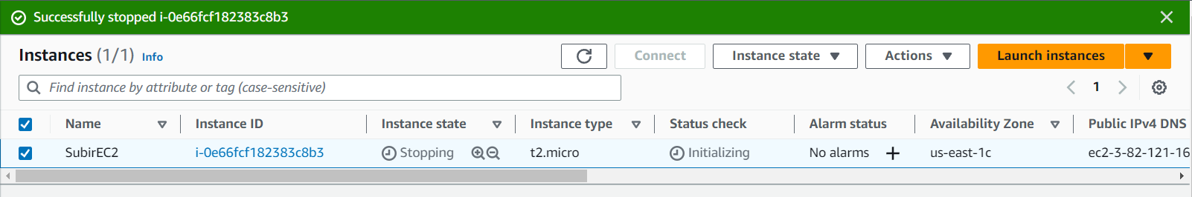

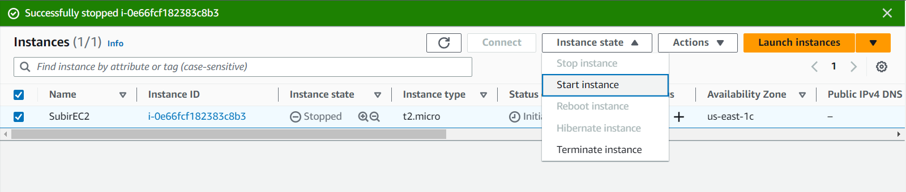

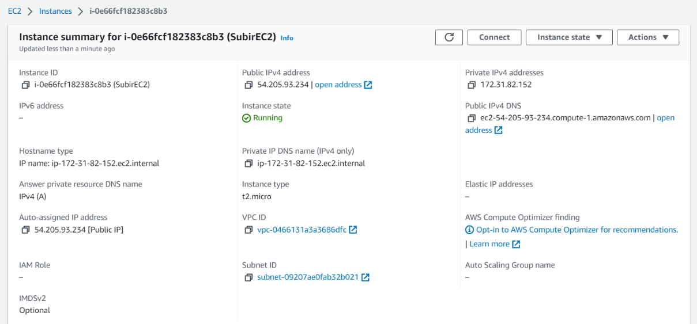

1. Now go to EC2 Dashboard and open Elastic Ips.Then allocate Elastic IP address. Set settings as default and click on allocate.

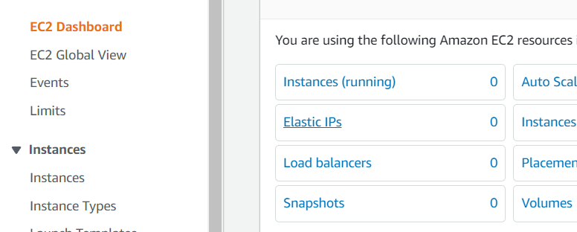

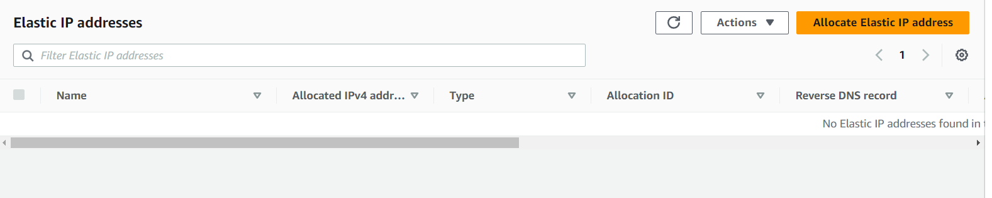

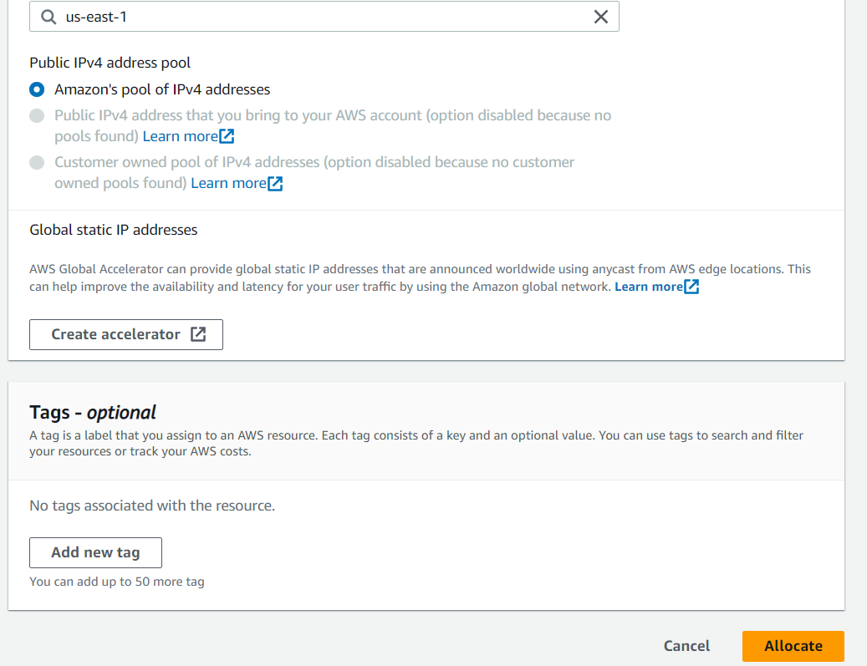

1. Now the allocation part is complete.Then click on the ‘Associate Elastic IP address’.

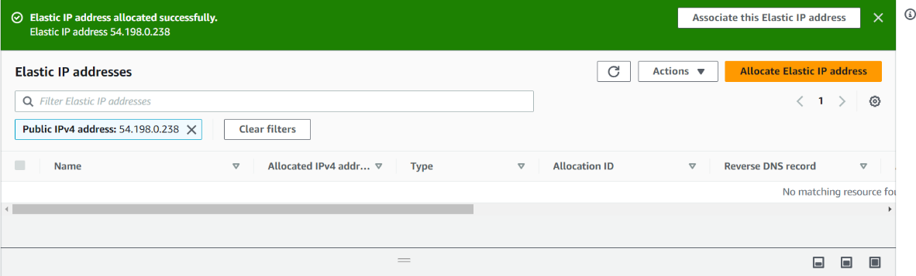

1. Select Resource type as instance, choose the Instance & Private IP address. Tick the ‘Reassociation’ checkbox and then click on ‘Associate’.

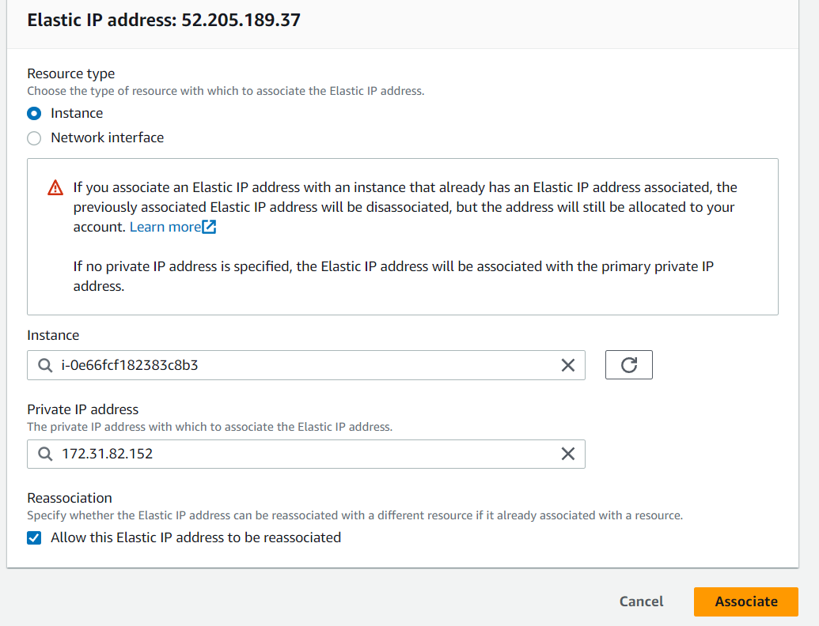

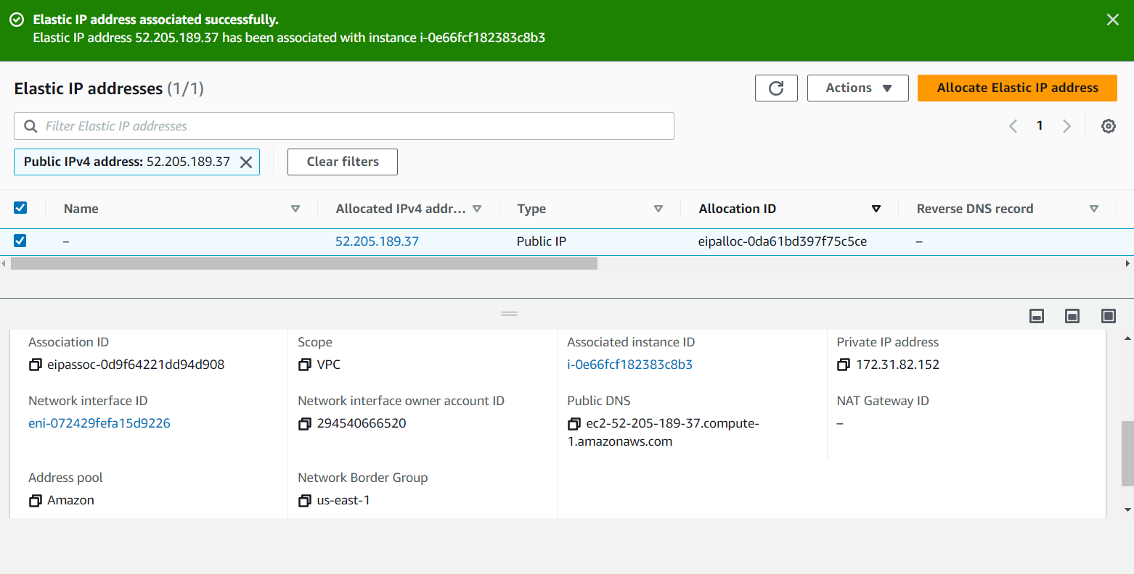

1. Now check the instance.The Elastic IP becomes Public IPv4 of the instance.

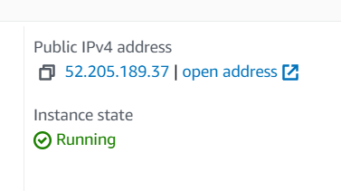

1. Now again stop and start the instance and check the Public IPv4 address again. The allocated Elastic IP becomes the constant Public IPv4 address .

