**Assignment 15:**

**Problem Statement:** **Create a Serverless Computing Service.**

**Procedure:**

1. At first open your AWS Console Home and search lambda on the top search bar.

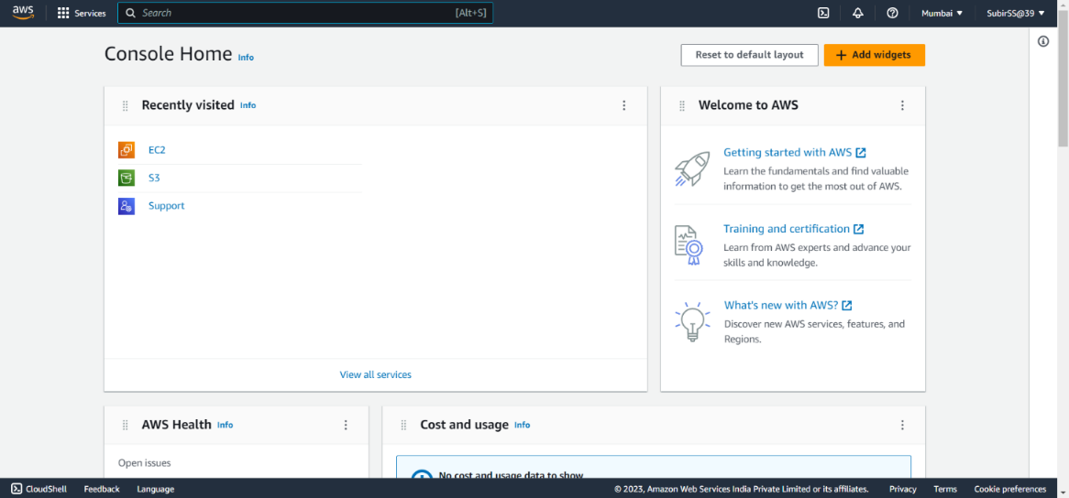

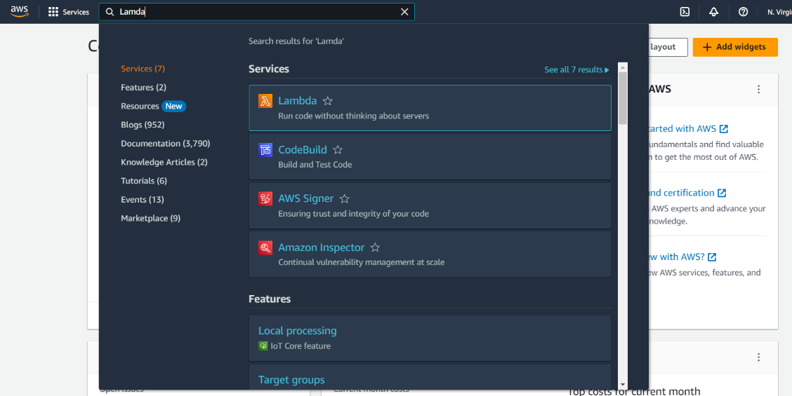

1. Open the first option ‘Lambda’.Then click on ‘Create a function’.

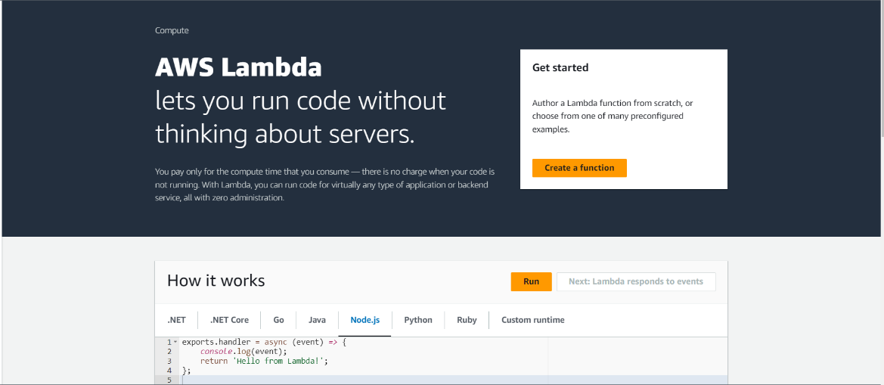

1. Select ‘Author from scratch’, give a Function name, select runtime as Node.js 18.x and other things will be remain as default.Then click on ‘Create function’.

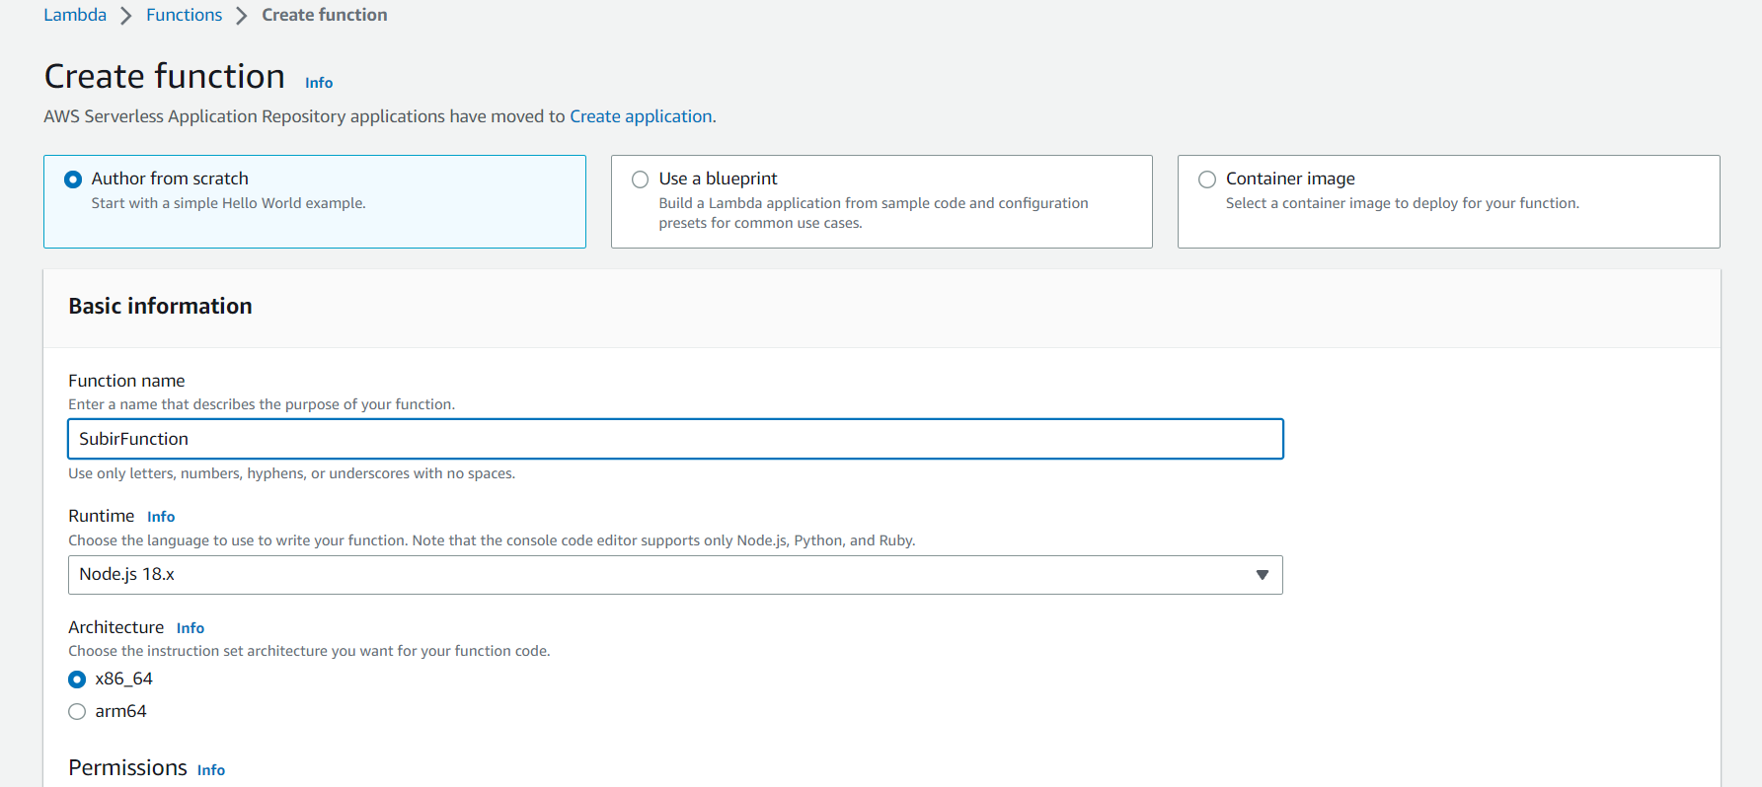

1. Change the string(Hello from Lambda) in the code then save it(File->save).

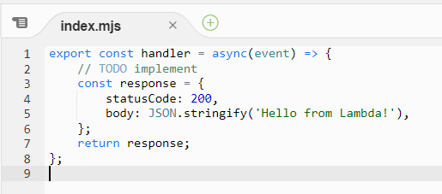

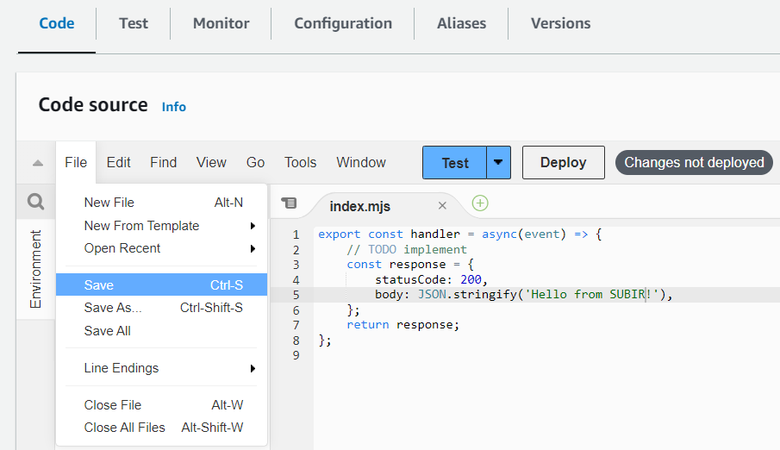

1. Then click on ‘Test’.Give an Event name,select Event sharing settings as Private and save it.

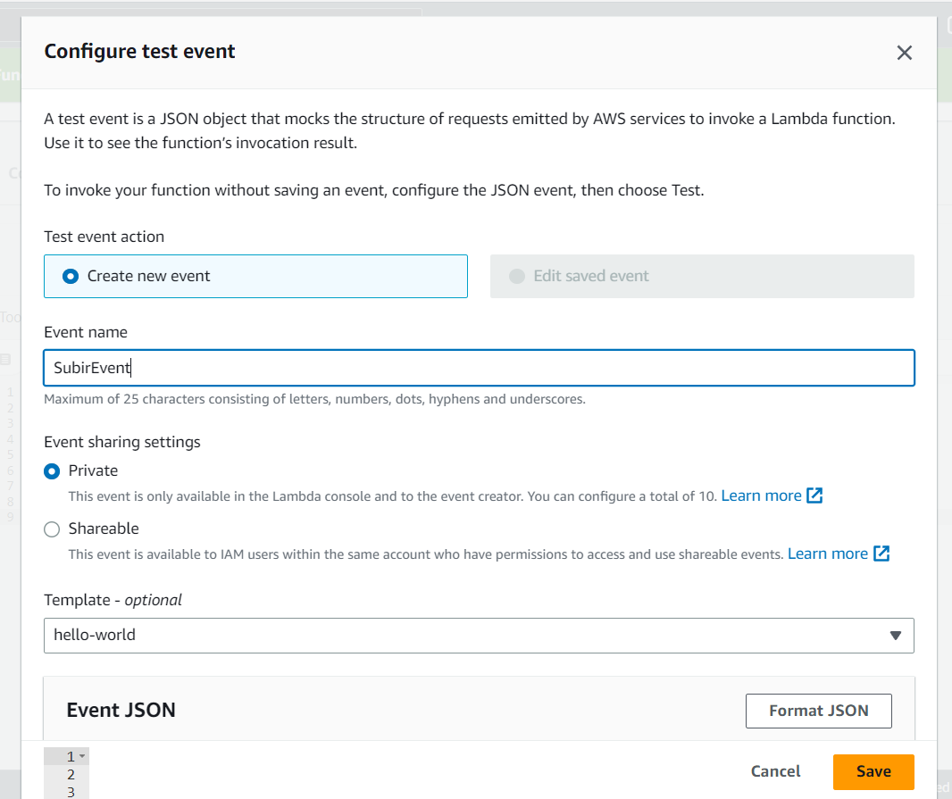

1. Now again click on ‘Test’ and then click on ‘Deploy’.

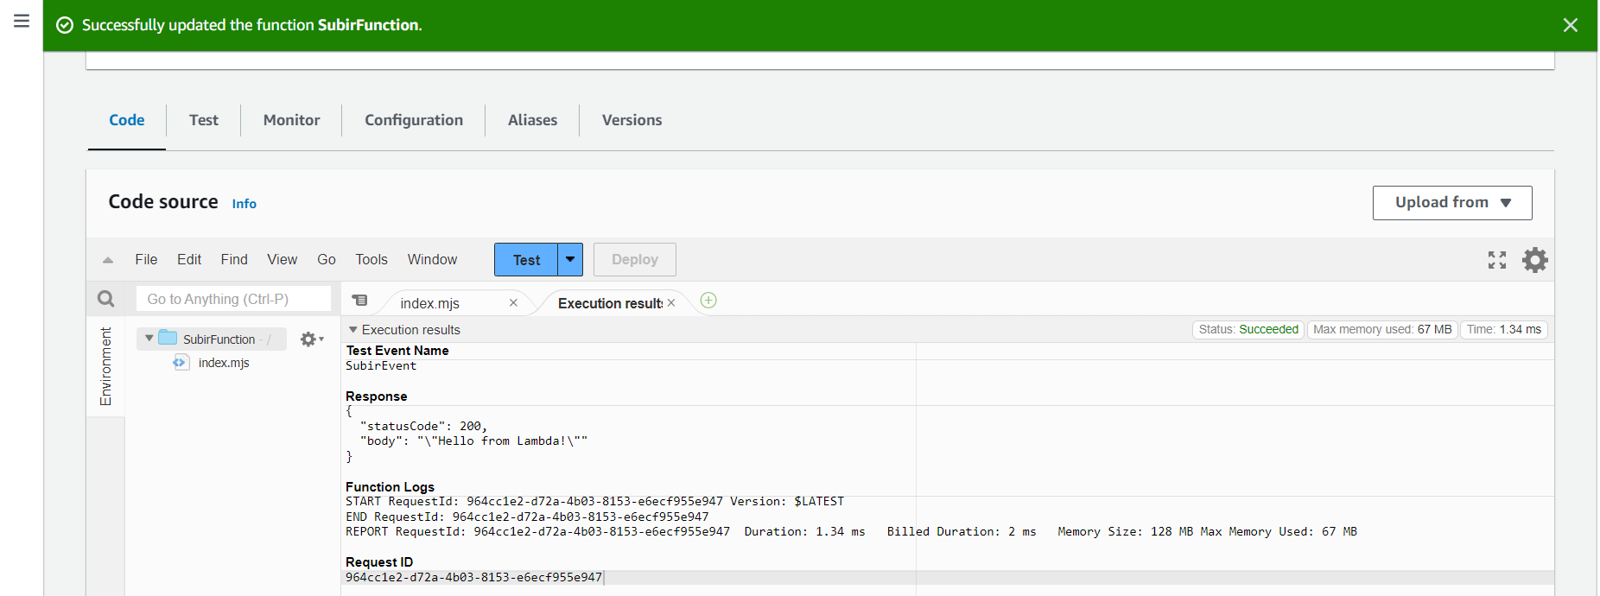

1. Then go to ‘Configuration’ and select ‘Function URL’ then Create function URL.Select Auth type: NONE and save it.

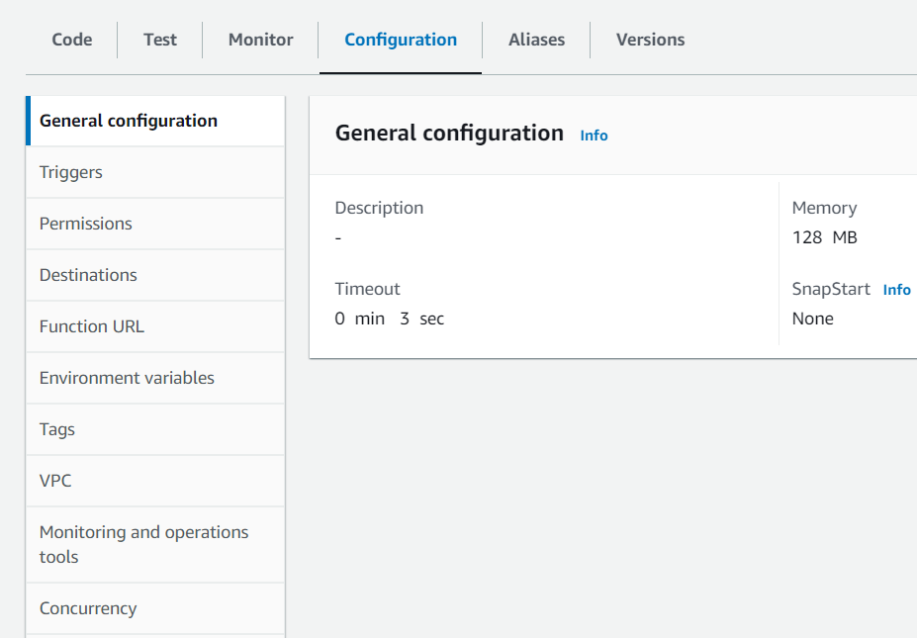

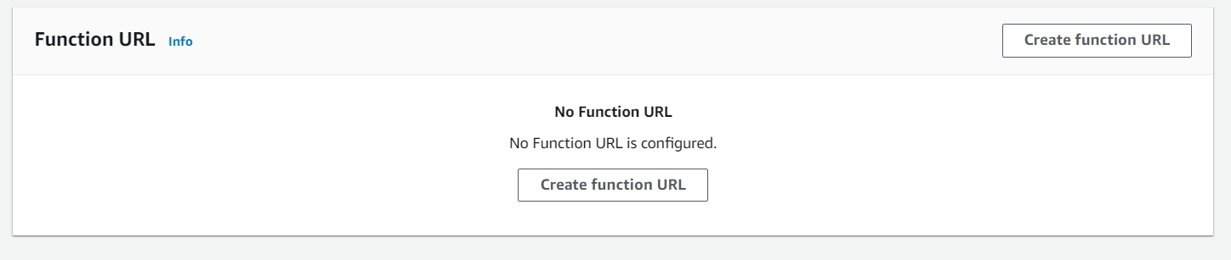

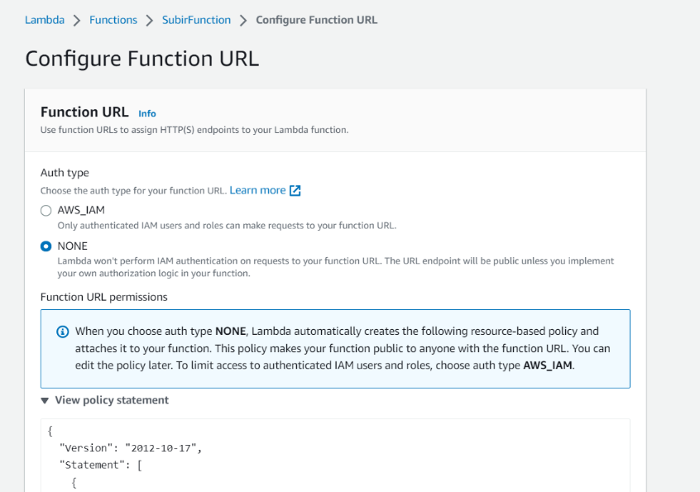

1. Then copy the function URL from your function overview and run it in the browser or you can simply click the URL to open it.

